Liquid Dimension Icon AFM Experiment Instructions
J. Thompson Aug 2014
**Do not do any liquid experiments until you have been given permission to do so**
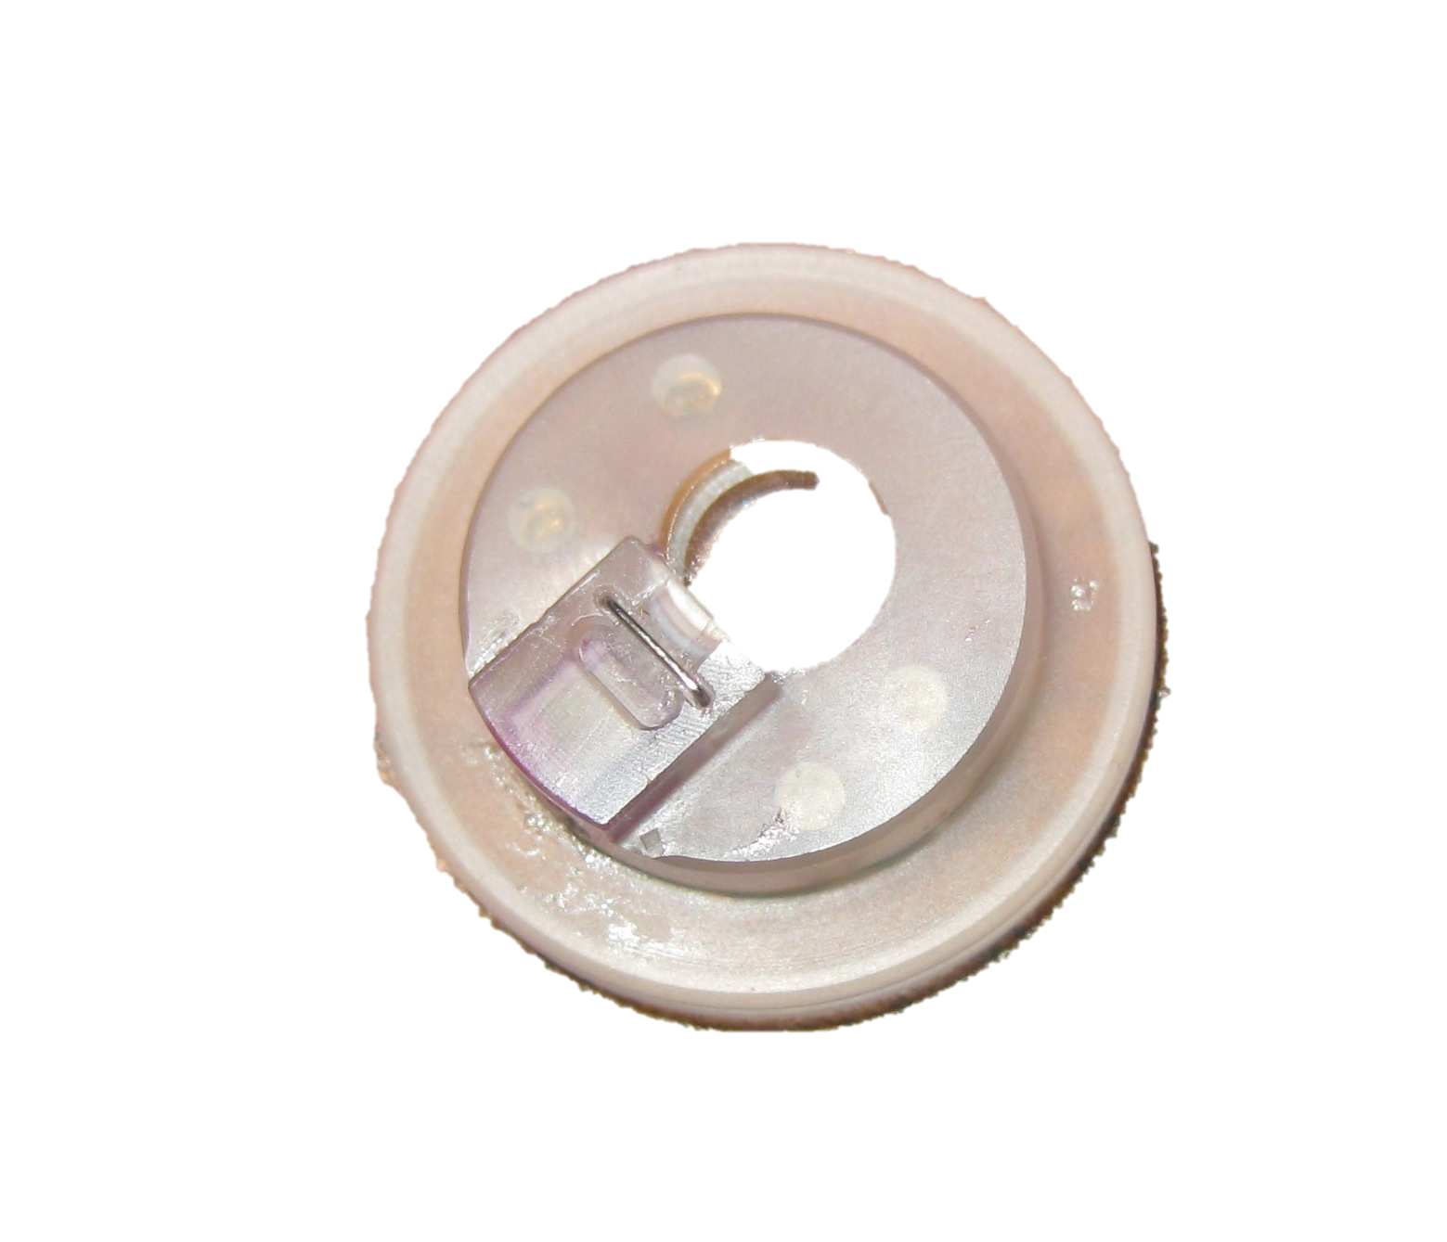
- Be very cautious when using liquid around the AFM. Any exposure of the electronics to liquid could cause severe damage. Be particularly careful of exposing the scanner head to liquid. Since the scanner head will necessarily be brought close to liquid, improper operation substantially raises the risk of causing damage. The instrument will be severely damaged if the metal pins that the probe holders connect to are shorted to each other by liquid contact. Additionally, be cautious about letting liquid into the vacuum system. The probe holder is rated for operation in liquid between 1 and 13 pH. Strong organic solvents such as chloroform or oxidizing chemicals can harm the probe holder and should not be used. If you are unsure about a solvent you would like to use, consult a GLA.
Figure 1. Liquid probe tip holder.
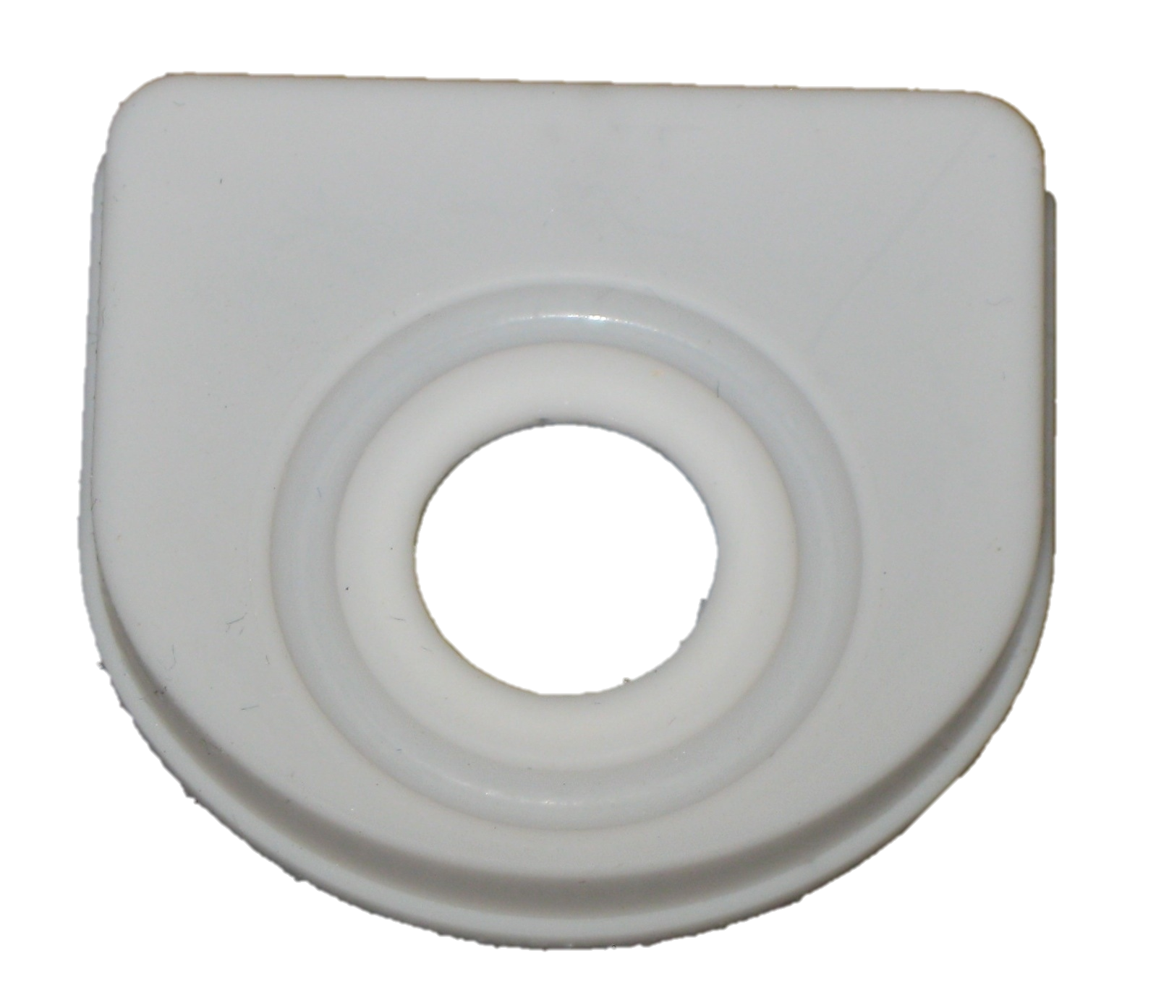
- Press the flat side of the liquid probe tip holder (Figure 1) down against a flat, clean surface. This will cause the metal clip that will hold the AFM probe in place to rise. Place the AFM probe under the clip and stop pressing the holder against the surface. The clip should now hold the AFM probe in place
Figure 2. Evaporation Cover.
- Check to see that the clip is in fact holding the AFM probe securely. If the tip moves when the holder moves, let a GLA know so that the holder can be serviced. A damaged holder can allow fluid to make contact with the metal pins.
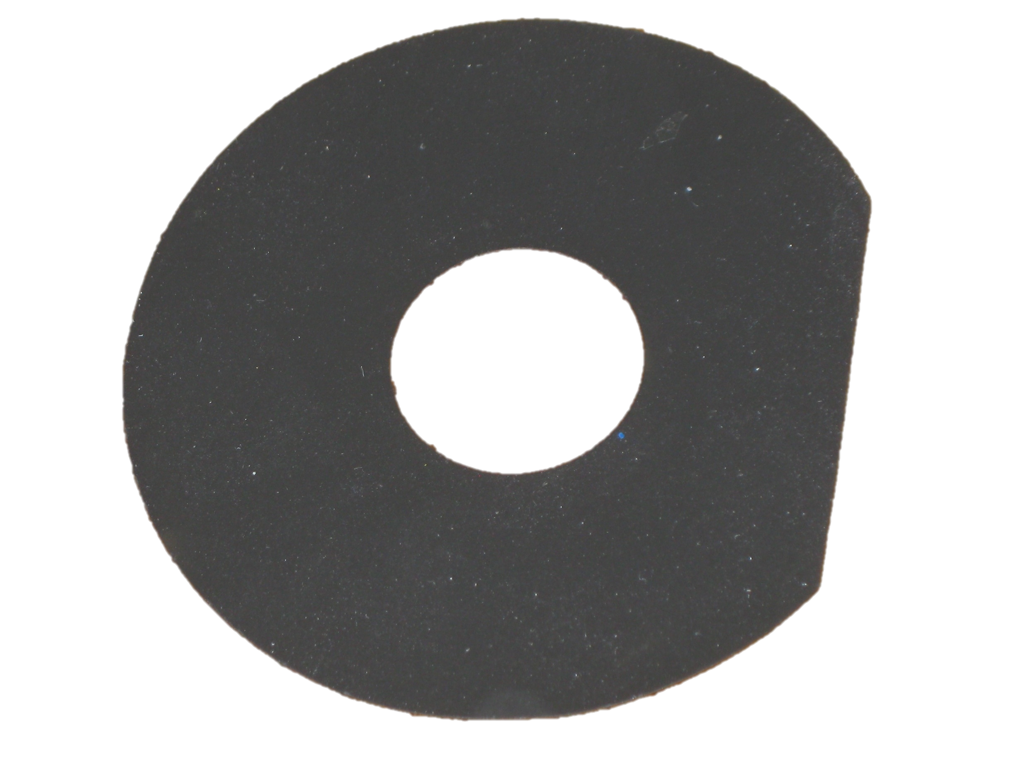
- If using an evaporation cover (Figure 2), attach it to the probe holder and mount the probe holder on the scanner. If using a splash guard (Figure 3), mount the probe holder on the scanner and then attach the splash guard. Make sure that the probe holder is still properly attached after the splash guard has been attached. Be careful that the guard/cover and the probe holder make good contact (Figure 4). Otherwise, liquid can reach the scanner head through the guard/cover.
Figure 3. Splash Guard.
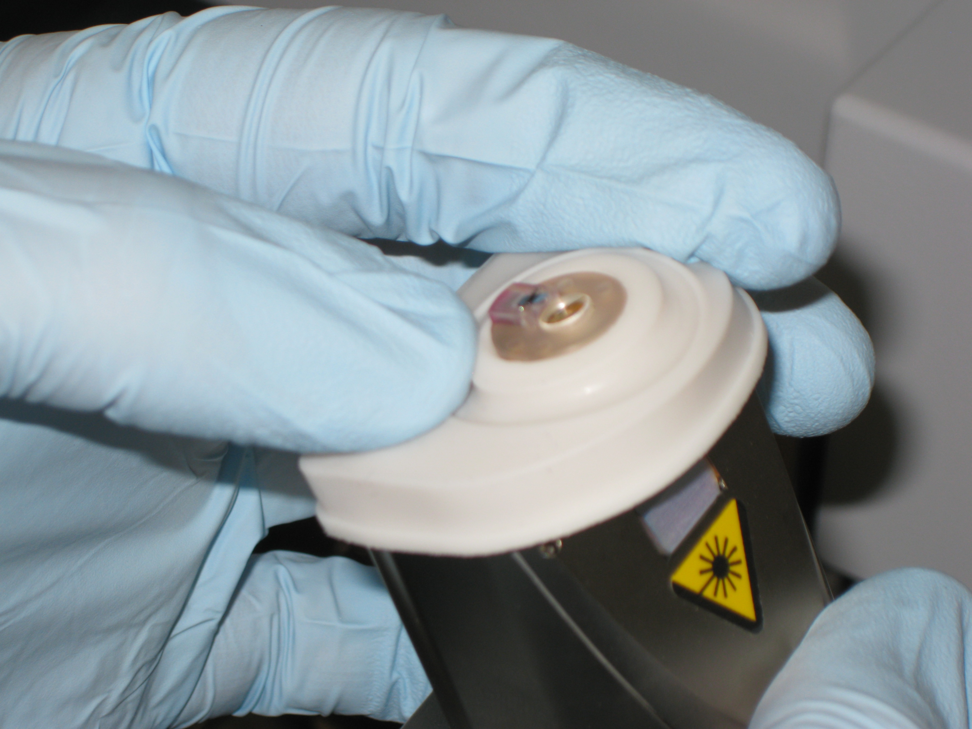
- Raise the scanner high above the stage or move the stage out from under the scanner so that there is substantial clearance between the scanner and the surface below it. Place a piece of white paper beneath the scanner. Now align the laser on the cantilever by turning the alignment knobs and looking for the cantilever's shadow in the laser beam. Once you have found the cantilever, maximize the sum and adjust the deflection as you normally would. Do not twist the holder when it is on the scanner. This can cause the pins to bend. If the pins do get bent, do not try to bend them back. Inform a GLA instead. Repairing a bent pin is less expensive than repairing a broken pin. Once the sum and deflection readings are acceptable, focus on your cantilever.
Figure 4. Mounting Probe Holder with Evaporation Cover.
- There are several methods available for bringing the liquid probe holder in contact with the liquid sample.
  - With the sample dry, find the surface as you normally would if you were doing an experiment in air. The AFM tip should be about 1 mm above the surface of the sample. Then rotate the stage counterclockwise so that the sample is no longer beneath the scanner. Using a μl pipetter add a very small amount of solvent to the sample. A ~20 μl drop should usually be sufficient. Now rotate the stage clockwise to bring the wet sample under the tip. Watch from the side as you do this to make sure that excess liquid does not reach the pins. There should be just enough liquid to bridge the gap between the sample and the holder. Because this method frequently produces bubbles on the cantilever, you should check the cantilever with the optical microscope. You may need to repeat the procedure to remove the bubble. The liquid between the window and the cantilever will diffract the laser beam, so you will need to maximize the sum and zero the deflection again.
  - Find the surface normally in air. Hold the scanner firmly in place and unscrew the knob holding the scanner in the dovetail. Without letting the tip make contact with the surface, lift the scanner a few cm above the surface of the sample. Using a μl pipetter add a ~20 μl drop of solvent to the sample and lower the scanner back into place. The tip should now be submerged. Tighten the knob that holds the scanner in the dovetail. This method can also produce bubbles, so it may need to be repeated, as well. Adjust the sum and deflection.
  - This procedure requires the solvent used to have high surface tension. Water works with this method, but other solvents may not. Add solvent to the sample. Remove the scanner from the dovetail and invert the scanner. Add a small amount of solvent (about ~20 μl drop from a μl pipetter) to the quartz window on the probe holder. Return the scanner to its normal position and secure it back in the dovetail, being careful not to dislodge the droplet. Adjust the sum and deflection. Align the scanner over the sample and lower the scanner until the liquid above the sample and the liquid on the probe holder merge together. You may need to adjust the sum and deflection after the two drops are brought into contact. Now find the surface of the sample. Though this method does not produce bubbles, it requires the experimenter to pipette liquid directly onto the probe holder, which could lead to damaging the cantilever or shorting the pins on the scanner. Be very careful if you choose to use this method.
- You can now proceed with your experiment.
- Once you are finished with your experiment, withdraw and raise the scanner as you normally would. Use a Kimwipe to soak up the remaining fluid on your sample and the probe holder. Make sure there is no liquid left on the probe holder or the splash guard/evaporation cover before you remove them. While keeping the scanner in its normal orientation, remove the scanner from the dovetail and remove any covers and the probe holder. Inspect the pins. If there is any fluid on any of them, wick it away with a Kimwipe, being careful not to let the liquid short any pins or move due to scanner rotation.
- Remove your probe from the probe holder. Gently clean the probe holder and the evaporation cover or splash guard using isopropanol applied to a cotton swab or a Kimwipe. Dry the probe holder and return it to its case. Note that biological samples may require special cleaning procedures.

