**PeakForce SECM with Bio-Logic SP-300 Potentiostat**

**Weilai Yu (Caltech)**

2018.12.29

**Preliminaries:**

1. To use a Bio-Logic bipotentiostat in place of a CHI760E, follow the Bruker PeakForce SECM manual for all settings except for the CHI760E bipotentiostat in that manual.
2. Both of the ultra-low current probes (or amplifiers) on the end of the two SP-300 cables **MUST** be inside the AFM hood as shown in Figure 1, to get a noise level of ~10 pA at 10 nA current range with a 1 kHz filter,. The AFM hood acts as a Faraday cage for the experiment.

Figure 1. Low Current Probes (or Amplifiers) located inside the AFM hood, an effective Faraday cage. Cables are routed through a sealed clamp slot.

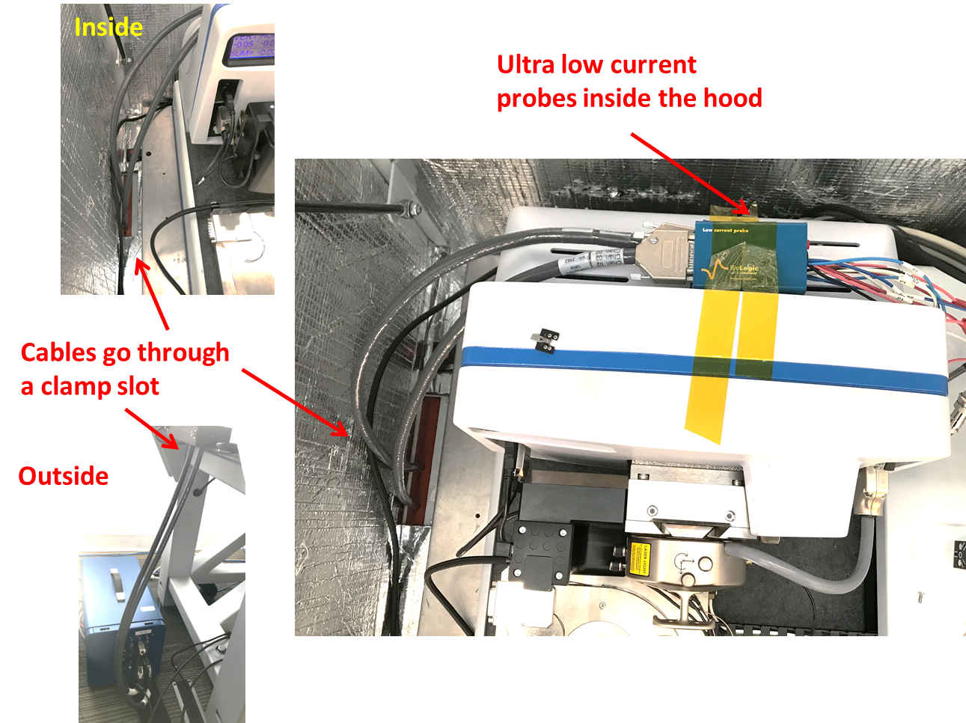

1. Filter setting: The filter should be set at a frequency of ≥ 1 kHz to be fast enough for AFM imaging. Our testing gave similar noise levels using 1 kHz or 50 kHz filters. This may suggest that the bandwidth might be below 1 kHz.

**Figure 2.** Typical current noise level (~10 pA) in CA mode. The noise level was tested using CA setting with setting time interval at 0.03 s, the filter at 1kHz, and the current range at 10 nA

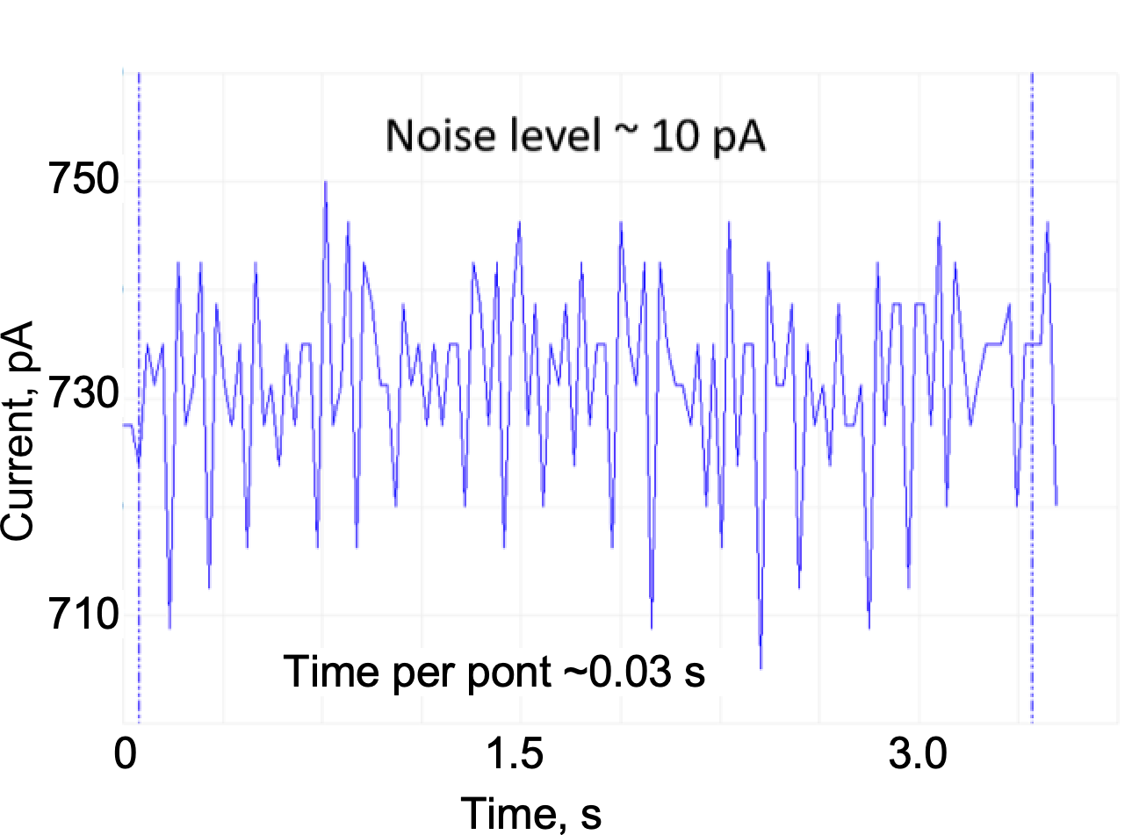

1. The noise level was tested using CA, 0.03 s/point, a filter of 1kHz, and a current range at 10 nA. The noise has a range of ~ 20 pA peak-to-peak and a standard deviation of ~9 pA, Figure 2.

**Installation:**

1. Connect the two low-current cables to the SP-300 Potentiostats and insert the cables into the hood of the Dimension Icon through the holes at its bottom, Figure 1. Channel 1 and 2 cables are shown on the left and right, respectively, Figure 2. The potentiostat cables can be fixed to appropriate position using tape, Figure 6. Low-current probes (blue ports) should always be inside the AFM Hood during measurement to reduce the noise level of the current signal.
2. For the use of the Bio-Logic as a bipotentiostat you **must** configure the instrument to use the counter electrode (CE) as ground (CE to Ground) configuration. To do this

**Figure 3.** Hardware configuration between the Bio-Logic SP300 potentiostat and the Dimension Icon AFM

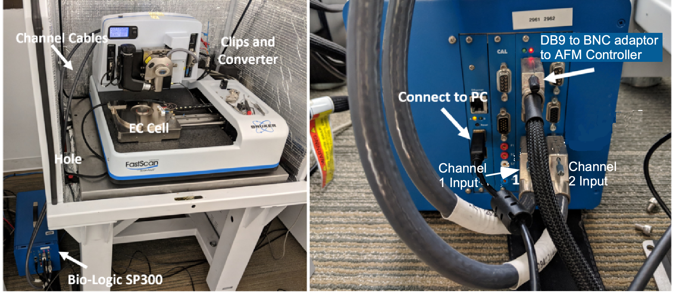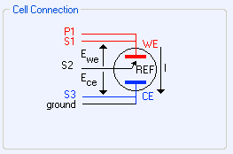

Figure 4: CE to ground connection mode for using SP-300 as Bipotentiostat .

* 1. In the EClab Express software under Hardware configuration choose CE to Ground or in “Advanced Settings”, select the “CE-to-Ground” option, Figure 7.
  2. **Disconnect the cables from the cell.**,
  3. Connect the P1 and S1 (red) leads to the working electrode, Figure 4.
  4. Connect the S2 (black) lead to the reference electrode
  5. Connect the GROUND (black) and S3 (blue) leads to the counter electrode
  6. The P2 dark blue cable is not be used (open-circuit).
  7. Using the alligator clips, these cables can be connected to the multi-channel BNC converters provided by Bruker and finally to the small electrochemical spring terminal on the SECM chuck;

1. The potentiostat cannot auto range you must choose a range to use.
2. The output of the SP300 Bio-Logic can be connected to the AFM controller by use of the female DB9 connectors on the SP300, Figure 3, by use of the Bio-Logic DB9 to multi-BNC converter. Two of the outputs from the converter are labeled E and I. Note that the E and I outputs have the opposite polarity to the measured values i.e., if the analog output -2V, it is actually +2V at the cell (see ECLab Installation and Configuration manual).
3. For SECM experiments, connect the Bio-Logic channel 1 S1 and P1 to the nano-tip working electrode and channel 2 (S1 and P1) to the sample. To allow the AFM controller to monitor the currents and potentials for the tip and sample you need to connect the outputs E and I of the Bio-Logic to the Icon controller. Connect Channel 1 outputs E and I to the AFM controller using the “Low Frequency Analog” panel inputs 1 and 2, respectively.

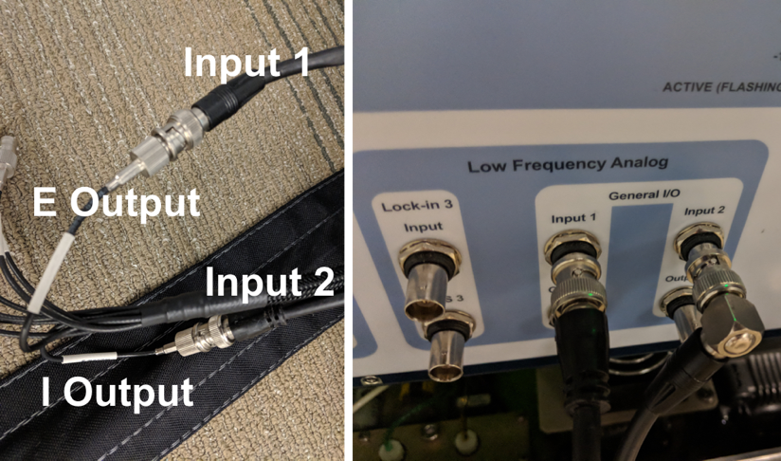

**Figure 5.** The BNC connection from the SP300 potentiostat (E/I signals) to the AFM controller (Input 1/2) so that the electrochemical signals can be directly recorded on the NanoScope Software. To monitor the sample current (or working electrode 2 in a 4-electrode configuration), connect channel 2 to Lock-In 3 input.

1. To monitor the sample current (or working electrode 2 in a 4-electrode configuration), , if needed, connect Channel 2 output I to Lock-In 3 input.
2. Before starting EC experiments, in the EC-Lab “Advanced Settings”, make sure to select the “CE-to-Ground” option chosen for a bi-potentiostat, Figure 7. The band width can be set at 1kHz to allow data collections consistent with scanning speed of the tip. In selecting an experiment, one can either choose a single-channel experiment (CA/CV) that will only monitor channel 1, or a bi-potentiostat experiments (CV-CA, CA-CA, CP-CA) by that monitors both Channels 1 and 2, Figure 8. Before starting an experiment, a dialog box may appear asking you to the change the electrode configuration, be sure to select “No” and keep the configuration at “CE to ground”.

Figure 6. The connection of Bio-Logic Cables and Clips and the four-terminal converter inside the hood of the Dimension Icon

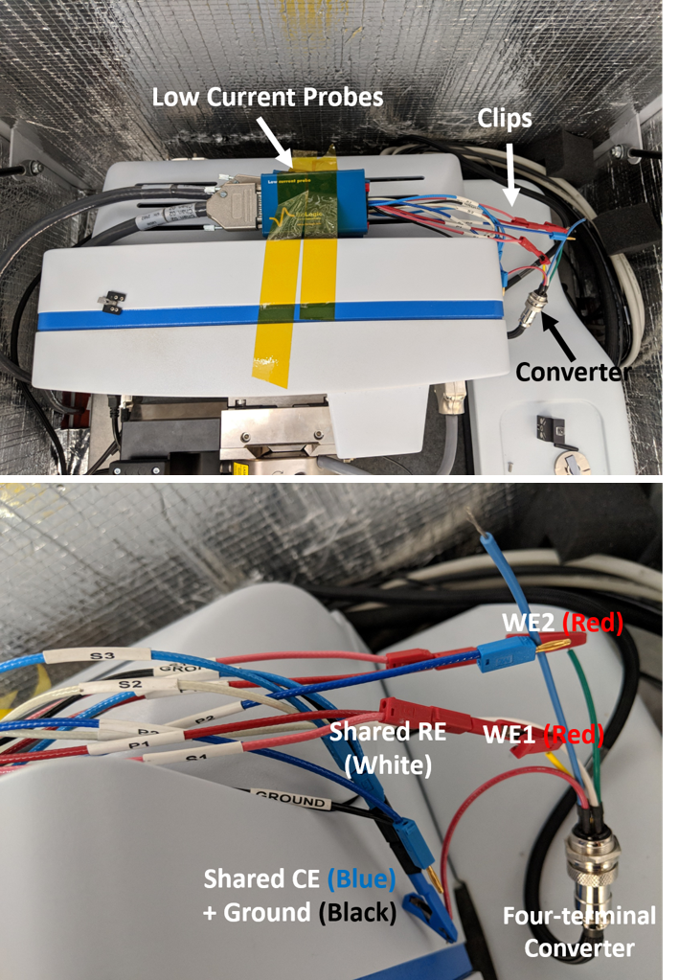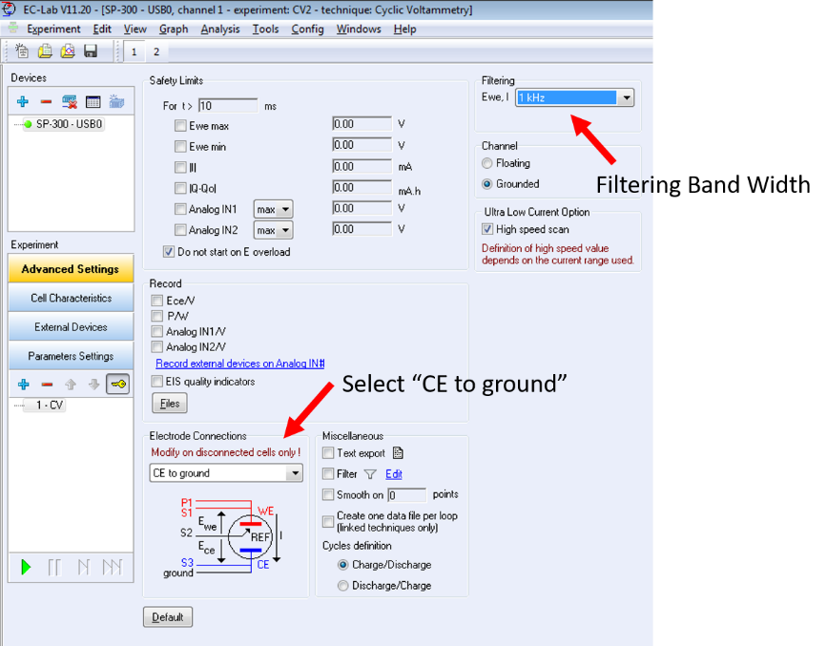

Figure 7. Selection of the electrode connection and the filtering band width in the EC-Lab software

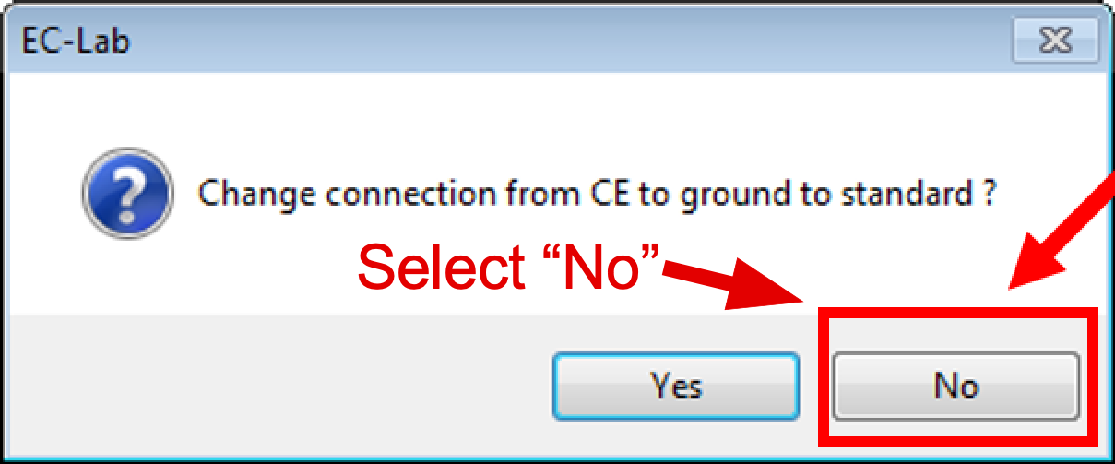

1. During the scan, the noise level in CA mode with a time interval of 0.03 s/point and band width of 1kHz was found to be ~10 pA (Figure 2).

**Figure 8.** When selecting either a single-channel or a bi-channel experiment, be sure to select “CE to ground” as the electrode connection

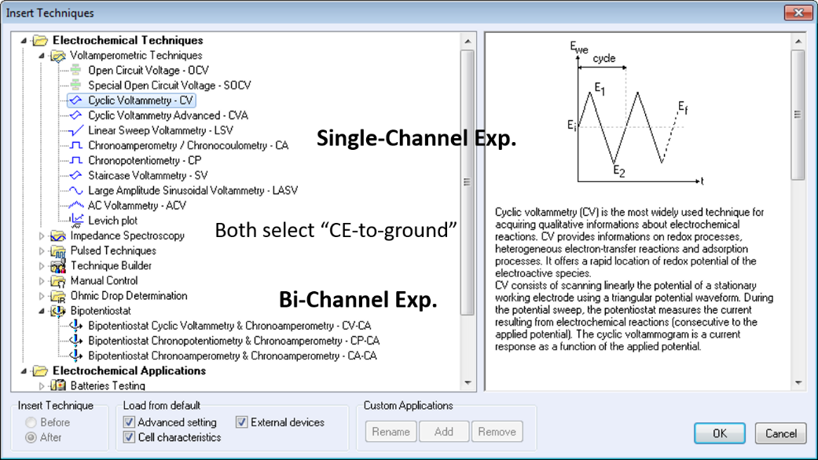

1. When recording electrochemical data in the NanoScope Software using the XY data capture, the potentiostat must be in a selected current range, not auto range/\. The current range selected in the EC-Lab software must match the range in the NanoScope Software. For example, if the I-range is “1 nA” in the EC-Lab, “1 nA/V” should be selected in the NanoScope Software.
2. Figure 9 shows a typical CV graph of the tip working electrode in the NanoScope Software recorded by the AFM controller.
3. [Warning] During experiment, an obvious discharging behavior from the tip electrode at the beginning of each experiment was observed. This may be due to the ultra-small size the tip. This discharge may impact the quality of the electrochemical data gained at the start of experiment. For example, The Figure 10 shows several continuous CV curves of the tip electrode. Due to the discharging behavior, the first CV was impacted and the CVs obtained later on appeared more well-defined and reasonable.

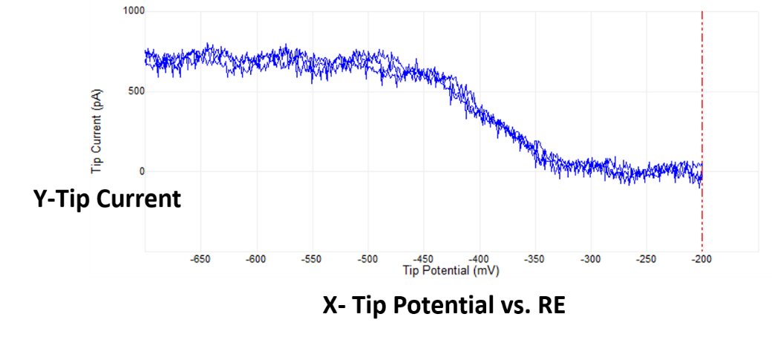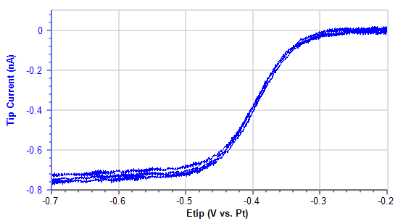

**Figure 9.** Typical CV curve of the tip electrode recorded in the Bio-Logic software and in the strip chart of the NanoScope software. Note that the polarity is reversed which can be adjusted in the NanoScope software

**Figure 10.** Typical charging behavior of the tip electrode at the beginning of experiment and its impact on the gained first CV curve

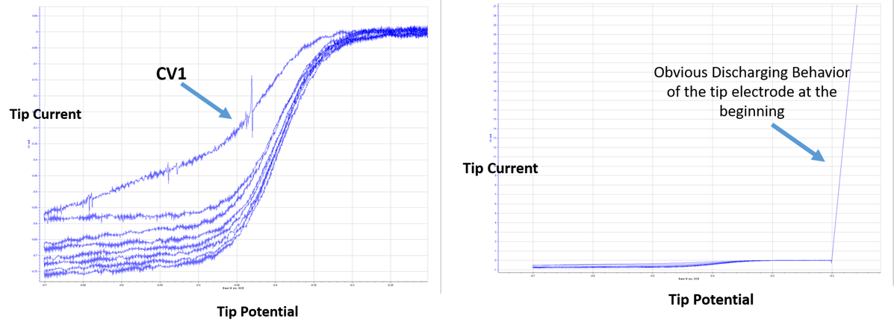

1. From here on follow the PeakForce SECM manual for your experiment. Below is a screen show of SECM tip current profiles at different tip-sample distance. The line plots on the right from bottom are at nominal 30, 100, 200, 400, and 750 nm tip-sample distance. The noise level is about 10pA (std = 9.3 pA).

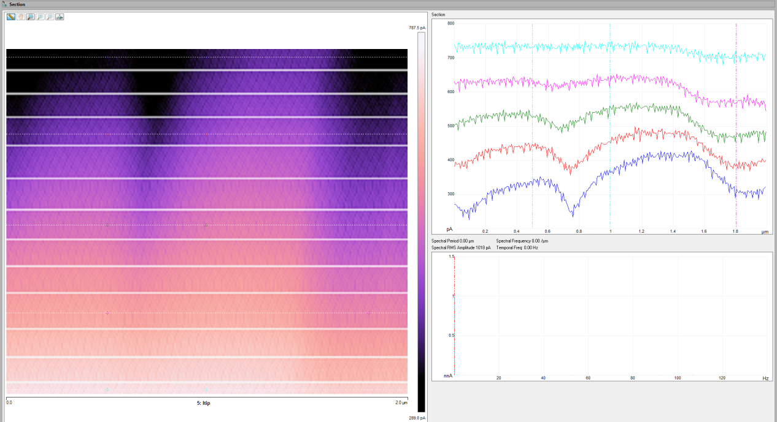

Figure 11. A typical SECM results using the Bio-Logic SP-300 bi-potentiostat.