Quick Start Bruker Dimension Icon AFM
Do not remove
March 3, 2015
GLA Contacts
Harold Fu (hfu@caltech.edu)
Weilai Yu (wyyu@caltech.edu)
Bruker Tech Support (AFMSupport@bruker-nano.com 800-873-9750)

- Watch the videos on the desktop of the Dimension Icon computer about how to load the probe, align the laser, and ScanAsyst operations.
- For each step below, read the complete instructions for the step before attempting it.

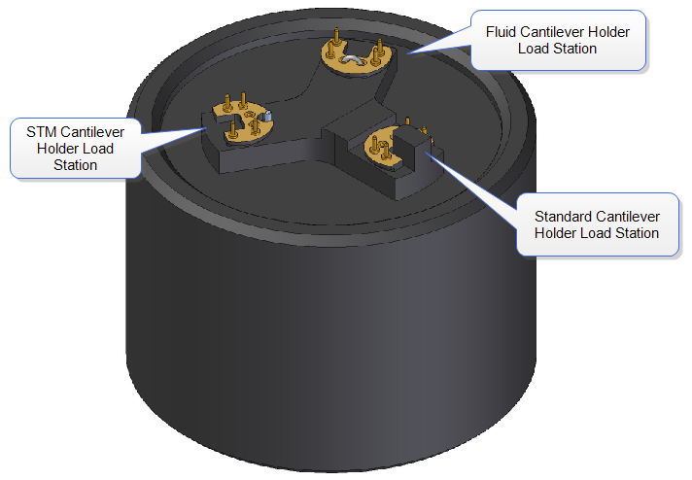
- Read “How to avoid breaking the instrument” on the MMRC website.
Figure 1. Probe holder Stand
- Fill out the logbook before you begin.
- Check that the computer and controller are both on. Open the instrument hood and check that the scanner is mounted on the dovetail rail and that there is enough clearance between the scanner and the stage. If the computer or controller is off, the scanner is not mounted in the dovetail rail, or there is not enough clearance, contact a GLA for assistance.
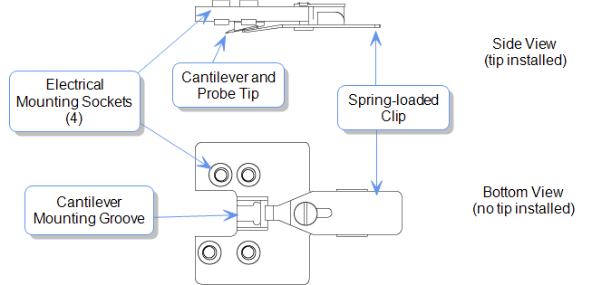
- Launch the Nanoscope software program on the desktop. Select which experiment mode you want to perform and load the program. This turns on the laser in the scanner head. Click on “Setup” at the top of the menu on the left.
Figure 2. Tip Holder
- Put on gloves and open the instrument hood. Verify the stage and area around the stage is clear of all debris and the scanner head is resting in its dovetail mount. If you need to clean the stage, use only a KimWipe moistened with isopropanol. DO NOT use compressed air, acetone, or other methods to clean the stage and do not directly apply any solvent to the scanner.
- Loading the probe. The probe holder, Figure 1, should be in the black cylindrical case (the probe holder stand) on the desk. Mate the probe holder sockets (Figure 2) to the pins on the probe hold stand at the appropriate loading station. For AFM ensure that the probe holder’s large spring clip faces up.
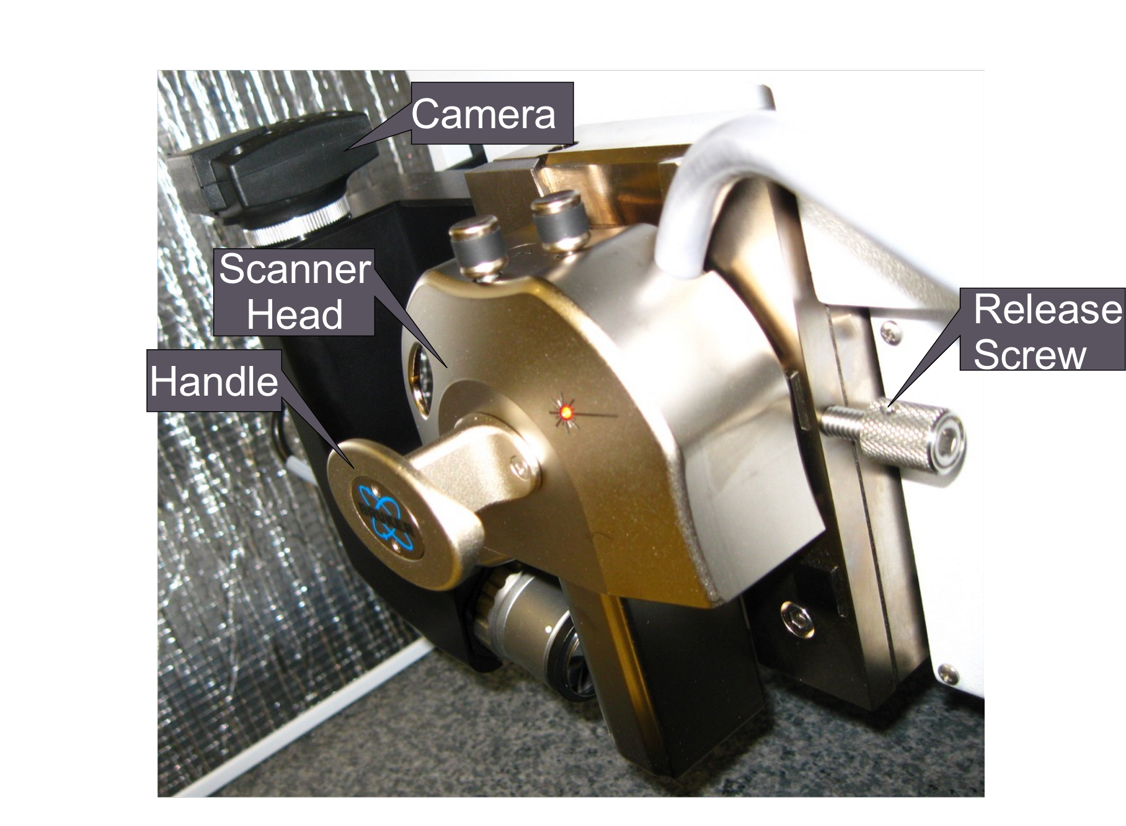
- Load the desired probe into the probe holder by pressing down and slide back the spring clip on the probe holder. Using tweezers to transfer your probe, and than replacing the clip. The probe pointing up is preferred. Hold the probe holder securely between your fingers when you withdraw and replace the clip. Make sure the clamp is not touching the sidewall of the probe housing. Enter the probe type you are using into the software. If the probe is not found in the database, select “unknown” or a probe that has similar physical properties (spring constant, resonance frequency, shape and etc.)
Figure 3. Dim Icon Scanning Head mounted on dovetail rail.
- Make sure that the head is well above the sample so the tip will not hit the sample. If the tip will touch the sample you must got to the software and choose Microscopy>Withdraw several times.
- Unlock the scanner head by carefully gripping the head by the handle (Figure 3) and loosening the screw on the right side of the head, Figure 3 & 4. One or two turns should be enough. There is no need to turn the screw all the way out. Lift the head out of the dovetail rail. The scanner head should always be mounted on the dovetail rail unless you are loading the probe holder. If it is not, contact a GLA.
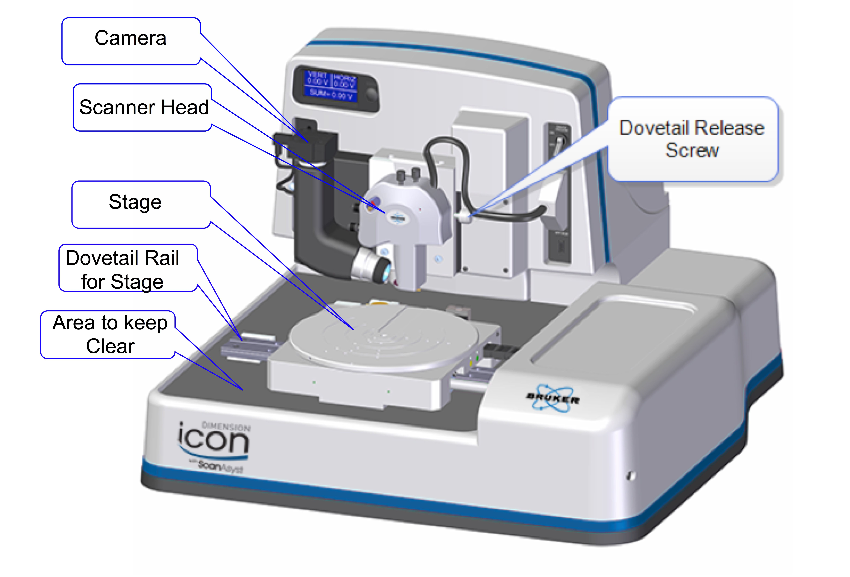
- Transfer the probe holder to the scanner head, using the utmost CAUTION. Securely hold the scanner head by the handle. Unintentionally bumping the scanner head can result in a broken scanner; it is EXTREMELY delicate and costly (~60k). If the orientation of the probe holder is incorrect, simply put down the holder, adjust your grip on the head, and try again. Make sure the tip points down and away from the scanner and verify the probe holder mounts flat against each pin on the head.
Figure 4. Dimension Icon
- Place the head back on the dovetail while watching that the head is ACTUALLY in the dovetail and that the tip does not touch the sample! (If it will touch you must got to the software and choose Microscopy>Withdraw several times.) Make sure the scanner head rests securely in the dovetail mount and tighten the screw on the right of the scanner head to lock it in place before you release your grip on the head.
- Move the scanner head to the alignment station by clicking on the “Move to the Alignment Station” button in the software. The alignment station is simply a mirror that allows you to see the laser reflection in the camera. This alignment station is only useful for standard probe holder.
- When the scanner head is at the alignment station position, you should be able to see your tip in the optical window on the software. If not, check
i). The optical window has been all the way zoomed out.
ii). It is also likely that the tip is out of focus. Use the focus tip panel to adjust the focus. Move the focus all the way up, and then move it down. You will see sequentially the tip, the mirror surface and the tip reflection. Then set the focal plane at the tip reflection
iii) Do not touch the camera (Figure 3 or 4) it should not be moved.
- If the tip is out of focus that prevents the laser alignment, see Step 15. Align the laser on the cantilever and maximize the sum of the signals on the detector using the knobs on the top of the scanner head as shown in Figures 5 & 6. If needed, a video is available in the software to help . Do not turn the knobs too far in one direction, as this can break the mechanism and even worse break parts inside the head. NEVER FORCE THE KNOBS.
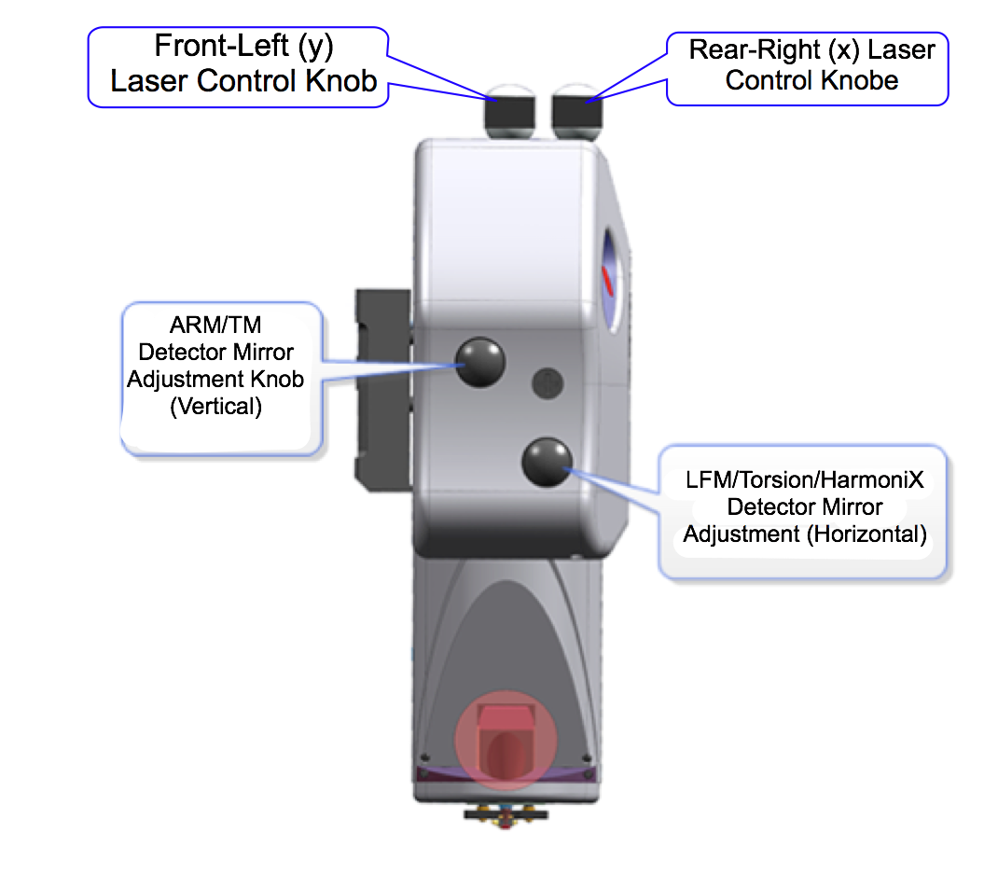
- Align the signal on the detector by adjusting the knobs on the left of the scanner head, Figure 5, until the vertical and horizontal deflection are either zeroed or nearly zeroed. 0 ± 0.3 V are acceptable, Figure 7. Again, a video is available in the software to assist you. Do not turn the knobs too far in one direction, as this can break the mechanism and even worse break parts inside the head. NEVER FORCE THE KNOBS.
Figure 5. Dimension Icon Scanner Head side view.
- In the software, click the “Return from the Alignment Station” button to move the head back to the sample analysis position. Wait for 1-2 minutes until the stage stops moving.
- Focus the optical microscope optics on the cantilever by using the buttons in the software and click on the cantilever to align the red cross with the tip of the cantilever. You can zoom in to place the red cross more accurately, but be sure to zoom out after you are done with the red cross. This helps you locate the exact position of the cantilever when the camera is not focused on it.
- Depending on the mode you are using, you may have to tune the cantilever at this point. To do this, the auto tune option is usually sufficient, but some users may prefer to tune manually. Make sure the cantilever tunes to a frequency within the range specified on the probe box.
- Select “Navigate” from the menu on the left.
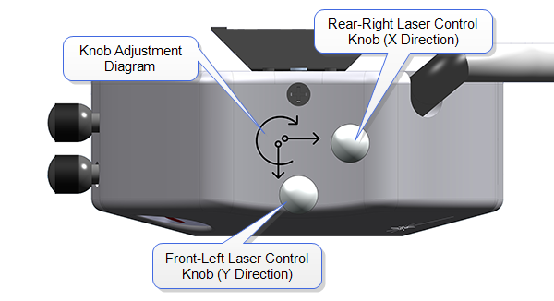
- The next step in the software is to move to the “Sample Load Position.” This is only necessary if you are loading a large sample that will cover a good portion of the stage or will use the projection method to align the laser. In most cases, this step can be skipped and the sample can be loaded without the use of the “Sample Load Position.”
Figure 6. Dimension Icon Scanner Head top view.
- Loading your sample:
(i) To load a large sample with the vacuum: The sample must cover all open vacuum holes on the stage. Remove the screw(s) from the hole(s) you will use and block all other holes with screws. Turn on the vacuum button to the right of the scanner head.
(ii) To mount small samples: Mount your sample with tape or paste on a puck and use the magnet to mount the puck to the stage. When mounting, keep in mind that you can rotate the stage like a turntable.
- Make sure there is sufficient clearance between the sample and the scanner head before proceeding. If necessary, use the software to raise the scanner head. Move the stage using the buttons in the software, the track ball, or by rotating the stage so the scanner head is positioned directly above your sample. The stage navigation function only works when there is sufficient signal SUM on the detector (> 0.5).
- You might need to reduce the initial set point for the engagement to avoid dulling the probe. To do this, go to “Microscope”->”Engage Settings”, in the “Engage Parameters” window, reduce the value of “Peak Force Engage Set point”, typically to 0.05 V. If you use a set point too low, the AFM will do false engagement and cannot track the surface well.
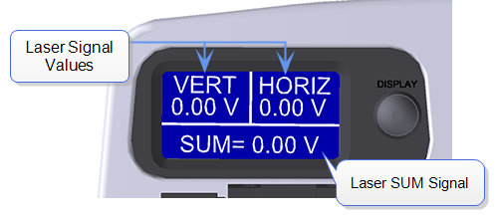
- If the workspace starts with default “smart engage” selected in the “Engage Settings”, you can also use the software to find the surface of your sample. This function requires tuning of the cantilever similar to the regular tapping mode. Therefore, the software needs to know the right type of probe to make sure the tuning occurs in the correct frequency range. In addition, not all probes work with cantilever tuning. Soft probes require high drive amplitude and might not be applicable for cantilever tuning, nor “smart engage”. If “smart engage” or “find surface” do not work, go to “engage settings”, select “standard engage”.
Figure 7. LCD display
- To manually find the surface, select whether you want to focus on the sample surface or tip reflection. Only use the tip reflection focusing option if your samples are extremely clean and reflective. Then, watch the scanner head as you move it as close to the surface as possible without crashing the tip (crash protection will help, but you may still dull the tip if you aren’t careful). Use a slow speed to move the scanner head until it is focused on the sample, or, if you are using tip reflection mode, on the reflection of the tip. (A trick: when you start seeing the red laser diffraction, you are very close to finding the surface, decrease the approach rate of the scanner head.)
- Find the area of the surface you want to scan using the buttons in the software or the trackball and select the “Check Parameters” option in the menu on the left. Or, double click on the region you are interested in on the video window.
- Enter the scan parameters you want to start with. Depending on which mode you are in and the characteristics of your surface, the parameters you need will vary. To get a feeling for the parameters, it is best to read the instrument manual, which is available by pressing F1. Additional parameters can be made available by clicking on the “Expanded Mode” button.
- Repeat Step 11 to adjust the vertical and horizontal deflection to both 0±0.3 V if necessary.
- Close the hood carefully following training instructions. Be careful with the instrument since the tip is very close to the sample. It is not recommended to do this action after the tip is engaged, which will very likely break the tip.
- Select “Engage” from the menu on the left. The instrument will engage and automatically proceed to “Scan.”
- Note: In the event of a software crash or instrument malfunction, an emergency withdraw button is located on the back left-hand side of the instrument. This will withdraw the tip 100 µm.
- The image should appear on the screen with the trace and retrace plots. Adjust the appropriate parameters until the image is satisfactory. Use the error plot to gauge the magnitude of the error and reduce high frequency noise (bright white spots).
- Select the directory for saving your files by clicking on the “Select Capture Directory” button. Name your file. All files must be saved on Data disk E. Do not save any files on the desktop, they will be discarded.
- When you are ready to save your image, select one of the capture options (“Capture,” “Capture Continuous,” or “Capture Now”). The image should save in your directory with the file name you gave it.
- To scan a new position on the same sample click “Withdraw” in the menu on the left of the screen and then “Navigate”. You can now move the stage using buttons in the software or using the track ball.
- To remove the sample: When done collecting data, click “Withdraw” in the menu on the left of the screen and then select “Navigate” and raise the scanner head so it is visibly clear of the surface. Lift the head up AT LEAST 1 cm above your sample. If the scanner is too close to the surface there is a risk of damaging the scanner during disassembly. Remembering to wear gloves, open the hood and remove your sample.
- If you want to scan a new sample go to step 19. If you are done go to step 38.
- Some ICON users align the laser using the projection method. For these uses, it is convenient for them to start with having the AFM with the sample stage in “Sample Loading” position. Therefore, please use the sample loading position when removing the sample and leave the stage there.
- Loosen the screw on the right of the scanner head. Grasp the scanner carefully b the handle and lift it out of the dovetail, again taking the utmost CAUTION. Remove the tip holder and replace the scanner head, making sure it is securely in the dovetail mount. Tighten the screw holding it in place.
- If necessary, clean the stage. Only use isopropanol on a KimWipe and never wet the stage directly with solvent. Do not use compressed air or acetone.
- Close the hood carefully following instruction from your training, and close the software. Sign out of the logbook.

