MFP-3D AFM – Quick Start
11/10/2010

- Turn on the vibration insulation table.
Figure 1. Tip holder
- Turn the laser on BEFORE the computer (otherwise the camera doesn't work), first turn on the power switch, then turn the key.
- Check if the camera on the microscope is on. The switch needs to in the "FL" position.
- Turn the computer on, log in as user MFP-3D, pwd: bi019
- Start the program MFP-3D (don't open Igor itself).
- Old tips for demo are in the upper right desk drawer, so are some tools like a small Philips screw driver and tweezers. In general, you need to bring your own tips or replace what you take.
- In the MFP-3D program, close the cantilever window. You need the Master Panel and the Master Channel Panel open.
Figure 2 Cantelevel changing station
- The checkmark in the green MFP-3D box in the lower left corner of the program screen should appear. If not, turn everything off and back on again in the right order.
- Click the camera icon. If the camera works properly you should see video of gray noise. If you see a green screen in the video window, check the camera connections and if it is turned on, then restart the MFP-3D program.
- If the tip needs to be changed, take the AFM assembly off the inverted microscope, set it upside down on the metal plate.
- Remove the tip holder (Figure 1) from the scanner and place the tip holder in its cantilever changing station, Figure 2
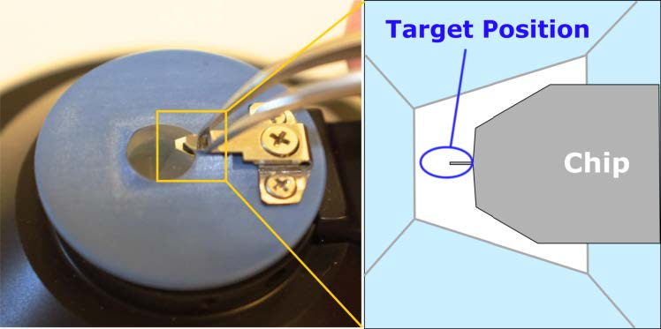
- Use the small Philips screw driver to loosen the center screw (Figure 3), remove old tip, take new tip from its box with tweezers and slide it under the metal lid until the line on the cantilever lines up with the metal lid, without ever setting the tip down. Tighten center screw until the tip appears spring-loaded.
Figure 3 Changing the tip
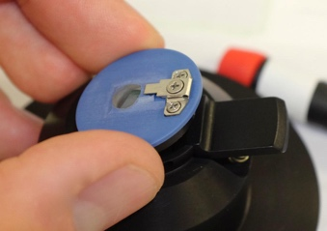
- Take the tip holder from the changing station, place carefully in the AFM assembly, tilting it in at the pins first, then pressing the button on the right to lock it in place (the end at the pins will slightly come up).
Figure 4 Placing tip onto AFM
- Place your sample on the translation stage.
- Flip AFM assembly and place it with its three legs in the wells. Make sure there is enough room so the cantilever does not hit the sample.
- Align the cantilever to the laser,
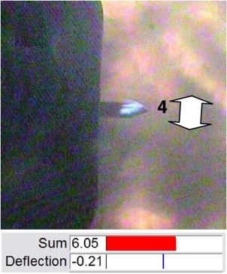
- Find the tip of the cantilever with the camera, adjust the focusing for the sharpest image by lowering the AFM assembly. Turn both wheels in the back (EVENLY!) counterclockwise, then lower the front by turning the wheel counterclockwise until the video image appears sharp. When tip and cantilever are illuminated by the laser only, the tip appears as a dimple in the straight edge of the brightly illuminated cantilever.
Figure 5 Laser spot on tip of cantilever.
- In the Scan and Deflection Meter window, maximize the Sum by aligning the laser on the tip with the control wheels LDX and LDY at the AFM assembly. If the Sum reading is ~3, do not screw things up by trying to visualize the tip. Aligning the laser in one direction will make the Sum reading go through a maximum with sharp drop-offs at both sides, find the maximum by moving right and left of it. Turning the other control wheel will increase the Sum reading slightly with a sharp drop-off at the end.
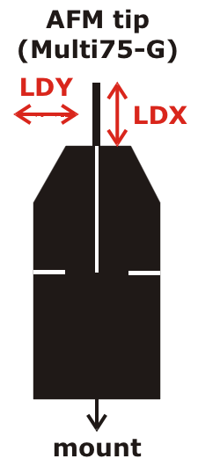
- In the Scan and Deflection Meter window, minimize the Deflection reading to 0 by turning the phase control wheel at the AFM assembly.
Figure 6 How to move spot relative to tip
- Now the laser is aligned.
- Always take an AFM image of a standard before attempting taking data of unknown samples.
- Only the silver part of the microscope table is the translation stage and moves. Samples need to be held in place with two magnets on microscope slide to dampen noise.
- To load a sample:
- Raise the back of the AFM assembly evenly (clockwise = up) until there is ample clearance (~4mm is good) to slide in the sample that is attached to a microscope slide that was de-dusted with the duster can. The front should be up ~4mm too.
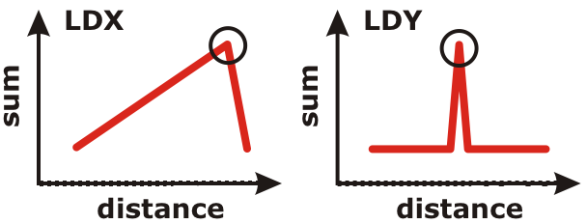
- Slide the sample slide in, hold the slide on one end and place a magnet on the other end to avoid tilting the slide and destroying the tip, repeat with the other magnet.
Figure 7 Change in sum with LDX and LDY controles
- Bring the back of the AFM assembly down to ~1mm above the sample; the front is still ~4mm above the sample.
- Press "E" (= enable) on the insulation table, a red LED comes on.
- In the Master Panel window, click the tab Main, go to Imaging mode and choose AC mode (= tapping mode) or Contact mode. Choose AC mode. Click the tab Tune and click Auto tune; this determines the natural tip frequency.
- Close the Auto tune window once a curve with a nice maximum is shown.
- Click the tab Main again, choose a scan size, depending on your feature size. The maximum scan size is 90um, at scan size 500nm images can be quite noisy.
- In the Scan and Deflection Meter window, click Engage (this starts the feedback loop). The Amplitude should be ~1. Before there is physical contact with the sample established the z-Voltage reads 150. A z-Voltage of ~70 is ideal for AC and contact mode operation.
- CAREFULLY lower the front of the AFM assembly by turning the wheel counterclockwise while watching the z-Voltage reading and the physical distance of the tip from the sample. This approaches the tip to the surface. Once the z-Voltage reading changes, turn the wheel VERY slowly until the z-Voltage reads ~70. Do not run the tip into the sample, it will be destroyed and you'll have to change tips and realign the laser. (In the z-Voltage reading, red is good, blue is bad.)
- Now the sample is loaded.
  - In the Master Panel window, check Save Images and select a path, type in a Base Name. This ensures that all images will be saved with a base file name and a number.
  - If you want to take data in AC mode, turn the camera off to reduce noise. Also wait a couple of minutes after locking the vibration enclosure to let the air settle. Other noise reduction measures include turning off the room lights and sitting still while taking data.
  - In the Master Panel window, click Do Scan. Three windows appear: phase, amplitude and height. In the height window, the blue and red traces should overlap. If they don't check your tip and sample (some samples repel tips).
  - Click Auto in the Master Channel Panel window to automatically zoom the z-direction in the false color image.
  - The program is set up so that it keeps repeating scans (and saving every single scan) until you tell it otherwise. To do so click Last Scan, then the current scan finishes and gets saved.
  - If the data acquisition needs to be stopped during a scan (e.g. because the data are crappy), click Stop. This automatically withdraws the tip (which means in this context that the feedback loop is cut, so no electronics can be damaged), BUT the tip is still physically right at the surface. Be aware that you need to remove the tip from the surface MANUALLY to avoid damaging the tip!
  - Stopped scans do not get saved automatically but can be saved by clicking Save Image.
  - If you want to image your surface in contact mode instead of AC mode, click Engage in the Scan and Deflection Meter window. While watching the z-Voltage reading, lower the tip slightly more compared to AC mode.
  - To change samples, click Withdraw, manually raise the front of the AFM assembly (~3-4mm) and follow instructions of loading a sample.
  - Solid samples are typically mounted on microscope slides with double-sticky tape.
  - Loading a liquid sample onto a normal microscope slide:
    - Have a blank microscope slide (or whatever you want to squirt your liquid onto) under the tip.
    - Lower the tip (back and front) to ~1mm.
    - Squirt liquid with a pipette with a yellow plastic tip under the tip head so that the tip is fully immersed in the meniscus. Do not try to approach the tip through the meniscus, it will break the tip.
    - Depending on the surface tension of your liquid you may need to use a well plate. Be aware that the well needs to be shallow enough to allow for the tip to penetrate into the liquid.
    - Click Auto tune.
    - Choose Contact mode, this usually works better in liquids.
    - Engage the tip.
    - Move the tip CAREFULLY down until the z-Voltage reads ~70. There is a lag in reading in liquids.
    - Click Do Scan.

Shut-off:
      - Manually move the tip head ~4mm above the sample.
      - Turn the camera off.
      - Turn the vibration table off.
      - Lock the vibration enclosure. (This keeps the dust out.)
      - Turn the program off.
      - Shut the computer down.
      - Turn the laser off. First the key, then the switch.
      - Clean up. Don't leave a mess for others.

