Absorptance of a Solid Measured on the Integrating Sphere

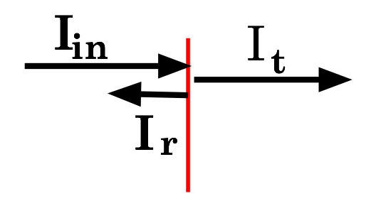A simple solid has two interfaces (air/solid and solid/air) and the absorbance of the material. At each interface an incoming ray, *I*in produces a reflected ray, *I*r, and a transmitted ray, *I*r.

 or 

 ` (1)

where *r* and *t* are the reflectance and transmittance. For the solid part some of the light is absorbed in the solid and the rest transmitted.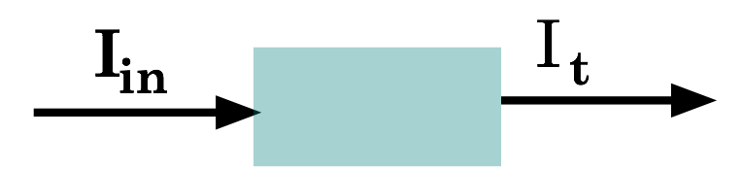 If *I*in is the incoming ray’s intensity that enters the solide (after any reflection at the interface) and It  is the transmitted ray’s intensity before interface reflection and *I*A is the intensity absorbed by the solid.

 or 

where *a*s is absorptance, i.e. . For the complete sample we measure the intensity of the transmitted beam or the transmittance, T

 (2)

where the subscripts 1 and 2 indicate the front and back air/sample and sample/air interfaces. Thus

 (3)

where T transmittance that the integrating sphere measures. If the sample is mounted on the exit port you can measure *r*1 and then if you rotate the sample 180º you can measure *r*2, which are related to *t1* and *t*2 by eq 1. Since the transmittance of the sample is related to the extinction coefficient, **, or the attenuation length, **,

 and  (5)

where *l* is the length of the sample.

Notes:

1. When measuring the reflectance of one interface the second interface must not contribute to the measured reflectance.
2. The reflectance is normally independent of whether you are going from air to solid or solid to air.
3. For a flat surface normal to the surface the reflectance at a particular wavelength is given by  where n is the refractive index at the wavelength.

|  |  |  |  |  |
| --- | --- | --- | --- | --- |
| Material | Refactive index | Wavelength range | Reflectance Air/material | Reflectance  Water/material |
| Air | 1.00 | all | – | 0.02 |
| Water | 1.33 | Visible to NIR | 0.02 | – |
| Silicon | 3.96 | Visible | 0.36 | 0.25 |
| Quartz | 1.46 | UV-visible | 0.035 | 0.002 |
| Glass | 1.5 | Visible | 0.04 | 0.004 |
| TiO2 | 2.50 | Visible | 0.18 | 0.09 |

Note that transmittances are multiplicative so while the air/silicon interface reflects 36% of visible light an Si wafer in a water cell only reflects about 26% ((1-0.04)*(1-0.004)*(10.25)) of the light.