User Guide for Cary 5000 spectrometer with external DRA 1800 attachment.
Do not remove
(Last updated 09/20/2021)
This guide is for use of the Cary 5000 with the external diffuse reflectance accessory, DRA. For use without the DRA see User guide for Cary 5000 in absorption mode.

Important warnings!
- Never plug or unplug the external DRA electrical attachment when the instrument is on.
- Never put white light into the DRA with the DRA connected to the Cary.
- Do not use Align command.
- Do not use compressed air dusters on any mirrors or optics.
- Do not use any samples that can fall apart in the integrating sphere.
Introduction and Help
For a complete guide to the Cary hardware and open the Cary “Scan” program and click on the Help tab.
Hardware: Help > Help topics > Accessories > Cary 4000/5000/6000i > Solid Sample > external DRA
Software Help > Help topics > Software Applications > Scan

Turning the instrument on:
The DRA must be fully closed for the instrument to initialize. Turn on the instrument (0/I switch on the lower left side of the front of the instrument).
Open the Cary Scan program on the taskbar or Desktop.
In the Scan program, watch the lower left corner to see the status of the instrument. When the traffic light is green the Cary is ready
. If there is an error message see Startup Error section above.

Integrating Sphere Configuration
The sample can be placed for use with the integrating sphere (see figure 1 and 2) at four positions.
- The entrance to the integrating sphere is for normal incidence diffuse transmission
- The rear slot is for normal incidence diffuse reflection
- The center mount holder allows for variable angle diffuse transflectance measurements
- In addition, the VATH (variable angle transmission holder) accessory can be put in front of the integrating sphere for variable angle specular transmission measurements. If you would like to use the VATH accessory, please talk to one of the GLAs for the instrument first.
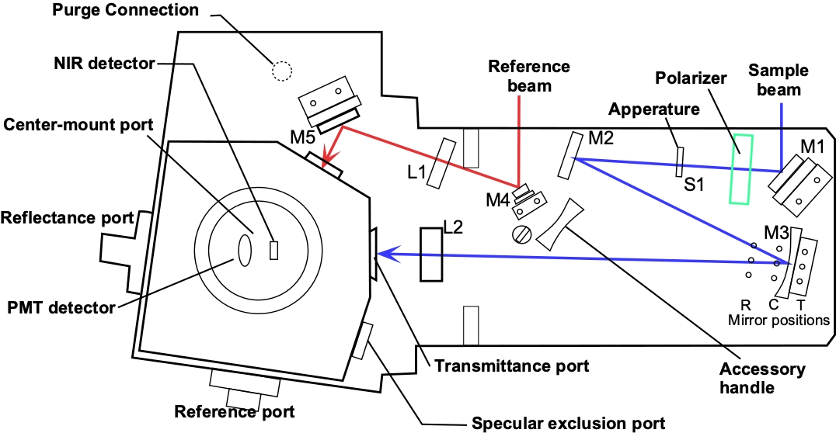
Large Sample Setup
Figure 1 Diffuse Reflectance Accessory showing optics and beam path.
For Large samples one must remove lens 2 (Figure 1) and use the large sample setup mirror M3. The large sample standard M3 mirror (Figure 1) has three sample positions depending on where the sample is (Transmission, Center, and Reflection). Each of the mirror positions will focus the light onto the position of the sample. The three positions are marked T (transmittance slot), C (center mount), and R (rear reflectance slot) in Figure 1. Thus, the mirror needs to be moved to the right position depending on the placement of your sample. The cable for the DRA can get in the way of moving this mirror. Wear gloves to handle the mirrors or lens. Turn off the Cary first, if you need to unplug the DRA to move the mirror.
Small Sample Setup with SSK
The M3 mirror is replaced by the small sample kit (SSK)mirror (Figure 1) in the T position. Lens (L2) mounts in front of the sample. There are three lenses that can be used at the L2 position again for the three sample positions marked as T, C or R.
The optics need to be aligned every time you start and experiment, so that the sample and reference beams are not clipped and that the sample beam is centered on the sample.
- Put on clean gloves.
- Under the commands menu click on Go to, and then type in 550 nm (do not use the “align” option).
- Darken the room lights.
- With a thin white card, you should see a green spot at your sample position. (If you cannot see the beam: Block both sample and reference beams from entering the integrating sphere. Then under the commands menu choose align to switch the gratings to zero order to send white light into the DRA. The white light must not enter the integrating sphere, or it will damage it!!)
- Check that the beam hits the center of the M3 mirror and goes through the center of L2 and hits the center of your sample.
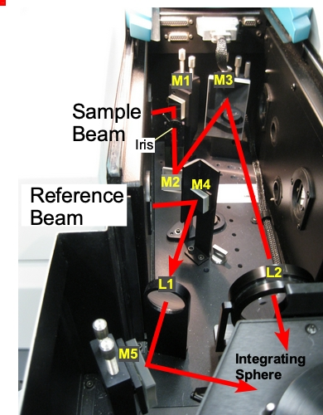
- Most of the mirrors have two knobs, which you can rotate to adjust the vertical and horizontal positions of the beam.
Figure 2 Photo of diffuse reflectance accessory with beam path.
- If your sample will be at the reflectance port, use mirror M1 to make the light beam go through the center of the entrance to the sphere, then use M3 to make the beam hit your sample. Redo this several times until the beam does both at once.
- If your sample will be at the transmittance port, use mirror M1 to make the light go through the center of M3 and lens L2, then use M3 to hit your sample. Redo do this several times until the beam does both at once.
- Check that the sample beam does not overfill your sample or hit any white surfaces. If the sample is small you need to mask the sample and/or use an aperture to restrict the entrance to the integrating sphere (look in the drawers for the Cary for apertures). You can also reduce the slit height in the software or close the iris/aperture in the sample compartment (Figure 1 & 2). Do not put anything that can scatter light close to the beam path at the entrance or exit to the sphere. This includes edges of glass slides.
- If you have very small samples, see the small sample kit in the Users Guide below for more suggestions on small samples
- Check that the reference beam hits mirrors M4 and M5 close to the center and goes through the center of L1 and is not clipped at the entrance of the reference beam into the integrating sphere. Use mirror M5 to center it on the entrance.
- Do not adjust the mirrors with no knobs. If they need adjustment call the GLA, usually they do not need adjustment
Running your Sample
- Select Setup → Instrument Settings → Cary Options
  - Set the wavelength range, and the Y mode, %T, Abs, or %R
  - Set the Ave time (time/data point) as 0.1 s and a Data interval of 1 nm if your measurements will show significant changes (if you have small intensities or small changes, you may consider using an Ave time of 0.5 or 1 and a Data interval of 2 nm/point.
  - Under Advanced Settings set SBW, to 2 nm, and Detector and Grating change wavelengths. (Again, if you signals are small you can set the SBW to 4 nm, but it will increase the beam width and may overfill you sample).
  - Under Baseline tab: chose zero/baseline correction
  - Under File Storage tab: set whether it prompts to save the spectrum.
  - Then click Ok to close the Instrument Settings window.
  - Note that the signal to noise ratio, S/N, is a function of the amount of light that reaches the detector. Increasing the SBW by a factor of 2 will increase the light to the detector by 4. Decreasing the slight height to reduced will decrease the light by 4. Increase the Abe time by a factor of 2 will decrease S/N by √2. A setting of SBW=4 nm and reduced slight height give an approximately square spot on the sample.
- Check that all exits of the integrating sphere are blocked with full reflectors.
- You need to run the 100% Baseline correction with everything in the beam path except your sample. If using an aperture for reflection or transmission measurements, please see the “Aperture kit for small samples” in the User Guide below.
- Choose Baseline and run 100% T (or R) scan, then block the sample beam at the entrance to the integrating sphere for the 0% scan.
- It is good practice to run a spectrum with no sample after running Baseline to make sure that you have a good 100% T line.
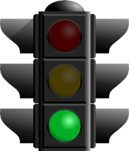
- Note that the signal to noise (S/N)of your sample spectrum can be no better than the S/N of your baselines and will likely be worse by a factor of about 1.4 to 2.
Start
- Mount your sample
- Choose Start to run the spectrum
- If you have small intensities (low % R or T) use longer time/point and SBW settings to reduce noise. However, if you increase SBW you increase the light beam size and so need to check if the beam overfills your sample.
- Notes:
  - The S/N will increase if the SBW is increased, if the slit height is set to full, or if the Ave time (time/point) is increased.
  - The time to run the spectra will decrease if the Ave time is decrease or if the Data interval is increase.
  - Since the SBW setting in the IR is not used and the instrument uses the energy mode the S/N in the IR is usually very good.
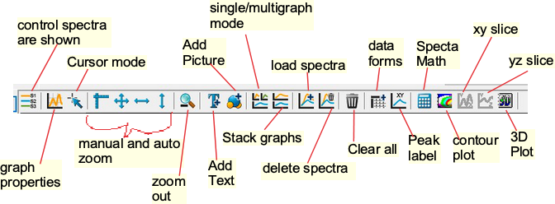
ToolBar

Small Sample Considerations
Most typical lab samples are smaller in size than what the instrument was designed to measure. For all three types of measurements (T, C, and R), it is best to under fill the sample so that no light goes around the sample.
Spot size - There are two ways of reducing the beam spot size:
- In the Setup: options tab, change the slit width and height
  - Slit width: You can narrow the slit width by changing the SBW parameter.
  - Slit height: Under slit height, switch to Reduced. It takes about a minute for the slit to change.
- Small spot kit (SSK): There are a series of lenses and a mirror that can be put in the optical path to focus the beam into a smaller spot on the sample. The large mirror (M3) must be changed to the SSK mirror. The SSK mirror is always kept in the T position. There are three lenses (L2, Figure 1) with different focal lengths and marked T, C, and R for the three positions of the integrating sphere.
- There are aperture kits that can used with the SSK to adapt a small sample to the beam
  - Transmission measurements Aperture kit : There are apertures in the drawer for the Cary used for transmission measurements. They can be used on the entrance slit with the white spectralon facing toward the integrating sphere. You ideally would like the sample to completely fill the hole in the aperture and the sample light beam to be about the same size as the aperture. If the sample is smaller than the hole in the aperture you need to mask the sample with black tape.
  - Reflection measurements Aperture kit : For normal incidence reflection measurements, the port at the rear of the integration sphere is several inches in diameter. A series of apertures can be used, which have the white Spectralon material on the side that faces toward light beam. The spring-loaded mount that holds the sample against the integrating sphere needs to be taken off. Slide on the appropriate aperture (you can use a little tape to hold it in place) then put the spring-loaded sample mount back on.
It is best if the beam spot does not overfill the aperture. If the beam overfills the aperture, you can reduce the beam size as mentioned in 1 above or by using an aperture on the entrance to the integrating sphere or closing the aperture/iris S1 (Figure 1 & 2). If the beam spot overfills the aperture a little, you can correct for this “stray light” by performing a Zero/baseline Correction. Normally, the 0%T Baseline scan is run by blocking the beam before it enters the integrating sphere, which accounts for electronic noise. To correct for slight overfilling, do not block the beam and if doing reflectance leave the exit port open (but with the aperture in place) so that the 0%T Baseline will see light that hits the aperture). This is only useful if the refection from the sample is significantly stronger then the light that hits the exit aperture. One can check the amount of light hitting the apperature by runing a spectrum with the sample light blocked at the entrence slit. It is best if you can control the beam size so that only the sample is illuminated.
Performing a Zero/Baseline Correction: Select this option zero/baseline correction, to apply both a 100%T baseline correction and a zero-line correction to the sample scan. This correction is performed with the raw transmission data and is given by:
$$\frac{R_{S}-R_{0\%Baseline}}{R_{100\%TBaseline}-R_{0\%TBaseline}}$$
Where R_{S}, R_{0%Baseline,} and R_{100%Baseline} are the ratios of the light intensity coming in the sample port to that coming in the reference port for than there is a sample, the sample beam is blocked and when there is no sample, respectively. With this option, the Cary will prompt you to perform a 100%TBaseline first, followed by a 0%TBaseline when you perform a baseline collection.

Basics of measurement configuration
The wavelength range possible is from 250 to 1800 nm. Scans normally go from long to short wavelengths. There are two detectors, a PMT and an InGaAs. The wavelength at which the system changes from one to the other (accompanied by a grating change) can be adjusted. Usually, 800 ± 50 nm is a good value for this change over. You can see the change in the spectrum when you take a baseline (% Transmission or Reflection). If you see a step in the spectrum, it may mean your baseline is bad or that your sample has a polarization dependency.
Setup – The setup button located in the upper left-hand corner defines the scan parameters. The following useful tabs can be found under Setup.

Instrument Setting: Cary Options: Here you can set the Wavelength Range, the x-and y axes units (nm, cm⁻¹, etc. and A, %T, %R, etc.), as well as the axes ranges. Under scan controls, the average time per data point and the data interval can be set. Note that the Scan Rate will be automatically determined from these values. Note if taking a low light spectrum longer time per data point will yield a better spectrum.

Instrument Setting: Advanced Settings: Here you control the Beam Mode, Spectral Band Width (SBW), and Slit Height (see Appendix below for more info). The Double beam mode needs to be used for the integrating sphere measurements and the SBW is typically set to 2 nm.
The Slit Height can be used to decrease the beam spot size normally it is set to full.
Typically, the UV-Vis button will be selected. If you do not need to go to shorter wavelengths than 400 nm, you can select the Vis button, which will turn off the UV lamp.

Instrument Setting: Baseline: Sets the type of baseline(s) corrections used in the Scan. The different types of baseline corrections are useful with some accessories. You should collect a zero/baseline correction immediately before scanning a sample after the instrument has warmed up for > 20 minutes using the same scan parameters that you will use for your sample Also a stored baseline can be used.
The Cary WinUV system collects a new baseline when you select any type of baseline correction in the Baseline tab of the Setup dialog box and then click Baseline button in the application window. Depending on the type of correction you have selected, the Cary will prompt you to a 100%Tbaseline (for the DRA with the 100% reference material in the sample positions and, , a 0%Tbaseline (with the sample beam blocked) if a zero/baseline correction was chosen.
Once the baselines have been collected, they will be automatically applied to each collected sample data point as it is displayed (indicated by the red display). The correction applied is shown below in the Appendix B.
A baseline cannot be applied to a sample where the wavelength range of the sample exceeds that of the baseline. If you change your wavelength range to one outside that of the baseline, the Cary will display an error message. Also, the red text in the ordinate (y) display, which indicates that the baseline correction mode is activated will disappear.
See Appendix B for more info on the acquisition, storing, and retrieval of baseline files
Instrument Setting: Independent UV-Vis: This is normally not changed from default Auto in Measurement Mode. In this mode the instrument will collect double beam spectra using a fixed SBW in the UV-Vis region and a fixed energy or detector gain in the NIR region. In this mode, you must set a SBW value for the UV-Vis region. The normal setting is 2.00 nm. You will find that the gain to the detector (Energy level) will change automatically to maintain the required signal level.
You can explicitly set how the instrument controls the detector readings in each region. If you want the instrument to scan in another mode i.e., fixe SBE in the NIR or fixed energy (gain) in the UV-Vis region you can set that here, see Appendix A for details.
File Storage: The Auto Store tab allows you to specify if you want to be prompted to store the collected data. You can store the data in a Batch or Data file at the start or end of a collection. If you set Storage Off you will need to manually store your unsaved data after the run is complete.
Note: In the Scan application, Prompt at Start and Prompt at End saves the spectrum as a data file (*.DSW) unless there are multi or cycle scans being performed.

Commands In the Menu Bar: Commands can be accessed both from the menu items at the top of the main window and from the application buttons on the right-hand side of the screen. Alternatively, you can use function key shortcuts for some of the commands. These appear next to the item in the Commands menu.
Start: Start a Scan using current set up parameters. Function key is F9.
Stop: Stop a Scan. If you have selected Storage On in the Auto Store tab, all data collected is automatically stored in the file specified in the Batch name field of the Save window. Function key is F12.
Connect: The Connect command becomes available when more than one software application is running at any one time. The application that is in use will be online and will control the Cary. All other applications will be offline and display the Connect command. If you wish to swap to a different application (and still keep other applications running) you will need to select Connect in the application you wish to connect to the Cary.
Zero: Best never to use this. Zeros the current ordinate value using the Start wavelength (or equivalent) value set in the Setup dialog box. Function key is F5. Do not use this if you sample is not zero at this wavelength.
Goto: Moves the monochromator to a wavelength specified. Function key is F4. Only available if the instrument is not currently collecting data.
Align: Moves the Cary spectrophotometer to white light (0 nm). Only use if both sample and reference slits to integrating sphere are blocked. You can then use this light for aligning accessories
Lamps Off: Switches off all lamps.
Lamps On: Switch on selected lamps.

Graph menu: The Graph menu allows you to view data in various graphical formats or in multiple graphs in the Graphics area. You can double-click on the Graphics area to toggle the display. The graph functions can also be accessed by clicking one of the Toolbar buttons or right-clicking in a graph box or the Graphics area. Not all functions are available on every menu.
Red Spectrum: The red spectrum in any graph box is the focus spectrum, the one for which all information appears and the one used for cursor tracking. If you hold the cursor over a trace, bubble text identifying the trace is shown.
Trace Preferences: Use to choose the trace(s) to display in the selected spectrum.
Graph Preferences: Use to change the appearance of your graph.
See Appendix C for more option under the Graph menu as well as the Trace Preferences and Graph Preferences menus

Storing Data
Under the File menu you can save your Method (the Setup configuration used to perform the scan), your Data, or the combination of the Method and Data as a Batch file.

File, Save Method As: Used to store the current method. You can store the method, data, report, or graphics template separately or together as a Batch file. The data can also be saved as a Cary GRAMS file, a comma delimited ASCII spreadsheet file or in formats suitable for other Cary software systems (depends on which application you are running).

File, Save Data As: Used to store the collected data. You can store the method, data, or report separately or together as a Batch file. The data can also be saved as a Cary GRAMS file, a comma delimited ASCII spreadsheet file or in formats suitable for other Cary software systems (depends on which application you are running). After a batch file has been saved, you can use this option to manually save the file as a method file, a batch file, a comma delimited ASCII spreadsheet file or a Rich Text Format file.

How to Export Collected Data
If you want to export data from a Cary WinUV application into a third-party application, then save your data as an ASCII *.CSV file. To do this:
- Click File → Save Data As.
- Click the down arrow next to the Files of type list box.
- Select Spreadsheet ASCII (*.CSV).
- Type your file name into the File name field and click save.

How to Combine Data Files into a Batch File:
If you have several data files that you need to combine into a batch file, then you need to:
- Select Open Data.
- . Click the down arrow at the right of the “Files of Type” list box and select 'Data' to list all the data files.
- Check the Overlay Data check box.
- Highlight the data files that you require and click Open. The highlighted data files will load into the application and appear in the same graph box.
- Select File → Save Data As.
- A list of previously stored data files will appear. Click the down arrow at the right of the “Files of Type” list box and select 'Batch' to list all the batch files.
- Make sure that the Save only focused trace check box is not checked.
- In the File name field, type in the file name for your new batch file.
- Click Save to create the new batch file. The current method will be stored with the batch files. All the data files are now combined into the one batch file.
Error on Startup
- Click ok and let the Cary continue the initialization process.
- Go to the Commands:GoTo menu option to go to 500 nm.
- Check that the small aperture in the sample light path is all the way open.
- Check that there is no sample on any of the ports or inside the integrating sphere.
- Turn the room lights off. Check that the sample green light beam comes out of the sample monochromator window and goes into the integrating sphere. Check the reference beam in the same way (Figure 2).
- If you don’t see any light coming out of the monochromator
  - go back and use the GoTo command again and wait until it completes before opening the instrument.
  - Check that there is nothing blocking the light from entering integrating sphere.
- Close the sample compartment on the Cary and make sure you hear the interlock click.
- Turn off the Cary, wait 10 s, and then turn the Cary back on. It should now startup correctly.
Appendix A

How the Cary 5000/6000i Controls SBW and Energy
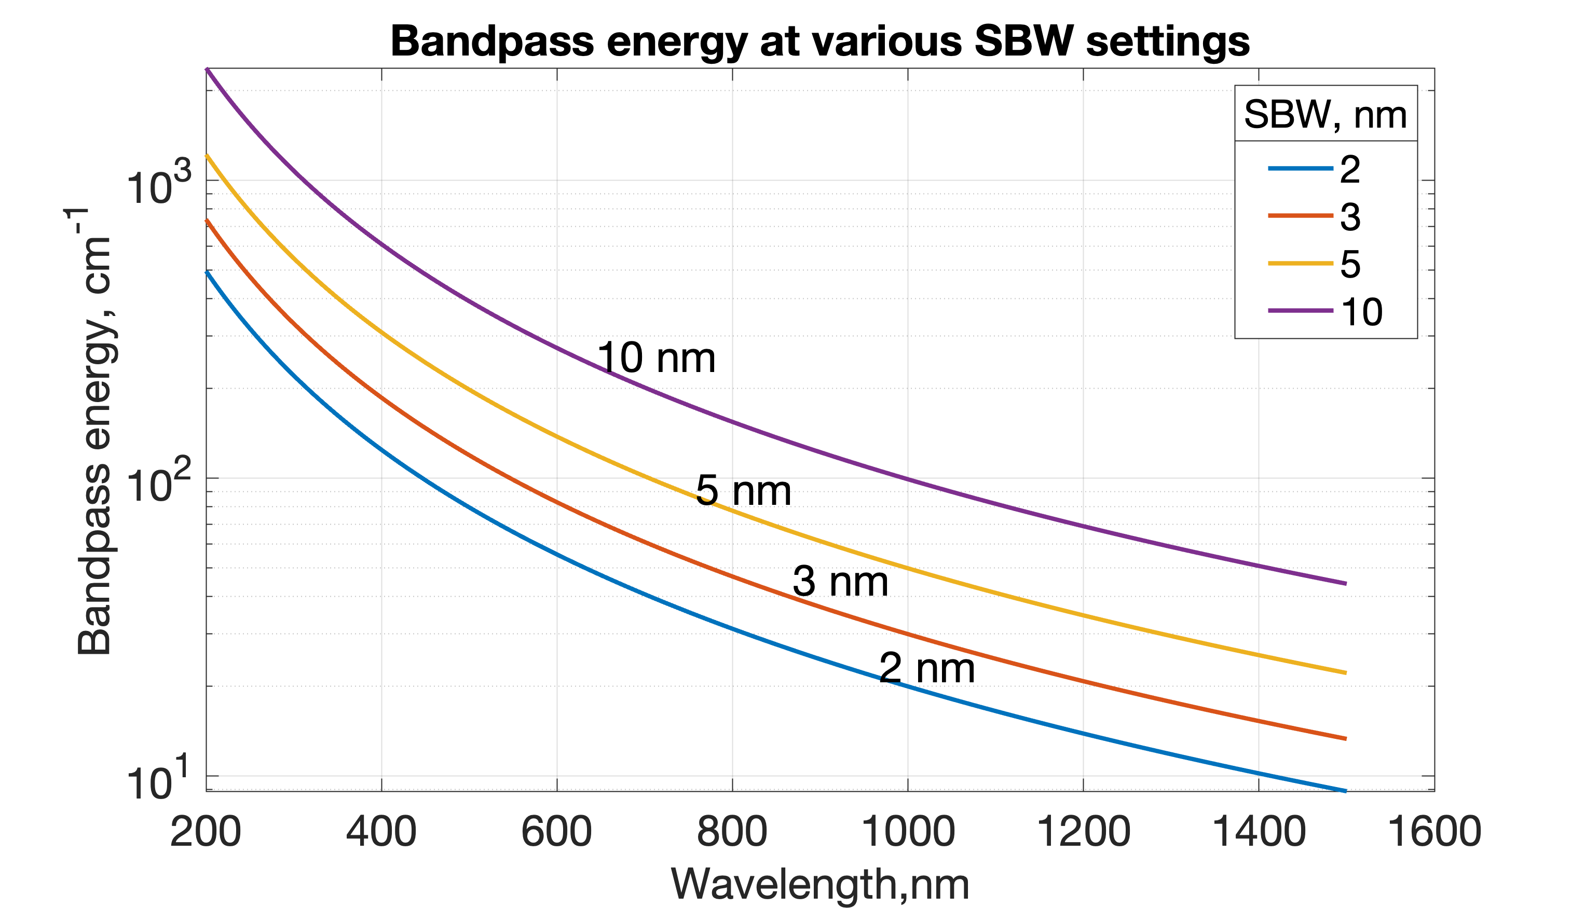
In a spectrometer the intensity observed by the detector changes with wavelength. Double beam spectrometers can monitor the detector readings to make sure that they stay within their optimum region. This can be done in two ways. You can open and close the slits to increase or decrease the amount of light that reaches the detector, or you can change the gain on the detector to increase or decrease the reading. In the former mode the spectral band width (SBW) will change as the slits open and close. To prevent changes in the SBW with wavelength the latter method of changing the gain is used. However, the SBW is in wavelength (nm) units while the spectrum is more linear in energy units (cm⁻¹) so even with a constant SBW the band width in energy will change across the wavelength range (see figure).
In the UV-Vis region the detector is a photomultiplier tube (PMT) that allows a large change in gain with applied voltage. However, in the NIR region, where PbS detectors were traditionally used this was not possible. Thus, the SBW was normally allowed to vary to maintain the detector output. In the Cary 5000 an InGaAs detector is used that has very low noise so that an amplifier with settable gain can be used to boost the signal.
In Double or Double Reverse Beam Mode in the UV-Vis region the slit width (SBW) is normally kept constant, and the gain of the detector is changed. In the NIR region (InGaAs detector) the reverse is normally true i.e. the Energy level is constant and the SBW (slits) changes. Due to the inherent differences between the two types of detector, the different methods of control normally ensure the widest dynamic range and the best signal to noise. However, in the experimental setup window the mode used can be controlled in all regions (see below).
The instrument uses two detectors (PMT and InGaAs diode), two light sources (W bulb and D₂ lamp), two gratings in the monochromator, and five order sorting filters. You can set the wavelength at which the detectors and gratings change. Both of these are typically set at 800 nm, if you have an important spectroscopic feature at 800 nm, you can move the change over ± 50 nm. The lamp changeover is normally set to 350 nm but again can be moved ± 50 nm
Note Since gratings are used to disperse the light 2nd (and 3rd ) order light from the output beam (i.e., at 800 nm you would also get 400 and 200 nm light) would reach the detector. The filters changes are at 350, 570, 800, and 1200 nm. You cannot move their changeover wavelengths.
If collecting data in double beam mode in the UV-Vis regions, you can set how the instrument controls the detector readings. In SETUP under the independent tab if you choose how the double beam spectra are collected. With either Auto or Fixed SBW set as the Measurement Mode, you set SBW (slit bandwidth) value in the UV-Vis group. The normal setting is 2.00 nm. You will find that the Energy level will change automatically to maintain the required signal level.
In double beam mode in the NIR region (where the detector change wavelength occurs, generally λ > 800nm), in either Auto or Fixed Energy Measurement Mode, the Energy level is kept constant by changing the slit width (SBW) in the NIR. An Energy setting of 1.0 will provide the best signal-to-noise ratio but with a larger SBW. In most cases, the recommended setting is 3.0; this provides a smaller SBW over the entire region and a better match of the SBW in the NIR region and the Vis region. You will find that the SBW will change automatically to maintain the required signal level.
In double beam mode across the UV-Vis and NIR regions with Fixed SBW set as the Measurement Mode then you will need to enter values in the SBW fields in both the UV-Vis and the NIR group boxes. The values can be the same if you want to use the same SBW across the whole scan or you can set different values for each region, normally the SBW in the NIR is >> then the SBW in the UV-Vis.
Note that the SBW is in nm and for a fixed setting of the SBW the resolution in energy terms will be much better in the NIR then in the UV or Vis regions (see figure). A spectral band width of 2 nm at 400 nm corresponds to 124 cm⁻¹ while at 1200 nm 124 cm⁻¹ give a SBW of about 18 nm. This is one reason that most absorption peaks in the NIR are much broader in wavelength then peaks in the UV-Vis regions. It also suggests that you can collect at a wider SBW in the NIR than the visible regions.

Appendix B:

Acquiring, storing, and retrieving baseline files
The Cary WinUV system collects a new baseline when you select any type of baseline correction in the Baseline tab of the Setup dialog box and then click the Baseline button in the application window. The then Cary prompts to perform a 100%Tbaseline (with nothing in the beam, or in the case of a Diffuse or Specular Reflectance measurements, with the 100% reference material in position). If required, you are prompted for a 0%Tbaseline (the sample beam totally blocked so that the instrument can measure the electronic zero values).
Once collected, they are applied to each collected spectrum. If there is no corresponding data point in the current baseline, an interpolated point is used. The correction applied to each point is shown below
A baseline correction cannot be applied if the Y range of the spectra exceeds the 100% baseline. If you change your abscissa range to outside that of the baseline, the Cary displays an error message and, the red text in the ordinate display which indicates that baseline correction mode is activated will disappear.
All values within the Baseline abscissa range are corrected, even the value displayed while the Cary is idling at a particular wavelength.
Note
Parameters for Energy, SBW, Beam Mode, Source Changeover, Detector Changeover Grating Changeover, Selected Lamp for the collection, Signal-to-Noise Mode, Slit height and the Independent Control need to be the same in the baseline file and the samples files for a valid correction.
Baselines are saved as a part of a batch file. However, if you want, you can also store the baselines by themselves in a baseline file without the collected data. To do this you simply select the Baseline (*.CSW) as the Save As Type in the Save As window accessed from the File | Save Data As menu. When you want to use the baselines for another Scan run, you simply open the file using either the File | Open Data command or click the Baseline button in the Baseline tab of the Setup dialog box.
Notes
- If you collect a new baseline, the Cary will use the new baseline in all corrections. However, the Baseline tab will still display the name of the baseline in the baseline file. You need to save the collected data as a batch file if you want the new baseline included in that file.
- All corrections are performed with the raw transmission data that comes directly from the instrument. These transmission values are then converted into the selected Y mode for display.
- A baseline cannot be applied to a sample where the abscissa range of the sample exceeds that of the baseline. If you wish to use that baseline, then you will need to reduce the range of the scan by changing the Start and Stop fields on the Cary tab of the Setup dialog box

Types of baselines. Choose the type of baseline correction under the Baseline tab in the Setup menu

Baseline Correction: A 100% only baseline correction is applied to the sample scan,
$$\frac{R_{S}}{R_{100\%Baseline}}$$
Where R_{S}, and R_{100%Baseline are} the ratio of the sample beam to the reference beam with and without the sample.

Zero/Baseline Correction: Both a 100%T baseline correction \and a zero-line correction is applied to the sample scan.
$$\frac{R_{S}-R_{0\%Baseline}}{R_{100\%TBaseline}-R_{0\%TBaseline}}$$
With this option, the Cary will prompt you to perform a 100%TBaseline first, followed by a 0%TBaseline when you perform a baseline collection.
This baseline option corrects for any inherent variations in the electronic zero line of the instrument. Use this baseline option if your samples have areas of very low transmission or reflectance as variations in the instrument's zero line will affect your measurements. You should refer to ASTM method E903 for further details.
Zero SRA correction: Applies a 100 %T baseline correction and a zero-line correction to a sample measured with an Absolute VW Specular Reflectance Accessory (SRA).
$$\sqrt{\frac{R_{S}-R_{0\%TBaseline}}{R_{100\%TBaseline}-R_{0\%TBaseline}}}$$

Note: The VN SRA and the single bounce relative SRA accessories should not use this correction. Select a Baseline/Zero correction instead. Refer to ASTM method E903 for further details

Zero *Std. Ref. Correction: Applies a 100 %T baseline correction and a zero-line correction to a sample measured with a reflectance accessory which is not absolute (e.g., a Diffuse Reflectance Accessory or the Variable Angle Specular Reflectance accessory). The Cary then multiplies the result by the appropriate value in the ‘Baseline Stdref’ file which are the transmission values associated with the Standard Reference material you used to establish the baseline. Refer to the help for the Diffuse Reflectance accessories for further details about Standard Reference materials.
$$\left[\frac{R_{S}-R_{0\%Tbaseline}}{R_{100\%Tbaseline}-R_{0\%Tbaseline}}\right]\left(Baseline Stdref\right)$$

Note: If you select this option the Baseline button in the main window will not be enabled until you have retrieved a Std Ref file. Click this button to browse for and select a Std Ref file. This file must be in the correct format

Known Mirror: Used for a VW Specular Reflectance Accessory (SRA) with a small sample or a sample of low reflectance. Refer to your SRA manual for more information. Uses:
$$\frac{\left[\frac{R_{S}-R_{0\%TBaseline}}{R_{100\%TBaseline}-R_{0\%TBaseline}}\right]}{Known mirror corrected}$$
where
$$Known mirror corrected=\sqrt{\left[\frac{R_{mirror}-R_{0\%TBaseline}}{R_{100\%TBaseline}-R_{0\%TBaseline}}\right]}$$

Tip If baseline correction is activated, the type of correction that the Cary will apply will appear in the in red. However, sometimes you may notice that the text has turned to gray and is in italics. This indicates that the Cary is currently idling outside the abscissa range of the baseline file, but that the current method Start/Stop parameters do not exceed the abscissa range of the baseline

Retrieve Baseline File, Displays Windows Open dialog box to select a stored baseline file. The spectrum(s) in this file will be used for the selected baseline correction. The name of the selected file appears next to the Baseline button.

Tip: If you want to use the baseline again with other samples, save the method using File | Save Method As. Then, when you re-open the method, the baseline will also open and be ready to use. All collection parameters are saved this way and used for the new Scan runs. Good Laboratory Practice recommends use of a new baseline for each laboratory session View Baseline File Displays the spectrum in the selected baseline file.

Retrieve Std Ref File Displays the Windows Open dialog to select a stored reference file. The trace in this file will be used in the Zero x Std Ref Correction. The name of the selected file appears next to the Std Ref button.

Tip The Std Ref file must be in the valid format. You can obtain these files from the manufacturer of the standard that you are using
- How to create and use a standard reference file
Q. Why is my Retrieve Std Ref button unavailable?
A. You need to select the Correction type as 'Zero *Std. Ref. Correction'

View Std Ref File: This displays the traces in the selected standard reference file in the Graphics area.

Show Status Display: Select this check box to display the Show
Status window. This window allows you to view the status of various parameters during the data collection.

Appendix C

Graph menu, Trace Preferences and Graph Preferences options
- Graph menu options
Print XY point: cursor's current X and Y coordinates shown in the report area. Only available when right-clicking in a graph box.
Trace Preferences: choose the spectrum to display in the selected graph
Graph Preferences: change appearance of graph; changes apply to all graphs.
Cursor Mode enable use of a free cursor that moves or fixed to focus spectrum (red scan).
Axes Scales: change the range of the axes.
Autoscale[XY]: automatically scale X and Y of spectrum to full screen.
Autoscale[X]: automatically scale X width to full screen.
Autoscale[Y automatically scale Y height to full screen.
Zoom Out: Zoom back to the original X and Y axis scaling
Add Label enables placement of text label on your graph.
Add Picture : insert a picture, bitmap, or chemical structure into your graph.
Edit Annotation: alter the content or look of an annotation (such as a label or a picture).
Delete Annotation: remove an.
Single/Multi Graph : toggle between displaying one or all graphs.
Auto Arrange Graphs: view and arrange all graphs simultaneously.
Copy Graph: copy the Graphics area onto the Windows Clipboard.
Paste to Graph: paste the contents of the Windows Clipboard into the Graphics area.
Add Graph: add a new graph box to the Graphics area.
Remove Graph: delete the selected graph box from the Graphics area.
Clear All Traces: Select Clear All Traces to delete all traces from the graph/s.
User Data Form: display the User Data Form.
Maths: enable the Maths window, available when right-clicking in a graph box.
History List: displays a list of the current graphs.
- Trace (spectra) Preferences Note that red spectrum is the focus spectrum and used for cursor tracing. A single graph box can display many spectra. Spectra or Trace Preferences are accessible from the Graph menu, by right-clicking on a trace, in the toolbar, or in the spectra listing
Visible: In single graph view, all checked spectra appear in a single graph; in Multi Graph view, selects spectra appear in currently selected plot.
Color: choose color and line width of the spectrum.
Name of Spectrum shows info for spectrum currently in memory. Right-clicking in this column displays the Trace Preferences menu.
File Name: file name and path of the saved spectrum.
Trace Audit Log: information about the last spectrum selected.
Select Traces: The drop-down arrow reveals any columns you have created in the User Data Form. You can select traces based on any of the columns you have created.
- Graph Preferences Used to change the appearance of graph. Accessible, by right-clicking on a trace or by clicking Graph preferences icon on toolbar. Changes made apply to all graphs.
Standard Tab: alter the way your graph appears on screen.
Preview Box: preview of the axis’s variables shown to right of dialog box. To change the view, alter the settings in the variables on the left.
Axes Color: select the color that you want to assign to the axes of the graph(s).
Axes Width: select the width of the axes. The width is between one and five pixels.
Grid Style: turn on or off grid in graph.
Plot Area Color: specify color of graph background.
Trace Width: select the width of the spectrum from one and five pixels.
Font: define the font style for the axes of the graph(s).
Trace Style: define the way that a spectrum will appear, points, line with points, line.
Advanced Tab refine the way your graph looks.
Auto tick marks: alter the number of tick marks on your graph. If you have selected the Major Ticks check box, this option is unavailable.
Major ticks: number of tick marks on each axis of graph.
Decimals: number of decimal places shown at tick marks.
Show Legend: display a legend on the right side of each graph box.
A single click on a sample name or example line within the legend will make it the focused or red scan. Information about the trace will be displayed below the X axis.
Double-clicking the legend will automatically display the Trace Preferences window, allowing you to view more detailed information about your trace (e.g., audit log, file name, etc.).

