Quick Start for Cary 5000 spectrometer with external DRA 1800 attachment.
Do not remove
(Last updated 09/20/2021)

Important warnings!
- Never plug or unplug the external DRA attachment when the instrument is on.
- Never put white light into the DRA with the DRA connected to the Cary.
- Do not use Align command.
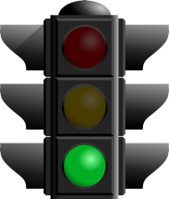
- Do not use compressed air dusters on any mirrors or optics.
Start
- Do not use any samples that fall apart in the integrating sphere.
Quick Start
- Reserve time on the scheduling website.
- Fill out logbook for the Cary
- Fully close the cover for the DRA, turn Cary on, and wait till it stops making noise about 2 minutes.
- Turn on computer and click on the Cary Scan icon and wait till you get the green light.
- If you get an error turn off Cary for 10 s and then turn back on.
- If still get an error, see the section on Startup Errors in the Cary Users guide.
- Wait 20 minutes for the lamps to warm up.
- Put on clean gloves.
- Check that the needed lens and mirror are in
  - Install Small Sample Kit mirror (M3 SSK) or regular M3 mirror if needed
  - If using SSK install correct lens L2.
- Τhe optics need to be aligned before each use to check that 1) sample & reference beams are not clipped and 2) the sample beam is centered on the sample.
  - Under the commands menu click on Go to, and then type in 550 nm (do not use the “align” option).
  - Darken the room lights.
  - With a thin white card, you should see a green spot at your sample position.
  - Check that the beam hits the center of the M3 mirror and goes through the center of L2 and hits the center of your sample.
  - If you sample will be at the reflectance port, use mirror M1 to make the light beam go through the center of the entrance to the sphere, then use M3 to make the beam hit your sample. Redo this several times until the beam does both at once.
  - If your sample will be at the transmittance port, use mirror M1 to make the light go through the center of M3 and lens L2, then use M3 to hit you sample. Redo do this several times until the beam does both at once.
  - Check that the sample beam does not overfill you sample and hit any white surface. If the sample is small you need to mask the sample and/or use an aperture to restrict the entrance to the integrating sphere (look in the drawers for the Cary for apertures). Do not put anything that can scatter light close to the beam path at the entrance or exit to the sphere. This includes edges of glass slides.
  - If you have very small samples, see the User’s Guide for more suggestions on small samples.
  - Check that the reference beam is hits mirrors M4 and M5 close to the center and goes through the center of L1 and is not clipped at the entrance of the reference beam into the integrating sphere. Use mirror M5 to center it on the entrance.
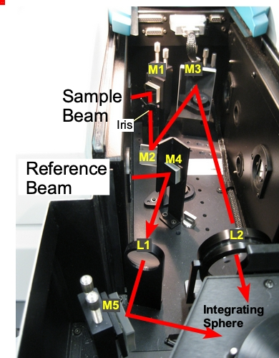
- Select Setup → Instrument Settings → Cary Options
Figure 1 Photo of diffuse reflectance accessory with beam path.
  - Set the wavelength range, and the Y mode, %T, Abs, or %R
  - Set the Ave time (time/data point) as 0.1 s and a Data interval of 1 nm if your measurements will show significant changes (if you have small intensities or small changes, you may consider using an Ave time of 0.5 or 1 and a Data interval of 2 nm/point.
  - Under Advanced Settings set SBW, to 2 nm, and Detector and Grating change wavelengths. (Again, if you signals are small you can set the SBW to 4 nm, but it will increase the beam width and may overfill you sample). Note that the signal/noise ratio, S/N, is dependent of the amount of light that gets to the detector. Increasing the SBW by 2 increase the light to the detector by 4. Decreasing the slit height decrease the light by 4. Increasing the Ave time will also increase the S/N. A setting of SBW to 4 and slit height to reduced gives a square spot on the sample.
  - Under Baseline tab: chose zero/baseline correction
  - Under File Storage tab: set whether it prompts to save the spectrum.
  - Then click Ok to close the Instrument Settings window.
- Check that all exits of the integrating sphere are blocked with full reflectors.
- You need to run the 100% Baseline correction with everything in the beam path except your sample. If using an aperture for reflection or transmission measurements, please see the “Aperture kit for small samples” in User Guide.
- Choose Baseline and run 100% T (or R) scan, then block the sample beam at the entrance to the integrating sphere for the 0% scan.
- It is good practice to run a spectrum with no sample after running Baseline to make sure that you have a good 100% T line.
- Mount your sample
- Choose Start to run the spectrum.
- If you have small intensities (low % R or T) use longer time/point settings to help reduce noise.
- When done remove sample and remount reflectors.
- Turn off Cary
- Shut down computer.
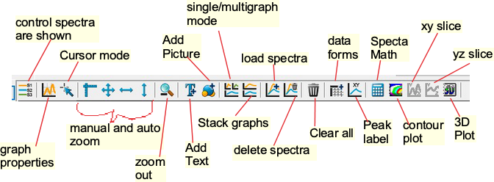
Toolbar

