Quick Start for MMRC DektakXT Stylus Profilometer
Do Not Remove
Document Updated: 12/16/2016
The full user manual should be found on the desktop of the control computer.
How the system works:
The DektakXT system takes measurements electromechanically by moving a diamond­tipped stylus over the sample surface according to a user­programmed scan length, speed, and stylus force. The stylus is linked to a Linear Variable Differential Transformer (LDVT), which produces and processes electrical signals that correspond to surface variations of the sample.
System Configuration:
- Our system is configured in 2D mode:
- Manual X­Y translation: 101.6 x 101.6 mm (4 x 4 inches) of X­Y translation, manual leveling
- manual theta rotation
- Maximum sample thickness: 50 mm (1.9 inches) thick
- Maximum scan length: 55 mm (2.16 inches) Stylus Tip Diameter: 2 microns
Before Starting:
- Fill out the logbook before you start.
- The instrument should be off, and the cover to the isolation chamber should be closed.
- The bottom of your sample must be clean (no Hg or Ga/In contaminated samples allowed!)

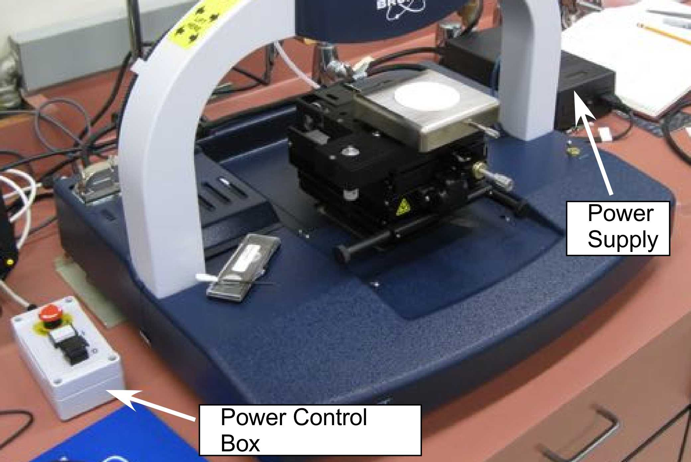
Start­Up:
Figure 1. DektakXT with cover removed
- Turn on power supply (Black box on right of instrument, see Figure 1).
- Press (I) button on white power control box (on left of instrument).
- Start the Dell computer to left of Dektak.
- Start Vision64 Software. The following should happen:
  - The tower assembly will move to its upper limit. The system stops with the stylus in the Tower Up position.
  - The scan stage initializes.
  - The Vision64 Welcome screen appears, followed by the Vision64 “Instrument”
  - tab, which includes the DektakXT Live Video Display
- Put on gloves before touching anything inside of the lid
- After the system initializes, it is safe to load your sample onto the stage (Bruker recommends letting the system warm up for 15 minutes).
- Check that the flat glass block is free of dust (this flat surface is what allows us to measure accurately over longer distances. It should be kept clean at all times!) If you see any dust, please blow it off with compressed air or N₂.

Loading your sample:

In the “Live Video” Window, hit “Unload Sample” ­ the stage should move toward you (if not, it was already in unload).
- You can now position your sample on the chuck (vacuum capabilities are currently not installed, so just center it carefully)
- In the “Live Video” Window, hit “Load Sample”
Note: During a scan, the machine will move the stylus toward the back of the instrument, so you need to position the sample to start at the front edge of your desired scan area.

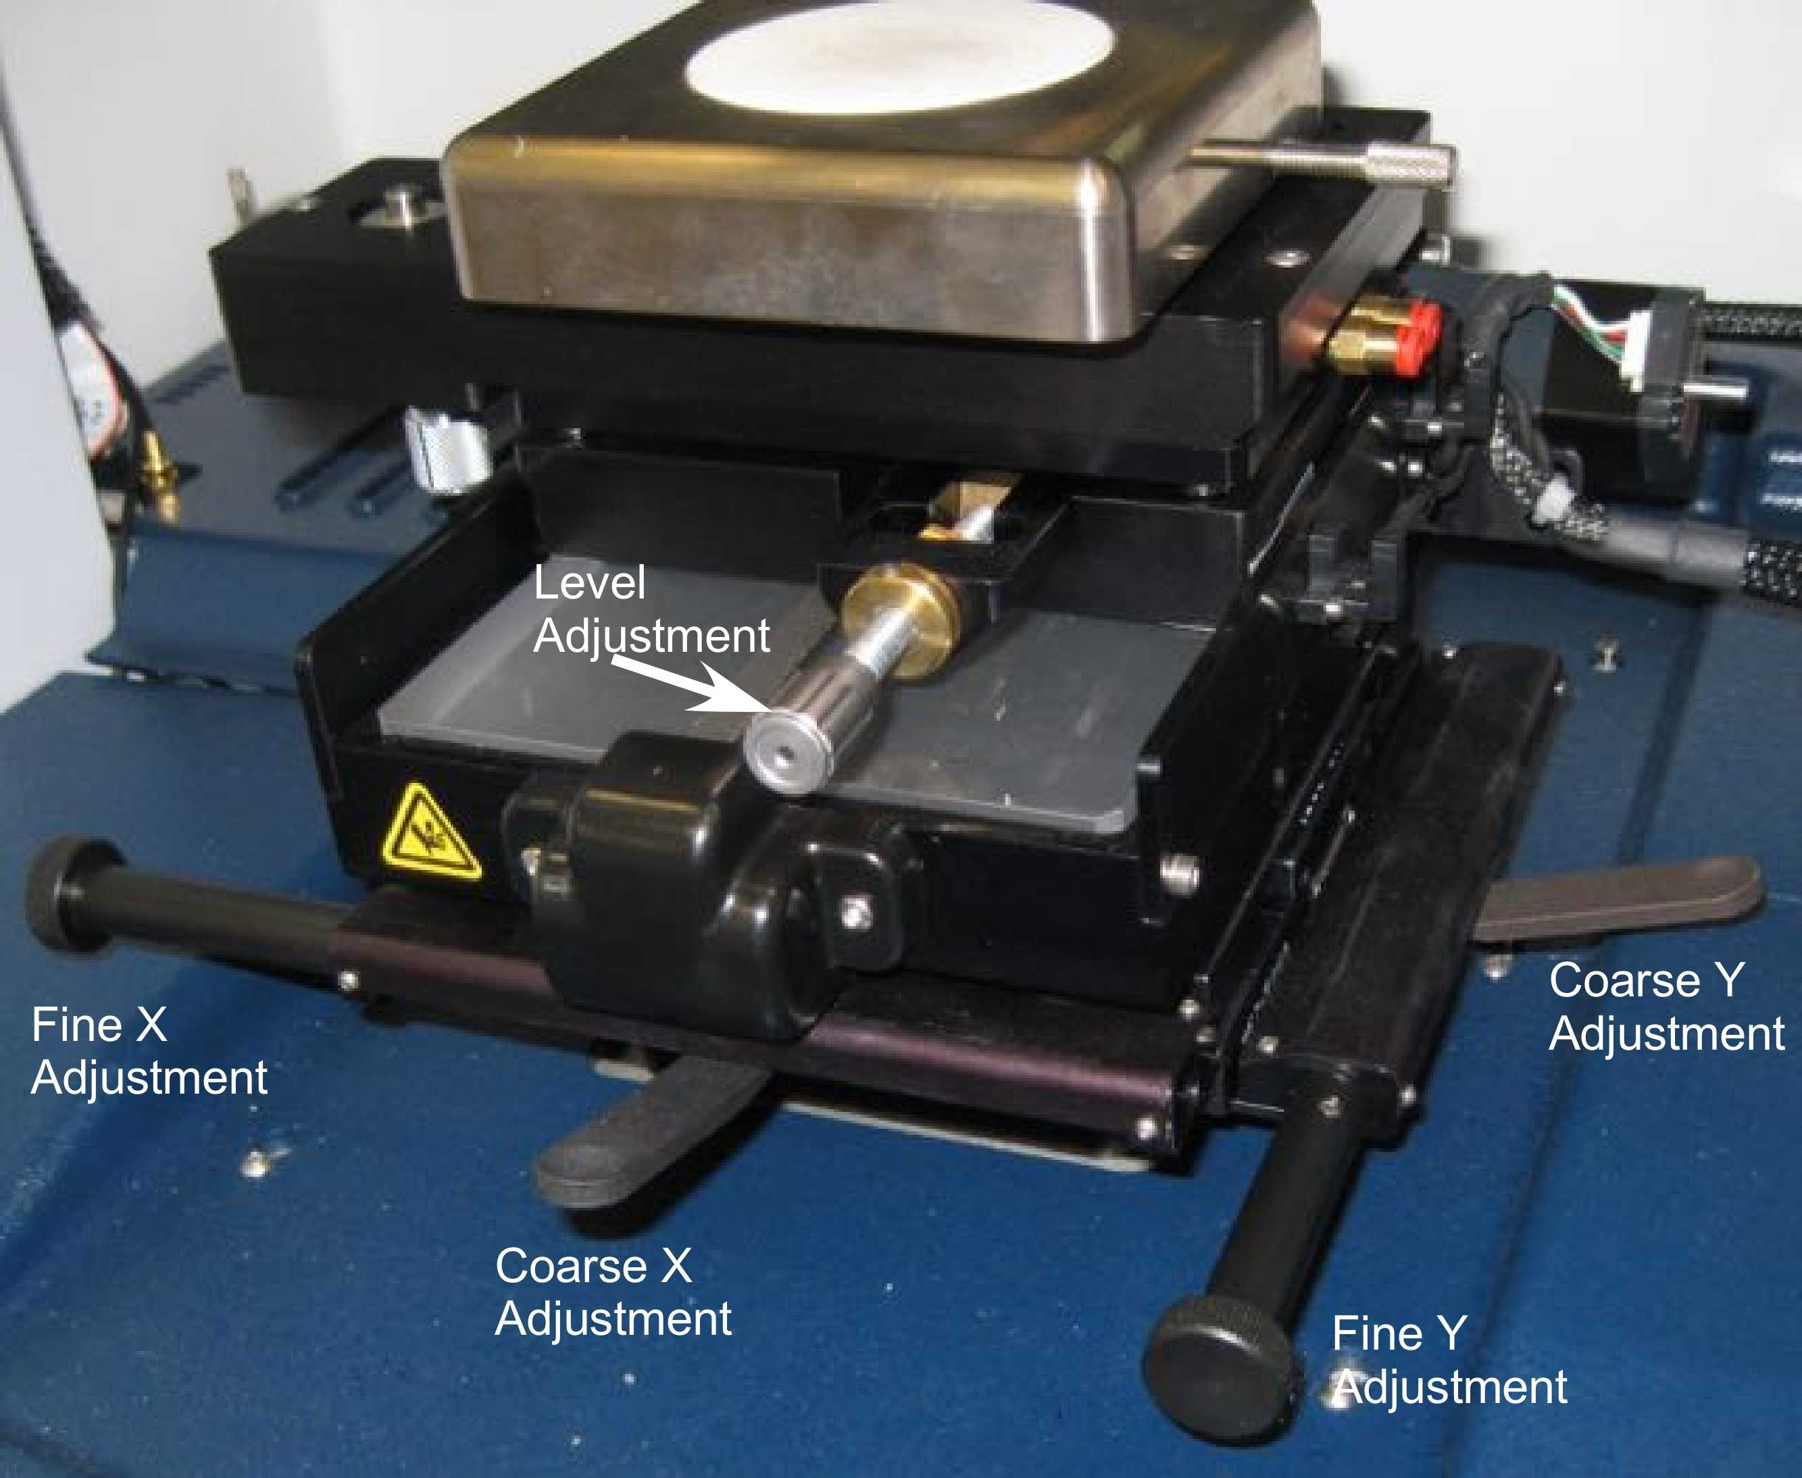
Adjusting sample position:
Figure 2. DektakXT stage.
- To position a sample using the manual sample­positioning stage controls:
  - Ensure the stylus is not touching the sample surface. If it is, click the Tower Up button on the toolbar.
  - Position the scan start site by using the X­Y positioning levers.
    - Push the lever below the front of the platform down for coarse X movement. Push the lever back up to secure coarse position, Error! Reference source not found..
    - Pull the lever on the right side of the platform down for coarse Y movement. Push the lever back up to secure coarse position.
    - Turn the respective X and Y adjustment knobs (Error! Reference source not found.) to fine adjust the sample position.
- Hit “Tower Down” to lower the stylus. The stylus will hit the sample, and then retract to ~1mm above the surface. Do not to bump the instrument during this process.
Calibration:

If desired, you can use the calibration standards (in DektakXT drawer) to calibrate the instrument prior to use to check that the system is working properly. To do so, follow the instructions above for loading and running a scan, and ensure that the measurements correspond to the calibration standard specs. If the standards are off significantly, contact the GLA.
Software ­ Scan Parameters:

The “Measurement Set­up” window allows you to control scan parameters. Set each of the following:
- Scan Type: Standard Scan
- Range: Sets the Z range of the instrument. Set this to a range slightly larger than the feature you want to measure. Note if using Hills and Valleys mode, you can only measure half of the range above the starting point, and half below.
Vertical Range | Vertical Resolution
μm | nm
6.5 | 0.1
65.5 | 1.0
524 | 8
1000 | 15

  - The selected scan range is scaled across the LVDT output of the stylus head sensor and digitized. The greater the scan range, the lower the vertical resolution of the measurement, see table. So while the 65.5um, 524um, and 1mm scan ranges would all work for a 10um step, the 65.5um is the best.
- Profile: Will determine whether you start at bottom, middle, or top of designated height range.
  - Valleys: Provides 90% of the measurement range below the zero horizontal grid line. This option is used primarily for measuring etch depths.
  - Hills and Valleys: Provides 50% of the range above the zero horizontal grid line and 50% below. This option is used in most applications, especially if the surface characteristics of the sample are not well known, or if the sample is out of level.
  - Hills: Provides 90% of the range above the horizontal grid line. This option is used primarily for measuring step heights.
- Stylus Tip: 2 microns (need to be sure to reset this everytime you start the program!)
- Stylus Force: Standard range is between 1 and 15mg. Default is 3mg, but use less force for soft/fragile samples. (*Can use N­Lite mode for very low force (down to 0.03mg), but you need to select the box... this limits your scan length as well)
- Length: Y length of scan(can measure up to 55000um (5.5cm))
- Duration: Time of scan (Length and Duration determine the resolution of your scan)

Running a Scan:
- You can run single or multiple scans. To run a single scan, click the “Single Acquisition” button, and the scan will begin automatically.
- To run multiple identical scans,under the measurement setup menu, click the “Advanced Options” tab and change the number of measurements. Press “Measurement” to begin scanning.
- Manual Leveling: Note: If you notice a significant slope to your data during the scan, you can adjust the stage tilt by turning the silver knob in the front of the instrument. Turn the knob to counteract the slope in your data. You should not have to adjust this significantly (you can further level the data during the data analysis step). If something seems wrong, contact a GLA.
- After the scan is complete, the “Data Analysis” window should automatically open. If not, you can click on it. To export your data, you can right­click on the plot and select “Export Data”.

To zero/level data on computer:
Under “Data Analyzer” window, select “Terms Removal (F­Operator)”. You should now be able to right click on your data to set your reference cursor to zero and level your data.

Analysis:
- Select the “Data Analysis” Screen (if you’re not already there) . You should see a trace of your data in the “Data Analysis” box.
- Right click inside the “Analytical Results” box and select “Append”.
You can then select whatever it is that you want to measure, and select a location for R and M cursors. When you hit “Calculate” you will see all of those values listed in the Analytical Results box.

Saving Data:
Under the “Advanced Options” tab (in “Measurement Setup), you can select whether you want the software to auto­save your data.

Unloading Sample:
- Hit “Tower Up”.
- Hit “Unload sample”.
- Either load a new sample or power the system down.

To power down the DektakXT system:
- Close the Vison64 software.
- Press the black OFF button on the EMO Box .
- Turn off the power switch on the black power supply box.
Bruker User Manual is at
http://mmrc.caltech.edu/DektakXT/Manuals/User%20Manual%20Dektak%202011-05-31.pdf
Bruker Customer Service: 800­873­9750.

