**Using The Germanium Wide Angle Attenuated Total Reflectance Accessory.**

The GATR is a single reflection 65ºATR accessory designed for analyzing monolayers and adsorbed species on semiconductor and metallic substrate

October 03, 2017

1. **Installing the GATR**

Figure Harrick GATR accessory.

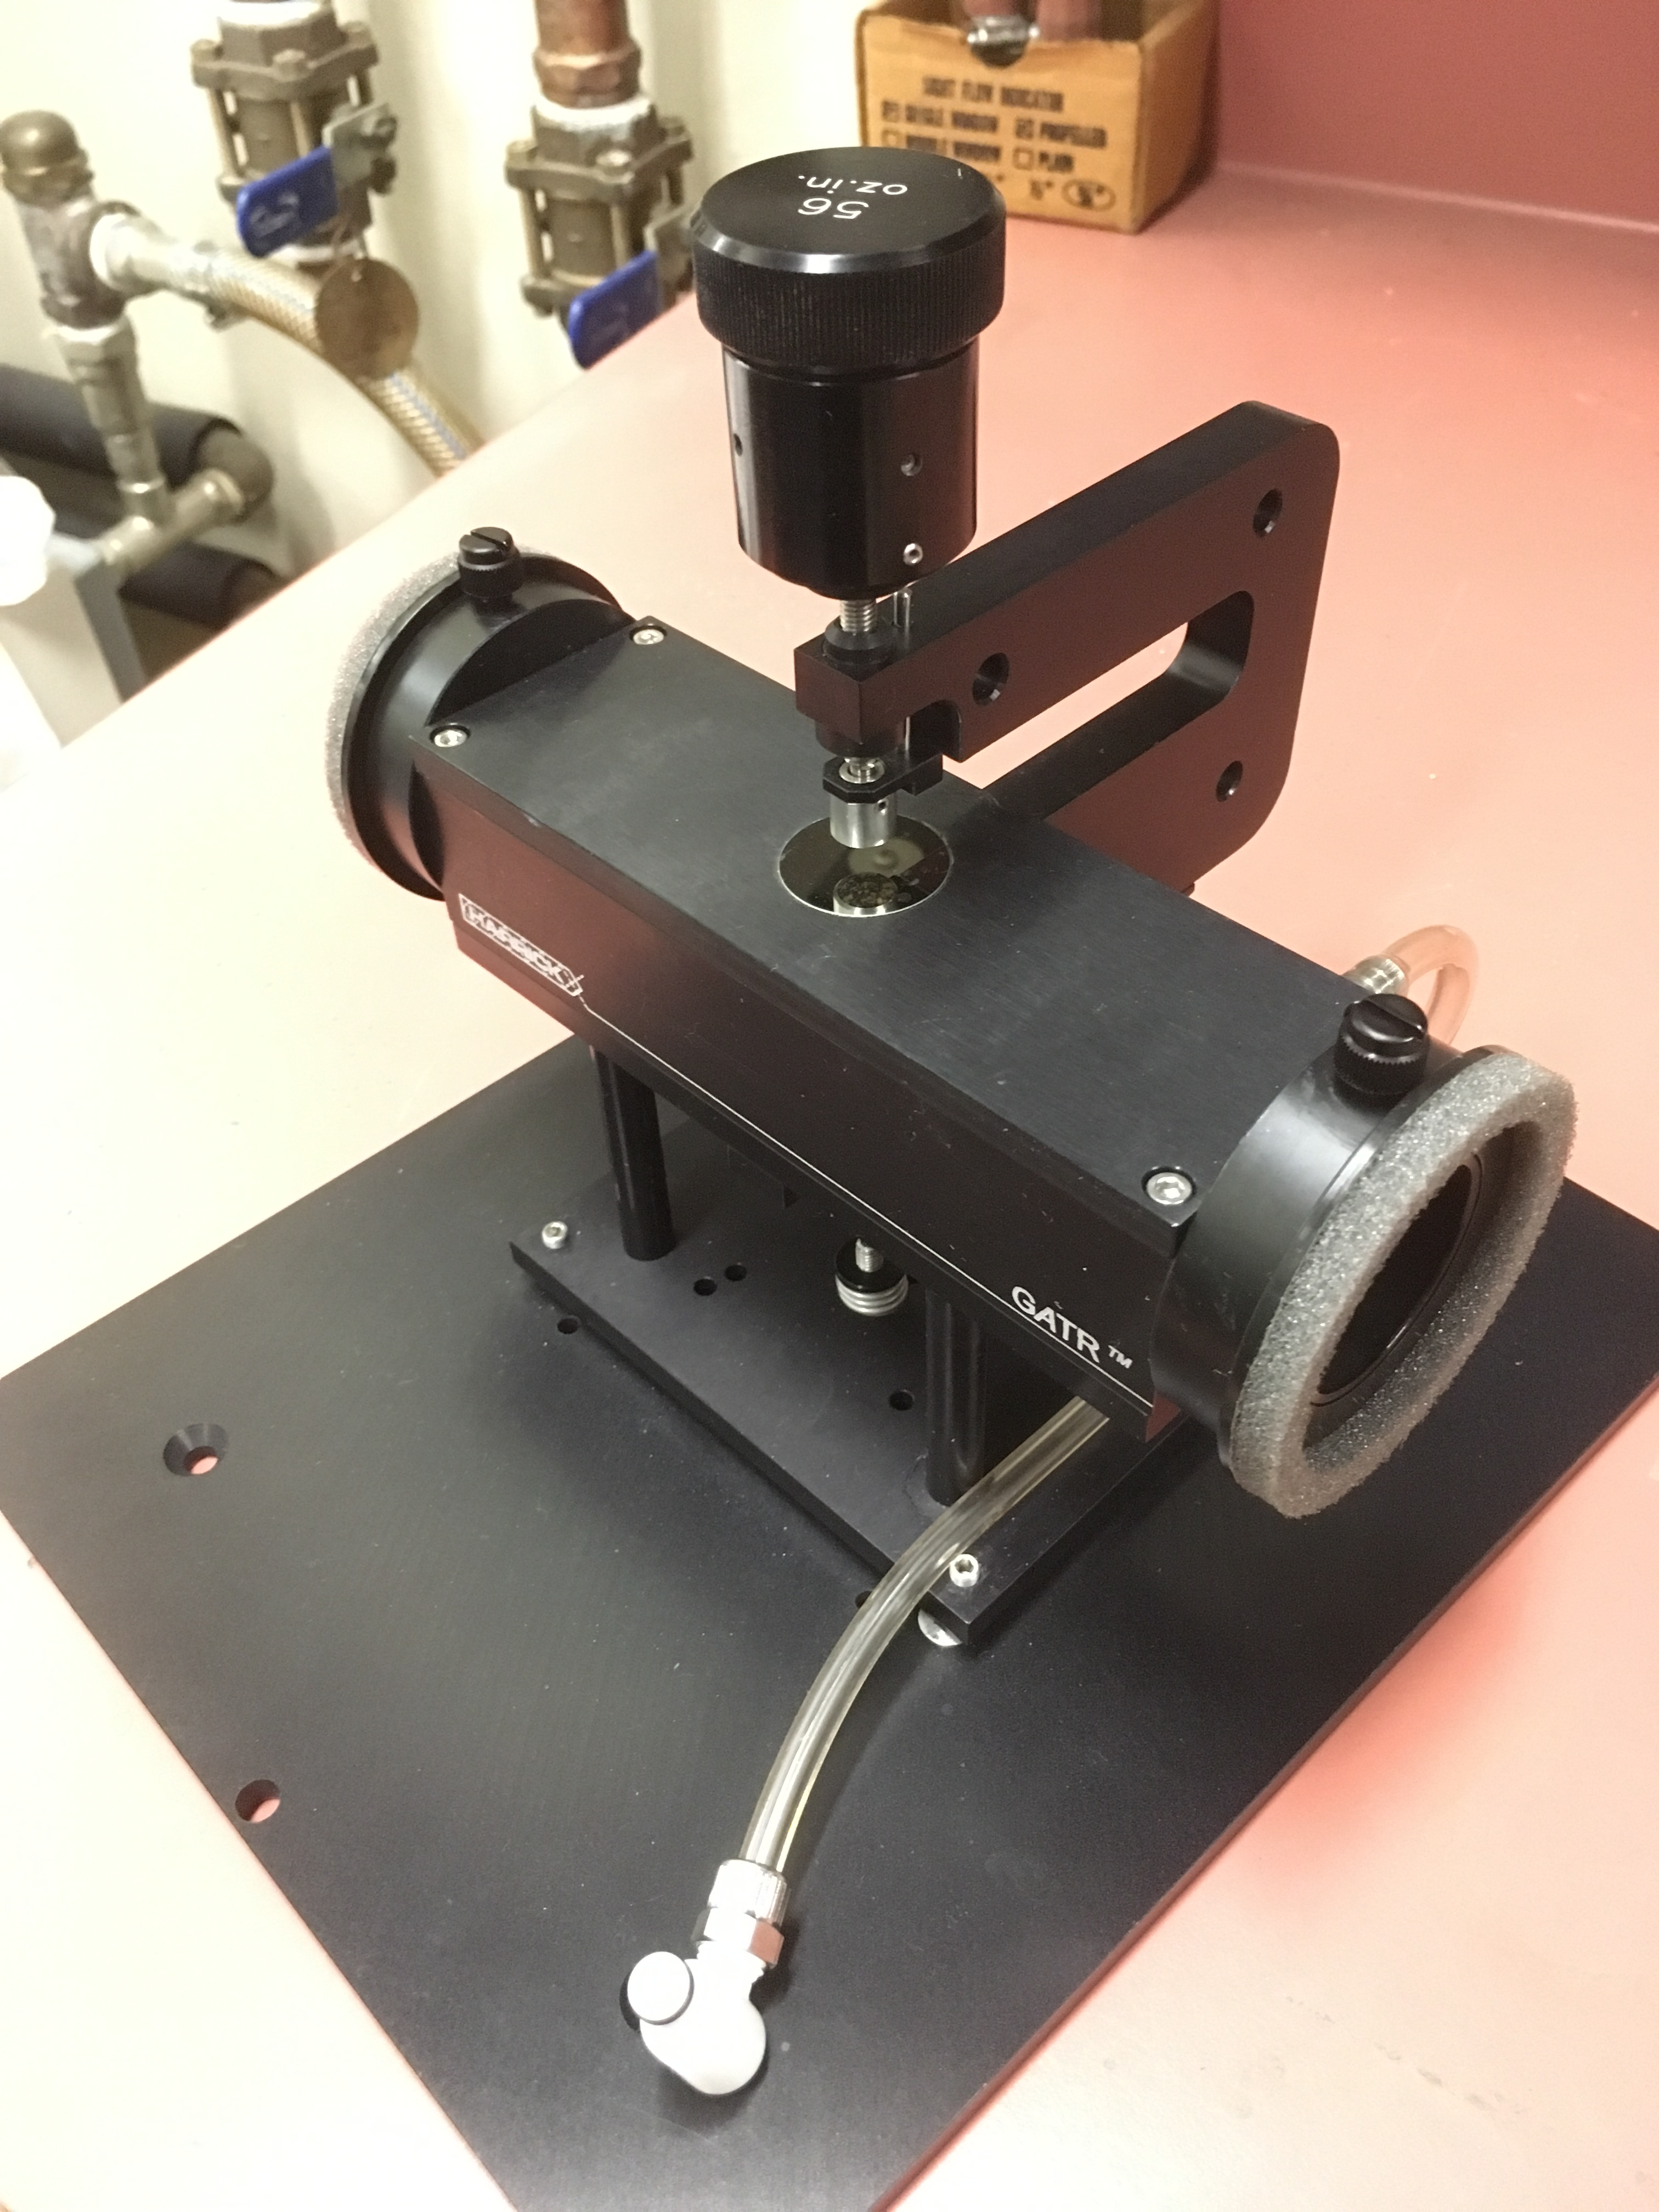

* 1. Remove any accessory in the Nicolet 6700.
  2. Remove the snap in baseplate.
  3. Install the “ears” or sidewall adaptors from both beam path holes,
  4. You need to attach the purge tube of the GATR to the connection at the back of the sample chamber.
  5. The GATR should be mounted on it own base plate. Lift the GATR up and lower it down into the sample compartment of the Nicolet.
  6. There is a pressure clutch drive set for 56 oz in that should be in the GATR box and mounted on top of the pressure drive.
  7. The purge sleeves of the GATR need to align with the beam holes on the FTIR and need to be extended to fit snugly in the instrument.

Figure 1 GATR germanium wide angle attenuated total reflectance accessory.

* 1. Make sure the GATR plate and pressure foot are clean. If not you can clean them with a optical lens paper or cotton Q-tip damp with isopropanol or water. Do not rub the GATR crystal.
  2. Check the flowmeter behind the FTIR, to make sure the purge is N2 with a flow rate of 30 ft3/hr (scfh) into the FTIR.



Figure The accessory compartment showing “ears”.

1. **Collecting the Background Reading** 
   1. Open OMNIC on the computer by double-clicking the OMNIC desktop icon. You should see the tool bar shown in Figure 3 below.
   2. Click the menu bar icon “Expt Set” to enter the *Experiment Setup* window.

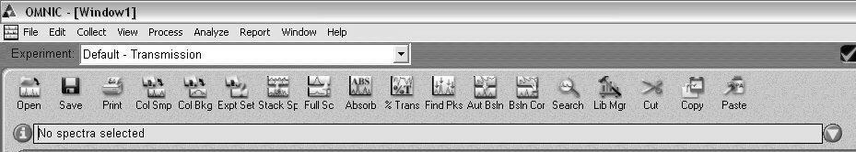

Figure Omnic tool bar.

* 1. Under the *Bench* tab, set the accessory to *ATR,* Figure 5.
  2. Under the *Collect* tab, Figure 4, set the number of scans to > 100 and the final format to what you want (we usually use single beam as described below). Enter a title for the experiment. Your window should be similar that shown in Figure 5.
  3. You can run the diagnostics under the Diagnostic tab to make sure everything is ok.
  4. Click *OK*.
  5. You will need to wait about 30 minutes to make sure the background is clean enough to measure monolayers.

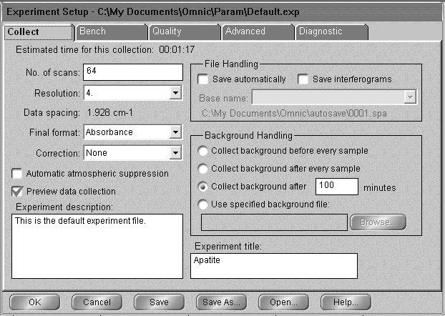

Figure Experimental Setup in Ominc

* 1. Make sure nothing is touching the Ga; click the menu bar icon “Col Bkg” to collect the background and click *OK* to start collection. (Is this how you do it or do you use a Si wafter for the background?)
  2. When the background looks stable – no major changes in peaks – click *Start Collection* in the top right corner of the window. An unstable background indicates that the instrument is not fully purged, so you need to wait for purging to finish. See Figure 6

**Figure 5: The *Bench* tab of the *Experiment Setup* window.**

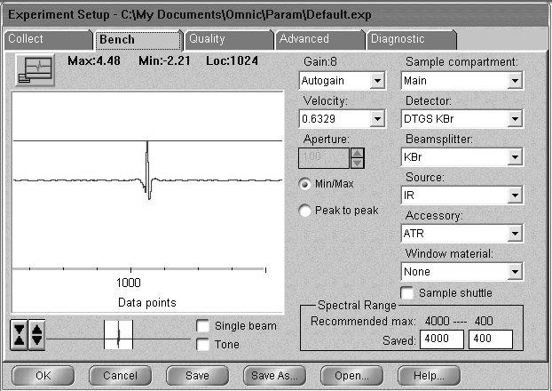

* 1. Click *Yes* when prompted about adding the background to Window 1.

1. **Placing the Sample in the GATR Accessory** 
   1. Make sure that the pressure applicator’s tip is well above the crystal.
   2. If your sample is a single solid piece, place it on the opening in the metal plate under the pressure foot.
   3. If your sample is a powder:
      1. *Hard materials must ground to a very very fine powder in a mortar and pestle to use*.
      2. *Cover the Ge surface with a thin layer of the materials. Do not allow a metal spatula to touch the Ge surface*.
2. **Collecting the Spectrum**
   1. Low the pressure foot to increase the pressure applied to the sample by turning the pressure control clockwise until when??.
   2. Click the menu bar icon reading “Col Smp” to begin collecting the sample.
   3. At the prompt, enter the sample’s chemical name or formula in front of the default title (the current date and time).
   4. Click OK when prompted and press Start Collection in the top right corner of the screen.
   5. Click Yes when prompted Add to Window1? Unexpected peaks in the range of O-H (~3800, ~1600 cm-1) or CO2 ( ~3700, ~2340 (doublet) and ~660 cm-1) and sample should be re-run with ample time allowed for the system to purge.
   6. Save the spectrum by clicking the Save icon. If multiple spectra are open in a window, you will need to click on the desired spectrum before clicking Save.
   7. Click Set Filename to Title, and save the file to you directory.
   8. You can reprocess the blank and the sample spectrum to get a %T or Absorbance spectrum.
3. **Cleaning Up** 
   1. Close OMNIC.
   2. Clean the pressure applicator and Ge crystal. In most case where a slide sample such as Si was use no cleaning is necessary. If cleaning is necessary, be careful to use only lens tissue or a cotton tipped applicator. .
4. **Remove the GATR**
   1. Remove the GATR , lift it out of the FTIR and place it in it’s storage box.
   2. Replace the box on the shelves.