Using The Horizon Attenuated Total Reflectance Accessory.
The Horizon is a single reflection 65ºATR accessory designed for analyzing monolayers and adsorbed species on semiconductor and metallic substrate it has a spectral range of 700 – 5000 cm⁻¹.
October 04, 2017

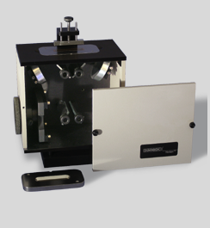
- Installing the Horizon
Figure 1 Horizon ATR
  - Remove any accessory in the Nicolet 6700.
  - Remove the snap in baseplate.
  - Make sure the “ears” on the sample ports are installed.
  - The Horizon, figure 1, needs to be mounted on the base plate with the adaptor on it, Figure 2.
  - The Horizon is centered on the baseplate and the small thumb screw under the Horizon is turned CCW to tighten the Horizon on the base plate.
  - Remove the diffuser from the purge connection at back of sample compartment.
  - Attach the purge tube of the Horizon to the purge connector.
  - Place the Horizon in the sample compartment of the Nicolet.
  - Remove the front cover of the Horizon.
  - Extend the beam tubes by loosing the thumb screw and pulling them out to align with the beam ports on the spectrometer.
  - The Horizon should be prealigned so you should not need to touch the mirrors. If you need to use a polarizer talk with the GLA.
  - Replace the front cover of the Horizon.
  - Make sure the Horizon ATR plate and pressure foot are clean. If not you can clean them with optical lens paper or cotton a cotton Q-tip damp with isopropanol, methyl-ethyl ketone, or water. Do not rub the Horizon crystal, rather use light pressure. If required the sampling plate can be completely removed from the Horizon for cleaning.
  - Check the flowmeter behind the FTIR, to make sure the purge is N₂ with a flow rate of 30 ft³/hr (scfh) into the FTIR.
- Collecting the Background Reading
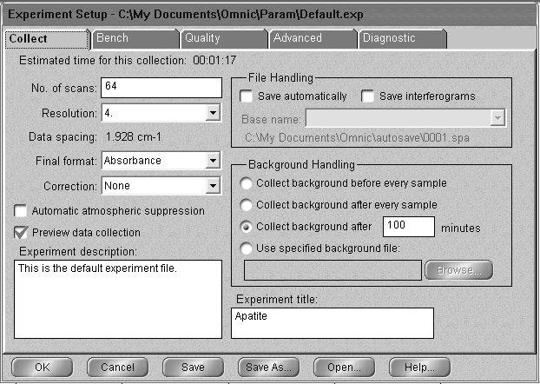
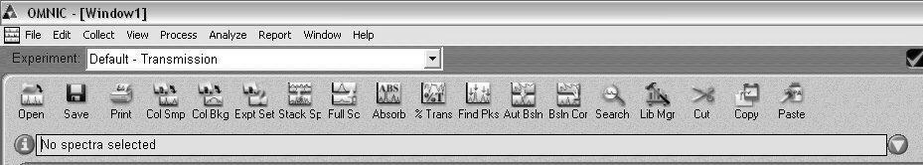
  - Open OMNIC on the computer by double-clicking the OMNIC desktop icon. You should see the tool bar shown in Figure 2 below.
Figure 3 Experimental Setup in Ominc
Figure 2 Omnic tool bar.
  - Click the menu bar icon “Expt Set” to enter the Experiment Setup window.
  - Under the Bench tab, set the accessory to ATR, Figure 5.
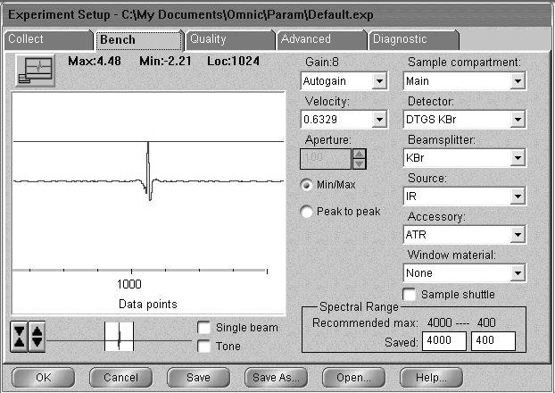
  - Under the Collect tab, Figure 4, set the number of scans to > 20 and the final format to what you want (we usually use single beam as described below but if all you want is the transmittance or absorbance spectra choose that). Enter a title for the experiment. Your window should be similar that shown in Figure 5.
Figure 4 Bench menu for Horizon
  - You can run the diagnostics under the Diagnostic tab to make sure everything is ok.
  - Click OK on Experimental setup.
  - You will need to wait about 10 minutes to make sure the background is clean.
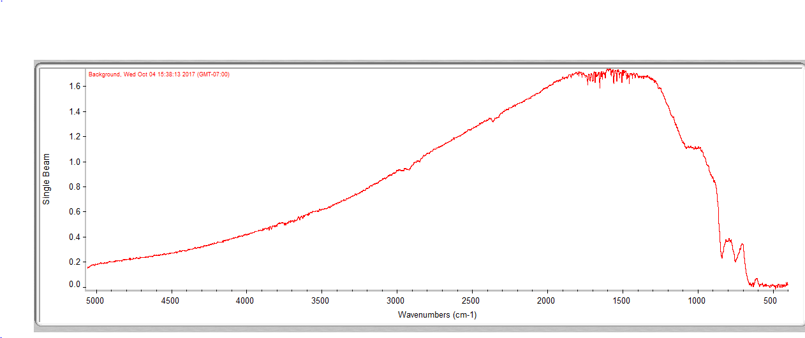
  - Make sure nothing is touching the Ga; click the menu bar icon “Col Bkg” to collect the background and click OK to start collection, Figure 5.
Figure 5 Single beam spectrum of Ge ATM background.
  - Click Yes when prompted about adding the background to Window 1.
  - To make sure that everything is stable you can collect a sample spectrum, Col Smp, to see if you get a Transmittance or Absorbance curve with no peaks. Peaks in the spectrum are mostly water and carbon dioxide and indicate that the instrument is not fully purged,
- Placing the Sample in the Horizon Accessory
  - Make sure that the pressure applicator’s tip is well above the crystal.
  - If your sample is a single solid piece, place it on the opening in the metal plate under the pressure foot.
  - If your sample is a powder:
    - Hard materials must be ground to a very very fine powder in a mortar and pestle to use.
    - Cover the Ge surface with a thin layer of the materials. Do not allow a metal spatula to touch the Ge surface.
- Collecting the Spectrum
  - Lower the pressure foot to increase the pressure applied to the sample by turning the pressure control clockwise until if firmly pushed down on the sample. Do not tighten it very hard.
  - Click the menu bar icon reading Col Smp to begin collecting the sample.
  - At the prompt, enter the sample’s chemical name or formula in front of the default title.
  - Click OK when prompted and press Start Collection in the top right corner of the screen.
  - Click Yes when prompted Add to Window1? Unexpected peaks in the range of O-H (~3800, ~1600 cm⁻¹) or CO₂ ( ~3700 (weak), ~2340 (doublet) and ~660 cm⁻¹) means that the sample needs be re-run with more time allowed for the system to purge. If the peaks are in a negative direction, i.e to T>100 or Abs<0 than the baseline needs to be re-run with more time to purge.
  - Save the spectrum by clicking the Save icon. If multiple spectra are open in a window, you will need to click on the desired spectrum before clicking Save.
  - Click Set Filename to Title, and save the file to you directory.
  - If you have taken all single beam spectra, you need to reprocess the blank and the sample spectrum to get a %T or Absorbance spectrum.
- Cleaning Up
  - Close OMNIC.
  - Clean the pressure applicator and Ge crystal. In most case where a slide sample such as Si was use no cleaning is necessary. If cleaning is necessary, be careful to use only lens tissue or a cotton tipped applicator. .
- Remove the Horizon
  - Lift the Horizon out of the FTIR
  - Loosen the thumbscrew that holds the Horizon to the base plate and separate the Horizon and the baseplate.
  - Place the Horizon in it’s storage box.
  - Replace the box on the shelves.
  - Put the baseplate in a draw in the cabinet.

