Nicolet 6700 Polarizer Installation:

Installation:
- Start the Omnic software and go to Help>SpectrometerHelp (this is the second help not the Omnic software help).
- Read through the instructions (Installing Optional Hardware>Installing An Internal Polarizer) and see pictures below.
- Turn off the spectrometer.
- Open the top of the instrument and prop it open with the prop on the right side of the instrument.
- Put on rubber gloves.
- Locate the Polarizer and mount with the small motor attached and the silver mirror (big corner mirror).
- Unscrew the mirror that is to the right of the sample compartment (it is a gold mirror, see Fig 1).
- Remove the mirror and take the screw out.
- Locate the two screws on the right bulk head wall (where the beam enters the sample compartment) that hold the filter holder (see Fig 2) on to the wall.
- Remove these screws.
- Locate the 2 longer screws in the little well inside the spectrometer bench.
- Orientate the Polarizer mount so that the open screw holds are aligned with the two screw holes that were not used above. The motor should be pointed toward the front of the spectrometer
- Put in the two long screws.
- Plug in the power connector to the polarizer.
- Put the silver mirror in place of the gold mirror that you removed in step 8.
- Screw down the mirror with the screw from the gold mirror.
- Put the gold mirror in the left back corner of the spectrometer.
- Close the spectrometer and turn it on.

Removal:
- Turn off the spectrometer
- Open the top to the spectrometer and prop it open.
- Put on gloves
- Locate the gold corner mirror (in the back left hand corner).
- Remove the screw for the silver mirror to the right of where the beam enters the sample compartment (see Fig 1).
- Remove that mirror, take the screw out of the mirror, and put the mirror in the back left hand corner.
- Unplug the polarizer.
- Remove the two screws that hold the polarizer in place.
- Put the polarizer in the back left hand corner make sure it will not touch anything.
- Locate the 2 short screws to hold the filter mount on the bulk head wall (in the well, see Fig 2) and screw them in.
- Put the long screws in the well where the short screws were.
- Take the screw from the silver mirror put it in the gold mirror, mount the mirror and screw it down.
- Put the top down on the spectrometer and power it up.

Above is the inside of the spectrometer with the polarizer installed.
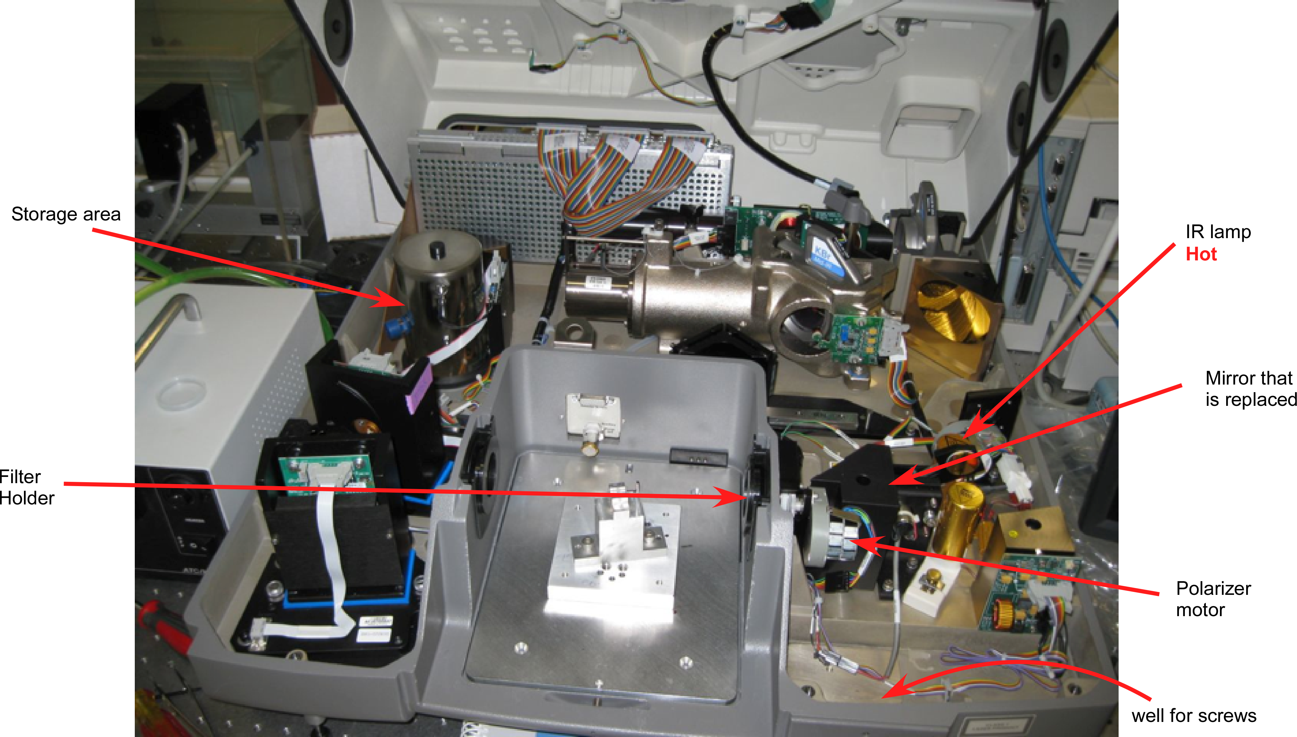
Figure 1. Nicolet FTIR spectrometer with top up and polarizer installed. On the right is the polarizer and the mirror that is replaced. At the top left is the storage area with the MCT detector.

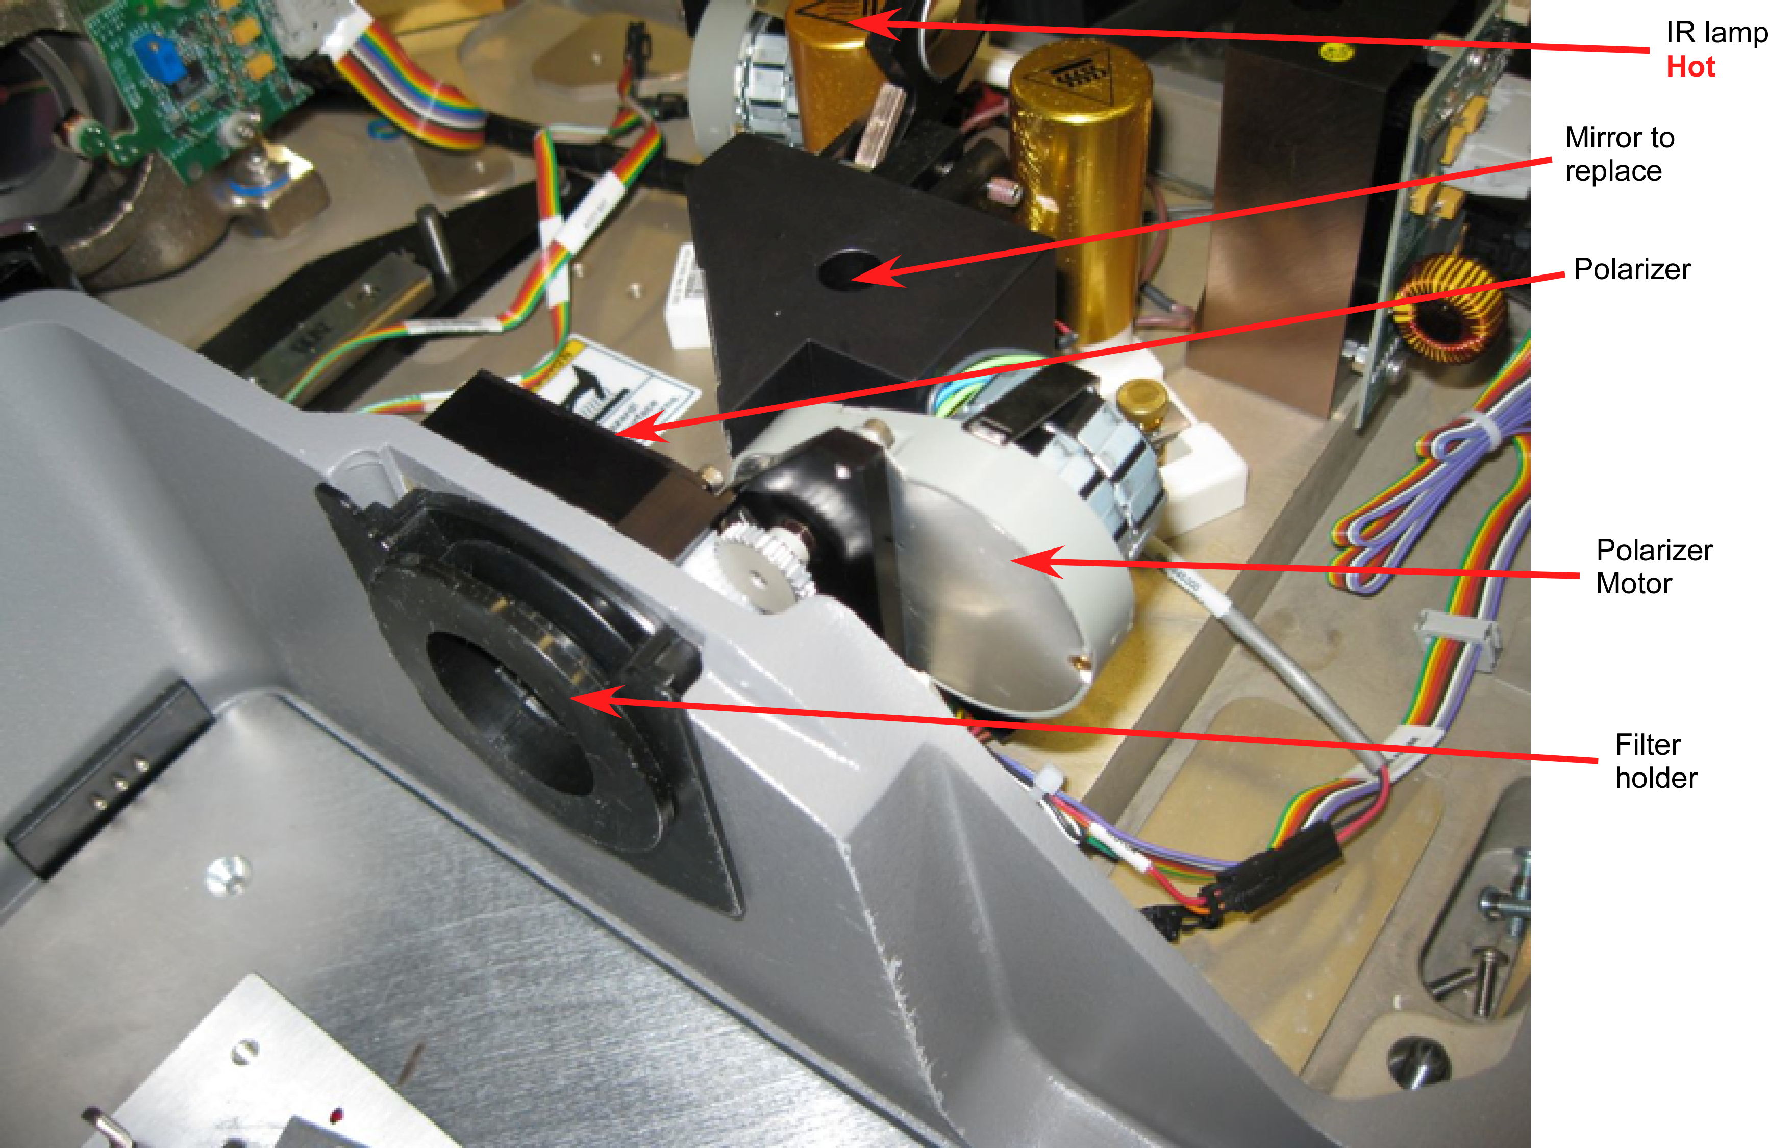
Figure 2. Bulkhead wall between sample compartment and spectrometer interior. The filter housing, polarizer and mirror are shown.
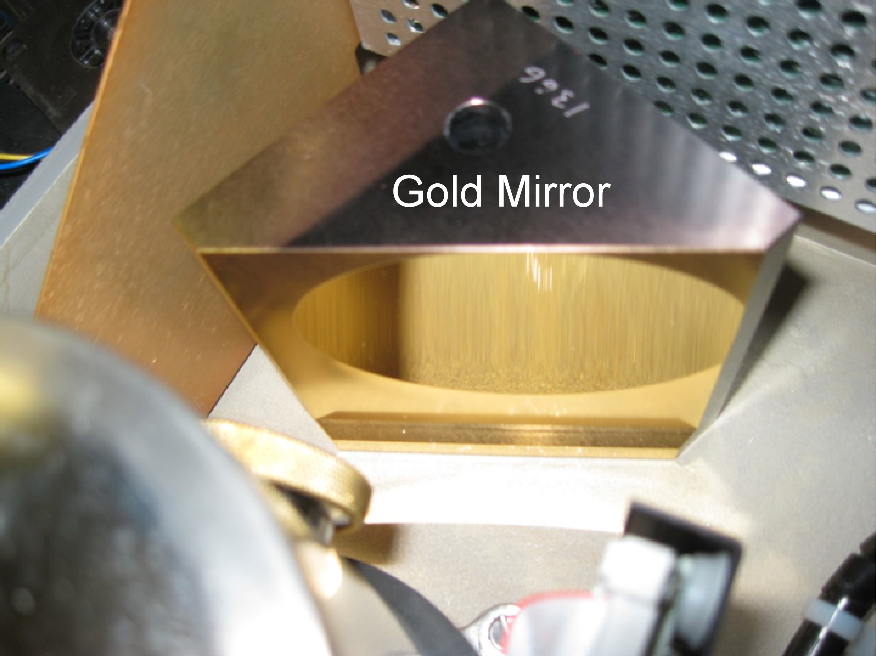
Figure 3. Gold surface mirror.

