ATR Accessory Performance Test

- Remove the accessory from the sample compartment. Click OK when OMNIC prompts that the accessory has been removed. OMNIC will load the default.exp experiment file.
- If there is a spectrum opened, click on the Window menu and select “New Window”
- Click on Collect menu and select “Experiment Setup”, and set the following parameters: Collect Tab
Number of Scans = 10 Resolution = 4
Final Format = % Transmittance
Select “Collect Background after” 0 “minutes”
- Click Ok to close the Experiment Setup window
- Collect a Background. When prompted, click “No” to not add to the window.
- Reinsert the smart accessory. When prompted by OMNIC that an accessory has been inserted, click Cancel. This will ensure that the experiment settings stay the same.
- Collect a Sample. When prompted select Yes to add the spectra to the current window.
- Select the Spectral Cursor tool in the lower left hand corner of the OMNIC window.

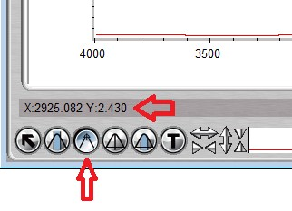
- Click on the spectrum window at 2000 cm-1. For Diamond crystals, click at 1000 cm-1
- In the lower left corner (just above the spectral cursor tool) you will see and X and Y value listed. The Y value is the % Transmittance at the currently select position of the spectrum (2000 cm-1). Compare this value to the listed specification for your Smart accessory and crystal type. If you do not know the listed specification, contact technical support.
- Remove and Reinsert the accessory and click Ok to reload the proper experiment file for the accessory.

Note:
- The factory communication (IR6118 Diamond ATR Smart iTR accessory) specifies the anticipated throughput of 30% at 1000 cm⁻¹ for a diamond crystal.
- Horizon ATR has 24% throughput at 2000 cm⁻¹.
- Seagull ATR has 30% throughput at 2000 cm⁻¹.
- Praying Mantis ATR has 60% throughput at 2000 cm⁻¹.
- If the % transmittance measured is very low or significantly less than the published throughput, there is a good indication that that the crystal is damaged.

