Using the Smart IRT diamond ATR.
- Installing the Smart ITR ATR
  - Remove any accessory in the Nicolet 6700.
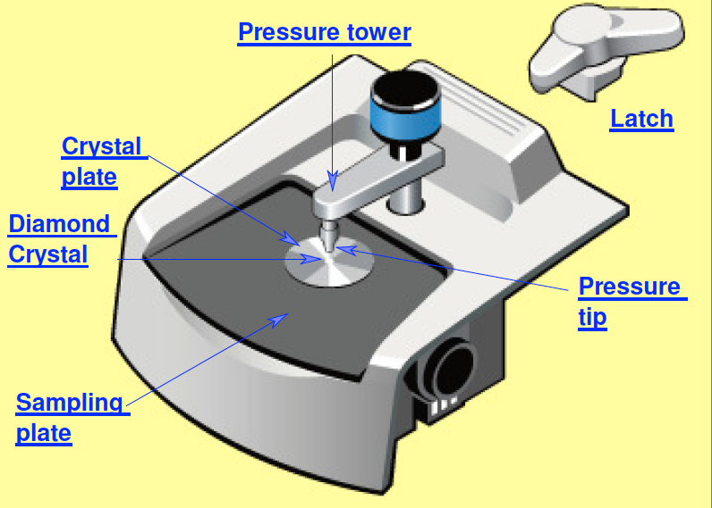
  - Remove the cover of the FTIR’s sample compartment using the thumbscrew at the center back of the cover.
Figure 1 Smart iRT diamond ATR
  - Remove the snap in baseplate.
  - Remove the “ears” or sidewall adaptors from both beam path holes, and place them in the bottom of the compartment, as shown in Figure 2.
  - Holding the ATR by the pressure handle and the front, lift the ATR up and lower it down into the sample compartment of the Nicolet.
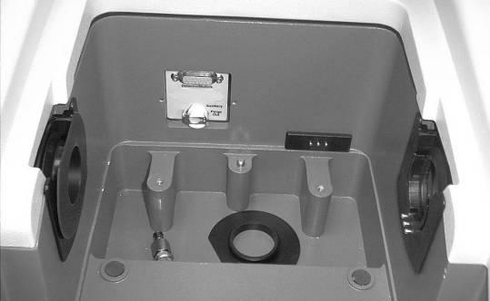
  - The rigid purge sleeves of the ATR need to align with the beam holes on the FTIR. When installed correctly, the accessory fits snugly in the instrument.
Figure 2: The accessory compartment with one ear inside and one ear not yet removed.
  - Screw in the lock-down clip into the hole where the lid’s knob was fastened.
  - Make sure the ATR plate and pressure foot are clean. If not you can clean them with a a Q-tip or optical lens cleaner damp with isopropanol or water. Do not rub the ATR crystal. You can lift the sampling plate and the crystal holder out of the accessory after rotating the pressure tower to get it out of the way. Solids can then be brushed off the diamond crystal. The crystal holder can come out of the sampling plate so make sure it does not fall out and break.
  - Check the flowmeter behind the FTIR to make sure that the purge is N₂ with a flow rate of 30 standard ft³/hr (scfh).
- Collecting the Background Reading
  - After you install the Smart Accessory, its name and the title of its associated experiment are displayed in a dialog box.
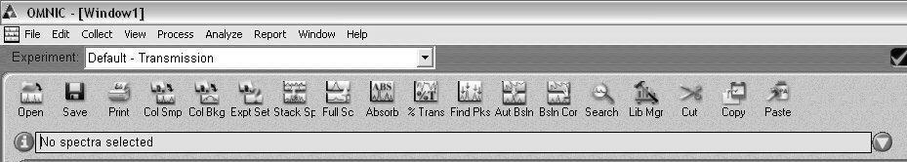
  - Open OMNIC on the computer by double-clicking the OMNIC desktop icon.
Figure 3: OMNIC Menu Bar.
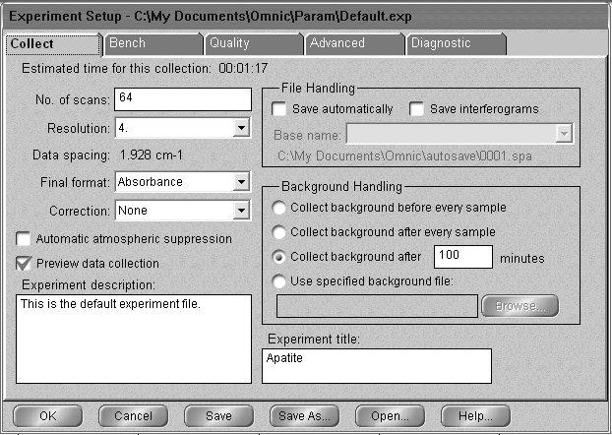
  - Click the menu bar icon “Expt Set” to enter the Experiment Setup window.
Figure 4: The Collect tab of the Experiment Setup window.
  - Under the Collect tab, Figure 4, set the number of scans to 64 or what ever you want and the final format to absorbance or Tramsmittant.
  - Enter a title for the experiment. Your window should be similar that shown in Figure 4.
  - Set the Background handling to either Collect background before every sample or after 100 minutes.
  - Under the Bench tab, set the accessory to ATR, Figure 5.
  - Click OK.
  - Make sure nothing is touching the diamond; click the menu bar icon “Col Bkg” to collect the background and click OK to indicate start to collect the background.
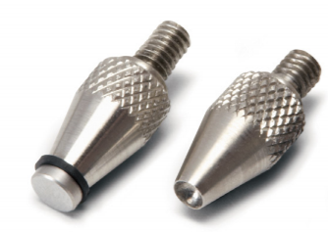
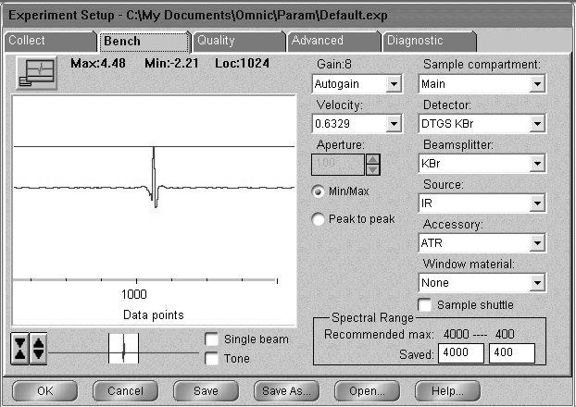
  - When the background looks stable (see Figure 6) – no major changes in peaks – click Start Collection in the top right corner of the window. An unstable background indicates that the instrument is not fully purged, so you need to wait a few minutes for purging to finish. See Figure 6
Figure 7: Pressure applicator tips.
Figure 5: The Bench tab of the Experiment Setup window.
  - Click No when prompted about adding the background to Window 1, unless you are troubleshooting the peaks of a spectrum already on hand.
- Placing the Sample in the ATR Accessory
  - Make sure that the pressure applicator’s tip is at its maximum distance above the crystal.
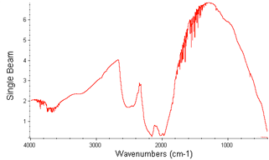
  - If your sample is a single solid piece, you can place it on the opening in the metal plate under the pressure foot.
Figure 6. Background spectra on Smart iTR diamond ATR.
  - If your sample is a powder:
    - The ATR is open beneath the crystal’s base. Take care not to drop sample or other items in the accessory while the base is absent.
    - Hard material must ground to a very fine powder in a mortar and pestle to use.
    - Do not allow a metal spatula to touch the diamond surface.
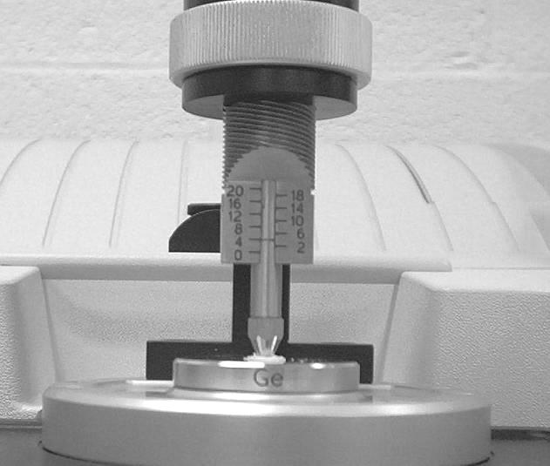
    - Use the pressure tip with a cavity (right one in Figure 7 above). The tips are stored under the sampling plate.
Figure 8: Application of pressure. As shown, the screw is turned to the left to increase pressure.
    - Add sample to the crystal’s surface, covering only the crystal with a thin layer. The beam reaches only two microns above the top of the crystal, so a thick layer of sample or sample on the metal base should be avoided.
  - If your sample is liquid: Put a drop on the crystal (do not use the pressure applicator).
- Collecting the Spectrum
  - Increase the pressure applied to the sample by turning the pressure control clockwise until you hear a click or two.
  - Click the menu bar icon reading “Col Smp” to begin collecting the sample.
  - At the prompt, enter the sample’s chemical name in front of the default title (the current date and time).
  - Click OK when prompted and click Start Coleection..
  - Click Yes when prompted Add to Window1? Unexpected peaks in the range of O-H or background and sample should be re-run with ample time allowed for the system to purge.
  - You may need to use the Kramers-Kronig transformation to get rid of derivative shaped peaks.
  - Save the spectrum by clicking the Save icon. If multiple spectra are open in a window, you will need to click on the desired spectrum before clicking Save.
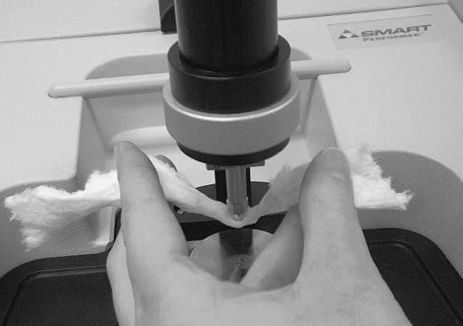
  - Click Set Filename to Title, and save the file to your directory.
Figure 9: Removing sample from the tip of the pressure applicator.
- Cleaning Up
  - Close OMNIC.
  - Turn the thumbscrew counterclockwise to lift the pressure applicator to its maximum height.
  - Clean the pressure foot, Figure 9. Use a small piece of lens tissue or a Q-tipwetted with water or ISP or a suitable solvent.
  - Clean the crystal:
  - You can remove the crystal, and tap its base gently to dislodge a powder sample.
NOTE: Do not rub the crystal, as that will scratch it. Only dab at the crystal with the tissue.
  - Replace the crystal and base plate.
- Remove the Smart iTR
  - Remove the Smart iTR by unscrewing the lock down thumb screw.
  - Lift the iTR straight up and out of the FTIR.
  - Place the iTR in its storage box.
  - Replace the sample compartment on the FTIR.

