EQCM Checklist
(9/01/2016)

- You need to have your own: QCM crystal, a reference and counter electrode. You ned the eQCM 10M and Ref 600 pstat. (The flow cell requires a special reference electrode that you need to buy).
Figure 1 QCM Crystal with connector.
- Plug in eQCM 10 M power cord
- Connect USB cables between the eQCM and the computer and the Gamry Reference 600 and computer.
- Switch on the eQCM 10M and the Gamry Reference 600
- Confirm that your eQCM 10M and Ref 600 are recognized
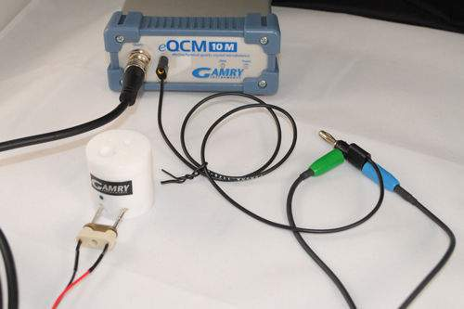
- Double click the Gamry resonator icon.
Figure 2 eQCM cell with electrical Connection to 10M
- Connect the eQCM crystal crystal to the special connector Fig 1.
- Assemble the eQCM cell with your crystal and connect to the 10M fig 2.
  - Make sure QCM crystal is centered in well and add solvent to the cell.
  - Connect the black wire to the electrode with the green dot.
- Find the resonant Frequencies
  - Enter a width frequency of 30,000 Hz.
  - Press single scan
  - If the amplitude is less then 1 or greater then 4.5 adjust to between 2 and 4.
  - If you do not see the S shaped spectrum increase your frequency window and press Single Scan.
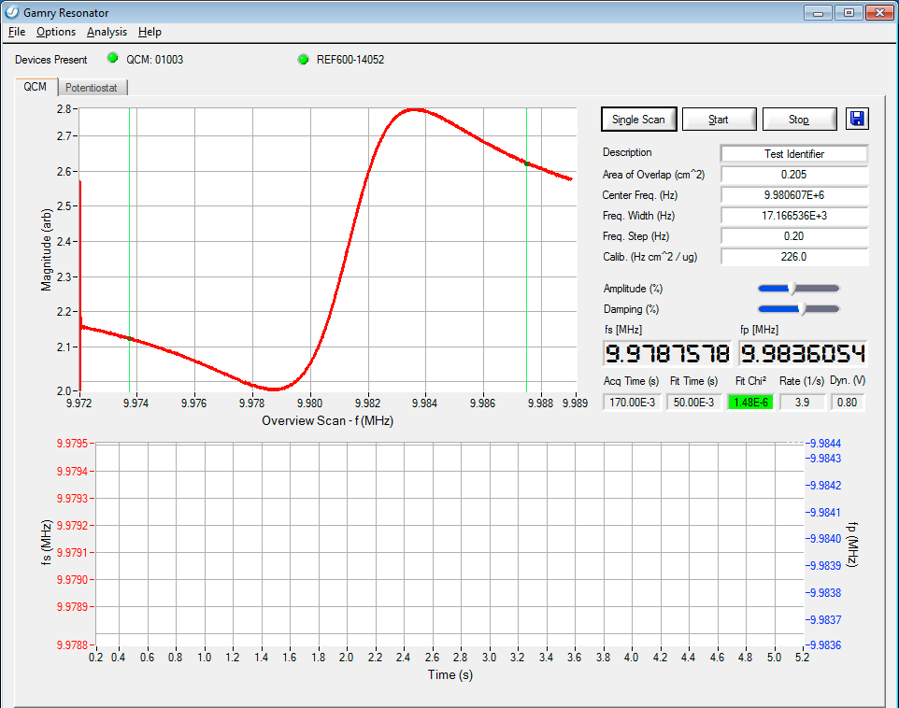
  - If the crystal is working in liquid
Figure 3 Resonator window
    - Isolate a region that contains both the low and high frequency peaks with the two green cursors Figure 3.
    - Set the Fequency width to 0.05
  - If the crystal is working in air
    - Isolate only the low frequency peak (negative going) with the green cursors.
    - Set the frequency step to 0.02.
    - Press single scan if the peak has a flat bottom increase the Amplitude slider.
  - Click Start and see if the frequency stabilizes.
  - If you have trouble look at the videos on the web page.
- Choose the potentiostat tab in the Resonator window and set up the parameters for your scan.
- QCM data acquired will be automatically saved if you are doing eQCM but for stand alone QCM experiment you need to save it manually.

