ImageJ with Drope Analysis Quick Start
- Start ImageJ program
- Load an image into ImageJ
- Use the angle tool to determine the tilt angle of the surface with the horizontal axis (the angle of the line with the horizontal axis is displayed below the toolbar) then use Image > Transform>Rotate to correct it (note positive angle rotate clockwise).
- Launch the plugin Drop Analysis Software (Drop Snake or LB-ADSA) to measure the contact angle of your droplet.
- For DropSnake:
  - Open the preferences menu by clicking the red heart ♥. Make sure the default preferences are chosen (see image at right).
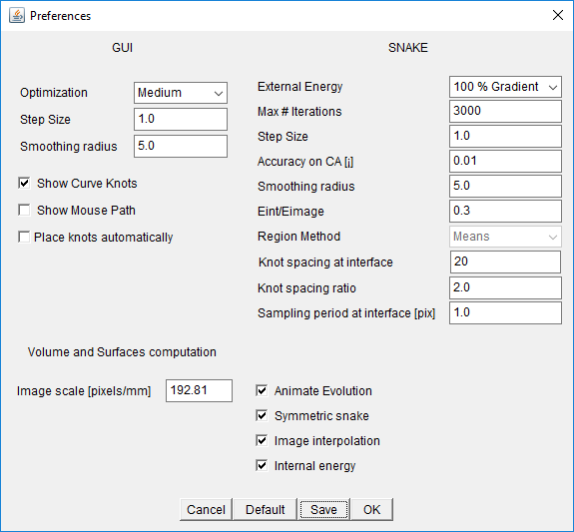
  - Choose Add/move knot mode, , to place “knots: on the drop contour (7-10 knots). Define the drop contour starting at the left interface point going along the drop contour until the right interface point. Place the last knot a little before the interface point and double click anywhere on the image to close the spline. Once the spline is finalized, the knots positions can be adjusted by drag and drop.
  - Make sure the two contact angles are both similar, if one is opposite the other adjust some points to get them similar.
  - First run the Fast Snake on this initialization spline to refine it
  - Move the cursor onto the picture window to see the red points that are the refined curve.
- If the red points of the fitted spline are a better fit to the curve, accept the curve by pressing on : The blue points will be replaced by the red ones.
- If the fitted spline is not good, either start again or adjust the blue knots positions and run the fast snake on this spline using:
- When the fast snake gives better points and you have accepted them use the full snake method to fit the blue curve by pressing the snake button:
- Contact angles are displayed in the image and in the table. Further information such as the surface of the meridional plane, the contour length of the meridional plane, the contact radius or the interface tilt angle are also available. The fitting or evolving of the curve can be done a number of times to make sure it is stable. In the preferences you and set the optimization to high and other parameters to try and improve the fit.
- If you want to fit another picture you must press the Quit DropSnake button, , (second to last button on right of button bar, has a microscope and a red left arrow) before you load another figure.
- Another way of initialization is to enable ”Place knots automatically” in the setting menu, and to create a new curve. In this mode, the user must click at the position of the first knot (left contact point) and then smoothly follow the drop contour until the last knot (right contact point). A double click defines the position of the last knot. You must not have points that are far off the surface of the drop or it will not work. This method is harder to use than the placing on individual points and it takes some skill to make it work well.
- Contact angle is still a tricky parameter to measure and several parameters such as dimensional parameters may influence its measure. Care should be taken when modifying parameters from the setting men.
- On the example drop if you use the automatically place points vs the hand placed points you find that the contact angle differs by about 10º!
- After analyzing one picture if you want to load a new picture you must push the Quit DropSnake button before loading the new picture.
- For help see drop analysis users guide.
Preferences panel:
  - External energy: Define the ratio of region energy and gradient energy. Region energy may have better converging properties, but gradient energy should be used to provide accurate detection.
  - Max iterations: Maximum number of iterations when evolving the snake. If reached an error message is displayed
  - Step size: Step size in the evolving process. If curve is oscillating, this should be reduced. If knot displacement is too small, this should be increased.
  - Accuracy on CA: Contact angle convergence criterium. The evolving process is terminated when change in the contact angle is within this range. Recommended: 0.01
  - Smoothing radius : Smoothing preprocessing realized on the image before the evolving procedure.
  - Eint/Eimage: Ratio of internal energy and image energy. Internal energy is responsible for the elastic component of the snake. Image energy allows the snake to stick on the image. Typical value [0.2 ... 0.5], Recommended: 0.3
  - Region method: Specify the statistical region method used. Means is recommended
  - Knot spacing at interface: Define the ideal distance between two knots at the interface. Typical value [10 ... 40], Recommended: 20. Note this can significantly affect the angle found.
  - Knot spacing ratio: Define the inter-knot distance ratio between knots at the interface and knots at the apex of the curve. This parameter allows to place more knots at the interface than on the rest of the drop. Typical value [1.0 ... 3.0], Recommended: 1.0
  - Sampling period at interface: Define the sampling period for the minimum knot distance. Best results should be obtained with a distance of 1 pixel. Increasing this value will allow an increase in speed but a loss in accuracy.
  - Animate evolution: Display knots during evolution. Faster when not displayed.
  - Symmetric snake: If set, the drop is defined with a symmetry between the first and last knot. The first and last knot are then evolved correspondingly. If not set, the first and last knots will be evolved horizontally only.
  - Image interpolation: When set, cubic spline image interpolation will be used. Important for accuracy.
  - Internal energy: Enable or disable internal energy. Internal energy is responsible for the elastic property of the snake.

