Agilent 8453 UV-vis Spectrometer

# Introduction

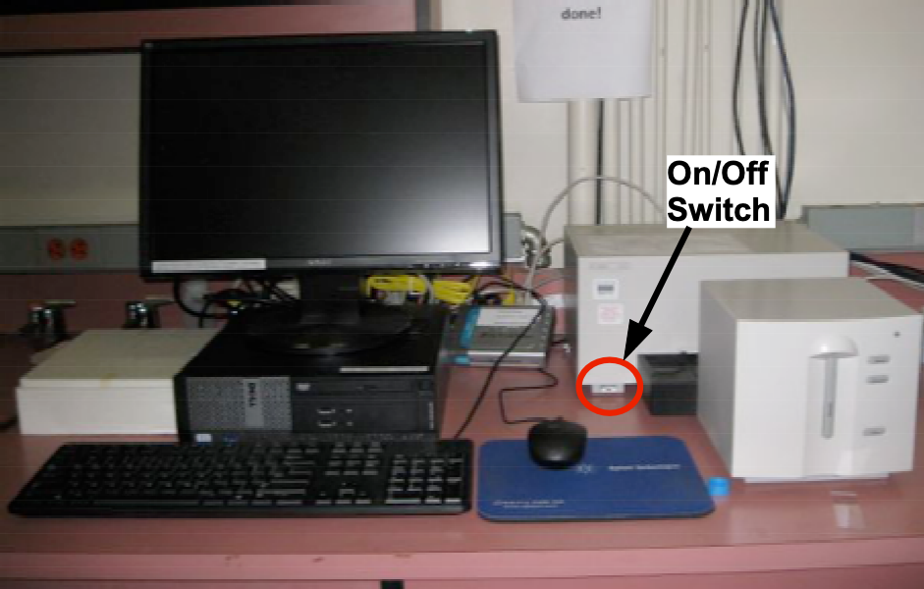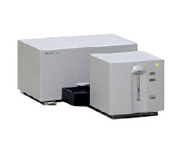The Agilent 8453 UV-Vis instrument is a simple but powerful diode-array spectrophotometer capable of quickly acquiring data in the spectral range from 190 to 1100 nanometers.

## Agilent 8453 UV-Vis Spectrophotometer

# Instrument Startup

1. Turn on the PC and monitor.
2. Login as Agilent 8453 with password bi019.
3. Turn on the instrument. The switch is at the lower left corner.

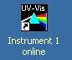

1. Wait until the spectrometer has made some clicking noises.
2. Double-click on the UV-Vis program icon to start the program.
3. A program login box will appear. We do not use this feature of the software. **Simply press “cancel” or “ok”.**

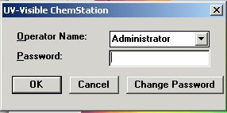

1. 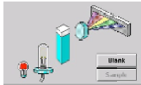The software should now open in the standard view with the visible lamp lit.

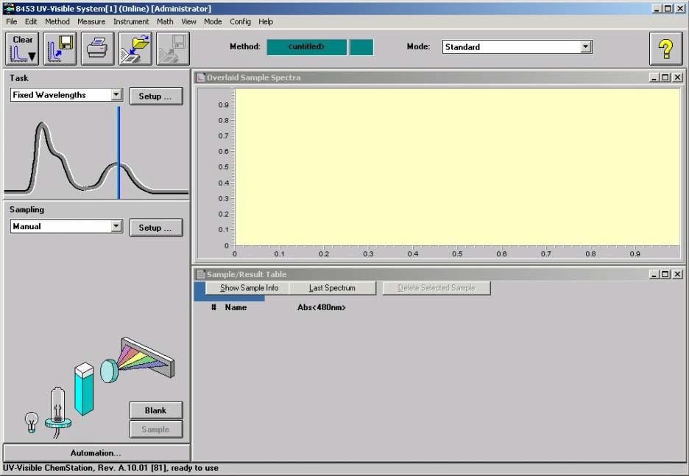

1. If you need to take a spectra below about 400 nm click on the UV lamp icon to turn it on. The lamp takes a few seconds to light. You should allow the lamps to stabilize for about 15–20 minutes. If the exact absorbance is not important you can begin measurements immediately.
2. For wavelengths below 350nm both lamps are needed.
3. For the visible region there are sample cuvettes in the cabinet above the instrument. If you need UV/quartz cuvettes you need to purchase your own.

# Acquiring Data

1. You should first run a spectrum of you sample cuvette to make sure it is clean.
2. With nothing in the sample holder select “Blank” from the source window.

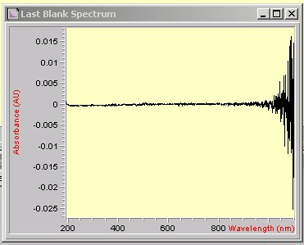

Figure . Blank Spectrum

1. The resulting air blank should be a straight line with the noise below ±0.002 Au. The noise will be higher in the region above 1000 nm.
2. After running an instrument blank, the previously grayed out “Sample” icon will now be accessible. Now put your solvent in your cuvette and run a spectra by selecting “Sample”.
3. Again, you line should be mostly flat but not at 0. If the absorbance anywhere goes about 0.5 AU above the flat section the cuvette or solvent is either not clean or is not suitable for the region of the spectra you are looking at. (Note in the UV you must use a quartz cuvette.)

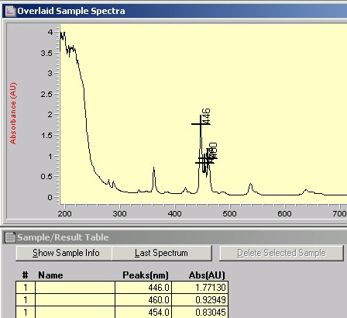

Figure . Typical Sample Spectrum

1. If you are going to use two cuvettes one for your solvent blank and one for your sample:
   1. You should run a blank with solvent in the blank cuvette.
   2. Then a spectra with solvent in the sample cuvette.
   3. If the Absorbance is not zero and flat the cuvettes are dirty or not matched.
2. To take a spectra of your sample:
   1. With your solvent in a cuvette in the sample holder, select “Blank” from the source pane.
   2. Place your sample in the cuvette and select “Sample”. Your spectra should appear on the screen.

# Processing Data

1. If you are going to save your data, you need to create a folder in the data directory with your name from the windows explorer level (not from within the program).
2. Data is not saved automatically.

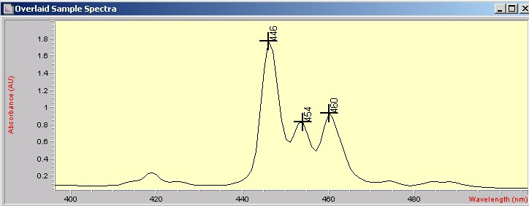

1. Each successive “Sample” measurement is overlaid in the “Overlaid Sample Spectra” view and added to the Results Table.
2. You can manipulate the current data; including zooming in, annotating more or fewer peaks, and printing results, but when you exit the program your data will not be automatically saved.
3. A spectral region may be selected by dragging a box around the area of interest.
4. Use ***View -> Reset Current View*** to return to the full spectral display.
5. When additional spectra are acquired, they will be overlaid in the spectra window.
6. To delete a spectrum from the view, select it by clicking on the appropriate trace in the Sample Spectra view. Diamond-shaped points will appear on the selected trace, and a “Delete Selected Sample” button option will appear below the Sample Spectra view. The selected trace may now be deleted.

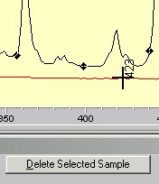

1. To save data files, click on the **Spectrum to Disk** icon located in the tool bar. Alternatively, select ***File -> Save -> Samples As*** from the File pull down menu. Only store your files in the data directory under a directory of your name.
2. If you want to export the data save it as a CSV (comma separated values). These files can be easily read by MATLAB or Excel. The data is in three columns, the wavelength in nm, the Absorbance (or Transmittance), and a noise or error estimate. Usually the last column is ignored.
3. If the Absorbance is > 1.3 or the Transmittance is <0.05 the data is likely to be unreliable and you should dilute your solution.

# Finishing Up

1. Exit the ChemStation software.
2. Turn off the instrument power unless you plan to return the same day.
3. Shutdown the computer and turn off the monitor.