HP 8452 UV-vis Spectrometer

Introduction
The HP 8452 UV-Vis instrument is a simple diode-array spectrophotometer capable of quickly acquiring data in the spectral range from 190 to 820 nanometers.
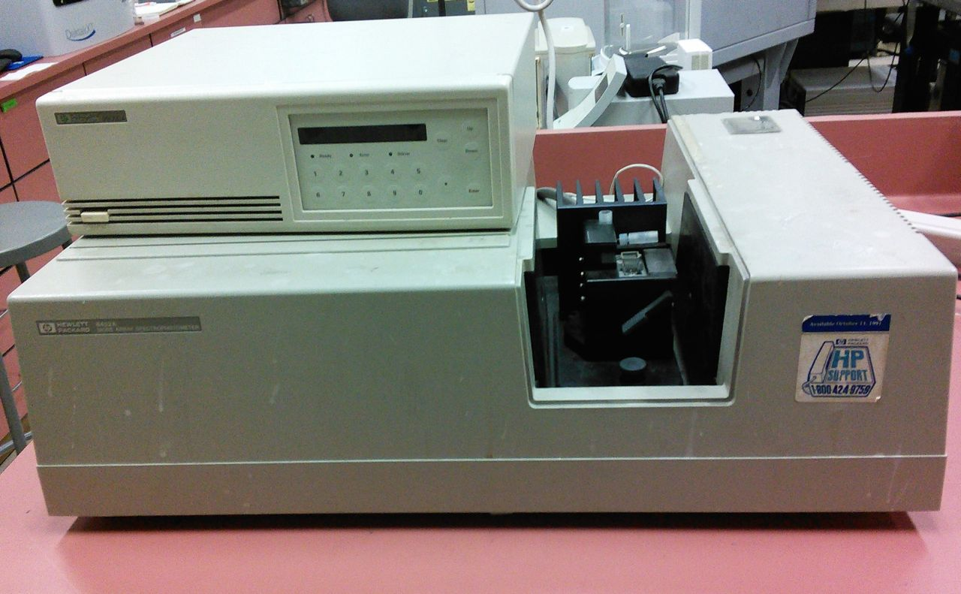
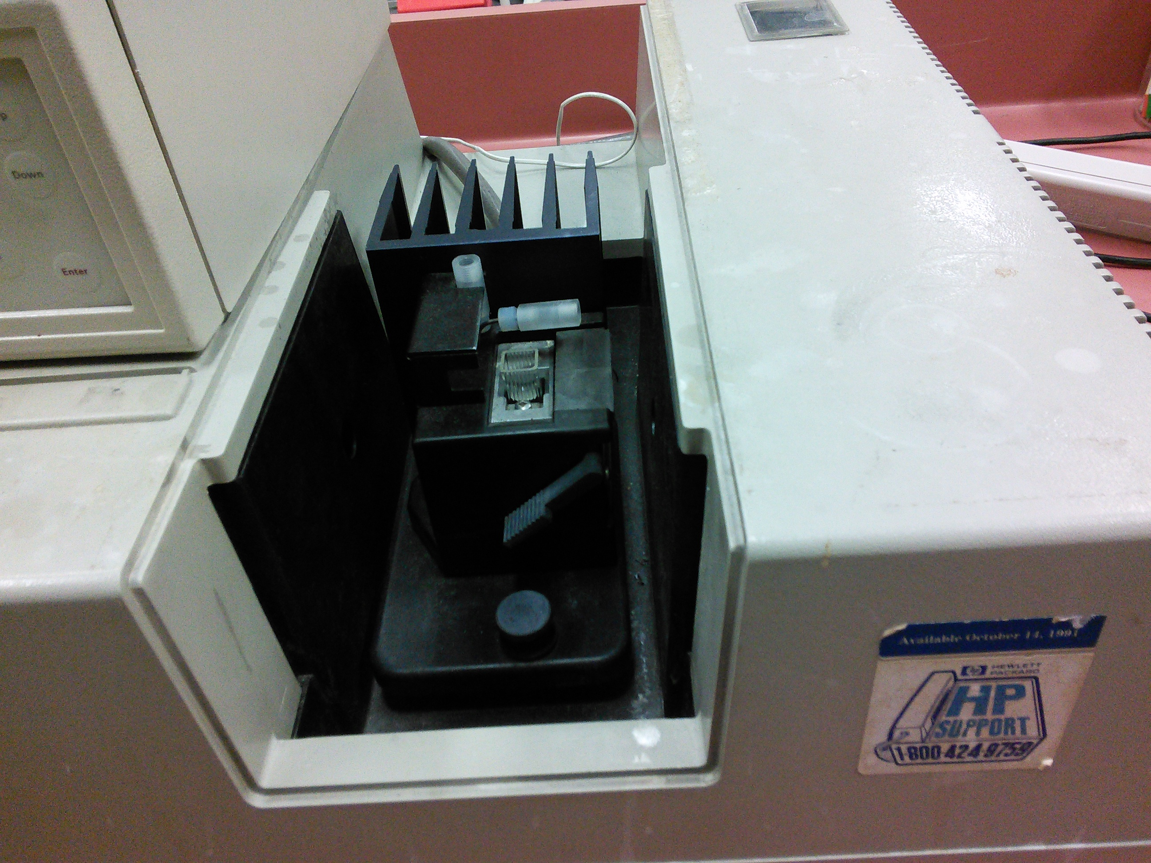
Figure 1 HP8452 UV-vis Spectrophotometer

Instrument Startup
- Turn on the PC (this is a laptop).
- Login as HP8452 with password SolarFun.
- Turn on the instrument, the switch is on the back left corner.
- Wait until the spectrometer has started to make some clicking noises.
- If you want temperature control turn on the temperature control unit on top of the spectrometer
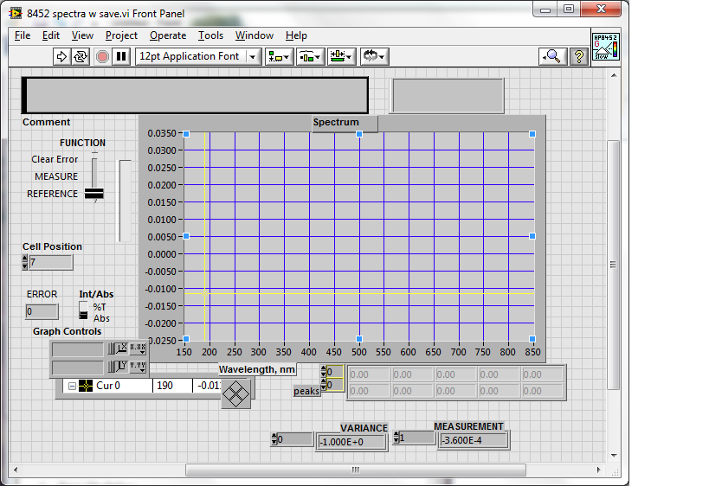
- There are two LabView programs that control the spectrometer, Spectra with Save or Med kinetics on the desktop. The first takes and saves single spectra and the second takes data at evenly spaced time points, i.e. kinetic data.
Figure 2 Program "Spectra with save"
- The Spectra with save front panel should look like the figure at right.
- There is only a D₂ lamp that is used and when it gets old the UV region of the spectrum will become very noise.

Acquiring a Spectra
- With solvent in the cuvette, place it in the sample holder in the spectrometer, select “Reference” and hit the run arrow on the menu bar ()on the front pane.
- If the lamps have been allowed to stabilize, the resulting “instrument blank” spectrum should be "straight", with the noise level below +/- 0.002 AU in the range from 350 nm to 800 nm. The noise will be higher in the region below 350 nm.
- Place your sample in the cuvette and select “Measure” and press the run arrow on the menu bar. The measurement will only take a few seconds.
Title1=['This is a comment line'];
Date1=['3/31/2014; 11:30:10 AM'];
header=['Wavelength ,nm; Absorbance; Variance'];
Data=[
1.90000E+2 1.65700E-2 -1.00000E+0
1.92000E+2 -2.56800E-2 -1.00000E+0
1.94000E+2 2.80300E-2 -1.00000E+0
1.96000E+2 -7.90000E-4 -1.00000E+0
1.98000E+2 3.86000E-3 -1.00000E+0
Figure 5 View of a kinetic data file
- It will ask you where you want to save the spectrum on the disk. If you want to read the ASCII text file that it writes using Matlab you must give it an extension of ".m".
- The data is always written as a text file so you can open it with a normal editor to see what it looks like. A few lines are shown in the text box at right.

Acquiring Kinetic Data
- Open the kinetics LabView program on the desktop. It should give you the window shown below.
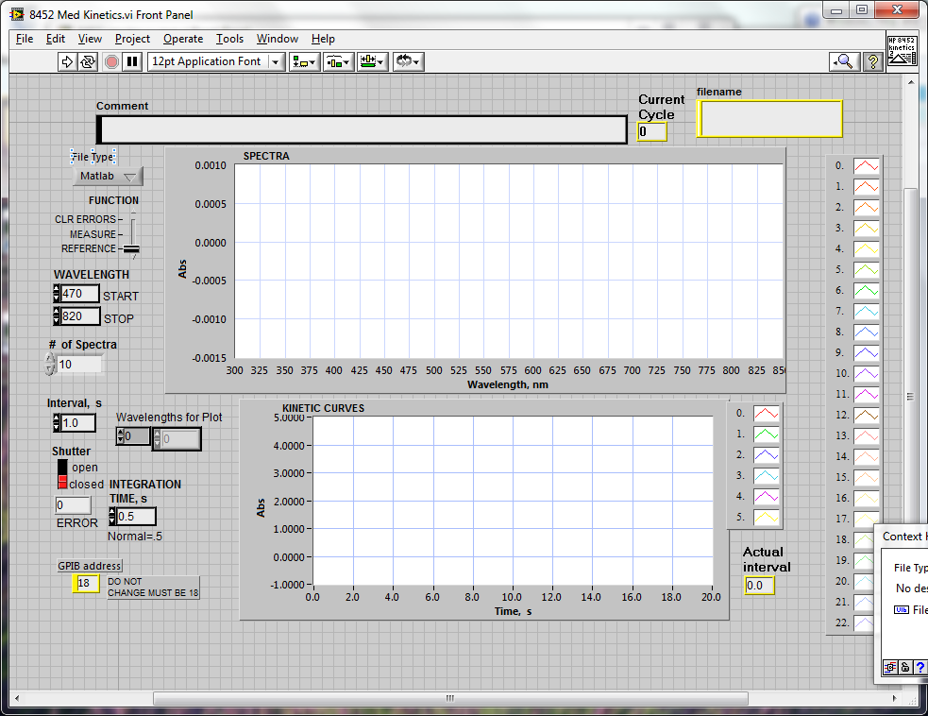
- The default time per spectra is about 1 s. If you want to collect data slower then this you can just set the interval time to any value you want in the program and set the number of spectra you want to take.
Figure 3 Program "8452 Med Kinetics"
- If you would like to see a time trace for a number of wavelengths put the wavelengths desired in the "Wavelengths for Plot" box.
- Put your solvent blank in the spectrometer and set the slider to the "Reference" position and click the run arrow in the menu bar.
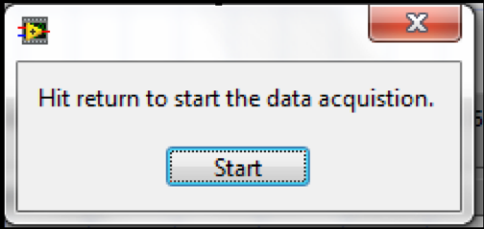
- Now move the slider to Measure and click the run arrow. You should get a screen that asks for a place to save the file (remember to use an extension of ".m" if you want to read the data with Matlab). Now a start window will now appear.
Figure 4 Start Button
- Mix your reagents in the curvet and place it in the spectrometer and click start.
- The spectrometer will then take all the spectra and save them.
- You can abort the run by hitting the stop sign in the menu bar.
- The data will be saved in a text and will look like the file show below.

Processing Data using Matlab
- Start Matlab on the computer.
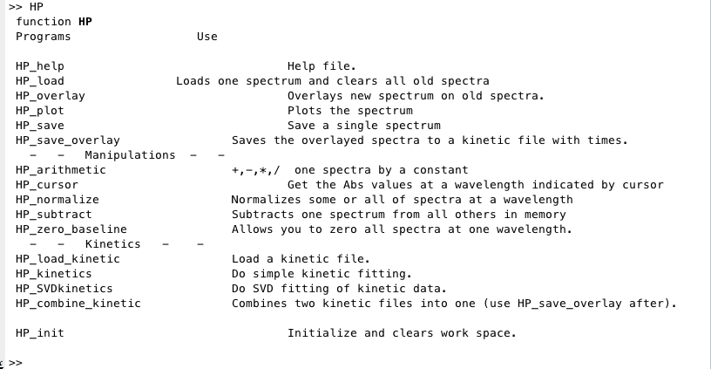
- The Matlab command window should look like Figure 6 below. It is the help window for the HP analysis programs. It is obtained by typing "HP." All the commands shown can be executed by typing the command in the command window.
Figure 6 Matlab HP help window
- Load Spectra: To use any of the analysis commands you first need to load the data. Load single spectra with "HP_load" or a kinetic data file by "HP_load_kinetic".
- The program can analyze kinetic data with either first or second order fits. To analyze kinetic data type HP_kinetics.

Finishing Up
- Exit the LabView programs and quit LabView.
- Quit the Matlab program..
- Turn off the HP8452 spectrometer and the temperature controller.
- Shutdown the computer and put it away.

