How to use the Ion Gun
Ion Gun Setup
- Load sample into SAC. Focus on your sample using the mono Al X-Ray gun. Make sure to turn off the X-ray gun. Ensure that the system is in a rest state with no data collection, filaments, or heating stages running before proceeding.
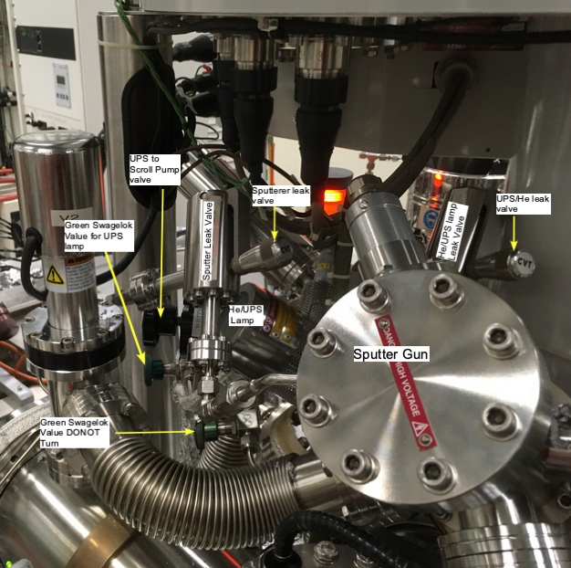
- In the Vacuum panel in the Instrument Manual Control window, select the “Automatic Sequences” radio button. Click on “Ion Gun Gas On” and wait for the sequence to finish.
Figure 1 Suptter Gun with leak valve
- At this point, the STC and SAC are connected, and no one should open any valves until the process is complete. Do not allow anyone to open or close any valves until you are finished.
- Slowly open, turn ccw, the Ar(g) leak valve (connected to the sputter gun) until the pressure is ~2 x 10⁻⁶ Torr in the STC. This will usually require about 1.75 rotations counterclockwise. After turning the valve 1.5 rotations watch the pressure carefully and turn the valve very slowly, Figure 1.
- Open the Ion Gun tab in the Manual Control window. Check the “Settings,” “Table,” and “Status” tabs.
- Select which beam energy you wish to use (4 kV, 3 kV, 2 kV, or 0.5 kV) from the table and click “Restore Row.” NEVER click “Update Row” because it will erase the settings in the selected row.
- Press the “On” button and wait until it turns green. Watch the Extractor current (µA) under Status and wait until it reaches 175 µA. Once the Emission Current (mA) reaches >30 mA, the sputtering process has started.
Turning off the Ion Gun
- If the Ion Gun is on, press the “Off” button in the Ion Gun tab and wait until it turns green.
- Close the Ar(g) leak valve on the ion gun. The pressures in the STC and SAC return to the original values within several minutes.
- In the Vacuum panel in the Instrument Manual Control window, select the “Automatic Sequences” radio button and press “Ion Gun Gas Off.” Wait for the sequence to complete. It will take some time to pump out the Ar line before finishing.

