**Kratos UHV System Sample Loading and Unloading**

Jan 2020

**Preliminary**

* Rinse and dry samples and stubs with low residue solvent (methanol, isopropanol (IPA), trichloroethylene, etc.) before loading into chamber. If you use any solvents other than IPA rinse with IPA after the other solvents. The use of the ultrasonic cleaner is recommended. Also you can dry samples in the oven.
* Be sure samples are **clean** and **dry,** no volatiles– do not use the XPS chambers to dry your samples.
* If you are unsure about your samples, discuss with a GLA.
* The Edwards turbo controller for the load lock (LL) is located on the floor below the LL.

**Sample Holders**

* *Pucks*: a few small samples may be affixed to the pucks via the short screws! Screws must not show below stub lip!!!
* *Bars with screws*: This bar allows for the loading of several samples affixed very well by screws.
* *Spring loaded bar*: The spring loaded bar allows for the loading of up to 4 samples with constant height. This bar is particularly good for angle resolved measurements.
* *Pots*: these are good for powder or nanoparticle samples. There is one special pot with a variable depth. The depth is controlled by a screw in rod. This holder is good for bringing different volumes of powder or nanoparticle samples to surface level.

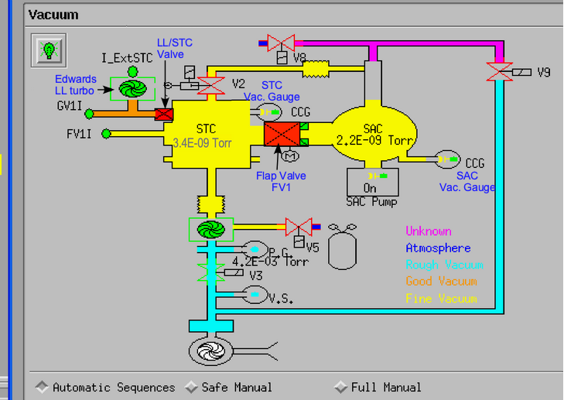

* *TPD stages*: These are assembled by the user prior to use and are specific for using the resistive heating stage in the SAC for doing TPD measurements.

**Loading Samples into the Load Lock (LL)**

1. Affixed your clean and dry sample to a sample holder.
2. Verify the LL/STC valve is closed, system is normal, and the pressure in the STC <10-8 Torr and SAC < 10-9 Torr. If this is not the case, discuss with the previous user and a GLA. Ensure there is enough space on the STC magazine for your sample holder. If necessary, remove a sample from the chamber before proceeding.
3. Vent the LL:
   1. The Edwards turbo controller (cart below LL) should display the LL pressure. If it is not, press the menu button ( ) until the pressure is displayed.
   2. Highlight ‘Turbo ON Back ON’ and push enter ()This brings you to the ‘System Control’ menu.
   3. Highlight ‘System ON’ and press enter again to turn off the pump. Unlock the clamps holding the LL closed.
4. Wait ~90 s for the chamber to vent then open by pulling back gently on the LL cylinder. If it does not open easily wait longer. It should be fully vented by the time the pump status bar runs down.
5. Load Sample: The transfer claws have tiny pins that hold samples in place when moving the arm. Take care not to damage the pins. Load pucks and bars on the claw using the top groove on the puck. The bars should be loaded on the claw on the one-cylinder side (in the top groove).
6. Check that the O-ring is fitted nicely in the groove on the LL cylinder (left or LL arm side), and close the LL by sliding the cylinder shut. Reclamp the cylinder using the right clamp first.
7. Be sure the turbo has spun down. On the Edwards turbo controll with ‘System OFF’ highlighted, push enter to start the turbo. Return to the pressure screen by pressing the menu button. Wait until pressure on turbo status window reads in the 10-6 Torr pressure range. If the turbo fails to spin up after the 1 minute delay or you can hear the hiss of a leak, put horizontal pressure on the LL arm (and restart the turbo as necessary) until ~5×10-4 Torr to ensure the LL seals properly.

**Loading Samples into the STC**

1. Verify the LL arm is fully retracted, the green light is lit in the sensor at the end of the arm, and the pressure in the LL <5×10-6, STC <10-8 Torr, and SAC < 3×10-9 Torr..
2. Verify the LL/STC gate valve and manual angle valve and STC/SAC Flap valve are all closed.
3. In the “Vacuum panel” of the “Instrument Manual Contol” window, verify the “Safe Manual” radio button is selected, Figure 1.
4. Click on the small red rectangle, which represents the LL/STC valve, to bring up a green light bulb button. Click on the button and verify that the LL/STC valve opens.
5. Carefully move the LL transfer arm into the STC by turning the rotary drive on top of the LL. Do not turn the rotary drive too quickly and do not apply force to the drive. Align the magazine by turning the magazine’s rotary drive under the STC (near lamp controller). Place sample on the magazine, then move the magazine northward toward the back wall (away from you) to move the sample holder off the LL transfer arm hook. The magazine drive has stops along its range where the magazine will not move with every rotation. Do not confuse this with rotating against the arm.
6. Fully retract the LL transfer arm. Watch the arm move through the window on the LL. Once the claw portion of the arm disappears in the window, it is less than a full turn until the arm is fully retracted. Watch for the sensor on the end of the arm to turn green. Be careful not to jam the arm.
7. Close the LL/STC valve by clicking on the valve in the software and selecting the green light bulb that appears.

**Loading Samples into the SAC**

1. Verify that the pressure in the STC <10-8 Torr and in the SAC < 10-9 Torr.
2. Verify the STC/SAC arm is fully retracted and the green light is lit in the sensor at the end of the arm.
3. In the “Vacuum panel” of the “Instrument Manual Contol” window, Figure 1, verify the “Safe Manual” radio button is selected.
4. Click on the large red rectangle, which represents the STC/SAC Flap valve, to bring up a green light bulb button. Click on the button and verify that the STC/SAC Flap valve opens. This will take 10 – 15 seconds.
5. The stage can be adjusted using the buttons in the “Stage” panel of the “Instrument Manual Control” window or using the “Autostage Manual Control” device. The top sample rotation section is not used with the sample holders we currently have. Pressing the button in the desired direction and then pressing the opposite direction allows for faster motion of the stage.
6. Set the stage in the sample load position. To do this, load the position table /C=/stage positions/Stub_bar_load_unload.dset in the “Stage” section of the “Instrument Manual Control” window. Then, select the “Stub Load” or “Bar Load” position and click “Go to.” Wait until the stage stops moving.
7. Load the desired sample from the magazine onto the STC/SAC arm. Move the magazine north toward the back wall to hook the sample holder on the arm. Then align the magazine such that the arm can move through the center or past the right end of the magazine (when looking towards the SAC).
8. Move the STC/SAC arm into the SAC and load the sample holder onto the stage. The stage can hold up to two pucks or one bar.
9. For bars, it will be necessary to drive the stage to the right in order to view the location where the bar is held onto the STC/SAC arm if you aligned the stage by hand or from the “Stub Load” position.
10. Manually move the stage south towards the door (“LEFT” on the “Autostage Manual Control” device) to unhook the puck from the transfer arm claw. The STC/SAC arm can be gently wiggled to prevent it from sticking.
11. Withdraw the arm fully into the STC and close the STC/SAC Flap valve by clicking on the valve in the software and selecting the green light bulb that appears.

**Unloading Samples**

1. Verify the system is normal and all data collection or processes have finished. The “Safe Manual” radio button should be selected in the “Vacuum” panel in the “Instrument Manual Control” window.
2. Open the STC/SAC valve by clicking on the large red rectange and selecting the green light bulb that appears. Wait 10–15 seconds for the valve to open.
3. Set the stage in the sample unload position. To do this, load the position table /C=/stage positions/Stub_bar_load_unload.dset in the “Stage” panel of the “Instrument Manual Control” window. Then, select the “Stub Unload” or “Bar Unload” position and click “Go to.” Wait until the stage stops moving. If unloading a bar, drive the stage to the right until the end of the bar is visible in the window from the “Stub Unload” position.
4. Move the STC/SAC arm into the SAC, taking care to avoid the magazine. Slowly move the arm past the sample holder until the claw is lined up with the sample holder or bar unloading groove.
5. Manually move the stage toward the back of the room using the “Autostage Manual Control” device. The arm can be gently wiggled to allow for easier loading.
6. Move the sample into the STC and place the sample on the magazine and move the magazine south toward the door (“RIGHT” on the “Autostage Manual Control”) to unhook the puck/bar from the arm.
7. Fully withdraw the STC/SAC arm and close the STC/SAC valve by clicking on the valve in the software and selecting the green light bulb that appears.
8. Verify that the LL pressure is in the 10-6 Torr range.
9. Open the LL/STC gate valve by clicking on the small red rectangle in the “Vacuum” panel of the “Instrument Manual Control” window and selecting the green light bulb that appears.
10. Move the LL arm into the STC by rotating the rotary drive above the LL clockwise slowly and carefully.
11. Hook the sample holder onto the LL/STC arm by moving the magazine south toward the door.
12. Withdraw the LL/STC arm by turning the rotary drive counterclockwise carefully and slowly. Watch the arm move through the window on the LL. Once the claw portion of the arm disappears in the window, it is less than a full turn until the arm is fully retracted. Watch for the sensor on the end of the arm to turn green. Be careful not to jam the arm.
13. Close the LL/STC valve by clicking on the valve in the “Vacuum” panel of the “Instrument Manual Control” window and selecting the green light bulb that appears.
14. Vent the LL as described above. Once vented, remove the sample and pump the LL back down as described above.

**Loading Samples – Portable Sample Transfer Suitcase, PTS**

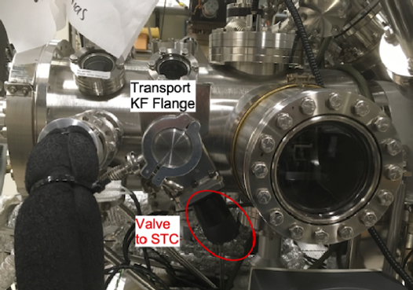

Figure 2 STC showing KF Flange for PTS attachment and Valve to STC

The portable sample transfer suitcase is designed to allow transfer of samples from inert atmosphere directly into UHV without exposure to air. It is only compatible with sample pucks or pots. The suitcase arm loads onto the quickflange port on the south side of the STC facing the door, Figure 2. It is mounted with the gate valve oriented vertical up, so the valve actuator mechanism is at 12 o’clock.

1. You need to mount your sample on a puck in an inert atmosphere.
2. Place the PTS into the inert atmosphere box.
3. Open the PTS’s gate valve and with the valve actuator oriented at 12 o’clock, move the claw out of the arm so it can be accessed.
4. Load the puck on the arm’s claw using the bottom groove on the puck, Figure 3, such that the sample faces up with the gate valve actuator mechanism at 12 o’clock. Be careful not to damage the pin at the end of the claw that holds the puck in place. Ensure the sample is secure, since the puck will be vertical during sample transport.
5. Fully retract the claw back into the PTS, lock the magnet, and close the gate valve.
6. Hold the suitcase arm such that the VAT label on the valve is oriented up while transferring the arm to the Kratos. In this orientation, the sample is vertical, but the claw holds the puck from beneath. Holding it the wrong way may cause the sample to fall out during transport. Use the screw on the end of the arm to lock the magnet in place during the transfer.

Figure 3 Puck mounted on portable transport arm claw.

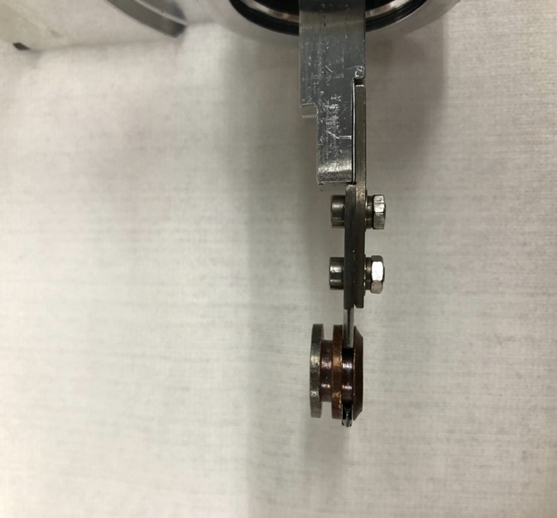

1. At the Kratos, check that the pressure in the STC is < 10-8 Torr and the LL Turbo is running. If not start it up and wait till the LL is at < 10‑7 Torr.
2. Check that the valve to the STC is closed by turning the valve clockwise (the one attached to the KF Flange that faces down), Figure 2. TAKE CARE: there are no interlocks on the valves for the PTS. You can vent the STC by mistake!!! If the valve to the STC is open, close it, and call a GLA.
3. Vent the LL as described above.
4. If the valve to the Transport is closed, open it, Figure 4. This valve should be left open all the times to prevent forming pressure differentials that can damage the pump or compromise the atmosphere of the STC if valves are inappropriately handled.
5. Attaching the PTS to the Transport KF Flange, Figure 2:
   1. Remove the KF caps from transport KF Flange and the PTS.
   2. Attach the PTS to the STC, such that that the valve actuator is at 12 o’clock.
   3. Fasten the arm with the KF clamp with the bolt/screw facing down, Figure 2.
6. Restart the LL turbo pump and check that the “V to transport” valve is open, Figure 4, so the space between the PTS and the STC gets pumped down.

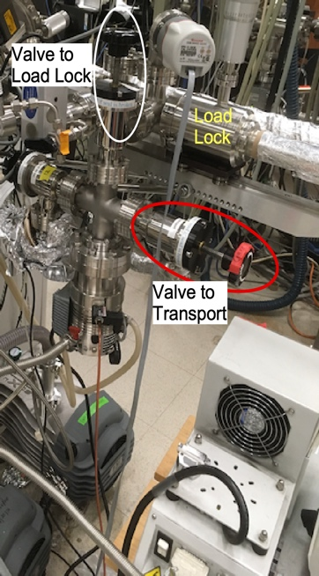

Figure 4 Valve to Transport and Valve to Load Lock from Turbo pump

1. *Put a sign on the LL turbo that the transport arm is attached and the operation of the LL turbo should not be changed*.
2. Keep the valve on PTS **closed** and wait until the turbo pump reaches full speed and the pressure is <10-4 Torr

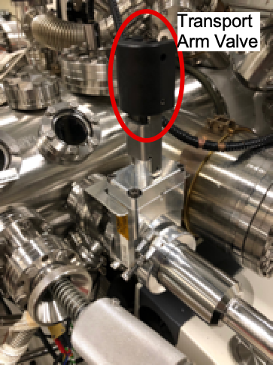

Figure 5 Transport arm attached to the KF Flange with transport arm valve handle facing up.

1. Vent LL again (venting LL is only possible if turbo pump is up to speed).
2. As soon as pressure gauge on LL reads 7.5×102 Torr (~90 seconds), i.e., the LL is still under a slight vacuum, start the LL turbo pump again and open the hand valve on PTS, Figure 5, the handle facing up, **NOT THE VALVE to STC FACING DOWN!!!!**)
3. Wait until LL pressure is <10-6 Torr, about 1h.
4. Open the regular LL/STC gate valve using the computer to check if it can actually be opened and no interlock prevents it (if you cannot open this valve, check if LL is at low enough pressure and the normal LL arm is fully retracted; if these were not the problem, stop here and call a GLA)
5. **CRITICAL STEP:** Check that
   1. The regular LL/STC gate valve is open
   2. “V to transport valve” is open, Figure 4.
   3. Hand valve on PTS (the one facing up) is open, Figure 5.
   4. **ONLY THEN** it is safe to open the valve to STC (the one facing down), Figure 4. If a, b or c is not open **STOP HERE** and restart from step (6).
6. Unlock the magnet and extend the PTS’s arm into the STC chamber.
7. Move your sample from the PTS claw onto the claw for the STC/SAC arm. This may require gently manipulating the suitcase arm to adjust its height inside the STC. Do not push or pull the PTS too hard or you will damage it.
8. Fully retract PTS’s arm back into its chamber, lock the magnet, and close the PTS valve, Figure 6.
9. Close valve to STC (the one facing down, Figure 2), make sure that it is fully closed.
10. Close the regular LL/STC gate via the computer.
11. Check that the pressure in STC goes back to normal (if not the manual valve might still be open, close it.)
12. Vent the LL as described above and remove the suitcase arm. This is important to prevent others from accidentally damaging the arm assembly. Place the arm on the sample prep counter with the valve closed and the plastic cover placed over the end.
13. Wipe the quickflange blank with IPA and place it back on the suitcase arm port, and secure.