Kratos Loading and Unloading Samples Condensed
Jan 2020
Load Sample Steps
- Clean sample
- Verify that XPS is ok and the load lock (LL) pressure <1×10⁻⁶ Torr.
- Vent LL, and wait for LL to reach 1 atm.
- Load sample (top groove, one cylinder bar side), and close LL, right clip first.
- Turn on turbo (check it pumps down).
- Wait till pressure goes down to 5×10⁻⁶ Torr (if not reseal LL, apply pressure, and pump again).
Loading Samples into STC
- Check that the pressure in the STC <10⁻⁸ Torr and LL < 10⁻⁶ Torr.
- Check: both arms are fully retracted, and LL/STC (2 valves) and Flap valve are closed
- Set “Vacuum panel” to “Safe Manual” and click on LL/STC valve to open.
- Turn rotary drive to extend LL arm into STC, align with magazine using drive under STC.
- Transfer sample to magazine, by moving magazine North towards the back wall.
- Fully retract LL/STC arm.
- Close LL/STC valve.
Loading samples into SAC
- Verify that the pressure in the STC <10⁻⁸ Torr and in the SAC <3×10⁻⁹ Torr.
- Verify both arms fully retracted
- Set “Vacuum panel “ to “Safe Manual”, and open STC/SAC Flap valve
- Set stage in sample load position.
- Load sample unto STC/SAC arm. Move magazine North, toward the back wall to hook sample onto STC/SAC arm claw.
- Move arm toward the West to pull sample off the magazine
- Move sample into SAC, and load sample onto stage (for bars move stage to the right).
- Move stage South toward hallway wall ”left on manual stage control” to unhook from STC/SAC arm claw.
- Withdraw the arm fully into STC.
- Close STC/SAC Flap valve.
Unloading Samples
- Verify that the pressures are STC <10⁻⁸ Torr and SAC <3×10⁻⁹ Torr.
- Verify all data collection has stopped
- Set “Vacuum panel“ to “Safe Manual”, and open the STC/SAC Flap valve.
- Move stage to unload position in “Stage” panel
- Move the STC/SAC arm into SAC (avoid Magazine) and line up claw with stage
- Move stage North toward back of room to push sample onto arm (wiggle arm to help).
- Retract arm into STC and place sample on magazine
- Fully withdraw STC/SAC arm and close STC/SAC flap valve in Vacuum control panel
- Verify that the LL pressure <5×10⁻⁶ Torr
- Open LL/STC gate in the Vacuum Panel, and move LL/STC arm into STC
- Transfer the sample to the LL arm by moving the magazine south toward the hallway
- Withdraw the LL/STC arm, watch for the claw in the LL window, and turn one turn more.
- Close the LL/STC valve in the Vacuum panel
- Vent the LL as described above.
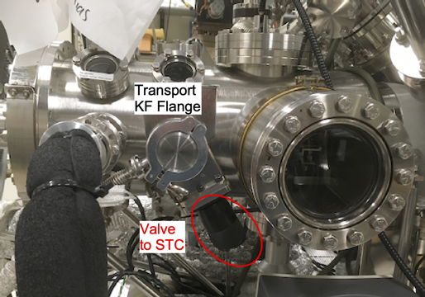
Load Samples from Portable Transfer Arm.
Figure 1 STC showing KF flange for PTS attachment and Valve to STC
- Mount your sample/puck in an inert atmosphere box on the Portable Transfer Suitcase (PTS) arm. Use the bottom groove on the claw with the gate valve actuator vertical up. Ensure the sample is secure.
- Fully retract the claw back into the suitcase, lock the magnet and close the gate valve.
- Hold the suitcase arm such that the VAT label on the valve is up while moving it.
- Check that the pressure in the STC is <10⁻⁷ Torr and that LL Turbo is on.
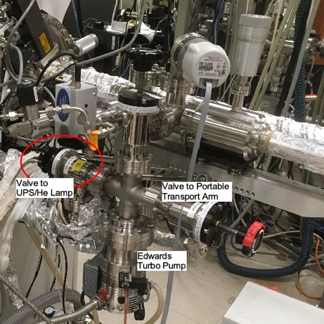
- Check that the valve to the STC is closed (the one attached to the KF Flange that faces down), Figure 1. TAKE CARE: You can vent the STC by mistake!!!
Figure 2 LL turbo pump with valve to Transport, valve to LL and valve to UPS/He lam
- Vent the LL as described above.
- If the valve to the Transport (LLV2) is closed, open it, Figure 2.
- Remove the KF caps from PTS and port.
- Attach the transport arm, valve facing up, to STC,
- Fasten the arm with the clamp with the bolt/screw facing down.
- Restart the LL turbo pump.
- Put sign up that the transport arm is attached.
- Wait until the the pressure is <10⁻⁴ Torr.
- Vent LL again.
- When LL gauge is 7.5×10² Torr (90 seconds), start the LL turbo and open the hand valve on PTS, Figure 3, the handle facing up, NOT THE VALVE to STC FACING DOWN!!!!)
- Wait until LL pressure is <10⁻⁶ Torr, takes about 1h.
- Open the regular LL/STC gate valve using the computer.
- CRITICAL STEP: Check that
  - The regular LL/STC gate valve is open
  - “V to transport valve” is open
  - Hand valve on PTS (the one facing up) is open
  - THEN open the valve to STC (the one facing down), Figure 2. If a, b, or c is not open STOP HERE and go back to step (6).
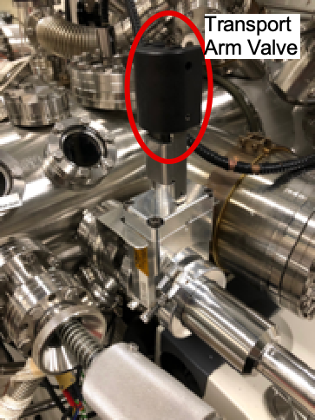
- Unlock the magnet and extend the transport arm into the STC chamber.
Figure 3 Transport arm attached to the KF Flange with transport arm valve handle facing up.
- Move your sample from the PTS claw onto the STC/SAC claw.
- Fully retract Transport arm, lock the magnet, and close the PTS valve (the one facing up).
- Close valve to STC (the one facing down, Figure 2), make sure that it is fully closed.
- Close the regular LL/STC gate via the computer.
- Check that the pressure in STC goes back to normal.
- Vent the LL as described above and remove the suitcase arm.
- Wipe the quickflange blank with a low residue solvent, place back on the suitcase arm port, and secure.

