How to use the UPS Lamp
UPS Lamp Setup
- Load sample into SAC. Focus on your sample using the mono Al X-Ray gun. Make sure to turn off the X-ray gun. Ensure that the system is in a rest state with no data collection, filaments, or heating stages running before proceeding.
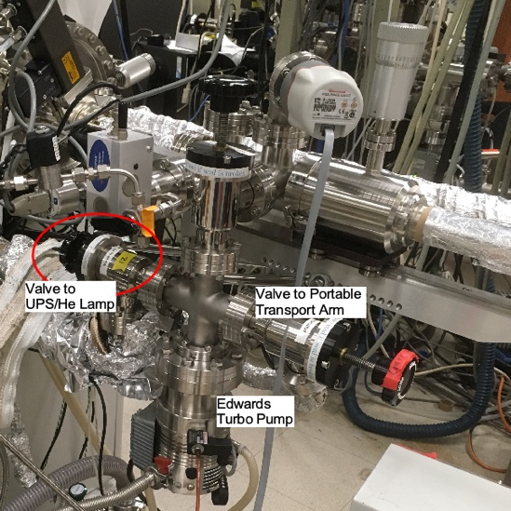
- Open the STC/SAC flap valve.
Figure 1 Load Lock turbo with valves to the UPS lamp and to the Portable transport arm flange.
- Turn off SAC Ion pump by pressing and holding the “Stop HV” button on the Ion Pump Power Supply control box (bottom left box). The screen should read “Standby” and the “Stop HV” button will change to “Start HV”.
- Open the load-lock turbo-to-UPS differential pumping valve located behind the load lock on the right (looking toward the EELS). Turn it fully counterclockwise until it stops, Figure 1.
- Open the green Swagelok valve, Figure 2. Turn it 1 full counterclockwise rotation. Be sure to turn the valve that is connected to the leak valve for the UPS lamp. There is the other green valve to the right of the correct valve marked with red tape that should NOT be turned, Figure 2.
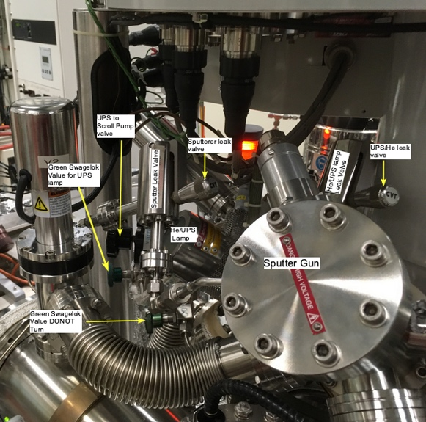
- Slowly and carefully, open the leak valve on the UPS lamp, Figure 2. This allows He(g) to flow into the SAC via the UPS lamp. The leak valve needs to be turned approximately 1.5 rotations ccw. After 1 full turn, SLOWLY turn the knob while monitoring the pressure until the STC reads ~2 x 10⁻⁸ Torr and the SAC reads ~1 x 10⁻⁸ Torr.
Figure 2 View of UPS/He lamp and Sputterer. Note two green swagelok valves, leak valves, and valve to scroll pump.
- Open the UPS-to-scroll differential pumping valve located to the left of the UPS lamp housing, Figure 2. Hold the valve base while opening to maintain the UPS alignment. Turn the valve fully counterclockwise until it stops. The chamber pressures should lower after the valve is opened.
- Turn on the power to the UPS control box, found on the back panel of the Kratos, Figure 1.
- Turn the dial clockwise for the emission current until it reaches 6.0. The digital readout will remain static while this knob is being turned.
- Open the leak valve slowly until the lamp ignites. Continue to open the leak valve until the pressure in the SAC/STC is ~1 x 10⁻⁸ Torr. For He I excitation, the lamp color should be peach, and for He II excitation, the lamp color should be violet.
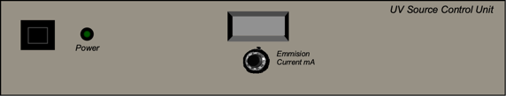
- Return to the UPS control box and turn the dial counterclockwise until the digital readout is 2.3 mA.
Figure 3 UV Source Control Box
- Verify the color of the desired excitation. Switching between He I and He II can be achieved by making small adjustments to the He leak valve. Make any adjustments slowly and carefully while monitoring the pressure. Do not allow the pressure in either chamber to exceed 5 x 10⁻⁸ Torr.
UPS Data Collection
- In the Instrument Manual Control, set the following parameters in the “Analyser” box:
  - Mode: Spectrum
  - Lens: UPS
  - Resolution: Pass Energy 5 eV (or 10 eV)
  - Select an appropriate aperture, usually 55 µm, 110 µm, or slot
- In the “Acquisition” box, set the following parameters:
  - Technique: UPS
  - Type: Spectrum
  - Ref: He I or He II
  - Region Center: 10 eV, Width: 24 eV, Step: 25-50 meV, Dwell: 100 ms
- To collect spectra via the manual control window, ensure your dataset is active and turn Acquisition “On.” Before the run is finished, click “off” to instruct it to stop when the sweeps are complete.
- To collect data via an automatic sequence, input a dataset or position table normally. Under the Acquisition tab, change the Analyser settings to the parameters described in step 1. Set the Excitation source to “UPS Lamp.” Under “Scan Control,” change the parameters to those described in step 2. Paste the acquisition step into the flowchart and begin the run normally.
- If you are going to leave the instrument with the UPS running, be sure to leave a note notifying other users that UPS is in progress. Do not allow anyone to vent the load lock or close the flap valve while UPS is in progress. Doing either of these actions could cause a rise in SAC pressure, which could damage instrument components.
Turning Off the UPS Lamp
- Turn the dial counterclockwise until it reads 0 on the dial. Switch off the UPS control box.
- Close the leak valve by turning it clockwise. Be careful not to overtighten.
- Close the green Swagelok He supply valve.
- Close the differential pumping valve to the scroll pump. Hold the valve base while closing.
- Close the differential pumping valve to the load lock.
- Turn the ion pump back on by pressing and holding the “Start HV” button until the orange light labeled “Supply 1” turns on. The screen will report the chamber pressure when the pump is on.
- Shut the flap valve.

