XPS Portable transport Suitcase, TS
(ATM pressure version)
1/2021

The portable sample transfer suitcase (TS) is designed to allow transfer of samples from an inert atmosphere glove box directly into the load lock (LL) of the Kratos XPS without exposure to water, oxygen, or air.
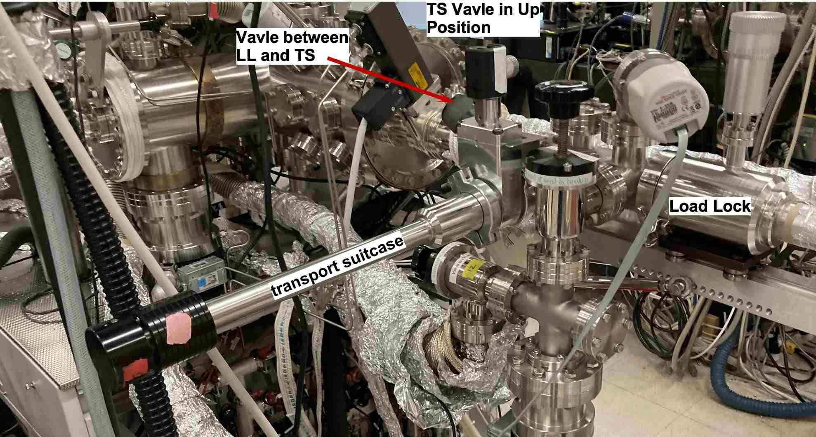
- The TS is only compatible with sample pucks or pots.
Figure 1 TS attached to the KF Flange with TS valve handle facing up.
- The suitcase arm loads onto the quickflange port on the north side of the LL, Figure 1.
- It mounts with gate valve oriented vertical up, valve actuator mechanism is at 12 o’clock.
- Be careful with the valves, Figure 1, where the TS gets attached. Opening these valve when the LL is under vacuum will crash the LL.
- Remove the TS after the sample is in the LL. Do Not leave the arm attached.
- Keep the TS capped to avoid damage to the KF mount (when not attached).
- The puck mounts to the TS using the bottom grove, Figure 2.
- Mount sample into the TS in an inert atmospher box.

- Witht the TS in your glove box mount your sample on a puck.
- Open the TS’s gate valve with the valve actuator oriented at 12 o’clock, move the claw out of the arm so it can be accessed.
- Mount the puck with your sample on the TS claw using the bottom groove (Figure 2), such that the sample faces up with the gate valve actuator mechanism at 12 o’clock. Be careful not to damage the pin at the end of the claw that holds the puck in place. Ensure the sample is secure, since the puck will be vertical during sample transport.
- Hold the suitcase arm such that the VAT label on the valve is oriented up while transferring the arm to the Kratos. In this orientation, the sample is vertical with the open end up and the claw holding the puck from beneath. Holding it the wrong way may cause the sample to fall out during transport. Use the screw on the end of the arm to lock the magnet in place during the transfer.
Figure 2 Puck mounted on portable TS claw.
- At the Kratos, check that the pressure in the STC is < 10⁻⁸ Torr and the LL is < 10⁻⁶Torr.
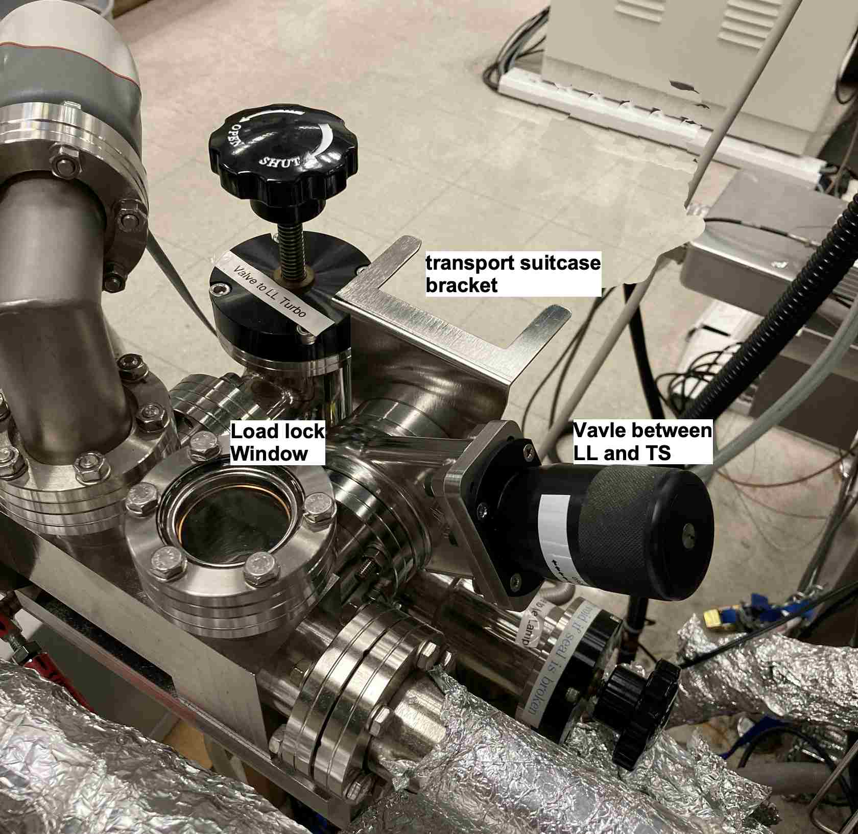
- Remove caps from the KF flange and the TS arm port.
Figure 3 Valve to STC and Transport KF Flange from in front of XPS.
- Attach the TS to the KF flange with the valve actuator facing at 12 o’clock, figures 1, 3, 4.
- Fasten the arm with the clamp for the KF with the bolt/screw facing down, Figure 1.
- Make sure TS is mounted evenly to KS flange.
- Vent the LL turbo pump and unclasp the LL springs.
- When the LL is completely up to atmosphere open the gate valve between the LL and the TS, Figure 4, so the space between the TS and the LL can get pumped down. The gate on the TS should be kept closed.
- Put a sign on the LL turbo that the transport is attached, and no one should touch the LL turbo.
- Turn on LL turbo and wait until turbo reaches full speed and the pressure is <10⁻⁴ Torr.
- Vent LL (venting only possible when turbo is up to speed).
- As soon as pressure gauge on LL reads 7.5x10² Torr, with the LL under a slight vacuum, restart the LL turbo and open the hand valve on the TS, Figure 4, the handle facing up, reclasp the LL springs.
- Wait until LL pressure is <10⁻⁴ Torr.
- Unlock the TS magnet and extend the TS arm into the LL chamber.
- Transfer your sample from the TS claw onto the claw for the LL arm. This may require gently moving the LL arm and the TS arm to mate. The claws for the LL and TS both have little springs that are to help hold the sample and provide a little resistance. The TS has been adjusted so it should go on without pushing on the end of the TS ifit is mounted correctly. Do not push or pull the TS too hard.
- After transferring the puck, retract TS back into its chamber, lock the magnet, and close the TS valve.
- Close valve from the LL to the TS (the one facing up at 45º, Figure 2).
- Wait for the pressure in the LL to reach < 10⁻⁶ Torr, about 1 hour.
- Check the STC is at low pressure < 10⁻⁷ Torr.
- When the pressure in the LL is < 10⁻⁶ Torr you can follow standard instructions to insert the sample from the LL into the STC.
- Withdraw the LL arm from the STM and the close the valve between the LL and the STC.
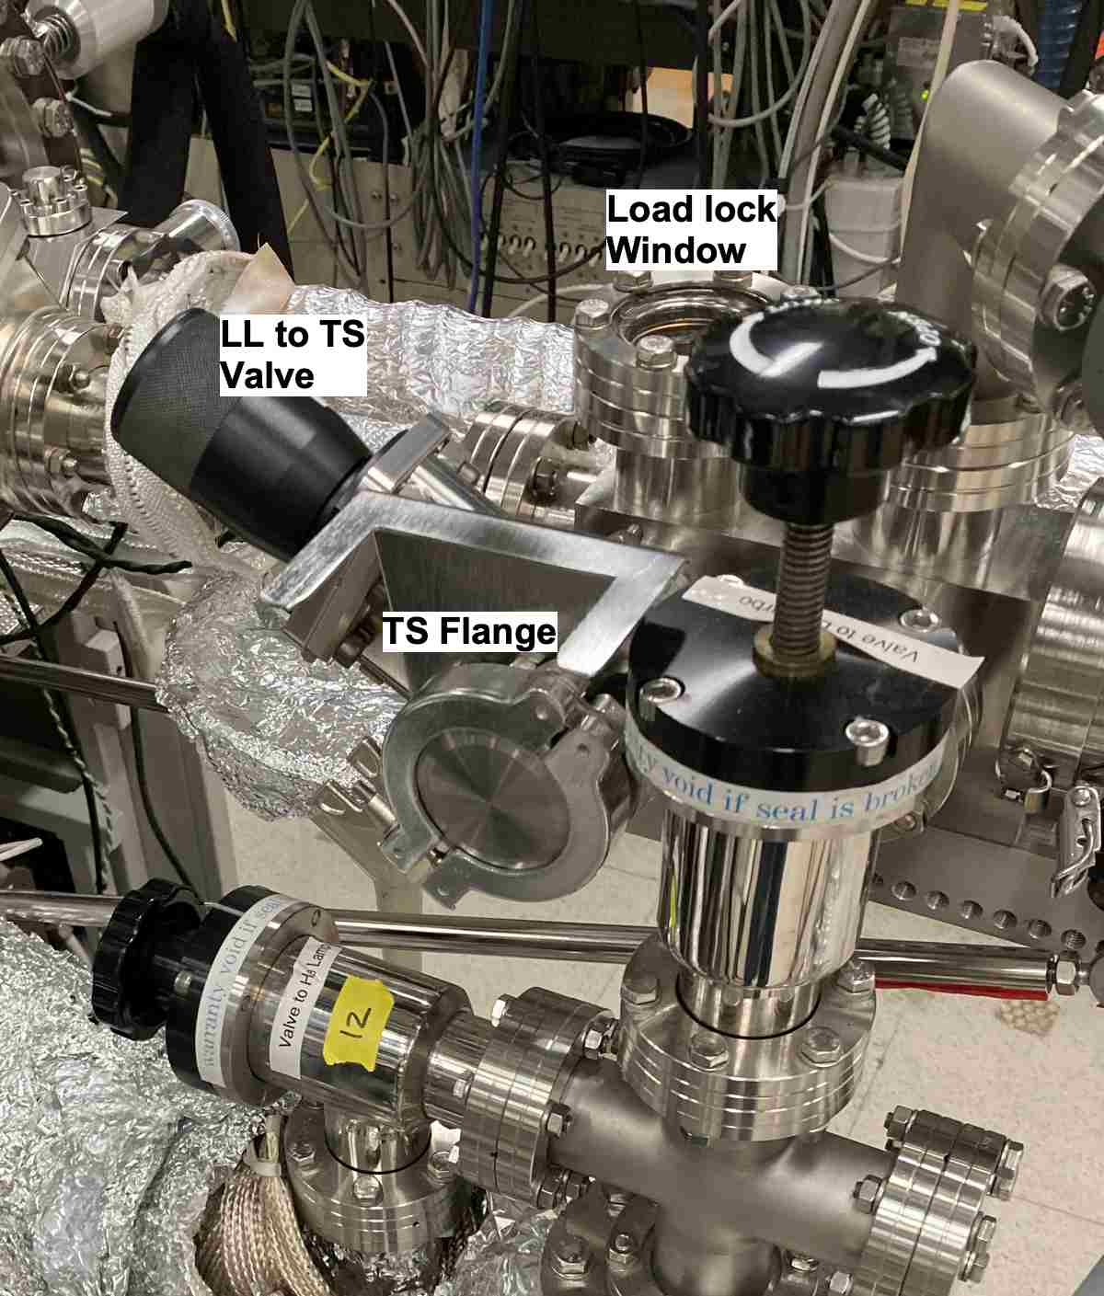
- Open the TS valve and then slowing open the valve between the LL and the TS (the LL pressure will rise).
Figure 4 View from back of instrument of Valve between LL to TS.
- Wait till the pressure is < 10⁻⁴ Torr.
- Unclasp the LL springs and vent the LL.
- When the pressure is up to atmosphere ~ 10 minutes), close the valves from the LL to the TS and on the TS.
- Remove the TS from the KF Flange port.
- Attach the KF flange blank to the KF port.
- Restart the LL turbo and clasp the springs on the LL.

