M-Probe XPS - Sputter Gun Manual

10/2019
Note: If you want to do sputter depth profiling and need to turn the sputter times into depts in nm you need to prepare a sample that has a known thickness of the material that you will sputter mounted on a substrate of another material. You then can sputter this sample till you see the underlying layer. That will calibrate the sputtering rate. You should put this sample on the stub with the sample you want to analyze.
Preparing to sputter

Prepare a stub that has your sample for sputtering, a known sample (Au?) and your calibration sample if you need one.

Follow standard procedure for loading your sample into analysis chamber.
- Ensure that the analysis chamber pressure is in the 10⁻⁹ Torr range.
- Turn on the nti nonsequitur ion gun controller and check the following items:
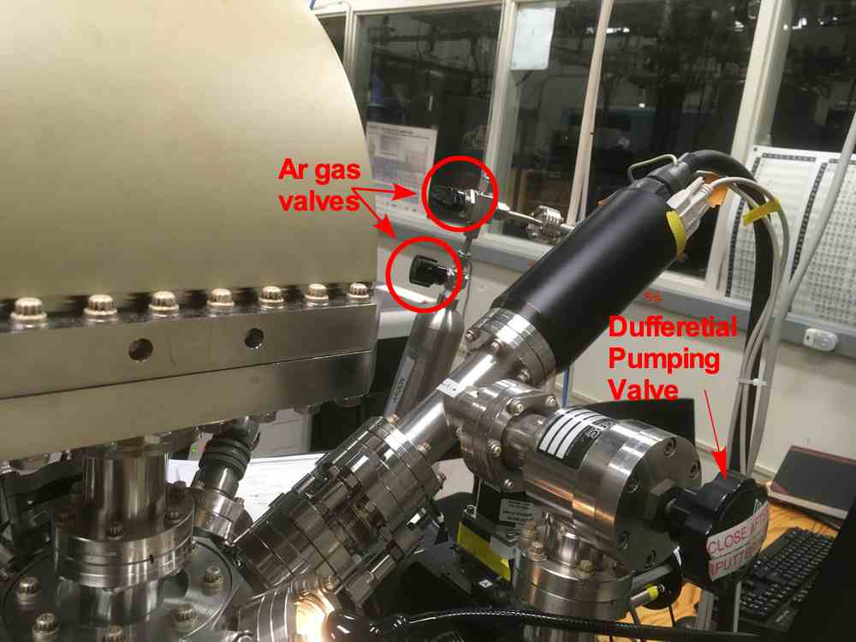
  - All four interlock LEDs in the lower left are green.
Figure 1. Sputter Gun
  - Emission current is on standby.
  - Raster is set to ON.
  - Remote/local switch is set to REMOTE.
- Slowly open the differential pumping line, Figure 1, watching that the pressure doesn't go above the 10⁻⁸ Torr range and quickly returns to approximately the previous base pressure.
- Open the Ar tank valve, Figure 1, there are 2 valves.
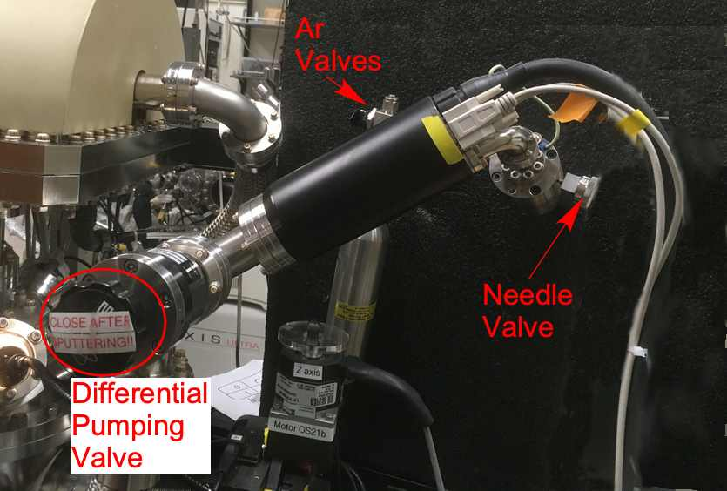
- Open the needle valve, Figure2 very slowly. Start by turning 1.5 turns ccw. This should not increase the pressure. At this point, slowly turn the valve until the pressure in the ion chamber is ~7 mTorr (meter on nonsequitur). The pressure only rises a little after the valve is turned. Be very careful, as the valve is highly sensitive. Be ready to turn it back cw if the pressure spikes.
Figure 2. Sputter Gun
Ramping up the power supply
- Navigate to an empty spot on the stub.
- Turn on the ion gun in the ESCA control panel using the software.
- Set the energy to the desired value (usually 3 keV for fast etching (see table)), and set the appropriate values for the condenser, focus, and raster (see Table 1 below). Do not change the extractor or centering controls.
Energy  V | Extractor | Focus | Condenser | Est. Rate | Raster
kV | V | V | V | Nm/min
0.05 | 1204 | -522
0.1 | 1204
0.2 | 1204 | -500 | 244
0.5 | 1205 | 451
1.0 | 1205 | 915
3.0 | 1205 | 2617 | 244 | ~10 | 2.5x, 3.5y raster

Table 1, Nonsequitur Sputter Gun Settings, nworking distance of 20 mm, Source Pressure 34 mTorr
- Ramp the current to 10 mA slowly over the course of two minutes, watching that the pressure in the chamber does not increase above the 1-2 × 10⁻⁷ range. Ensure that the beam on LED has turned green.
- Turn off the ion gun using the ESCA control panel.
Alignment of the Sputter with the X-Rays
- Put the known sample under the X-ray spot and collect a little data to see that it is optimized at that position. Turn off the X-rays but set the energy of the spectrometer to that of a known peak in known sample.
- Turn on the sputter gun.
- Move the x and y positions centring potson the nti nonsequitur to maximize the count rate on the 2503 meter.
- Now the sputtering spot and the X-ray spot should be the same,
Sputtering your Sample
- Navigate to the desired spot on your sample for analysis and set that position as home.
- Sputter one of three ways:
  - Manually using the ion gun control on the ESCA control panel.
  - Add an "Etch" step to a recipe by adding the desired sputter time in hh:mm:ss format. See table below for estimated etch rates.
  - Perform a depth profile experiment by selecting the Depth Profile recipe step. Click the pencil to define regions to scan, spot size, cycles, and etch time per cycle. Remember to add an off step after your depth profile to shut off the x-rays, the same as with a normal XPS run.
- XPS can be performed while the chamber is still at pressure with Ar, but the ion gun control box on the ESCA control panel should not be checked. Scans should be performed at spot size 300 and resolution 2 to ensure that the x-ray beam is smaller than the sputtered area.

Shutting down
- Ensure that the ion gun control box on the ESCA control panel is not checked.
- Ramp the current down to standby slowly.
- Close bleed valve carefully. Stop when you feel resistance, do not ove1iighten (should be 2 turns cw, with the mark at 11 o'clock from the reference line). The valve does not need to be snug to be properly sealed.
- Close Ar tank valve.
- Wait 5 minutes for the ion chamber to clear and turn off the control box.
- Close differential pumping line. This step is extremely important, so be sure to double check. Ensure that the pressure goes back to the initial base pressure.
- Follow standard procedures for XPS or sample removal.

