How to Replace the X Ray window on a SSI ESCA

Required:
- 5/16” Wrench
- 1/2” Wrench
- Mylar film window use either 1.5 micron ultra-polyester film or 2.5 micron mylar both from Chemplex spectrofilms.
- Cu gasket for 3.375” CF flange
- Long heavy duty tweezers
- Cleanroom gloves

Steps:
- Vent the entire system up to atmospheric pressure using dry nitrogen.
- Remove crystal monochromator and gimbal, be careful not to bump or turn the crystal adjustment knobs. Once Removed, set the crystal on something that allows it to rest on the flange rather than on the crystal itself. A 250ml beaker works well.

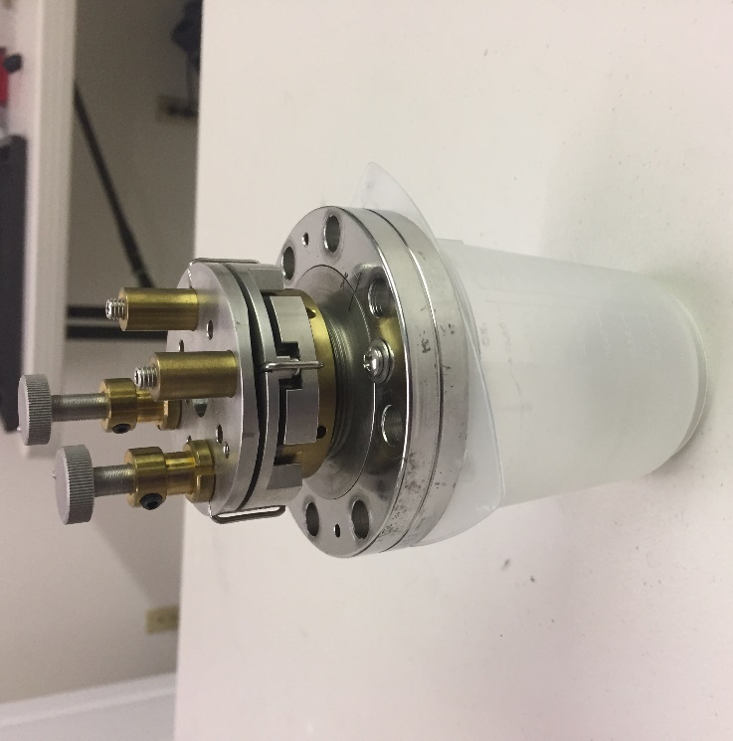

- Look down the crystal port to examine the x ray window. If it is not broken, then reattach the crystal.
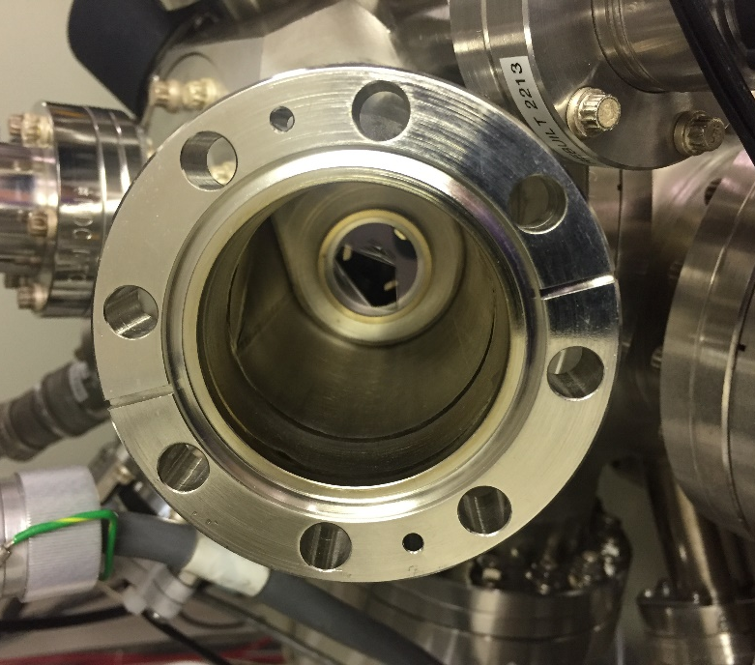
Broken XRay window

- If the window is broken, use a pair of long tweezers to remove it from the vacuum chamber.
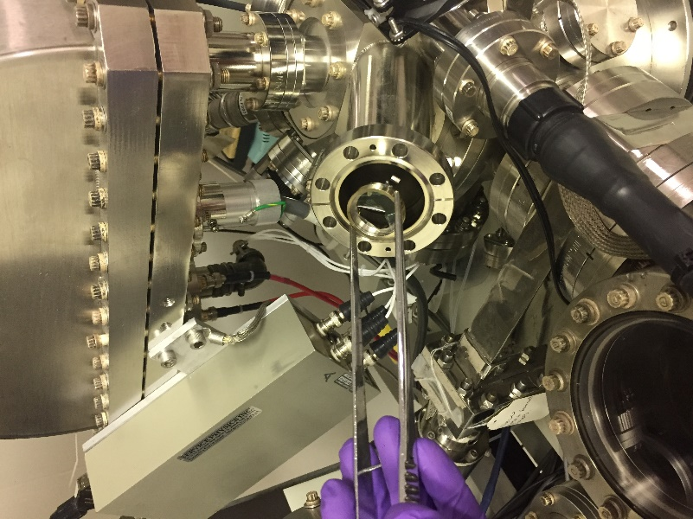
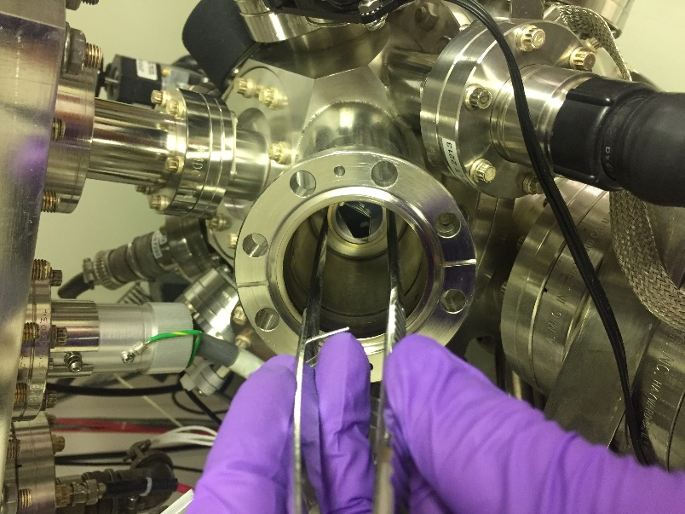

- Place the window holder on a clean surface and remove the retaining ring from the holder.
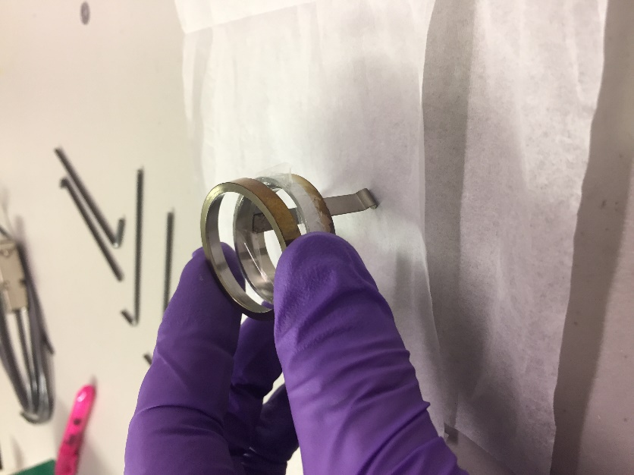

- Remove the broken x ray window and all stray pieces of mylar.
- Place the new window on top of the holder, with the retaining ring resting above. Then press down on the retaining ring to secure the new window in place.
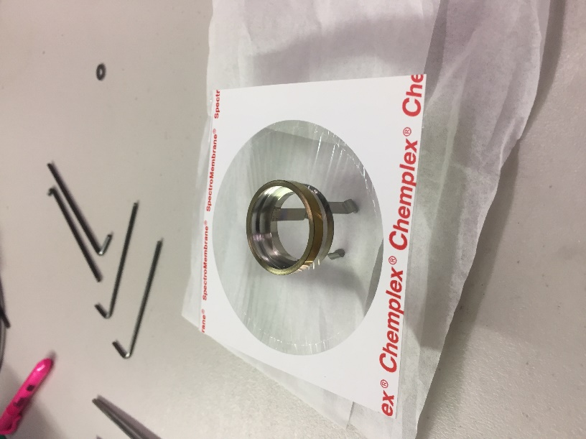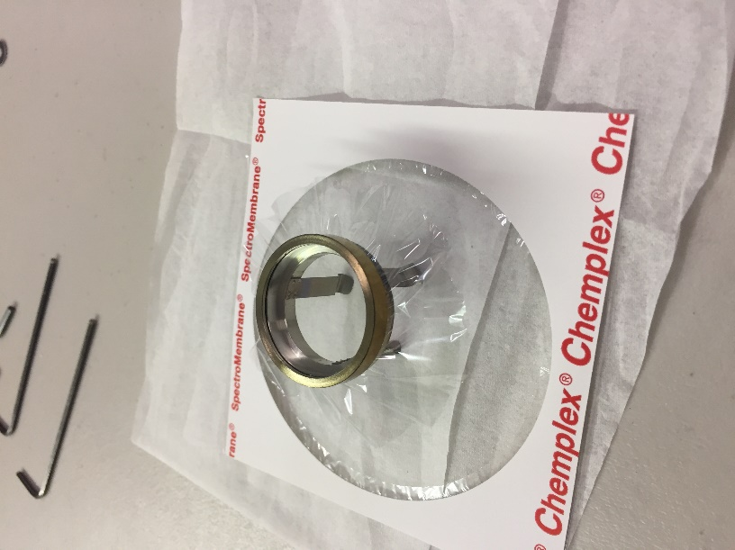
- Remove excess film from the outside of the window holder.
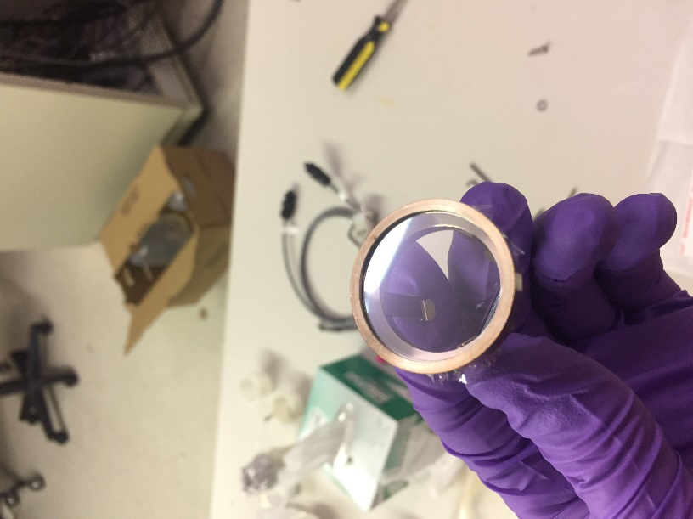
- Reinstall the window holder in the chamber. This can be tricky, it may help to find something about 8-10” long with a flat surface on the end to assist in seating the window holder in the port.
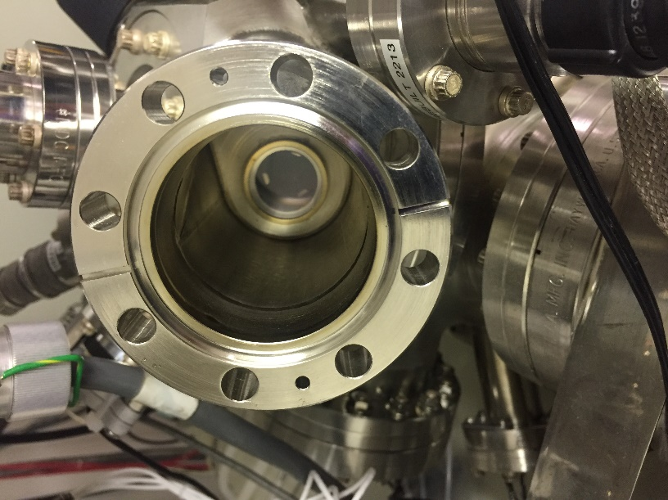

- Reinstall the crystal. Be sure the crystal in facing towards the electron gun anode.
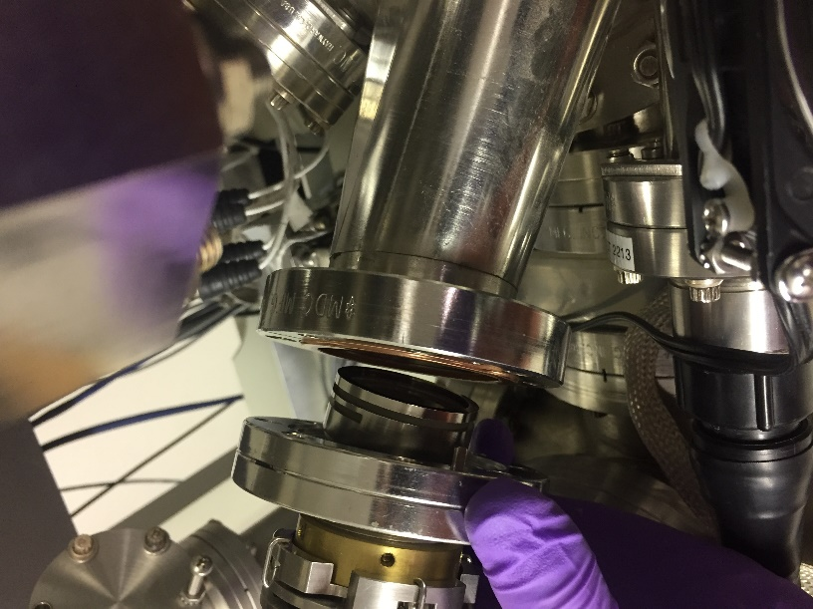
- Tighten bolts and recover vacuum.

