The transfer arm is hard to move and will be repaired in the near future
The arm is much easier to move in the locked position ( the flat section or the tape down)
When loading samples

- The stage MUST be at the 0,0,0 position on the motion control panewl.
- Move the arm to place the stub on the stage.
- To release the stub on the stage rotate the transfer arm magnet to the unlocked position (tape or flat side up).
- While watching the stub and move the arm a few inches away from the stub without the stub moving on the stage.
- Now rotate the transfer arm magnet to the locked position (tape or flat side down) to fully retract the arm.
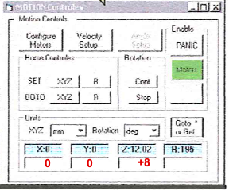
- For data collection, raise the stage and move the sample to a Z position of 0,0,+8 on the motion control panel.
- Rotate and translate the stage to find your sample and place it at the cross hairs on the screen.
- Set the analyzer to the position for an element in your sample and turn on the X-rays.
- Optimize the Z height of the stage to get the most counts.

When unloading samples\

- Lower the stage and move it to the 0,0,0 positon on the motion control panel.
- Make sure the magnet is in the locked positon (tape or flat side down).
- Advance the arm till it is close to the stage.
- Rotate the magnet to unlocked position (tape or flat side up) and then slowly engage the stub.
- Rotate the magnet to the locked postion (tape or flat side down) and slowly pull the stub off the state.

