Degassing the X-Ray filaments

- Turn off X-Ray Controller (9600), the Glassman High Voltage Power supply.
- Check
  - that the Hawk water circulator, is on and ready.
  - that the cryo is on and down to temperature and that the gates to the cryo are open.
  - that the vacuum is below 5 x 10⁻⁸⁻Torr.
  - that gate 5 is closed
- Turn on Glassman high voltage and the 9603 X-ray gun spot size controller
- Make sure the “Interlock OK” LED comes on otherwise you cannot get current from gun.
- Turn "ramp" knob on spot size controller to slowest, fully clock wise (“service” switch down)
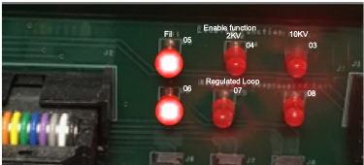
- Press "start filament" on 9600 followed by "HVon" on Glassman It will go through 2 cycles of ramping voltages?
- Ramp 1:
  - The front panel “Fil on” LED should turn on and the Panel meter should read I FIL mode and go from 0.6 to ~1.2 A. Inside the 9600 XRay controller the “Fil” (05) LED should be on and LED 06 will come on
- Ramp 2, 2KV:
  - Meter V2KV go to 2.3 KV
  - LEDs 05 off, 06 off, 04 (2KV) on, 07 will come on
- Watch that the Pressure does not go up too much.
- Set the "service" switch UP, keeping "ramp" knob on slowest setting (c.w.) and changing "stand by" to "operate". The Glassman should now read about 1KV and the Voltage control should be active. This will take ~8 h, watch pressure.
- Once 10 kV is reached, degas anode by starting X-ray gun on 100 micron spot and slowly increasing the spot size until largest spot does not raise pressure above 2 x 10⁻⁸Torr
- Turn off X-rays
- Turn on spectrometer boxes (top 3, spectrometer power supply, flood gun, memory interface)
- Open software, check "X-ray gun operate" in ESCA control panel
- Switch spot size controller from "manual" to "computer"
- Degas flood gun - check “Flood Gun” box in ESCA control panel and increase energy to 5 eV, watch pressure and wait for at least 1 hour
- Turn down flood gun energy, uncheck flood gun box, and close ESCA control panel
- Instrument is ready to use

