Degassing the X-Ray filaments

- Turn off X-Ray Controller (9600), the Glassman High Voltage Power supply.
- Check
  - that the Hawk water circulator, is on and ready.
  - that the cryo is on and down to temperature and that the gates to the cryo are open.
  - that the vacuum is below 5 x 10⁻⁸⁻Torr.
  - that gate 5 is closed
- Turn on Glassman high voltage and the 9603 X-ray gun spot size controller
- Make sure the “Interlock OK” LED comes on otherwise you cannot get current from gun.
- Turn "ramp" knob on spot size controller to slowest, fully clock wise set tge “service” switch down
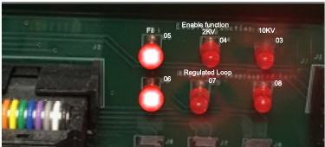
- Press "start filament" on 9600 followed by "HVon" on Glassman It will go through 2 cycles of ramping voltages?
- Ramp 1:
  - The front panel “Fil on” LED should turn on and the Panel meter should read I FIL mode and go from 0.6 to ~1.2 A. Inside the 9600 XRay controller the “Fil” (05) LED should be on and LED 06 will come on
- Ramp 2, 2KV:
  - Meter V2KV go to 2.3 KV
  - LEDs 05 off, 06 off, 04 (2KV) on, 07 will come on
- Watch that the Pressure does not go up too much.
- Set the "service" switch UP, keeping "ramp" knob on slowest setting (c.w.) and changing "stand by" to "operate". The Glassman should now read about 2 KV and the Voltage control should be active. This will take ~8 h, watch pressure.
- Once 10 kV is reached, degas anode by starting X-ray gun on 100 micron spot and slowly increasing the spot size until largest spot does not raise pressure above 2 x 10⁻⁸Torr
- Turn off X-rays
- Turn on spectrometer boxes (top 3, spectrometer power supply, flood gun, memory interface)
- Open software, check "X-ray gun operate" in ESCA control panel
- Switch spot size controller from "manual" to "computer"
- Degas flood gun - check “Flood Gun” box in ESCA control panel and increase energy to 5 eV, watch pressure and wait for at least 1 hour
- Turn down flood gun energy, uncheck flood gun box, and close ESCA control panel
- Instrument is ready to use

