Service Physics Revised 06.04.10

20340 Empire Ave Suite E4 BSB/DG V

Bend Or, 97701

541-318 8688

**E-gun replacement:**



1. When replacing the e-gun make sure the cutouts in the e-gun flange match the cutouts in the chamber flange.
2. Also the cutouts in the electrical connector to the e-gun should be at about 9 and 11 o'clock.
3. Restore system vacuum. After analyzer pressure is in the 10-8 T range, the e-gun start-up and alignment can be performed.
4. Reconnect E-gun connector.

**Degassing the E-Gun**

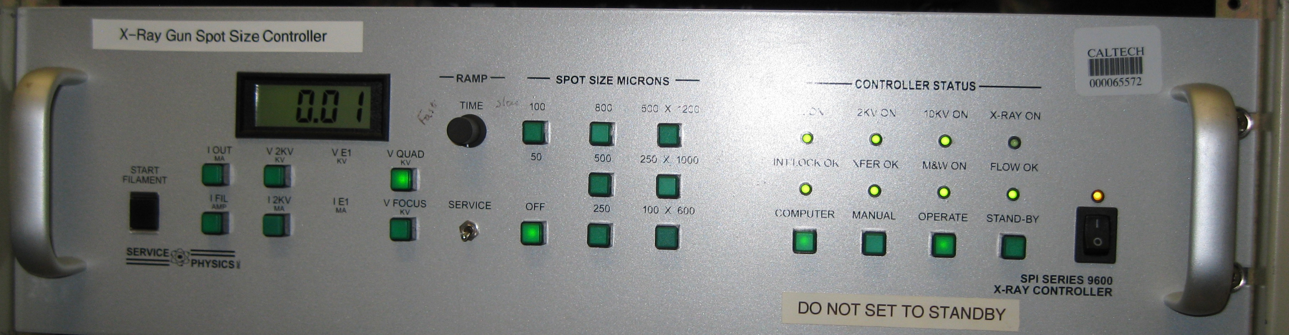

Figure 1 9600 X-ray gun power supply and controller

**9600 X-Ray Gun Spot Controller**

1. Turn on the 9600 X-Ray gun controller. The Interlock OK LED should come on. If not insure that all necessary interlock conditions are met as indicated on the manual vacuum controller front panel. Turn the Glassman on, turn the current limit10 turn pot fully c.c.w. and press the HV ON button. The 2KV supply is referenced to the output of the Glassman. It is important that the Glassman is on even if its output voltage is at zero to establish a useful reference. 4
   1. Set the front panel toggle switch labeled "SERVICE" to the SERVICE position. Rotate the INCREASE TIME potentiometer full clockwise.
   2. 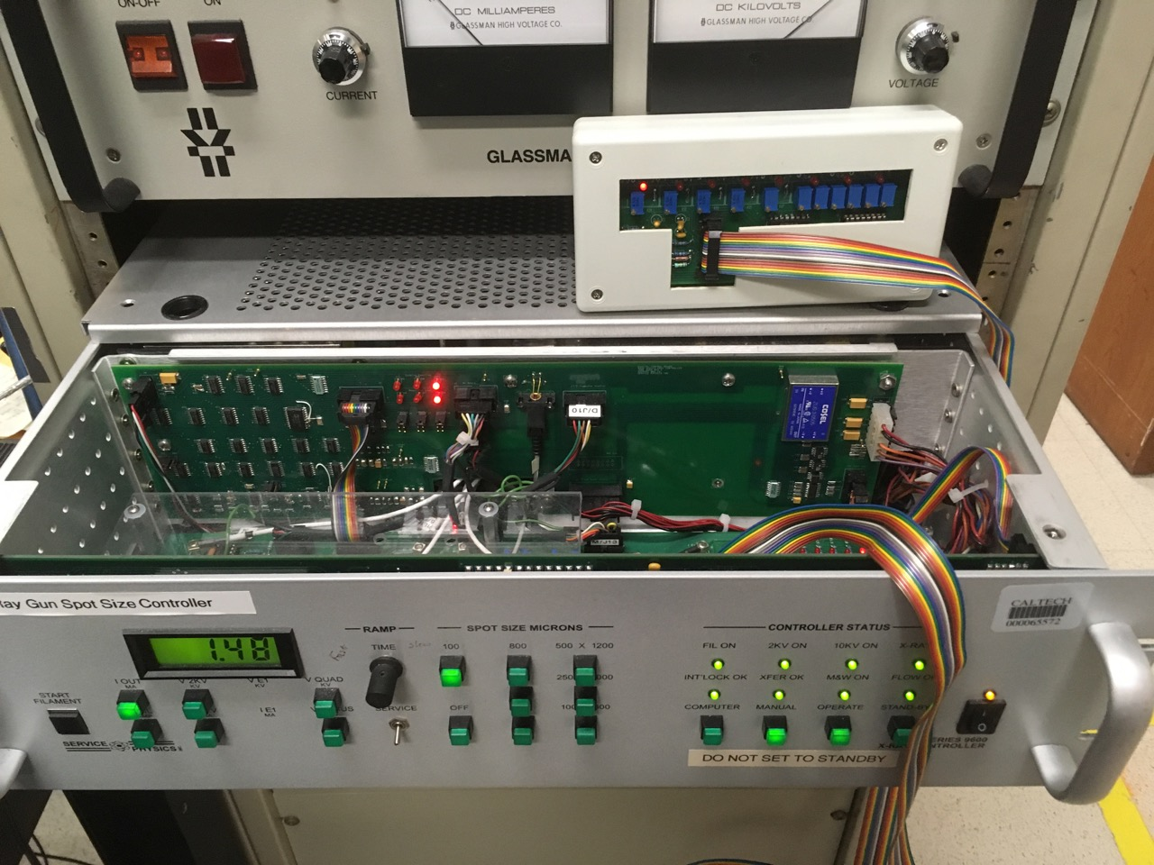Pull the box about 6 inches out of the rack and slide the cover back, Figure 2. Note the 6 red LEDs on the vertical board mounted to the inner bulkhead, Figure 3. They are a little left of center at the top. The first column indicates the filament ramp status. The second column indicates the 2KV status and the third column indicates the 10 KV status. The top light in each column indicates that that function is enabled. The lower LED indicates the control loop is regulating on IFil, I2KV or V10 KV. This will become more interesting as we proceed.

Figure 2 X-ray gun power supply with cover open and spot size control box sitting on top

**Filament Ramp**

* 1. 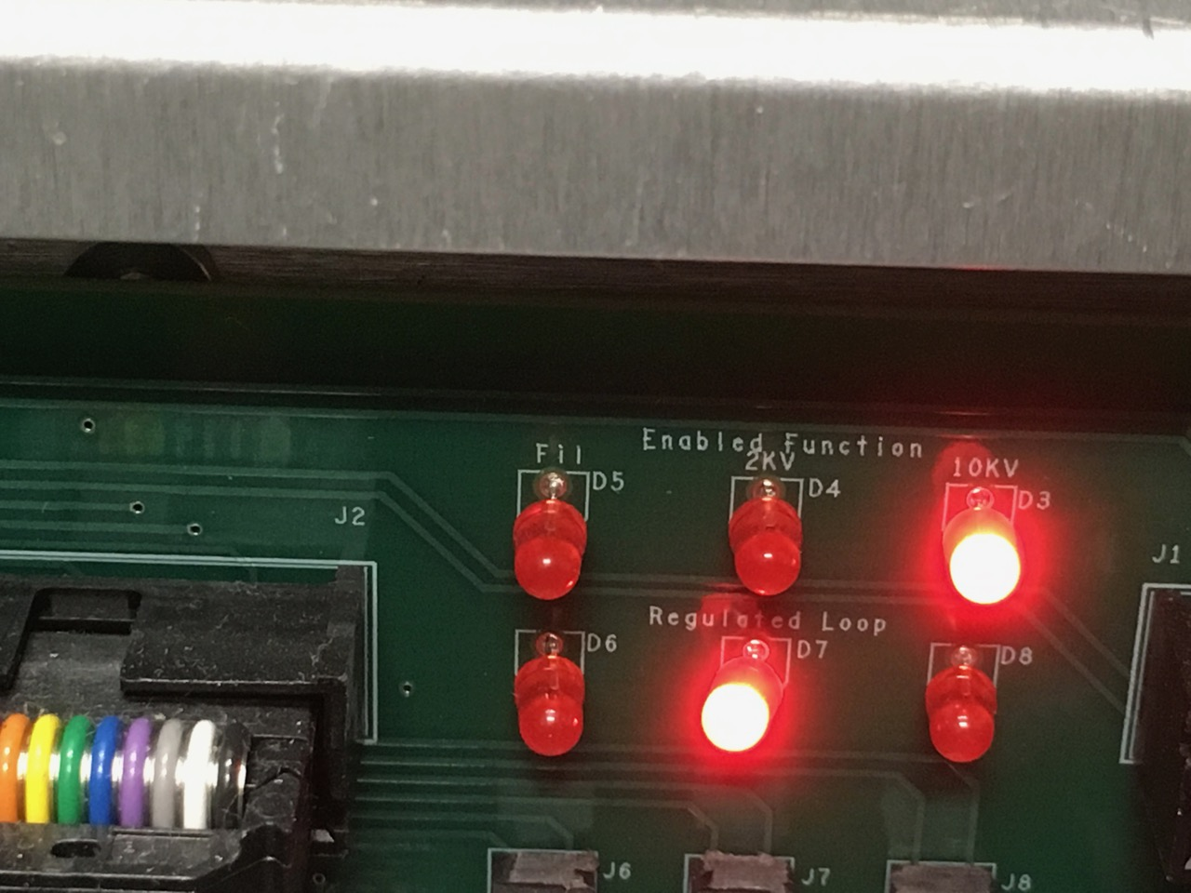Press the Start Filament push button. On the front panel the Filament On LED should turn on. If the Sample Transfer is homed and valve #4 is closed then the Xfer OK LED should be on. On the inside board the Two LEDs in column I should be on showing the system is ramping the Filament current.

Figure 3 LED indicator licks for I­fill, I­2KV, I10KV

* 1. The front panel meter will default to the I FIL mode. The meter should read about 0.65Amps.
  2. The supply will ramp the filament to 1.38 A. At the end of this period the ramp will switch to I2KV.

**I2KV Ramp**

* 1. To monitor this change watch the LEDs inside the box. When the change in mode is made the top LED in the first column will go out and the top LED in the second column will turn on. The I2KV control is enabled but the V2KV is not high enough to extract a significant emission current. To avoid damage to the filament the regulation remains tied to the filament current. This is noted by the Lower LED in the first column is still on.
  2. The 2KV will increase over about 30 second to 2.3 KV. This can be monitored on the front panel meter. At about 1.9 KV the 2KV OK light on the front panel will come turn on. This will enable the control loop to regulate the I2KV ramp. The bottom LED in the second column will come on.

**Stand-By**

* 1. When the I2KV ramp completes the auto start process will halt. This halt condition is the state used for Stand-By. The I2KV will be at about 6 mA. NOTE: This includes about 2.2 mA of bias current used for the Pierce circuit. The actual I2KV is about 4 mA in Stand-by. You can return to Stand-by from the operate mode at any time.

**Operate**

1. When the vacuum has stabilized the high voltage ramp may be started. Be sure the M&W is operational by turning on the M&W front panel power switch. The Flow OK LED, on the front panel, should come on as soon as the flow stabilizes. After verifying the flow interlock, turn off the M&W front pane power switch. The 9600 X-Ray Gun controller will turn the M&W back on.
   1. Turn the Glassman current limit 10- turn pot one (1) turn c.w.
   2. Select OPERATE on the 9600 X-Ray Gun controller front panel.
   3. Select the 100-micron Spot size.
   4. The M&W will turn on. The M&W On LED will indicate this. The Flow OK LED will come on when the flow stabilizes.
   5. The Glassman voltage will jump to about 2.5 KV.

**IT IS IMPORTANT TO RAMP THE HIGH VOLTAGE TO 10KV USING THE SERVICE RAMP FOR THE INITIAL TURN ON PROCEDURE. Turn the ramp rate control full ccw. This will provide about a 2-3 hr ramp.**

The Glassman voltage will ramp to 10 KV. (If the gun has been in service and is well conditioned you can switch the service switch down and let the 10KV ramp quickly to about 5 KV. Then go back to service and check all meter settings. The following values are typical at this point.

* •Iout • 0.5 to ~~1.2~~ 2.5ma
* Ifil • ~~1.40 to 1.44~~ 1.15 to 1.25
* V2KV • 2.3 KV
* 12KV • 5.8 to 6.5 mA
* VFocus • 3.8-4.2 KV 8.2 KV?
* VQuad 0

Next go to about 7 KV then return to Service. Hold for about 5 minutes. Then go to about 8KV. Let it ramp in Service mode the rest of the way the first time.)

When the Glassman voltage reaches about 9.2KV the 10 KV OK LED and the Spot On LED's will turn on. This indicates that the supply is now actively controlling the gun output current. The IOut should read 1.5 mA

**If the vacuum system has been opened to atmosphere for gun repair or any other reason the controller should be left in the Service Mode. Manual speedup steps should not be provided. If the gun has had major repairs the full c.w. position of the ramp speed control should be used. After conditioning of the gun the SERVICE switch can be in the down position at all times but the ramp rate pot should be in c.w. position for the HV ramp.**

**Preliminary Checks after 10 KV is attained**

|  |  |  |  |  |  |  |  |  |  |
| --- | --- | --- | --- | --- | --- | --- | --- | --- | --- |
| Figure 1  Range of typical values for the 9600 X-Ray Gun parameters | | | | | | | | | |
|  | OFF |  | 100  15W | 300  50W | 500  100 W | 800  200 W | L1  50 W | L2  100 W | L3  200 W |
| IOUT | 0.05-0.25 |  | 1.45(5) | 5.0(1) | 1.0(1) | 20.0(5) | 5.0(1) | 9.7(7) | 20.0(5) |
| IFil | 1.2(5) |  | 1.2(5) | 1.2(5) | 1.2(5) | 1.2(5) |  |  |  |
| V2KV | 2.30(2) |  | 2.30(2) | 2.30(2) | 2.30(2) | 2.30(2) |  |  |  |
| I2KV | 5.8(4) |  | 5.9(4) | 6.5(3) | 7.3(5) | 8.1(6) |  |  |  |
|  |  |  |  |  |  |  |  |  |  |
| VQ | 0 |  | 0 | 0 | 0 | 0 | 175(25) | 240(40) | 400(50) |
| VF | 8.2(1) |  | 8.2(1) | 8.25(.1) | 8.3(.1) | 8.4(.1) |  |  |  |
|  |  |  |  |  |  |  |  |  |  |

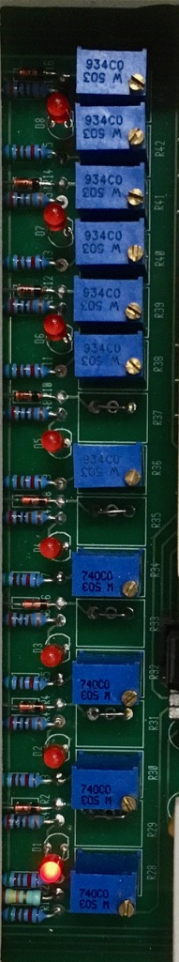

Figure 4 Spot size control pots for all ranges

1. Note, the 300 μm spot size can be referred to as 250 or 200.
2. Typical front panel values. The meter reads the major operating parameters. During start up these parameters help provide an indication of how well the gun is cleaning up. After the Glassman reaches 10KV all meter reading should be taken in the Spot OFF and 100 Micron settings. If any reading is out of range do not select any other operating conditions. Let the gun operate in the 100 Micron Spot condition for an hour and see if the out of bounds reading are improving. If not contact Service Physics Inc for trouble shooting help.
3. If the 100 Micron Spot parameters are in range and the vacuum is < 5 x 10-9 then adjust the 100 Micron spot for minimum size. The spots are adjusted using the Hand Held Spot Size Control Box. There is one pot for each of the 4 spots and two pots for each line. For the lines one pot is used to adjust the width and the other pot the length, Figure 4. The LED that indicates which set of pots to adjust is between the with and length pots for the spot currently in use.
4. If the vacuum is < 5 x 10-9 select the 200 Micron spot. Immediately check the spot size on the phosphor target. Make adjustments to insure the spot is no smaller then 300X300 Microns. Check the gun parameters against the final test values shipped with the gun. If a final test document is not available then Table 1 can be used as a guide. Let the vacuum return below 5 x 10-9 then select the next spot size. Immediately check and adjust the spot size and the parameter list of Figure 1. Note on measureing size. The spots will appear elipital since they x-rays come at 55º of normal to the surface. You need to correct the size the the spot in the tilt or horizontal distance (nonBragg) * sin(55) or by 0.57. This is correction is need for all the spots and lines.
5. 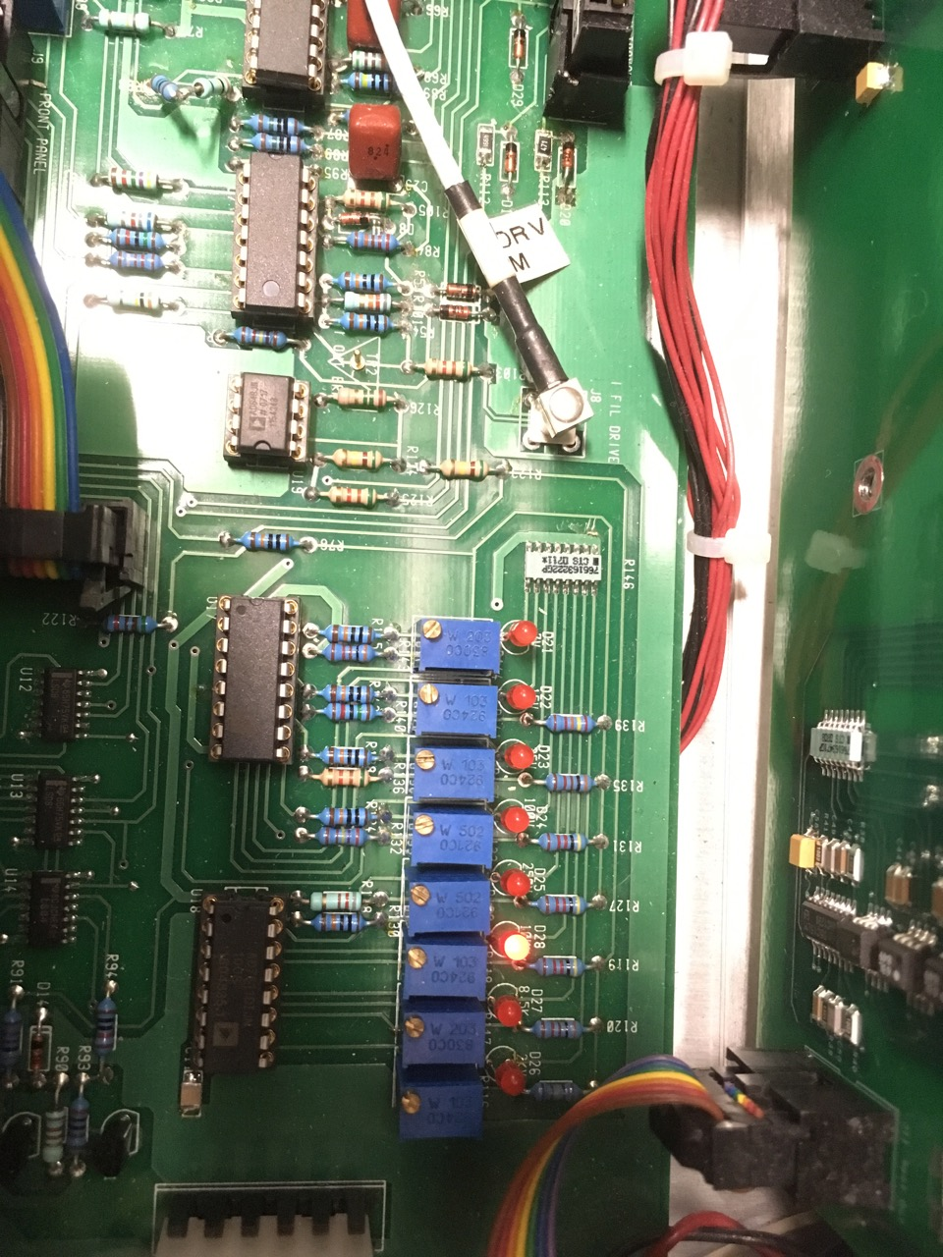For initial setup it is good to reduce the power (Power - IOut × 10,000 V) for the 500- and 800-micron spots and then adjust the power to the operating value after the spot size has been checked. This can be done using pots R129 and R133, Fugure 5. These two pots are found in the back right comer of the Analog Mother board. This board sits horizontal at the bottom of the front bay. There are 8 pots in a row. R129 and R133 are in the center of this group. They are the 4th and 5th pots counting left to right. The LED behind the pot will be on when the spot is selected. Turn the pot 10 turns clockwise to drop the power to it minimum value. Select the 500 Micron spot. Use the spot size control box to set the spot size. Then turn the power control pot counter clockwise to increase the power. It may take a few turns before power begins to increase. It would be best to take the 500-micron spot to 75 watts (ΙOut = 7.5 mA) and then wait 15 minutes to see how the pressure reacts. Re-set the spot size after obtaining full power. The voltage required to maintain the designated spot size increases as the power is increased. If the pressure is OK then go on to 100 watts. For the 800-micron spot use an intermediate power of 150 Watts. Then go to full power of 200 watts.

Figure 5 Iout control pots on board inside of 9600 power supply

Note: We recommend that after the initial setup you make a table of all the actual values shown in table 1. This table should be kept in a convenient place so all users can monitor the values on a weekly bases.

1. After the gun is set up and has run for a day it is OK to return the Service/Operate toggle switch back to the operate mode. This will allow the supplies to ramp up to full power in about 3 to 4.5 minutes.
2. If a Line/Spot gun is installed then the L 1, L2 and L3 line may be selected. The L1, L2, and L3 lines have the same power as the 250, 500 and 800 spots. The power density must be kept constant. A 500X500 Micron spot has an area of 250,000 square Microns. Any line with the same area may be used. ~~The silk screen suggests 200X800 Microns~~. This should be changed to 250X1000. The user may modify this to meet specific applications as long as the area is 250,000 square Microns is maintained. The area for Ll is 40,000 and for L3 is 640,000. The practica1line dimensions are Ll = 100X400 and L3 = 500X1200. Note when you set the spot sizes you need to correct the horizontal measurement by the 35º angle of the source? First adjust the Quad to the the line length and then adjust the focus. You need to repeat each a few times. Be sure not to over focus the spot. The focus pot is below and to the left of the led and the quad pot is below and to the right.
3. The controller can be set in the Computer Mode by pressing the front panel control. In this mode the computer can set the supply in Stand-by or in operate. The computer can also select any spot size and spot off.

Note: The X-Ray gun controller front panel is the same for both the spot controller and the line/spot controller. This allows any spot controller to be easily upgraded to a line/spot controller. If one of the line conditions is selected the controller will cause a spot gun to go to the appropriate power for that condition. As pointed out in section 9 above the 300-micron spot is at the same power as Lt, 500-micron spot is the same as L2 and the 800-micron spot is the same as L3. IT IS RECOMMENDED THAT IF A SPOT GUN IS USED THE L1, L2 AND L3 CONDITIONS HAVE THE SPOTS ADJUSTED TO BE IDENTICAL TO SPOTS 300, 500 AND 800. THIS WILL AVOID ANODE PROBLEMS IF THE L1, L2 or L3lines are accidentally selected. 8

**Setting Monochromator and Microscopy.**

1. Load a phosphor, Cu and Au sample into X-ray analyzer on the special stage that can measure the total sample current. **Make sure that the height of all the samples is the same.**
2. Place the Au sample into the x-ray beam.
3. Adjust the z motor control of the stage to maximize the counts for Au. You will need to use the software to set up a scan for Au and stop it near the Au peak.
4. 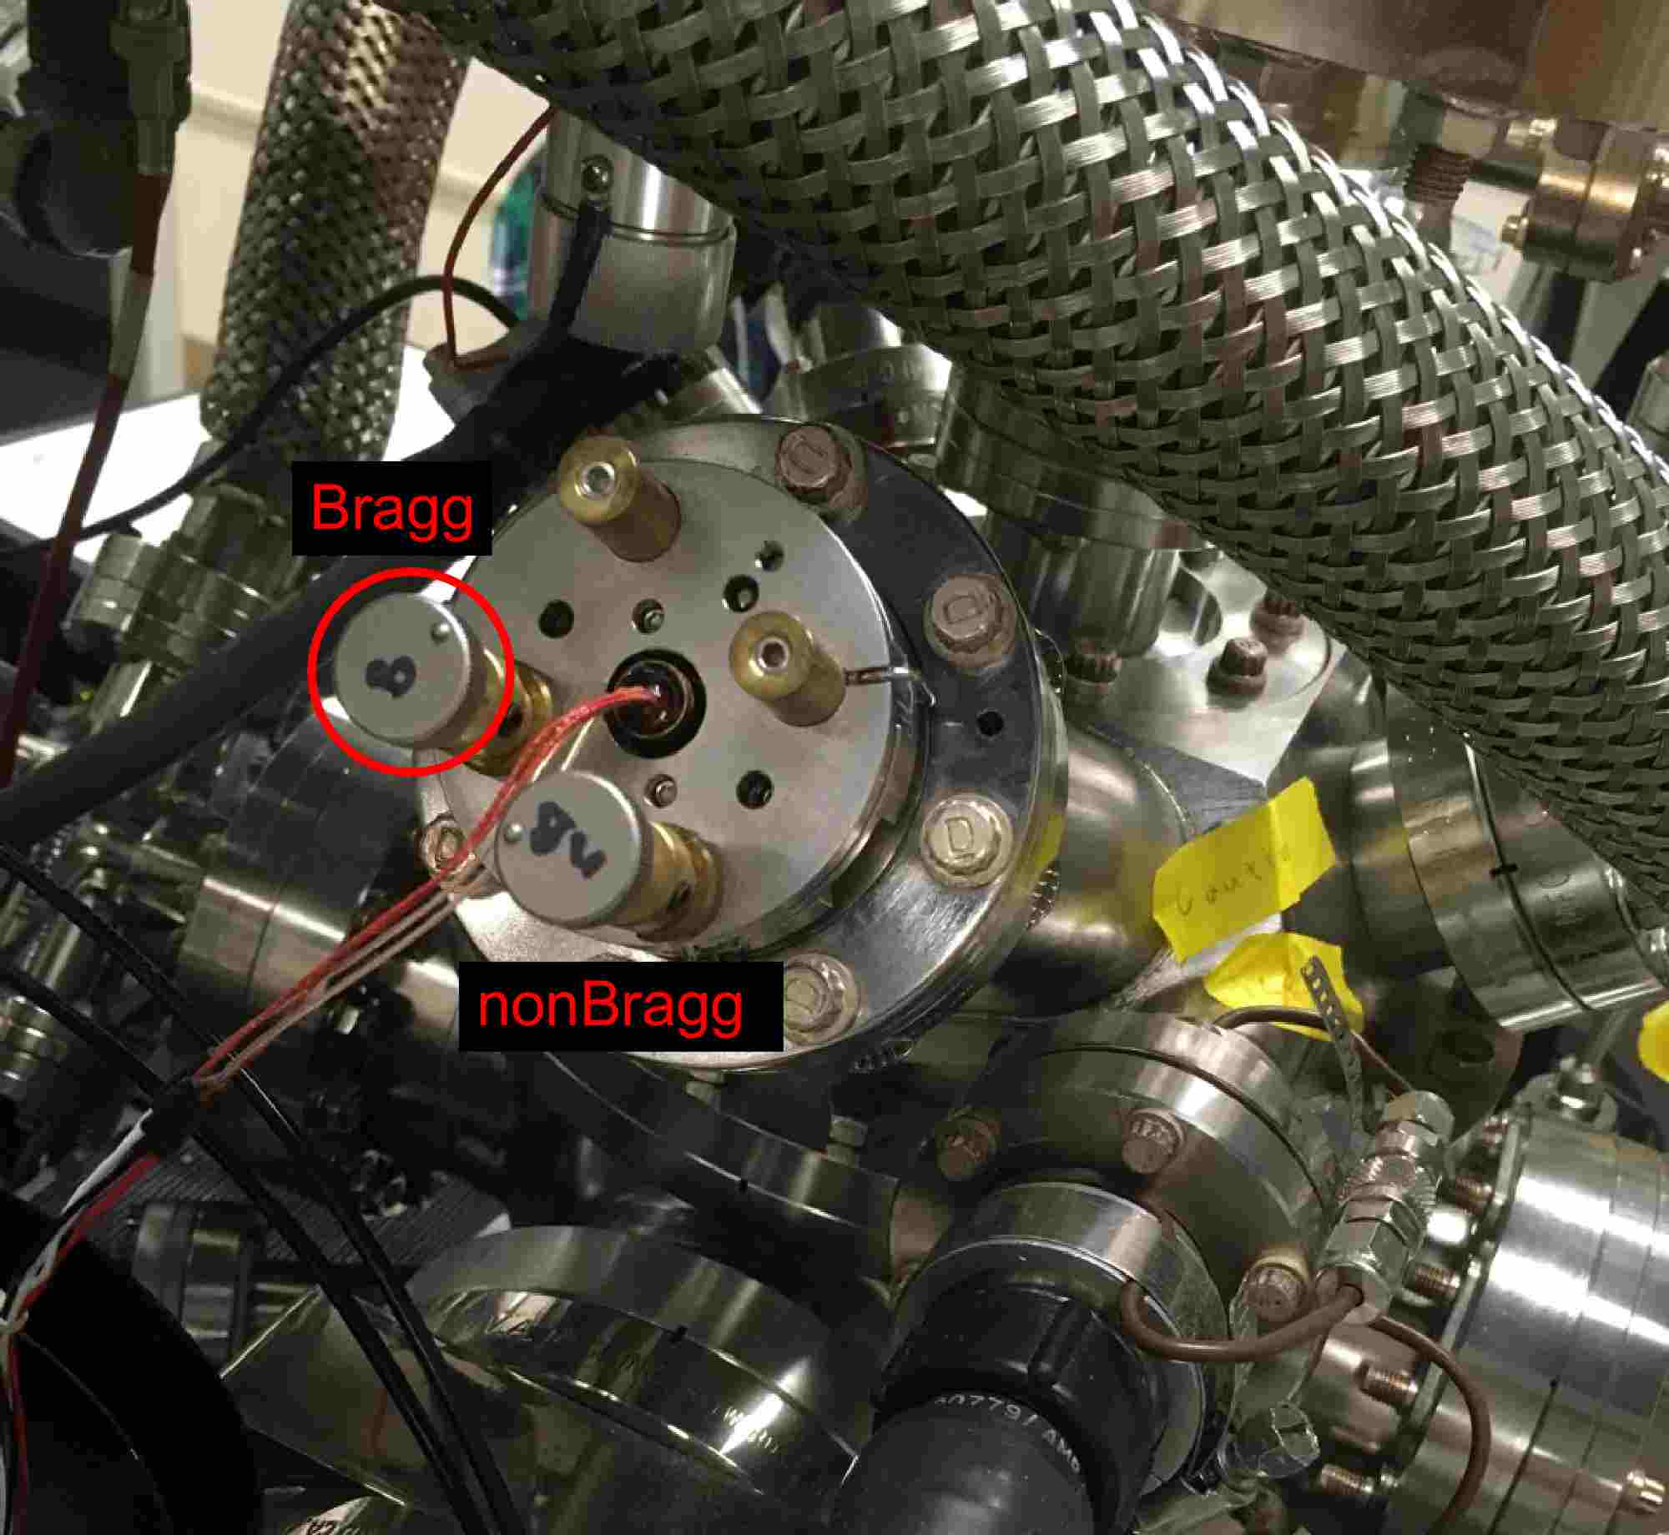 Remove the cover of the controls for the monochromator crystal (black plastic cap to the left of the microscope). There are two controls for the monochromator the Bragg and nonBragg control. The Bragg control is at 8 and nonBragg is a 5 o’clock or possibly the Brage is at 3 o'clock and the nonBragg is at 11 o'clock, Figure 6.

Figure 6 Quartz Monochromeator adjustments. Bragg contrl marked B

1. Adjust the **Bragg** control to maximize the reading on the electrometer. (This is best done with the electrometer by measuring the sample current, it can also be done with a Au sample and maximizing the counts or the Phosphor screen in the x-ray beam and you will be able to see the beam getting brighter.)
2. If using the electrometer:
   1. Move the stage up and down in small steps (best to turn off the auto motor control and even computer control of the stepper motors and move the stage by hand ) at each point maximizing the current. Using the **nonBragg** control
   2. After finding the position that yields the most counts tweek the **Bragg** controll to optimize (this should be a very small adjustment).
   3. GO to step H.
3. If not using the electrometer but measuring the count rate
   1. Maximize the count rate using the z control of the stage (if you go to the motor control panel and turn off the computer control of the stepper motors, this is easier) . Note the number of counts that you have.
   2. Move the **nonBragg** control in one direction to reduce the counts by ½.
   3. Adjust the z control to bring back the counts.
   4. If the maximum in the counts is more that it was in step a above continue in the same direction and redo step a-d If the maximum in the counts is less then it was in step E above adjust the **nonBragg** in the opposite direction. If it was more adjust the **nonBragg** again in the same direction.
   5. Continue doing steps a-e until no more improvement can be found.
   6. Adjust the **Bragg**to maximize the count rate.
   7. Redo steps D-H until both the Bragg and nonBragg are optimized.
4. Put the phosphor in the x-ray beam.
5. Maximize the counts by using the z stepper motor control . Note that the Au has a slightly different height then the phosphor.
6. Adjust the crosshair position so it is at the center of the spot.

**Calibration of Detector**

1. Load a Cu and Au sample into the XPS and focus on the Au sample. Note that the Au does not need to be sputter clean but the Cu will most certainly need sputtering. The Cu adjustment is less important and can be skipped most of the time.
2. Set the PS to computer control.
3. Start the data collection program.
4. Go to: "settings: set up ESCA: Detector width".
5. Use 500 μm spot size.
6. Running the detector width calibration takes about ~15 minutes.
7. Go to V1 curves and run the procedure. If it completes, click calculation and then update register.
8. Put the Cu sample into the XPS and go to DAC
9. Run the procedure
10. Put the Au sample into the beam
11. Go back to the collection main program
12. Open performance test (top left)
13. Choose Gold diagonal
14. Run the test
15. For each curve go to peak and analyze it for area and peak width.

