Stark Spectroscopy – Deanna’s Experimental Procedure
NWU Hupp Lab – Fall 2003

1. Generate mixed-valent state of compound – check in 1mm cell. Ideally want Abs ≥ 1.

2. Setting up the instrument

- Approx. 1hr before commence expt. turn on the Lamp and Cary switches, turn on the Arc lamp and slowly increase the supply to 0.90
- After 1hr, turn on extra switches and the DSP lock-in amplifier
- Setup the scanning programme: with Old dewar, absorbance spectra need to be obtained before Stark spectra.

>load olis-14
>n
>run

>’F5 key’ at main screen
>N to set no. of data points; then enter current slit width and wavelength.
>S

- Setup scan range etc. e.g. 900 – 1500 cm⁻¹ range; 300 points (2nm steps) using oxidised ITO plates and 100 μm path length.
- Set-up the amplifier – values should be retained from previous runs
- Maximise the detector signal at its max. wavelength e.g. HgCdTe max. at 1280 nm (which is the large ‘spike’ in the detector output). On computer, open slit width to full and set wavelength to 1280 nm and on detector. Also open bar graph on lock-in amplifier or take note of A1 values. Maximum is 10.9V, but set at 10V for old dewar (decrease the slit width to achieve this value e.g. for old dewar, slit width = 2.11 while voltage = 10 V). Vary the x, y and z position of the detector and the x position of the sample dewar to maximise the voltage.

New Dewar

liq. N₂

N₂ in (Al foil around opening)

air in
(both sides)

3. The sample dewar must be kept under vacuum (use pump) between experiments. Turn upside down in tort stand.

4. Fill outer dewar with liq. N₂ first – when full, fill inner dewar (use a funnel with paper to trap water droplets). Note: must use fresh, dry liq. N₂.
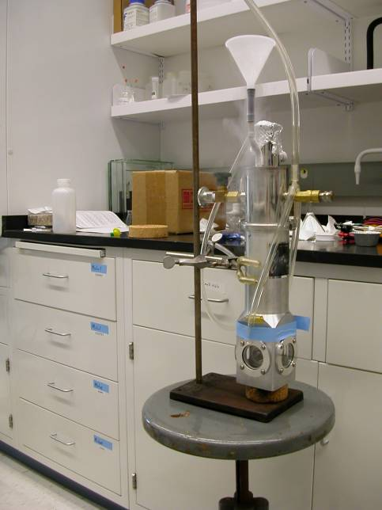
5. Continue to top-up outer dewar with liq. N₂ (every 5 mins during exp., but < 5 mins during preparation period).

6. Insert the electrodes very slowly into the inner compartment which is full with liq. N₂ (check that the plates using multimeter – they must overlap) Butyronitrile background first. Check electrodes are at 90º by sight, then clamp fully. Release pressure. Set stopwatch to 5 mins and start re-filling outer dewar at these intervals.
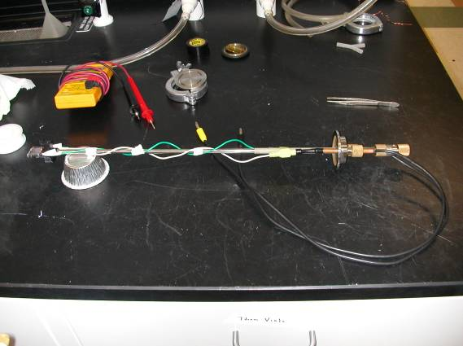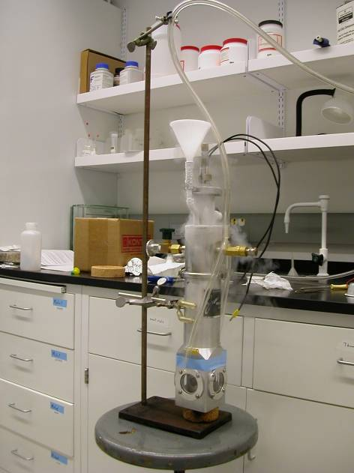
7. Mount the base in the CARY and set up using the saved “stark_method”. Place dewar in CARY (black material) and go to Align to turn on white light (don’t press OK). Check with paper. Determine plate spacing from the interference pattern
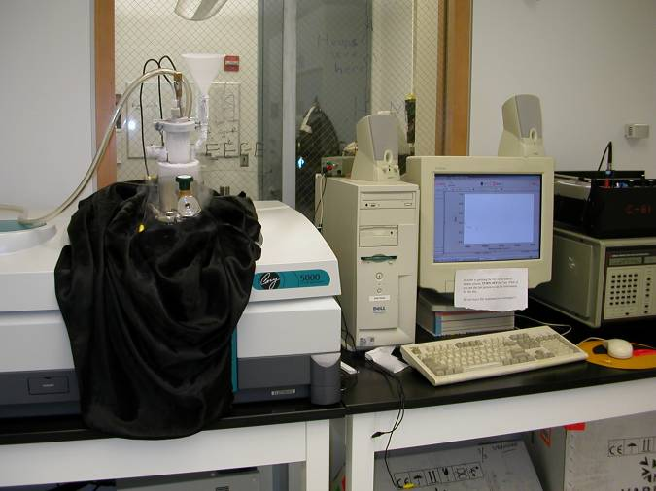
8. Once complete, place dewar in stand again. Release pressure through electrode seals and then release clamp and remove electrodes. Defrost slowly and wash with acetone. Once dry, filter sample through micro-filter between electrodes.

9. Run sample absorption spectrum.

10. Sample Stark spectra:-
Note: X = DC signal and A1 = AC signal
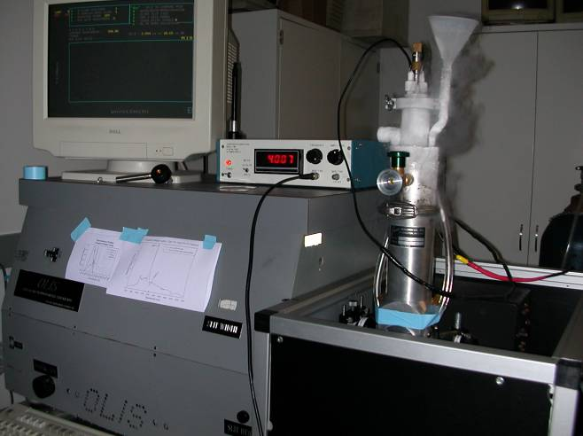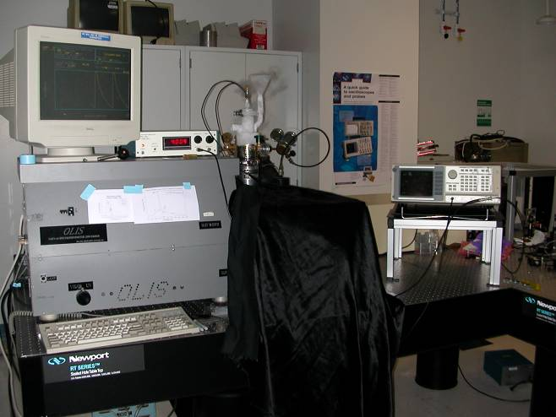
- Turn on air and refill N₂. Turn on blue box. Open slits.

- Align dewar horizontally (can change wavelength to 550 nm (green light) for alignment by eye). Use 980 nm spike for DE110 Si Vis detector or 1280 nm for HgCdTe detector.

- Observe A1 values and vary slit width and x, y, z position of detector to maximise. Change sensitivity etc to desired values.

- Connect electrodes, reset field, then slowly increase field until it breaks. Use the highest possible value which is sufficiently below the limit. Collect spectra - ‘G’ and ‘start’ to collect. Collect two scans at each angle. NB: rotate in direction that the electrode cords are coiled. On changing from 90º to 45º, open slits, change sensitivity and vary horizontal position of dewar.

- Refill inner dewar if a new set of stark spectra are to be recorded. Release pressure through electrode plugs first and disconnect field.

* Changing detectors during a run: e.g. HgCdTe (controlled by detector switch) to Si pin (own power supply). Turn off detector and unplug. Plug in Si detector and switch on. Align at 550nm and vary x, y, z etc.

* To empty:- empty liq. N₂ and blow air through *, then blow air through inner upturned dewar (through the main opening at the top).

On completion of experiment:

- Close slits (A = 0)
- turn current down gradually and then turn off
- Esc then Z
- turn off all switches except the right-most two
- place red cover on HgCdTe detector or switch Si pin detector off

Old Dewar

3. Fill the dewar with liq. N₂ (through paper funnel) and turn on air for windows. Remove polariser.

4. Background scans on Butyronitrile:- pipette ButN between plates and slowly lower into dewar. Electrodes not connected. Place He tube in and cover instrument with black cloth.

To start an absorption scan:- hit V, W (enter start value e.g. 2400cm⁻¹), hit G and when wavelength clicks over hit Start button on detector unit

To end an absorption scan:- hit Pause/Reset button on detector unit. Hit Disc button (if no save option on screen), hit the button next to file name of spectrum and change to next number. Then hit button next to Save Ascii data. After saved on disk, transfer data into my directory using another computer. Start to process this data while waiting during next scan.

To prepare for next scan:- Top-up liq. N₂, hit V, W (enter start value), erase data from detector screen (Pause/Reset button then Enter button). Hit G and Start button.

Repeat baseline twice then remove electrodes and dry with hair drier. Wash ButN out with acetone and dry with N₂ gas . Do not remove ITO plates.

5. Sample absorption scan:- using a multimeter check the electrode connections. Use a micro-filter syringe to enter sample between cells (place sample back in fridge). Lower electrodes slowly into dewar and repeat procedure given above for baseline scans. Top-up liq. N₂ between scans.

6. Sample Stark spectra:-
Note: X = DC signal and A1 = AC signal

- Blue box should have been turned on ~10-15 minutes prior to warm up.
- Insert polariser (check it is straight)
- Connect red and black electrodes and slowly turn up the amplitude dial on the blue box to 4kV max. If this cuts out during scan, field is too high. Turn off blue box and then increase field gradually after switching back on to 3.3kV say. Note that on detector unit, gain is 1mV. Also check that θ on detector unit is not fluctuating too greatly. Also check frequency reading on detector (200 Hz)
- Save both spectra on detector display – hit Disk, then change active display to 1 and then 2. Change filename and save as ascii files.
- Refill liq. N₂ and repeat. Two scans at 90º then two at the “magic angle” for ButN which is around 43º. Also may need to vary slit width to increase light transmission.
- Record:
Field (e.g. 3.25kV and 200 Hz), Slit width (2.11mm or 7.71nm bandwidth), Time constant (1s) and Sensitivity (1mV)

*Important Expt = Field dependence of the angle to confirm the quadratic dependence between 90º and the magic angle. This is important.

