INSTRUCTIONS
How to capture a picture:

Step 1
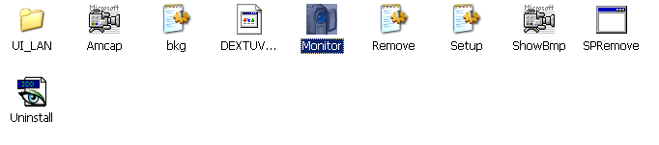
After opening the folder named “Amcap”, double click icon “monitor.exe”, as Picture 1:
Picture 1

Step 2
Double click icon “Amcap.exe” and you will see picture 2 as below:
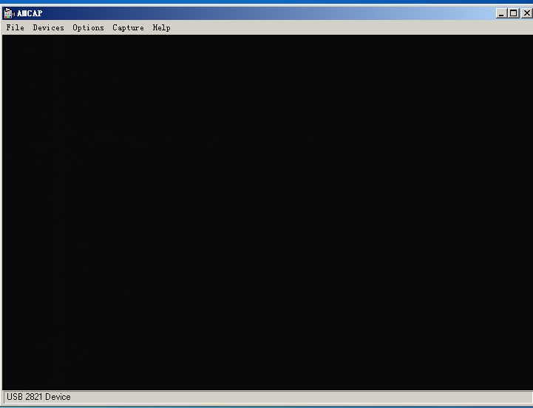
Picture 2

Step 3
Click “Capture” and then click “snap one” as shown by Picture 3 as below. You will then capture a picture, as shown in Picture 4:
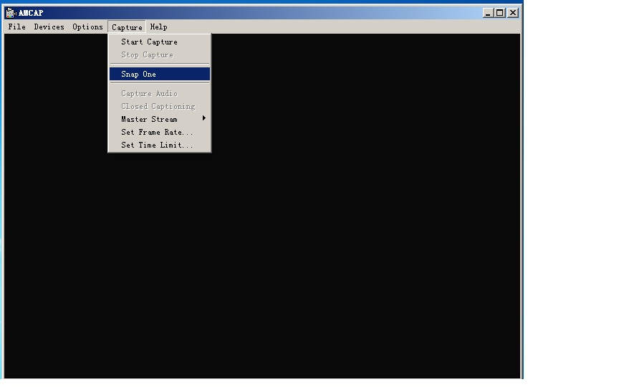
Picture 3

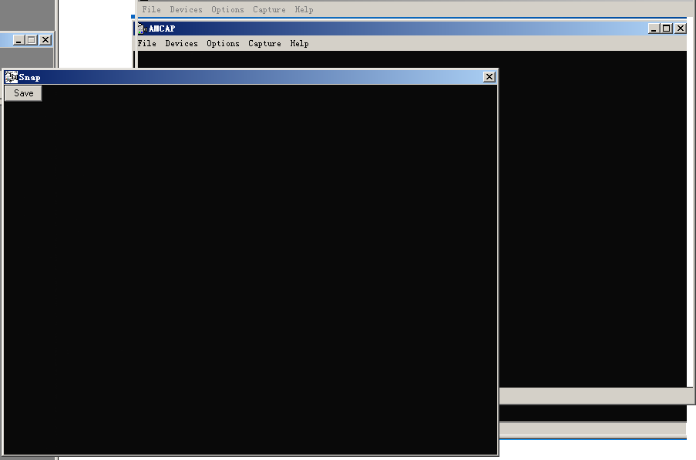
Picture 4

Step 4
Click “Save” you will get your picture saved.

How to record:
Step 1
Click “Capture” and then click “Start Capture”, a box will pop up, as shown in Picture 5 and 6:
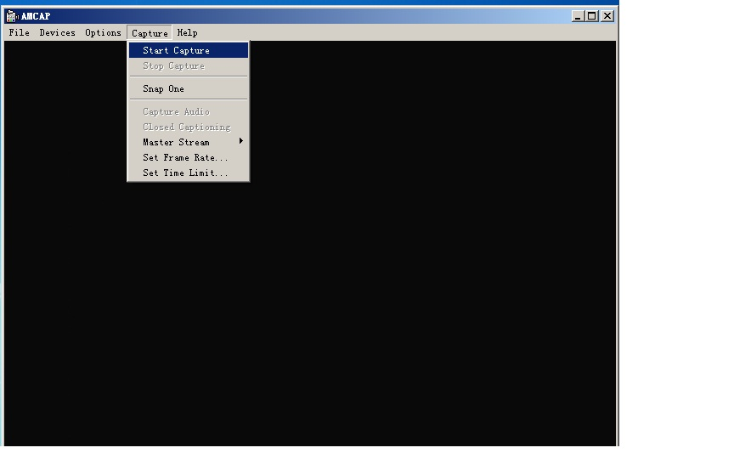
Picture 5

Step 2
Choose the folder you would like to put the video in from side bar, input the video name in “file name”, and then click “open”, as shown in Picture 6:
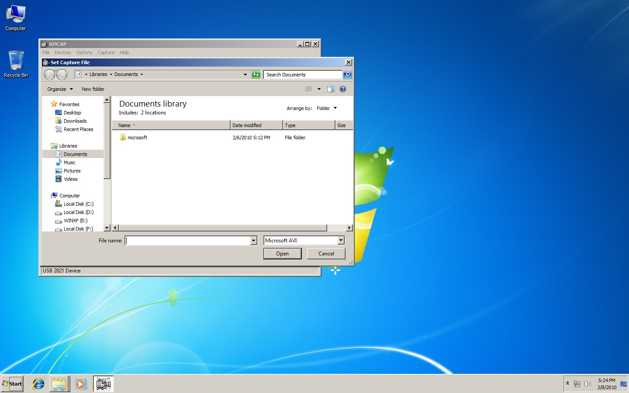
Picture 6

Step 3
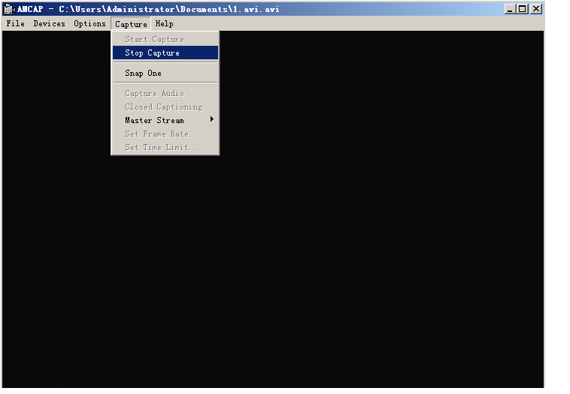
Again click “Capture”, and then click “start capture”. Follow the instruction to click “OK” and you will start to record the video. When you want to finish the recording, click “Capture” and then click “Stop Capture”, as shown in Picture 7:

Picture 7

Step 4
You will have got your video saved in the file you have chosen in Step 2.
- If the format of recorded video appears incorrect, add filename extension “.avi” after the file name and you will be able to open it through video player.
- If the format of recorded video appears correct, you can open the video directly.

If you want to change the files path, please click “Set Capture File” and choose the files path you want, and then click “open”:
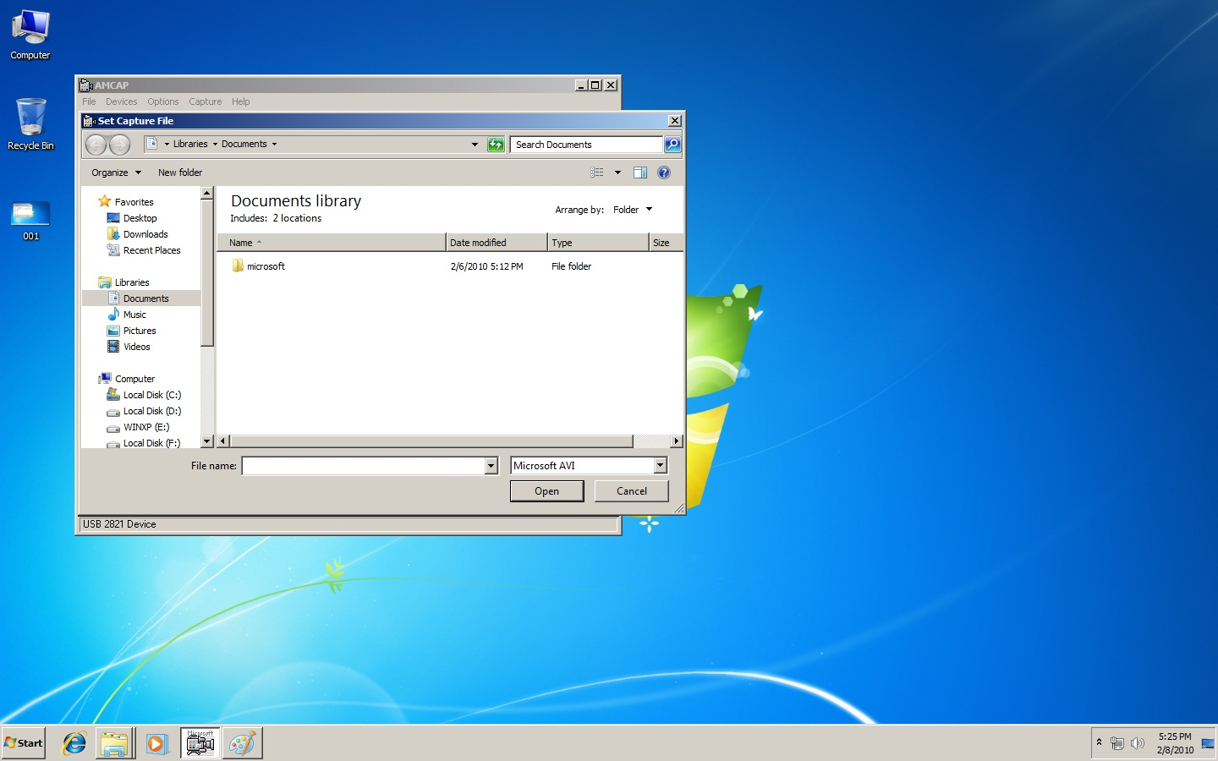
Picture 8

