Quick Start MMRC N icolet 6700
Do Not Remove
Revised 10/24/2018

- Fill out the logbook before you begin.
- Before you start the Nicolet should be on with purge gas flowing.
- Check that the purge gas is N₂ and that it has a flow rate of 30 ft³/h (14 l/s). The purge gas flow meter is behind the FTIR. Note that you can purge the system at a higher flow rate but at higher flow rates the performance of the spectrometer is not as good.
- If you want to use the MCT or Si detector you need to check that they are in the beam path (if you cannot tell you can see what is installed when you run Omnic). See table below for ranges of the detectors and beamsplitters.
- For the MCT detector you need Liq N₂ for cooling. You add the LN2 using the small white funnel near the instrument and opening the little door above the detector. Add the LN2 slowly at first because the rapid boil off tends to not let much LN2 into the detector. It will take about 5 – 10 minutes to fill it the first time and the detector holds ` 750ml of LN2. Allow the detector to cool ~20 minutes

Detector Ranges/cm⁻¹ |  |  | Bean Splitter Ranges/cm⁻¹
DTGS | MCT | Si | KBr | Quartz
10,000 – 420 | 10,000 – 370  (400-1000 nm) | 25,000 -9,000 | 7,800 – 370 | 28,000 – 4,000  (350 -2,500 nm)

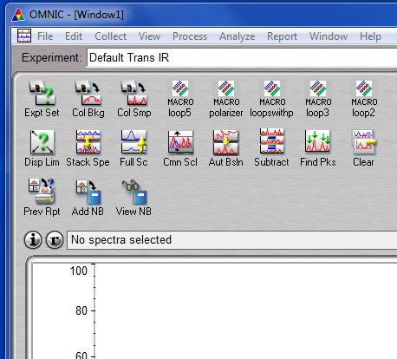
- If you have been trained and need to change the beam splitter and or the detectors see the directions for that below.
Figure 1 Omnic main screen
- If you need to install an accessory do that now.
- Start the OMIC software. It will offer an Experiment which if you know what you want you can choose. Otherwise cancel the experiment window.
- You should now see the window shown in Figure 1.
- Choose the icon “Expt Set” to setup your experiment.
- The experiment setup window will open with 6 tabs on top.
  - Choose the Bench tab shown in Figure 2.
    - You need to choose your detector, beamsplitter and source. The drop down menus for detector and source will show what is already in the spectrometer. If you need to change any of them see instructions below.
    - You should also set the wavelength range . Remember if there are absorptions outside the range you choose they will be “folded” into the range you are observing. Best if any region excluded has no light intensity.
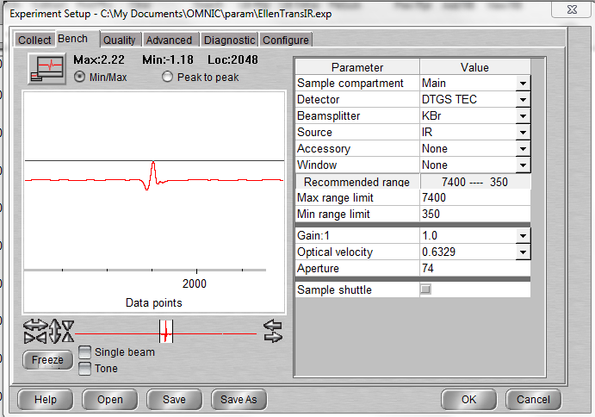
    - The Gain, optical velocity and aperture interact.
Figure 2 Bench tab in Experimental setup window.
      - Optical Velocity: This is the speed of the moving mirror in the interferometer. The velocity can be set from 0.18 to 6.3 in relative units. The slower the velocity the long it takes to collect a spectrum; however, as you increase the velocity you decrease the intensity of the spectrum. So sometimes with a slower velocity you can take fewer scans.
        - DTGS detector scan rate should be ≤ 0.6329 if uncooled with 4 cm⁻¹ resolution.
        - MCT can scan as fast as 1.89 at 4 cm⁻¹
Detector | Aperture
DTGS | 63
MCT, or Si | 32
      - Aperture: This determines the area of the opening to the light beam. Doubling the aperture doubles the area and should also roughly double the amount of light hitting the detector. However, a larger aperture will increase the absolute signal but also decrease the resolution. The instrument will tell you if the aperture is too large for the selected resolution.
      - Gain: The gain needs to be set so that there is sufficient signal to measure.
        - The autogain setting will measure the signal just before the spectrometer starts to collect a spectrum and set it accordingly. This takes only a small amount of time.
        - Otherwise one can set the gain by putting you sample in the spectrometer and setting the gain so that the peak to peak maximum of the interferogram is between 3 and 10.
  - Choose the Collect tab and you will see the window show in Figure 3
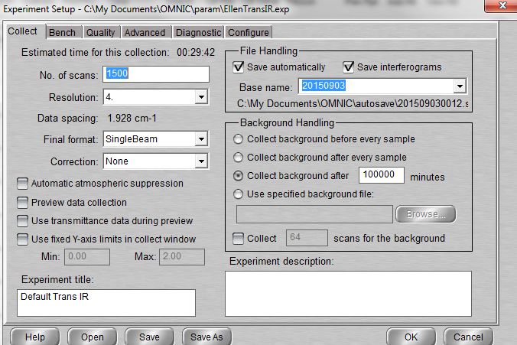
    - Set the No. of scans, the Resolution, and the check boxes you want. When you change the resolution, it interacts with the settings on the Bench tab.
Figure 3 Bench tab of Experimental Setup Window
    - The Final Format can be Interferogram, SingleBeam, %T, Abs, etc. If you choose SingleBeam you will need to ratio your reference and sample spectra to get %T after taking the spectra (see 15 d ii Processing below). If you choose %T or Abs you need to take a reference scan before you take a sample scan and the instrument automatically references the two.
    - Correction: This is for the use of accessories like ATR, reflectance or other. For “normal” transmission spectra none is ok
    - If you automatically save the spectra make sure the path is the one to your folder. (You can set the path under the menu Edit: options.)
    - It is always good practice to add an Experimental description that tells the sample you are running.
    - Finally, you can save your setup but since everyone’s setup is saved in the same folder you need to add you name or initials at the start of the file and a descriptive title like BSB_Abs1000.
  - Diagnostic tab: You can align the bench in this table ( need to set the gain to 1 to do an align).
  - 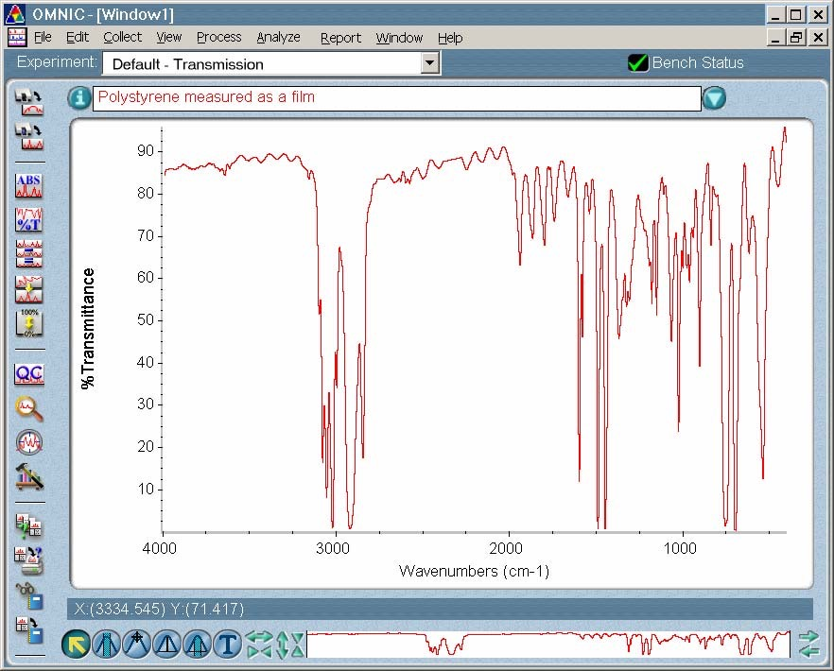Advanced tab: Can set Zero filling (none but I like level 1), Apodization (Happ Genzel), Phase correction (Mertz), sample spacing (2 or IR, 1 for NIR), filters (based on velocity) and single sided (not check) this gives a double side interferogram. Note that when you reprocess (see 15 d ii below) that these same parameters need to be set.
Figure 4 Spectra Window
- Once all the experimental parameters are set close the Experimental Setup window.
- Now on the main Omnic window choose collect sample “Col Smp” icon if you are in single beam mode or Collect background “Col Bkg” if you are in Transmission or Abs mode. In the latter case after it collects the background put in your sample and collect the sample spectrum. As if scans you will see the spectrum in the plotting area of the window. Hint: if you choose %T or Abs you will see an actual spectrum; however, if you choose single beam you will see the single beam intensity with doe not show much spectral information.
- You can save your spectra in a folder with your name. All spectra folders have the path C:\my_documents\omnic\spectra\XXXX. Please do not save spectra to the desktop or in other people’s folders.
- Spectra Window: Figure 4
  - The red spectrum is active. There can me multiple spectra shown at one time. You can delete or save the active spectrum. Select a different spectrum by clicking on it. Select multiple by shift clicking.
  - The View finder at the bottom right of window can change be used to change the wavenumber/wavelength limits of plot
  - Tools: Lower left of window
    - Right 4 icon lets you set x and y scale
    - Yellow arrow tool at left lets you select, expand or contract, move spectra
    - Other tools let you choose region of spectrum, create x,y cursor, measure peak height, measure peak area, and annotate.
- Options for other menus:
  - File: Save selected spectra, Open spectra, save and open configuration file.
  - Edit: editing annotations, toolbar, or menus, Options
    - Options: set path and many many other options. Note if you change the default options please save your configuration with your name and do not make it the default configuration.
  - View: Allows you to control how the spectrum is displayed:
    - Full scale draws all the spectra in the plot area so that each one will have a peak that goes full scale. The only spectra that relates to the Y axis shown is the one selected. In this mode the amplitudes on various spectra cannot be compared.
    - Common Scale draws the spectra show that they are all on the same scale. Be careful is the spectra have fundamentally difference Y axes such as one with %T and another with Abs.
  - Process: Allows one to convert a spectrum between various forms and convert a single beam spectrum to a true ratio spectrum.
    - Abs, %T, etc. converts from one to the other.
    - Reprocess: Allows one to convert from single beam to a ratio spectrum need to specify a baseline and the various other parameters (see Advanced tab 10d above)
- When you are done make sure the instrument is purging with air. You can quit Omnic.

FTIR Hints:

- DTGS detector scan rate should be ≤ 0.6329 if uncooled.
- MCT can scan as fast as 1.8988,
- Gain of detector should be set so the peak to peak reading for the interferogram is ∼ 10 V p to p
- In most cases you should scan forward and back and 2 sided
- Quick checks of Instrument:
  - DTGS detector. With nothing in beam path, using the DTGS detector, scan rate of 0.4747, aperture of 100% , and gain of 1, you should see an interferogram peak of about +5 and min of -3 or a max to min of about 8V.
  - MCT detector. With nothing in beam path, using the MCT detector cool (i.e. LN2 in detector), scan rate of 1.8988, aperture of 18% , and gain of 1, you should see an interferogram peak of about +7.4 and min of -6 or a max to min of about 13.4V.
  - ATR accessory. Run background with nothing in the beam. Using the same conditions (mirror velocity, aperture, detector, etc.) run a “sample” spectrum with only the ATR in the beam and no sample. The throughput should be 30% for the diamond Smart ATR at 1000 cm⁻¹, and Seagull at 2000 cm⁻¹. For the Horizon and Praying Mantis it should be between 24 and 40% at 2000 cm⁻¹.

Changing the Detectors:
The detectors that we have and their ranges are shown below.
Detector | Range cm⁻¹ (nm) | Sensitivity
MCT | 11,700 - 420 (1×10³ - 2×10⁴) | D* > 5 x 10⁹ cm Hz^{1⁄2} W⁻¹
DTGS | 12,500 - 370 (1×10³ - 3×10⁴) | D* > 2 x 10⁸ cm Hz^{1⁄2} W⁻¹
Si diode | 25,000 - 9,000 (400 – 1,100) | NEP < 10⁻¹⁴ W Hz^{-1⁄2}

- Turn off the power to the Nicolet FTIR (switch on power supply brick).
- Open the top of the Nicolet, by first loosening three screws on the bottom front of instrument, and prop open.
- Use a screwdriver to loosen the detector you want to remove.
- Put the new detector into the place of the removed detector and press down on the base to make sure the electrical plug makes contact.
- Screw down the base of the detector.
- Close the top of the Nicolet
- Turn on the Nicolet.
- Check that Omnic sees the new detector.

Changing Beamsplitter

Beamsplitter | Range cm⁻¹ (nm)
KBr | 7,800 - 370 (1,300 – 30,000)
Quartz | 27,000 - 4,000 (370 – 2,500)
The beamsplitters have the ranges shown at right.

- Unlock and open the beamsplitter door (top right-hand side).
- Rotate the locking handle counter clockwise 180º on the beamsplitter holder.
- Remove the beamsplitter in the instrument and place it in the storage area.
- Remove the other beamsplitter from the storage area place it into the instrument.
- Make sure that the beamsplitter is seated in position and rotate locking handle clockwise 180º.
- The label on the handle on the beamsplitter should face forward.
- Close and lock beamsplitter door.
- Start the Omnic software and go to experiment setup.
- Go to bench and make sure the correct beamsplitter, detector, and light source are chosen.
- Go to diagnostics in the experimental setup screen.
- If you are working in the NIR or vis see instructions on web for NIR or vis.
- Make sure you see the interferogram (if you do not try to reduce or open the aperture to see if the interferogram appears also check the settings of the beamsplitter, source and detector) .
- If you cannot see an interferogram see below.
- After you see the interferogram Press align.
- When alignment completes you are ready.

