Contact Angle Goniometer Quick User’s Guide
Updated 11/06/2018
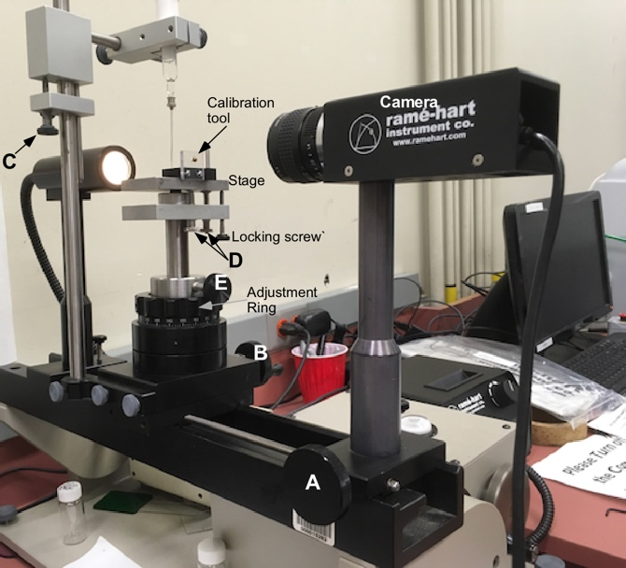
Start up
Figure 1 Contact Angle Goniometer
- Sign up in the logbook.
- Remove the cover on the instrument and start the computer, little Lenovo ThinkCenter.
- Make sure the instrument is level.
- Make sure the camera stand is locked to the rail and that the stage is unlocked and can move by turning knob A, Figure 1.
- Make sure the stage is level.
- Remove the syringe and needle. Clean both the glass syringe barrel, needle, and syringe plunger carefully in DI water. It is recommended that if you want to use different liquids you purchase your own Gilmont GS-1200 syringe and barrel.
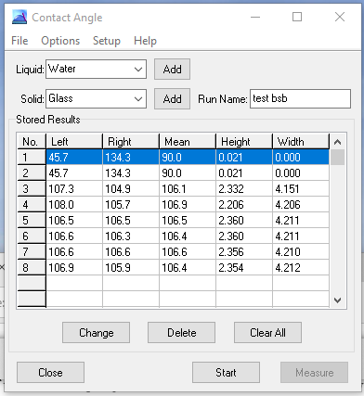
- Put your solvent in the syringe.
Figure 2 Contact Angle Window
- Turn on the fiber optic light for the goniometer to about 12:00 .
- Start DropImage software, you should see a live image if not check the “Live Image” box in the top right of the image, Figure 2.
- If the stage is at the wrong height: Adjust the height either with the Adjustment Ring or if you need to adjust it more, hold on to the stage with your hand and loosen screw E and move the stage so that it is in the light path.
- Select the Contact Angle icon, in the software.
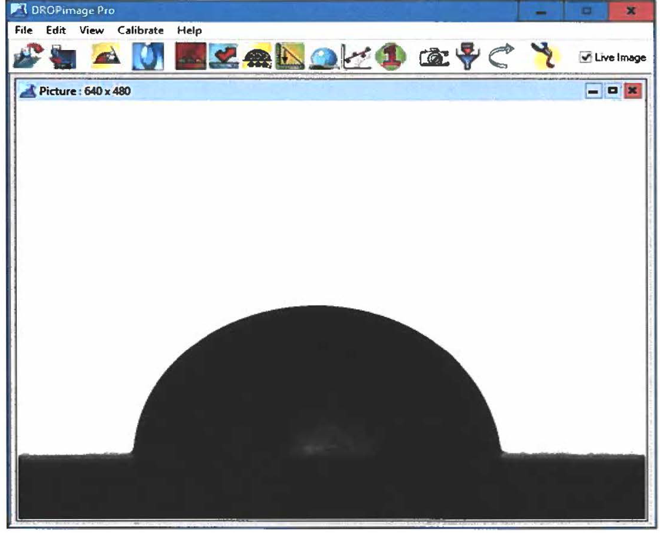
- In the Contact angle window, Figure 3, select the liquid and solid phases from the pull-down boxes in the upper part of the window. If the solid or liquid you want to measure is not in the list, new items may be added by pressing the corresponding Add button. Note this is only necessary if you plan to calculate surface energy.
Figure 3 Main DropImage window.
- Enter a Run Name. If you want to use the results in the Solid Liquid Liquid tool, the Run Name box should contain the name of the external phase.
- Place your clean substrate or a glass slide below the syringe needle on the stage.
- Move the syringe so that the needle close to the substrate, knob C.
- Place a small drop on the surface about a 1/2” or more back from the front of the slide best not to use very large drops.
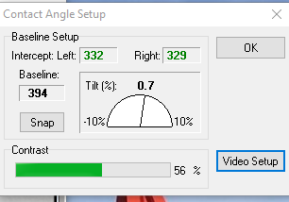
- Use knob A, Figure 1, to focus the image of the front edge of the substrate.
Figure 4 Contact Angle Setup window.
- Adjust the light level so the background is white and the substrate is black. Turn up the light up if needed.
- Select Setup from the menu option, Figure 3.
- Move the baseline to match the edge of the substrate. The Snap button should move the baseline to the edge if not you need to do it manually.
- If tilt is not close to zero you need to level the stage.
  - To Level the stage, loosen the black locking screw on the bottom of the stage and use the right knob D to set the tilt, Figure 1. You can watch the Youtube video of how to level the stage, https://www.youtube.com/watch?v=scIFT2c-8pg
  - Next Focus on the drop. Use the front knob D so you see a small amount of the reflection of the drop in the substrate, figure 6.
- . Select Options from the menu in the Figure 3. The Contact Angle Options dialog appears, Figure 5. Select the options you want, generally best not use right line, and close the Options menu. Options will be retained between experiments.
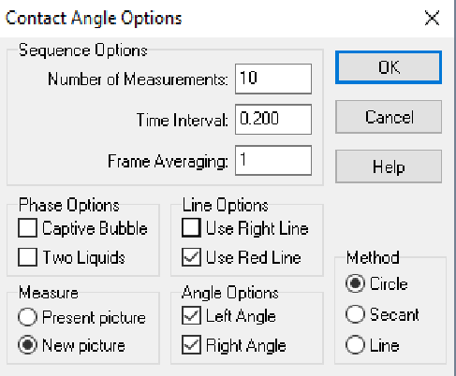
- Click the Start button, Figure 2. The crosshairs cursor lines appear.
Figure 5 Contact Angle Options window
  - Move the green horizontal line to the bottom of the drop using shift+left mouse button,
  - Move the red horizontal line to above the drop with cntrl+left mouse button,
  - Move the vertical green line by left or right mouse button to the center of the drop, see Figure 6.
  - If you use the “Right Line” you will have two vertical lines.
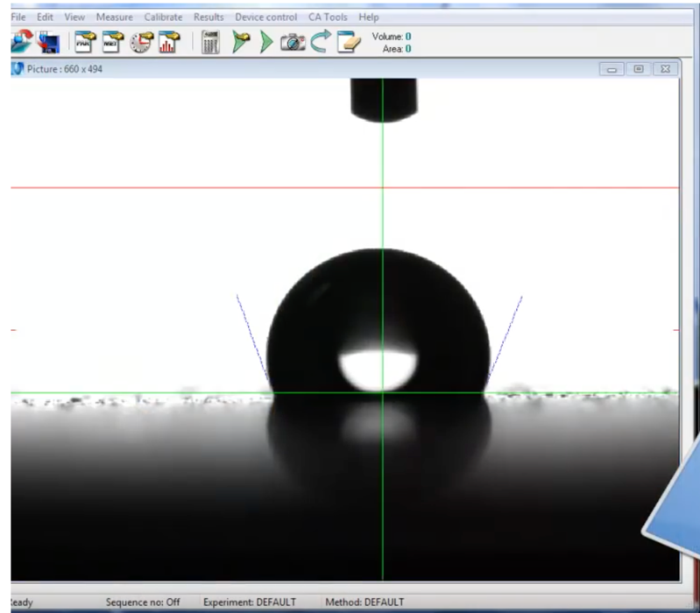
- Press Measure. One or more measurements are taken, according to your Options. The result(s) appear in the Stored Results table.
Figure 6 Active Contact Angle Screen with line placement
- Repeat Measurement as many times as you wish.
- When finished, press Stop (same as the Start button). The crosshair cursor lines disappear.
- Save the Contact Angle file by selecting Save As on the File menu.
- You may want to save the data in a text file, by selecting Make Log on the File Menu.
- You can also save the picture of the drop and analyze it with drop snake or other software.

Advancing/receding surface angle.
- By increasing/decreasing drop volume.
  - Place a drop on the substrate but keep the syringe needle attached to the top of the drop.
  - Focus on the drop.
  - In the Contact Angle Options choose a time interval of about 0.2 s and take about 100 measurements.
  - In the contact image window click start.
Figure 7 Side viewof Goniometer showning locking screws on camera and stage base.
  - Make sure the lines are correctly placed.
  - In the contact image window click measure.
  - Now slowly add or remove liquid to the drop using the syringe. During the time interval add or remove enough liquid so that the drop slowly advances or contracts its contact angle.
- By titling goniometer method
  - Connect the substrate to sample stage.
  - Lock the sample stage to optical rail, Figure 7.
  - Check that nothing is in the way of the goniometer tipping to the left.
  - Place a drop on the substrate.
  - Focus on the drop.
  - In the Contact Angle Options choose a time interval of about 1 s and take about 100 measurements.
  - In the contact image window click start.
  - Make sure the lines are correctly placed.
  - In the contact image window click measure.
  - Now turn the silver handle that tips the whole goniometer setup at a steady rate until either the drop slides off the substrate or it tips fully.
  - Raise the goniometer back up.
  - The analysis of the max and min of the drop angles are the advancing and receding contact angles.
Finish up
- Exit the software.
- Remove solvent from the syringe.
- Clean the stage.
- Power down the computer from the start menu.
- Cover the goniometer.
Calibration
- Start DropImage software
- Place the small calibration jig with the 4 mm ball on the stage and focus the camera on the ball
- Click the “Calibration” in the main menu, Figure 4, and choose new calibration
- Choose sphere
- In the live image place the cross hair just below the dark image of the ball so that the vertical line cut the ball in half.
- Click calibrate
- The ratio should be very close to 1.
- Done
Notes
Rame-Hart videos on Youtube:
  - All RameHart videos: https://www.youtube.com/user/ramehart/videos
  - Measure a Contact Angle: https://www.youtube.com/watch?v=EGquNqzxyVo
  - How to set the baseline: https://www.youtube.com/watch?v=934ov16YaB4
  - How to level stage: https://www.youtube.com/watch?v=scIFT2c-8pg
  - Placement of Lines: https://www.youtube.com/watch?v=PKRMzSK3xTU
  - Surface tension: https://www.youtube.com/watch?v=2FSnTeF-81I
  - Advancing/receding contact angle: https://www.youtube.com/watch?v=1wh0VtnCIEs
  - Advancing/receding by tilting: https://www.youtube.com/watch?v=UWMwSppjv6s
  - Tips for Improving measurements: https://www.youtube.com/watch?v=seyyMEYU-wk
  - Calibration: https://www.youtube.com/watch?v=SENtNTx5Wwo
  - Captive Bubble: https://www.youtube.com/watch?v=SENtNTx5Wwo
  - Acid base tool: https://www.youtube.com/watch?v=VlbI7bUBuIk

