M-probe XPS – Sputter Gun Manual
Edited 7-5-11 JAB

Preparing to sputter
- Follow standard procedure for loading sample into analysis chamber.
- Ensure that the pressure is in the 10⁻⁹ torr range.
- Slowly open the differential pumping line, watching that the pressure doesn’t go above the 10⁻⁸ torr range and quickly returns to around the previous base pressure.
- Open the Ar tank valve.
- Open the needle valve very slowly. Start by turning 1.5 turns ccw. This should not increase the pressure. At this point, slowly turn the valve until the pressure in the analysis chamber is 1-2 x 10⁻⁷ torr.
- Ensure that the 346 Physical Imaging Unit is powered on and set to the following settings:
  - Video gain: X1
  - Magnification: VAR
  - X magnification: 2 turns ccw
  - Y magnification: 2 turns ccw
  - X shift: 0
  - Y shift: 10
- Power on the 400X Gun Supply and check on the settings:
  - High tension: Standby
  - Extractor voltage: High
  - Emission current: 3 uA (left knob at 30%, right at 10 uA range)
  - Source energy: 1 KeV (coarse control at 0 KeV, fine at 1 KeV)
  - Focus: 5.600
  - Spot size: 6.980
Ramping up the power supply
- Navigate to an empty spot on the stub.
- Turn on the ion gun in the ESCA control panel using the software. The beam blank indicator light should come on, and the filament current should rise to a steady 2.5 A.
- Flip the switch to high tension.
- Ramp the source energy to 5 KeV slowly.
- Ramp the current to 10 mA slowly, watching that the pressure in the chamber does not increase above the 1-2 x 10⁻⁷ range.
- Turn off the ion gun using the ESCA control panel.

Sputtering analysis spot
- Navigate to the desired spot for analysis and set that position as home.
- Sputter one of three ways:
  - Manually using the ion gun control on the ESCA control panel.
  - Add an “Etch” step to a recipe by adding the desired sputter time in hr:mn:sc format. Expect a rate of around 50 nm/min for hard samples, and 150 nm/min for soft samples.
  - Perform a depth profile experiment by selecting the Depth Profile recipe step. Click the pencil to define regions to scan, spot size, cycles, and etch time per cycle. Remember to add an off step after your depth profile to shut off the x-rays, the same as with a normal XPS run.
- XPS can be performed while the chamber is still at pressure with Ar, but the ion gun must be off. Scans should be performed at spot size 300 and resolution 2 to ensure that the x-ray beam is smaller than the sputtered area.

Shutting down
- Ensure that the ion gun is off.
- Ramp the current down to 3 uA (10 uA range with 30% multiplier).
- Ramp the voltage down to 1 eV (zero on the coarse, one on the fine). Turn high tension to standby.
- Shut off power to 400X but not 346. Wait 5 minutes.
- Close bleed valve carefully. Stop when you feel resistance, do not overtighten (should be 2 turns cw, with the mark at 11 o’clock from the reference line).
- Close Ar tank valve.
- Close differential pumping line. Ensure that the pressure goes back to the initial base pressure.
- Follow standard procedures for XPS or sample removal.
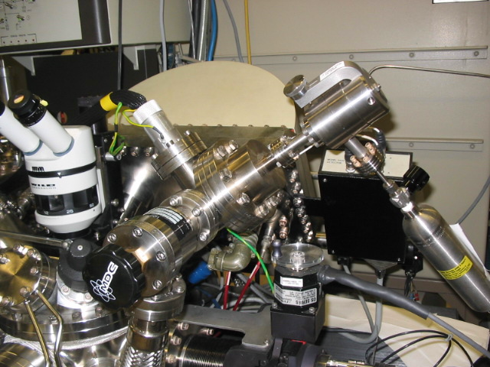
Bleed valve
Ar tank valve
Bleed valve
Differential pumping valve

