- Transfer arm requirements ≥44" linear travel of arm.
- Overall length of outer housing ≤ 65"?
- length of arm extending from end of outer tube 8" (including fork)
- camshaft on end of arm to operate Service Physics Fork with 1/2" cam (see Service Physics dimensional drawing of Fork below and website http://mmrc.caltech.edu/mmrc_html/XPS/XPS-Manipulator/XPS-Manipulator.html)
- Flat or adaptor to mount Service Physics Fork mount (see Service Physics dimensional drawing of Fork below also see website http://mmrc.caltech.edu/mmrc_html/XPS/XPS-Manipulator/XPS-Manipulator.html) Fork currently approximately 11.5 mm below center line of 2 ¾" CF.
- 2 ¾" CF flange to attach to system.
- 5mm inner shaft continuous 360 rotation
- extended handle to allow operator to position himself/herself to observe end of arm.
- extension handle will not be able to rotate inner shaft
- Ability to easily rotate inner shaft when necessary with 1:1 rotation of control magnet and inner shaft
- bakeout to 250 C
- port aligner.

All dimensions approximate. Will supply exact drawing for construction.
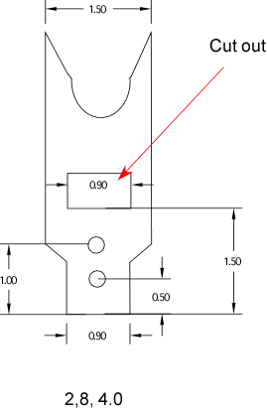

Top view of Fork. 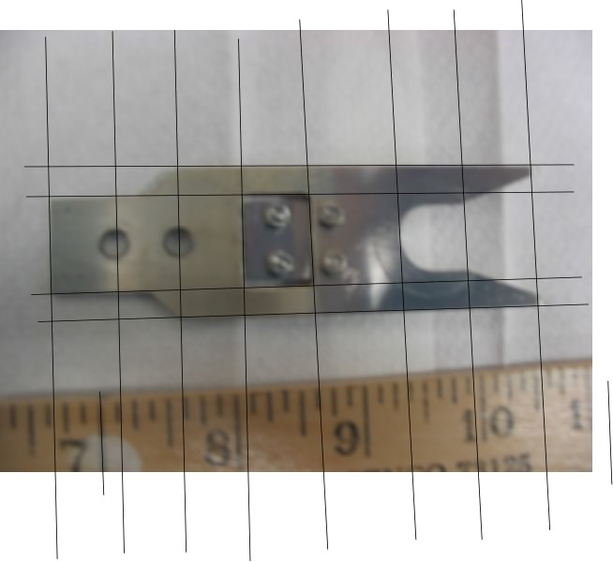

Side view of Fork. 