 | CALIFORNIA INSTITUTE OF TECHNOLOGY  NONCOMPETITIVE JUSTIFICATION

INSTRUCTIONS

This form must accompany a purchase requisition when noncompetitive approval is requested for equipment, supplies, or services exceeding $10,000.00.

- Please type or print legibly and complete all categories and sections that apply.
- Provide full explanation, complete description, and/or list all relevant reasons where space has been provided. The rationale must be clear and convincing, avoiding generalities and unsupported conclusions.
- Incomplete forms or forms lacking sufficient detail cannot be approved and will be returned possibly delaying issuance of a Purchase Order.
- Form must be signed and dated at the bottom.

Date: | 06/06/2017 | Requisition No.:
To:
From: | Bruce Brunschwig
Subject: | Noncompetitive Justification
Proposed Supplier: | Service Physics
Product/Service Description: | Service Contract
Estimated Price: | 12,492

STATEMENT

I am requesting a noncompetitive procurement based on the following criteria. (Attach additional sheets as necessary):
SECTION I AND SECTION II MUST BE COMPLETED

SECTION I

COMPLETE ONLY THE PARTS OF THIS SECTION THAT APPLY

1. The requested product/service is an integral repair part or accessory compatible with existing equipment.

A. Describe Existing Equipment: Surface Sceince M-Probe XPS
B. Manufacturer/Model Number of existing equipment: Surface Science M-Probe
C. Explain the relationship between current equipment and requested product:
Original manufacturer went out of business more than 15 years ago. The only known third party repair and upgrade service for this instrument is supplied by Service Physics. We have had this service contract for more then 10 years and have never found another company that will offer this service.

2. The requested product/service has unique performance specifications which are essential to my research protocol or other needs and are not available from comparable service providers.

Explain in detail:

3. The requested product/service is essential in maintaining experimental or administrative continuity. Provide a thorough explanation in “Explain in detail” section below.

Requested product/service is being used in continuing experiments;
Other investigators have used this product/service in similar research and, for comparability of results, I require it;
I have standardized the requested product/service; the use of another would require considerable time and money to evaluate.

Explain in detail:

4. The requested product or service is one with which I (or my staff) have specialized training and/or extensive experience. Retraining would incur substantial cost in money and/or time.

- Manufacturer/Model of existing equipment:
- Estimated hours/per person required to retrain:
- Numbers of persons requiring retraining:

5. There is a firm schedule requirement which only one supplier has the capability of meeting. In this instance, the schedule requirement must be of such compelling and unusual urgency that failure to meet the schedule will seriously impact a Caltech task/project. Provide evidence that other suppliers can not meet your schedule.

Explain in detail:

6. There is a substantial technical risk in contracting with any other supplier, thereby making that an unacceptable course of action; e.g., where only one supplier has been successful to date in implementing a difficult manufacturing process. Provide supporting evidence of other supplier’s with relevant capabilities and their inability to overcome the substantial technical risk.

Explain in detail:

7. Only known manufacturer/service provider of this product/service:

- What research/investigation has been done to support this claim (i.e. trade shows, internet searches, professional journals, colleagues, etc.?:
- Please list sources checked:

Note: A requirement for a particular proprietary item does not justify a sole source procurement if there is more than one potential bidder or distribution network authorized to provide that item.

8. Other factors not addressed above which may assist in the sole source justification review process are:

SECTION II

2. I have contacted other suppliers or service providers identified below and considered their product/service of similar capabilities. These products or services are not acceptable because they lack one or more of the technical specifications/capabilities described in Section I above:

MARKET RESEARCH (Other Suppliers Contacted)
(Identify all other sources whose products/services have been reviewed and why they are not satisfactory)
 | Supplier 1 | Supplier 2
Supplier Name: | NO known suppliers of Service for M-Probe XPS. Have searched Google, Bing, Global Spec. Also see US Air Force sole source here.
Product/Service Description
Representative Contact:
Phone Number:
Website URL:
Technical Deficiency / Capability:

Note: Attach any quotes, web documents or documentation you have received from other suppliers to support your rationale.

I am aware of Caltech’s requirements for competitive bidding for purchases over $10,000.00 and the criteria for justification for noncompetitive Purchasing. I have gathered the required technical information and have made a concerted effort to review comparable/equal equipment (e.g. Market Research). I have attached the pertinent documentation showing what Market Research was conducted to preclude other items from consideration.

Submitted:

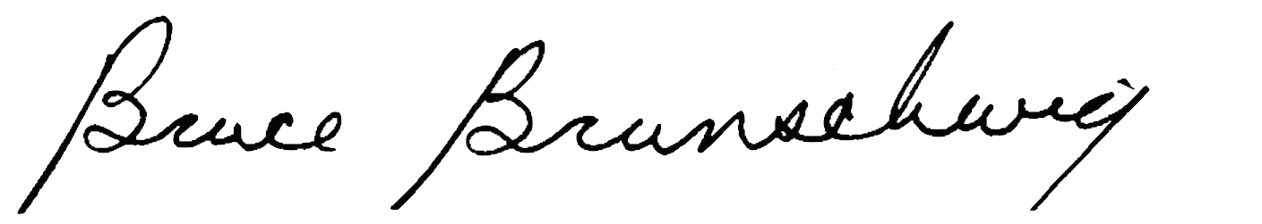 |  | 06/06/2017
Signature: |  | Date
Bruce Brunschwig
Typed/Printed Name:

Desktop: Noncompetitive Form 03/07

