Stark (Electroabsorption) Spectroscopy
Optical Layout for the Stark (electroabsorption) Spectrometer

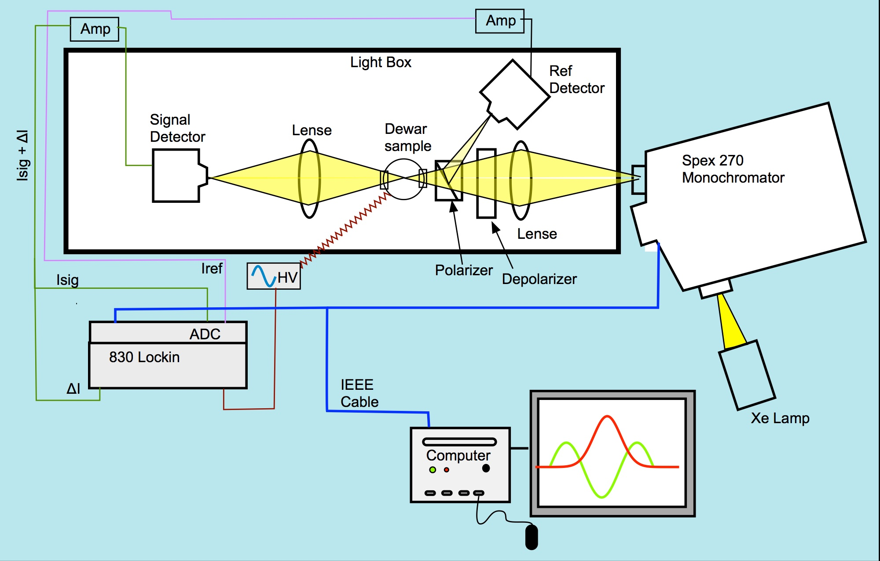
Carrying Out the Experiment

The experiment is straight forward to carry out and involves filling the Dewar with liquid nitrogen, preparing the cell, mounting the cell, freezing the sample, operating the spectrometer with LabVIEW and analyzing the spectra with MATLAB.

Fig.1 Schematic representation of a Stark spectrometer.

Preparing Sample Stark Cell (Fig.2)
- The cell consists of two pieces of indium-tin-oxide (ITO) coated glass separated by Kapton film (approximate thickness of 25 or 50 μm).
  - The exact thickness of the Kapton film needs to be determined before the Stark experiment; profilometer or other technique shall be used.
- With an Ohmmeter measure resistance of each side of the pieces of glass. The side with the low resistance is the ITO coated side (The Ohmmeter reads zero for non-coated side).
- Place one of the pieces of glass, ITO-side up, on a piece of tissue paper. Place two ca. 1 cm x 2 mm pieces of Kapton film on each side of the ITO layer along the long edges flush with one short edge.
- Place the other piece of glass, ITO-side down, on top of the first piece so that the other end of the Kapton film is flush with the top end of the piece of glass.
- Place clips along the long edges to hold cell together.
- Double check with the Ohmmeter that the two ITO coated sides are facing each other before removing the clip handles.
- Mount the ready cell on the sample rod (of the Stark spectrometer) using a smaller clip to attach it to the upper copper electrode and a bigger clip to attach it to bottom copper electrode. (Clean the electrodes with a course and fine sandpaper if their surfaces are not shiny). Remove the clip handles of the bigger clip (the handles of the small one can be kept there as there is enough room for them).
- Once the spectrometer is set up and you have ran your backgrounds using an empty (or glycerol-filled) cell (see next parts) then you can introduce a sample via pipette from the bottom part of the attached cell and start filling the Dewar with liquid nitrogen.
  - You can practice how to fill the cell as shown in Fig. 2iii. The tip of the pipette is placed at the edge of the overlapping ITO glasses and the cavity is filled by capillary action. There should be no air bubbles present once the cell is filled.

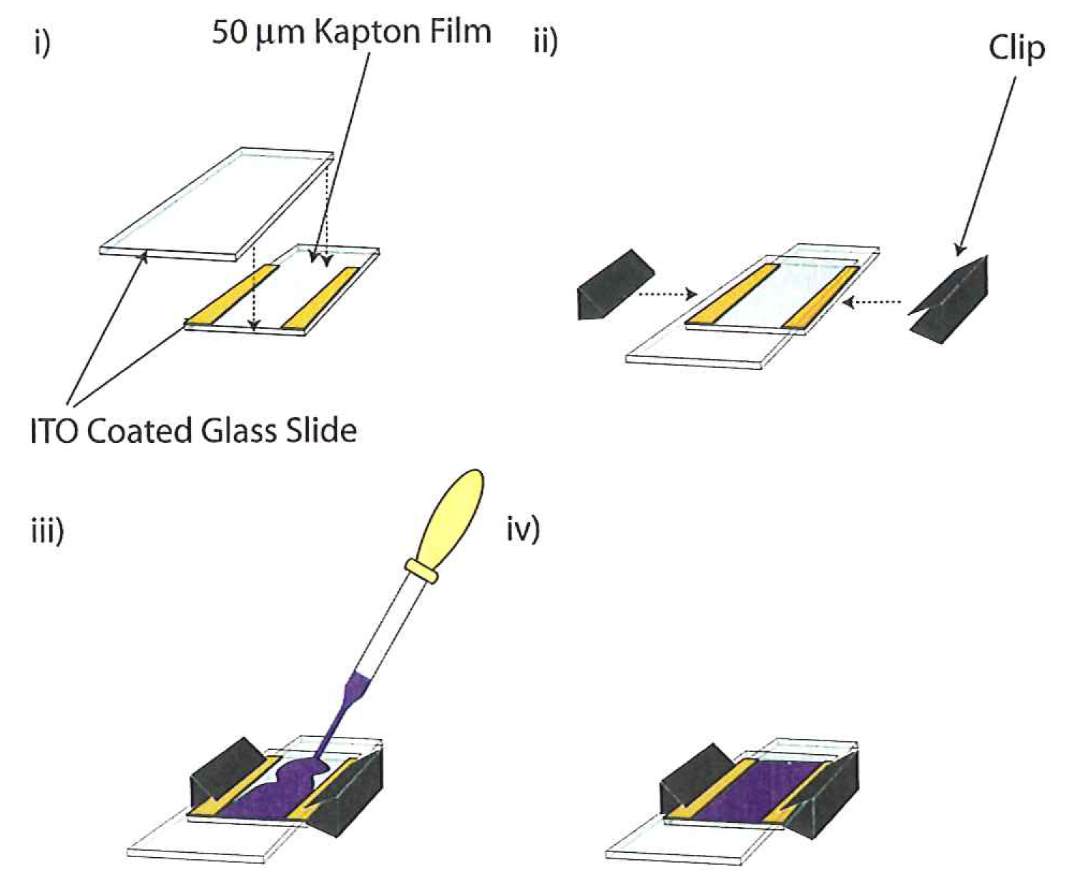
Fig.2 Building the Stark Cell
- Two ITO glasses are arranged such that the ITO coatings are facing each other; Kapton film spacers (in yellow) are placed on one slide so that two thirds of the slides overlap and the final third is exposed for electrical contact.
- The slides are held in place by clips.
- The sample is introduced by pipette.
iv) The finished Stark cell.

Stark Spectrometer Setup
- Attach Stark Dewar to vacuum system and leave it to pump for 20-30 minutes.
- Fill pump trap with liquid nitrogen.
- Switch on appropriate lamp for region of spectrum to be scanned (Xe lamp for UV/Visible; Tungsten filament lamp for Visible/NIR). Switch on an air-blow to the lamp (Make sure that it is not too strong flow as it will be popping out and you could burn the lamp). Make sure you have the corresponding detectors for the region of spectrum to be scanned. (Si for UV/visible; InGaAs for NIR). The lamp warms up for 20 minutes approximately. Adjust wattage to 75 W if it didn’t adjust itself after 20 min.
- Switch on rest of system (switch on extension lead and the On/Off button on the back of the monochromator).
- Turn on Stark computer.
- Start up LabVIEW (aliases on desktop: "stark top 830 2012.vi” and "open wide 2.vi”). Clicking noise (‘clunk’) will come once the monochromator is initiated (by pressing the hollow arrow, see the snapshot below). Set initially the wavelength to 530 nm, gratting 1200 g/mm UV-Vis with a resolution 2.00 nm. Make sure the initialize switch (Init 270m) is set in the up position. This only needs to be done once after monochromator has been switched on.

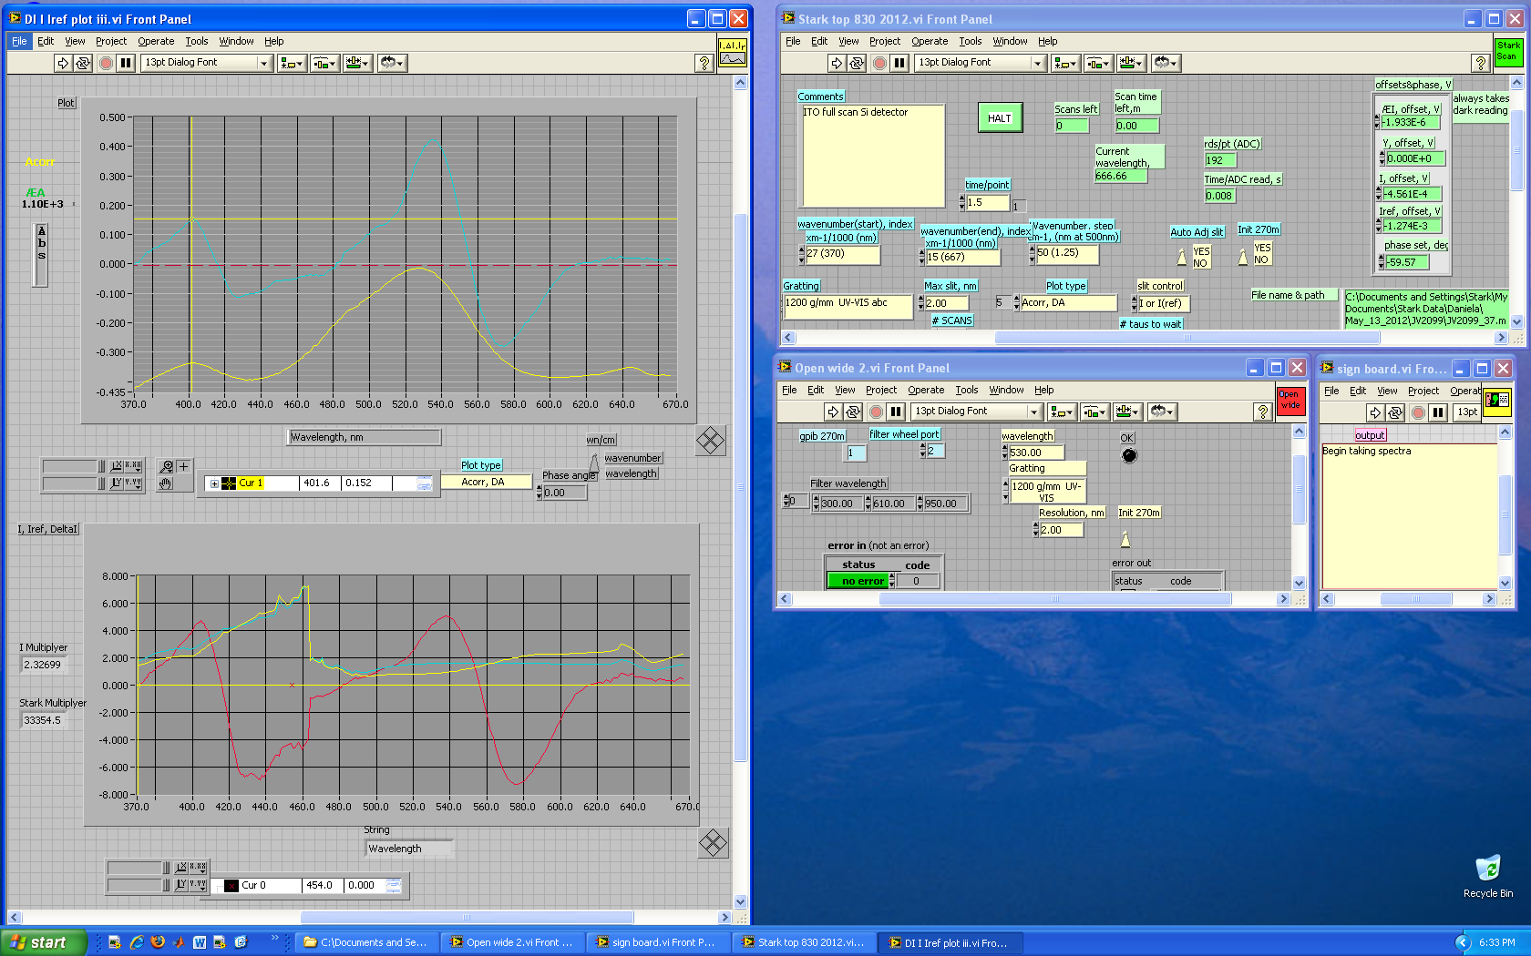
Now, you are ready to record your backgrounds at two different angles- 90° and 55°.

Recording a Background Spectrum
- Attach empty cell with no spacers into Dewar and clamp making sure that the cell is vertical with the spirit level. If you see an interference patter (oscillations in the spectra) try the suggestion below.
  - If after running one of your samples the Stark spectrum looks odd (unexpected wiggles or new Uv-Vis band-s looking features are observed which are not anticipated in your samples) or you expect to have a low solubility of your samples, you may need to re-do the background using a cell fill with glycerol. For this purpose, use Kapton film with U-shape, add a few drops of glycerol onto the ITO glass with the spacer on it and press the second ITO glass on top and place the clips. Clean the excess of glycerol with isopropanol and make sure the cell is clean outside and transparent. Then mount it to the sample rod and run the background as described below.
- Clamp the top of sample holder in place.
- Once the monochromator is initialized adjust the sample rotation to the 90° position. To do this, place a piece of cardboard with a slit in it in front of the first window. Rotate the sample and you will see a back reflection (from the sample cell) on the piece of cardboard. Rotate the sample until the back reflection is over the slit in the cardboard. You want to adjust the sample so that the back reflection overlaps the hole both vertically and horizontally. Write down the angle corresponding to the 90° position and switch off lights (you can use the small desktop lamp).
- In "stark top 830 2012.vi", set the start and end wavelengths to the desired numbers, adjust the step size to 1.25 nm and the time/point to 1.5 s/pt. (see snapshot below). Run the program by clicking the arrow button. This will be a high resolution 90° background to use when recording the Stark spectra. Make sure the background covers the full range of wavelengths that you want to cover with the Stark spectrum.

- You need to enter voltage (a “zero” in the background case), adjusted concentration (a”zero” in the background case too) and cell spacing when start running Stark so these numbers can be stored in the file. You do so for the background spectra too but pressing cancel option instead when the question for background choice pops up.
- Rotate sample by 36° and repeat steps 4-5 to record your high resolution 55° background.
Note: Keep a note of the settings you used (i.e. wavelength ranges and step sizes) so that you can use the same settings for your samples absorption and Stark spectra. You do not have to scan the same wavelengths with your Stark Spectrum, as long as the range covered by the background is more (or equal) to that covered by the Stark. Keep notes of your sample adjusted concentration too.
Often an interference patter in the 90º spectra. These are caused by reflections from the inside of the cell. Two things can be done to get rid of the oscillations a) you can run the background with only one piece of glass. b) you can put glycerol in the cell (or any other solvent ) to raise the refactive index of the gap and that will lessen the reflections of the interior surface of the cell.

Recording the Stark and Absorption Spectra
- Once you obtained the two backgrounds attach the liquid nitrogen tube to the liquid outlet of the Dewar. Feed the other end of the liquid nitrogen tube into the hole in the sample holder housing.
- Fill the cell (when it is already mounted to the rod) with your sample solution and load quickly into the Dewar.
- Clamp the top in place using the two broad clamps.
- Freeze the sample by opening the Dewar liquid tank as quickly as reasonable for health and safety reasons but gently operate with the tank’s valve! (Warning: If you are too slow your sample will be running out of the bottom of the cell.)
- Switch on He-gas and add the narrow He-tube into the hole in the sample holder (whilst the N₂(liq) is pumping in). When the Dewar is full the liquid nitrogen comes out and then you can gently close the valve of the N₂(liq)-tank (you can observe your glass-formation process via the Dewar windows, whilst nitrogen is pumping in).
- After the Dewar is full check the status of the sample: did it glass ok, are there many cracks etc.? To do this shine a flashlight on the sample and observe from the other side This will show any cracks. Now from the same position shine the flashlight away from the sample, can you see through the sample ok? Yes, then it's a glass.
- Once you frizzed the sample blow air onto the Dewar windows (to stop condensation). Make sure hoses are pointed at the windows correctly.
- In "Open wide 2.vi" set the wavelength to 530 nm and run the program.
- Adjust the sample rotation to the 90° position. With the back reflection.
- Check sample level to see if beam goes through sample okay. If the sample needs to go up or down then this can be done two ways: i) rotate dial at base of Dewar mount (usually this is enough) or ii) loosen the sample holder shaft by undoing the allen bolt and move the shaft up or down (Care! Do not lower the sample too much as you may hit the bottom of the Dewar). OK? Everything is set up so you're good to go.
- Close the Stark Spectrometer (with the black sheets) and switch off the lights.
- Turn on the high voltage power supply and make sure the safety switch has clicked and the red-lamp is on before adjusting the voltage.
(The phase of the lock-in should be set to around 130º?)
- Adjust the voltage to desired amount (from 2,000 to 3,500 V) by turning the right hand knob slowly. (Turning the knob too fast will result in the voltage cutting out).
- Check that the SRS Lockin is set up correctly (see SRA 830 lockin belwo)
- In "open wide 2.vi", set the wavelength to that of your sample band maximum. Now on the lock-in adjust the sensitivity (until you see overload-bars on the panel appearing then go a step back) and press the auto-phase button.
- In "stark top 830 2012.vi", set the start and end wavelengths to the desired numbers adjust the step size to 2.5 nm and the time/point to l.O s. Run a quick 90° Stark spectrum by clicking the arrow button. See an example of butyronitrile solution of Ru(bipy)₃(PF₆)₂ in the snapshot below:
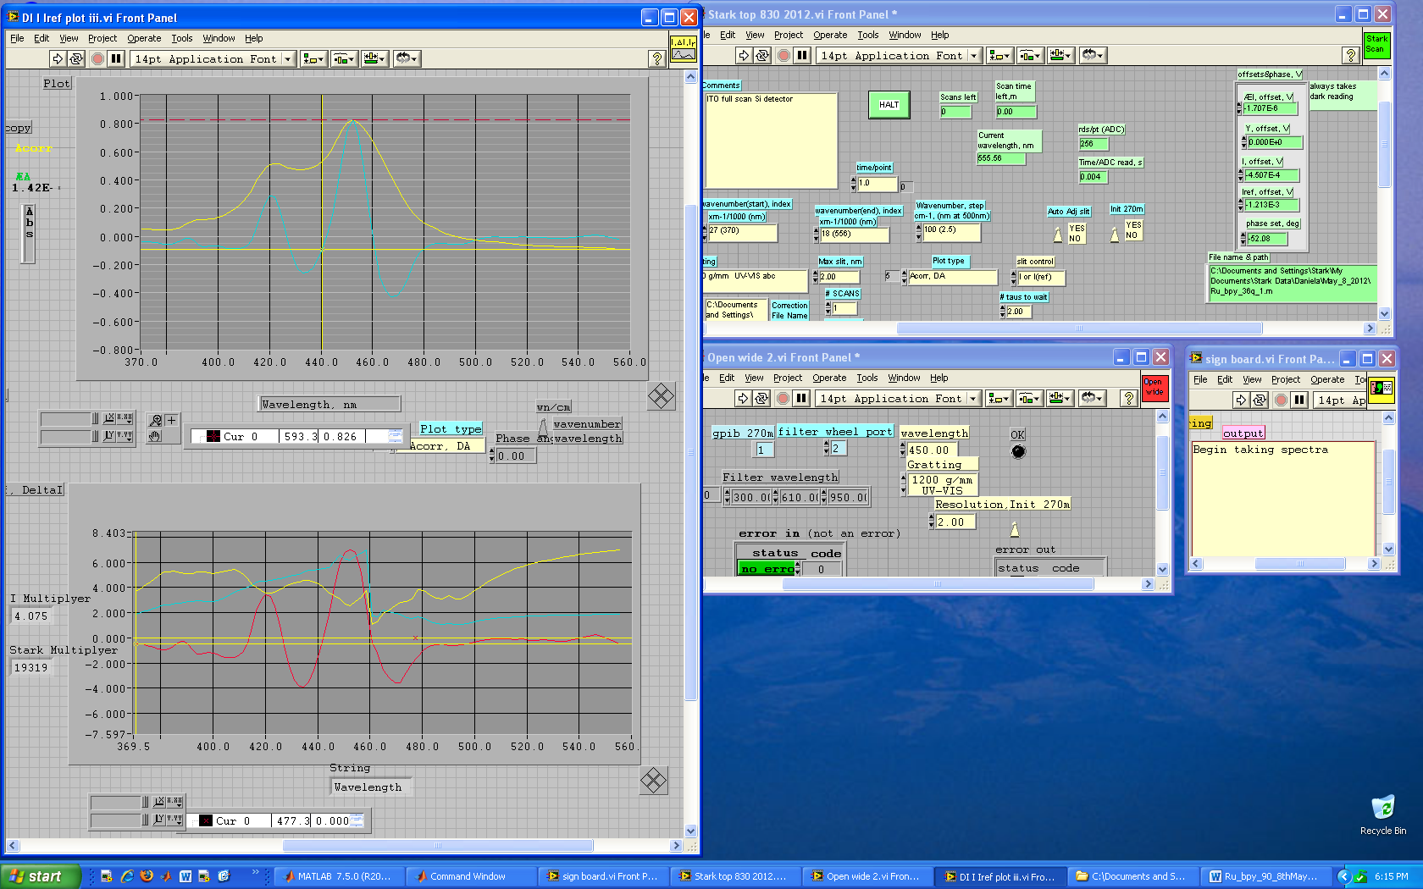
- How does it look? Your absorption spectrum (in yellow) and Stark spectrum (in blue) will be recording simultaneously. In the bottom plot you shall monitor the ratios of the different signals (I_{ref}, I, I⁰ and I⁰_{ref}). This will help you to see if your Stark signal is cut off - as it is marked here with a dashed rectangular (if this is so you will need to adjust again the sensitivity and start recording Stark spectrum from the beginning).
- If the spectrum is particularly noisy check the sample to see if glass is too cracked. If not then you are ready to move onto recording a high resolution Stark spectrum (otherwise remake your sample and star again).
- In "stark top 830 2012.vi", set the start and end wavelengths to the desired numbers, adjust the step size to 1.25 nm and the time/point to 1.5 and run your high resolution 90° spectrum.
Note: At 77K your sample band maximum is likely to differ from the one you have set (obtained at ambient conditions) so before you run your high resolution spectrum adjust the value based on the Abs spectrum of the quick ran.
- Rotate sample on 36° and record your high resolution 55° spectrum (may need to repeat step 15 – 18 if glass has gone bad).
Note: It may be a good practice to “top-up” the Dewar with liquid nitrogen before running the high resolution 55° Stark spectrum.

After recording the Stark and Absorption Spectra
1. Take the sample out and quickly dismount it and leave it for washing in the fume food.
2. Close the valve that connects the pump to the Stark Dewar, remove the metal black clip and gently separate the glass part from the Dewar.
3. Pour out the nitrogen that is left in and set the Dewar to dry upside-down, blowing air (use the air-source that it originally used for blowing on the Dewar windows against condensation). This takes about 30 min.
4. Close the He-gas valve and get the tube out. When all is dry you can start again to assemble all for the next sample.
5. It is a good practice to preliminary fit your data using MATLAB immediately after obtaining them, to make sure that all went fine! Later on you can improve the fits.
6. In the end of measurements day you also need to pour out the nitrogen from the pump trap and to switch everything off. Remember to wait 10-15min, after you switch off the lamp, keeping the cooling air on! Once the temperature of the exit air flow gets closer to the r.t. then you can stop the air-flow and go home! Leave the pump on 24/7.
(Do prepare for long days!)

SRS 830 Lockin
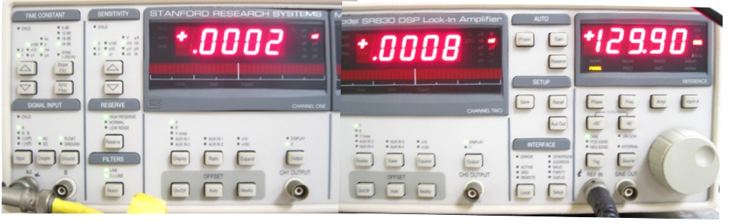
- The lockin should be set as shown in the picture above and the table below. Only the items highlighted in yellow normally need to be changed.
Time constant | Signal Input | Sensitivity | Reserve | Filters
100 ms  24 dB | A  AC  FLOAT | ~10 mV/nA (need to set) | Normal (or High Reserve) | line  2xline
Left Display | Right Display  Reference | Freq | Harm
X (When collecting data changes to Aux in 1) | Y (When collecting data changes to Aux in 2) | Same as set on HV supply | 2
- The 830 must be attached to the two detectors (I_{sig} to back Aux 1 and to the front IN), (I_{ref} to back Aux 2), the GPIB IEEE cable that goes to the monchromator and computer, the HV box to the REF IN0.
- Note that normally to see the Stark signal the left display should be set to X an the right to Y. However when you run the LabView program they will switch to Aux 1 and Aux 2.

Additional Notes:
- Keep voltages the same for pairs of 90° and 36° (55°) spectra.
- You would aim for the noise on the background spectra to be no worse than on the Stark spectra, so you should use similar time/pt and nm/pt settings in both spectra and background recordings.
- When the sample freezes it contracts so you must adjust the concentration accordingly. e.g. Butyronitrile contracts 15 %, hence a 2.00 mM solution becomes 2.30 mM (2.00 x 1.15 = 2.30); 50:50 water/glycerol does not contract so no adjustment is necessary. You need to enter the adjusted concentration value in the program when you run Stark.
- You only need to run a background once a day and can often use a background from a number of days (compare a few backgrounds and decide what to use).
- The refractive index of BuCN and water/glycerol are 1.44, and 1.4, respectively.
- If your Absorption spectrum looks wiggly but the Stark looks good it usually means that the N₂(liq.)-level is getting low and you need to re-fill and run again.
- If your Absorption spectrum looks fine but the Stark looks noisy (providing you confirm that the glass is good) it usually means that you have bubbles on the light path and you need to make sure that the vacuum is good and helium gas flow is not too strong or too weak.
- When save the files always use “.m” in the end so MATLAB can read the files and do not use names that start with numbers.
- Before recording your Stark spectra, it is advisable to obtain the UV-Vis spectra of your samples, in the same solvent as you will use for the Stark, in a Stark cell, using the Uv-Vis spectrometer in Bi019. Aim for solutions with Abs (at ambient conditions) ca 0.6-0.7. If you cannot get Absorption higher than 0.3 then using the glycerol-background you should see the recommendations to overcome the glass-interference wiggles.
- At about 460nm you may get a spike in the data due to the slit closing. This can be later removed using the “bad points” functions in the fitting procedures.

Additional Troubleshooting
- Monochromator will not initialize: If you switch on the Xe lamp after switching on the rest of the system it interferes with the monochromator. To solve this problem, switch off the monochromator (switch is at the back, top left corner) count to ten slowly and switch it back on and try to re­initialize.
Note: Sometimes the monochromator ‘forgets’ its GPIB address and thus the computer can no longer communicate with it. To solve this problem first you have to try all the different GPIB addresses (it usually defaults back to #14) then using 'Change IEEE address.vi' in LabVIEW change the address back to # l. Steps: Switch off monochromator, switch back on, run 'Change IEEE address.vi', switch off monochromator, switch back on and then initialize (the init.270m switch in the ‘Open wide.vi’ must be in the down position when you start doing this).
- No Stark signal: Electrodes are on the wrong surfaces of the cell? The ITO surfaces are facing wrong way? Sample too cracked?
- Spectra are noisy: i) Increase time per point. ii) Blow He gas over liquid nitrogen (reduces bubbling of liquid nitrogen and thus reduces noise), iii) Check the vacuum.
- The peaks of the Stark spectra are flat and look chopped in some way. The signal has gone off scale or the RESERVE is too low. Change the sensitivity (e.g. from 500 μ.V to 1 mV). Also may need to increase the dynamic range for the lockin.

