Notes:
- When in Scope mode the graph always shows raw counts with no dark counts subtracted. In %T, Abs, or Watts the plot shows the spectrum with the dark counts are subtracted. IN %T and Abs the reference is ratioed to the observed spectrum.
- A dark scan should always be taken to eliminate the dark current structure of the baseline. Take a "new dark" after changing the number of averages, smoothing, and/or detector integration time of the spectrometer.
- To take a dark scan, go to scope mode, block the light signal input to the spectrometer and then left click on the “Dark bulb” icon. You should darken the room if you see sharp lines in the spectra that come from the florescent lights.
- The icons of the dark light bulb and yellow light bulb are for taking a dark and reference spectra respectively. They are “saved” to the program memory. You can also take them from the File menu but remember they are not saved to disk only to program memory.
- In the irradiance measurement the numbers are relative intensities. To get absolute intensities you need to set up the spectrometer and light source the same way they were set up when it was calibrated.

Startup
- Plug the USB calbe into the computer and the spectromterc..
- Start the SpectraWiz program.
- The spectrometers will automatically load its wavelength calibration coefficients. You can double check this
  - Go to Setup Unit calibration coefficients and enter a value of 1 at the channel prompt.
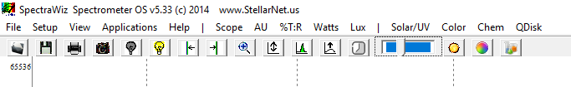
  - Check that the values for C1, C2, C3, and C4 are the same values listed on the bottom of the spectrometer. If no C4 value is found on spectrometer label, enter 0 for C4.
Figure 1 Memu Bar of SpectraWiz Software

For Emission or Intensity measurements:
- For irradiance measurements use the fiber optical cable with the diffuser and a view restrictor. The end of the fiber cable should be about 15” from the light source to start.
- Let the Blackcoment spectromenter and light source warm up for ~10 minutes.
- Start in "Scope” mode (Figure 1). With the spectrometer running (The 4th icon from the left should be a camera, if it is a click it to start the spectrometer scanning), with the spectrometer observing the light source you should view a spectrum (Figure 2). Go to Setup in the menu and set the following configuration:
  - Detector integration time, τ, = 200 ms
  - Number of Scans to average, N, = 2
  - Pixel resolution (smoothing) = 3 (box car)
  - Temperature Compensation = 1 (ON)
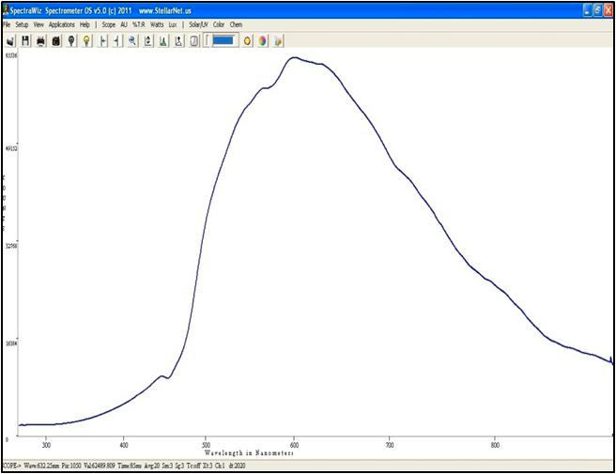
- If curve is small increase the integration time,τ, till the curve fills 85–90 % of the plot; however, if the curve touches the top of the graph (and/or is flat) reduce the integration time till the top of the curve is at ~58,000 counts. If the signal touches the top of the graph when the integration time is 1 ms (minimum value) you must reduce the input signal by moving the light source further away.
Figure 2 Optimum Integration Time
- If the integration time is < ~ 200 ms set the number scans to average to ~5. If it is more then 200 ms use a smaller value.
- Under Applications menu choose Radiometer Calibration. In the window Information window choose Yes to load the calibration and choose the file MyCal-C16082422-UVVIS-CR2.CAL and click open.
- Block the light so it does not reach the fiber, wait till the plot is flat and steady. Click the dark light bulb on the toolbar to take a dark curve and save it to program memory. You can right click the dark light bulb to remove the dark background spectrum.
- It should now show Watts as the y axis in the plot. The Watts is calculated using
where the C(λ) are the calibration coefficients that correct for the sensitivity of the spectrometer vs wavelength and are the Intensity measured in counts in the dark and light, respectively.
- Unblock the light and you should see the corrected spectrum for the lamp. Note the values of Watts/m² for each wavelength are only relative values to get absolute values you need to set the distance from the lamp and the integration time to those used when the spectrometer was calibrated.
- To save the spectrum to disk click on the floppy icon on the menu bar. The spectrum saved is the reading after the dark spectrum is subtracted. The file is saved with FileName.IRR. If you want the know how the dark counts are you need to take a dark spectrum (i.e. a spectrum with the light blocked and then save this spectrum).

For Absorbance or Transmittance Measurements
- Start in "Scope mode".
- Set up the spectrometer, cell holder, and light source as shown in figure 2 and allow to warm up for 10 minutes.
- A dark scan should always be taken. Take a "new dark" after changing the system parameters (e.g. number of averages, smoothing, and/or detector integration time). To take a dark scan, while in scope mode block the light signal input to the spectrometer and then left click on the “Dark bulb” icon.
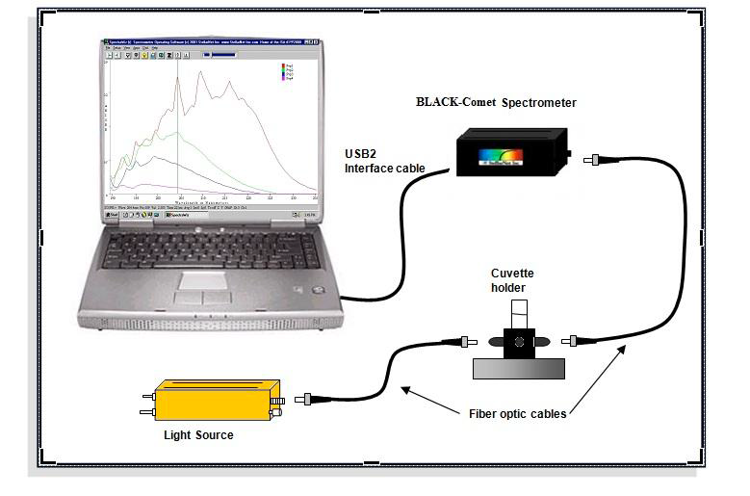
- Choose Scope mode. Place a cuvette with solvent in the cuvette holder. (For dip probes use your solvent solution for reference).
Figure 3 Absorbance/Tanmisttance setup
- Start with the following configuration:
  - Detector integration time, τ, = 50 ms
  - Number of Scans to average, N, = 5 (if τ < 100 ms)
  - Pixel resolution (smoothing) = 3 (Box Car)
  - Temperature Compensation = 1 (ON)
- If spectrum has low counts i.e., is small in the plot window, increase the integration time,τ, until the counts are ~58,000. If the curve touches the top of the graph (and/or is flat) reduce the integration time until the counts are ~58,000. If the signal touches the top of the graph when the integration time is 1 ms you must reduce the input signal by using a smaller fiber or inserting a filter. For reflectance, move the tip back from the white standard (reference) surface.
- If the integration time is < ~ 200 ms set the number scans to average to 5. If it is more then 200 ms use a smaller value.
- Now block the light at your light source. Click the dark light bulb to set the dark spectrum.
- Now turn the light source back on and put your reference sample (or white standard for reflectance) in the cuvette holder and click the yellow light bulb icon to set your reference.
- Choose Absorbance or Transmission using the View menu selection. You should see a flat line at 0 Absorbance or 100% Transmission.
- Insert your sample and observe the spectrum in real-time.
- You may now save the spectrum to disk or print it.
- The Absorbance and Transmittance are calculated:
where are the intensity in counts for the sample, or reference under light and the dark current, respectively.

Toolbar Icons
1 2 3 4 5 6 7 8 9 10 11 12 13 14 15 16 17

Icons from left to right:
- File open,
- Save active spectrum to disk,
- Print spectrum,
- Snapshot of spectrum (left click, freezes and unfreezes spectrum, right click copies spectrum to clip board.
- Save dark spectrum to memory (right click to erase),
- Save reference spectrum to memory (right click to erase, in Irradiance click starts the UV monitor),
- Move cursor left (click graph to set cursor).
- Move cursor right
- Zoom wavelength axis
- Rescale Y axis ( right click to undo)
- Compute Area
- Auto set integration time
- Detector integration time
- Integration Time Bar (slide to left decrease integration time)
- Solar Monitor
- CIE Color Measurement
- Chem Wiz

Click on word to switch mode

At the bottom of the plot there is a status bar with the following information.
SCOPE: Currently selected mode (also TRANS/ABSOR/REFS/IRRAD)
Wave: Wavelength of the data cursor location
Pix: Pixel location of the data cursor (0-2050 pixels)
Val: Value at the data cursor
Time: Detector integration period in milliseconds (ms)
Avg: Number of samples averaged
Sm: Pixel bxcar smoothing
0 = none
1 = 5 pixels
2 = 9 pixels
3 = 17 pixels
4 = 33 pixels
Sg: Savitzky Golay level 0, 1, 2, 3, or 4
Tc: Temperature compensation on/off
Z: An x-axis zoom has been performed
Y: A Y-rescale or Y-zoom has been performed
Xt: XTiming resolution control selected
Ch: Shows which channel is selected

