Startup
- Check for USB2EPP cable.
- New model spectrometers automatically load calibration coefficients. However, double check this by starting the SpectraWiz program and entering the 3 calibration coefficients.
- Go to Setup Unit calibration coefficients and enter a value of 1 at the channel prompt (and subsequently 2, 3…8 if you have multiple units connected).
- Enter the C1, C2, C3, and C4 (if listed) values on the next prompts. These values are found on the bottom of each spectrometer. This information tells the software how to provide the wavelength readouts. If no C4 value is found on spectrometer label, enter 0 for C4.

For Emision or Intensity measurements:

- Plugin the USB cable to the computer and the Blackcoment spectromenter and turn on the light source let both warm up for ~10 minutes.
- Note: A dark scan should always be taken to eliminate detector structure on the baseline. Take a "new dark" after changing system parameters (e.g. number of averages, smoothing, and/or detector integration time). To take a dark scan, while in scope mode block the light signal input to the spectrometer and then left click on the “Dark bulb” icon.
- You should darken the room if you see sharp lines in the spectra that come from the florescent lights.
- You can use the fiber optical cable with the diffuser and view restrictor. The end of the fiber cable should be about 15” from the light source to start.
- Start in "Scope mode". With the spectrometer observing the light source you should view a curve in Scope mode (see Figure 1). Start with the following configuration:
  - Detector integration time, τ, = 50 ms
  - Number of Scans to average, N, = 1
  - Pixel resolution (smoothing) = 0 (NONE)
  - Temperature Compensation = 1 (ON)
- If curve is small increase the integration time,τ, till the curve fills 90 % of the plot; however, if the curve touches the top of the graph (and is flat) reduce the integration time till the top of the curve is at ~90% of the graph. If the signal touches the top of the graph when the integration time is 1 ms (minimum value) you must reduce the input signal by using a smaller fiber or moving the light source further away.
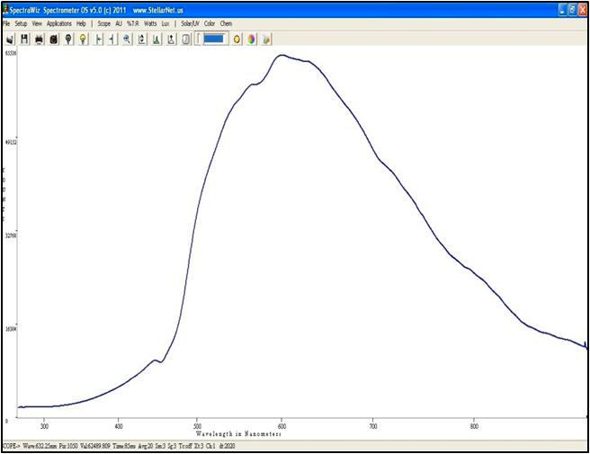
- If the integration time is < ~ 200 ms set the number scans to average to ~5. If it is more then 200 ms use a smaller value.
Figure 1 Optimum Integration Time
- Block the light so it does not reach the fiber. Save the dark curve by clicking the dark light bulb on the toolbar.
- Choose Watts on the top menu. Unblock the light and you should see the corrected spectrum for the lamp.
- Save the spectrum to disk or print it.

For Absorbance or Transmittance Measurements
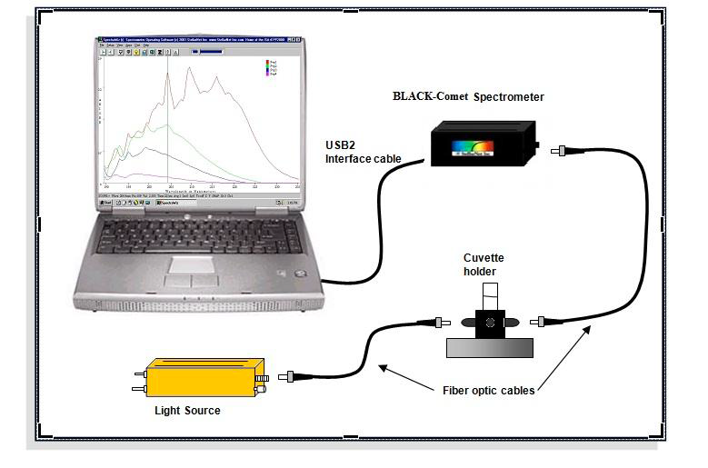
Figure 2 Absorbance/Tanmisttance setup
- Plugin the USB cable to the computer and the Blackcomet spectromenter, start the SpecWiz softaware and turn on the light source let both warm up for ~10 minutes Start in "Scope mode".
- Set up the spectrometer, cell holder, and light source as shown in figure 2.
- A dark scan should always be taken to eliminate detector structure on the baseline. Take a "new dark" after changing system parameters (e.g. number of averages, smoothing, and/or detector integration time). To take a dark scan, while in scope mode block the light signal input to the spectrometer and then left click on the “Dark bulb” icon.
- Choose Scope mode (see Figure 1). Place a cuvette with solvent in the cuvette holder. (For dip probes use your solvent solution for reference).
- Start with the following configuration:
  - Detector integration time, τ, = 50 ms
  - Number of Scans to average, N, = 1 (if τ < 100 ms)
  - Pixel resolution (smoothing) = 0 (NONE)
  - Temperature Compensation = 1 (ON)
- If curve is small increase the integration time,τ, until the curve files ~90% of the plot; however, if the curve touches the top of the graph (and is flat) reduce the integration time till the curve fills is only 90% of the graph. If the signal touches the top of the graph when the integration time is 1 ms you must reduce the input signal by using a smaller fiber or inserting a filter. For reflectance, move the tip back from the white standard (reference) surface.
- If the integration time is < ~ 200 ms set the number scans to average to 5. If it is more then 200 ms use a smaller value.
- Now block the light at your light source. Save the dark curve by clicking the dark light bulb on the toolbar.
- Now turn the light source back on and click the “light bulb” icon to set your reference.
- Choose Absorbance or Transmission using the View menu selection. You should see a flat line at 0 Absorbance or 100% Transmission.
- Insert your sample and observe the spectrum in real-time.
- You may now save the spectrum to disk or print it.

Toolbar Icons
1 2 3 4 5 6 7 8 9 10 11 12 13 14 15 16 17

Icons from left to right:
- File open,
- Save spectrum to disk,
- Print spectrum,
- Snapshot of spectrum (left click freezes and unfreezes spectrum, right click copies spectrum to clip board.
- Save dark spectrum (right click to erase),
- Save reference spectrum (right click to erase, in Irradiance click starts the UV monitor),
- Move cursor left (click graph to set cursor).
- Move cursor right
- Zoom wavelength axis
- Rescale Y axis ( right click to undo)
- Compute Area
- Auto set integration time
- Detector integration time
- Integration Time Bar (slide to left decrease integration time)
- Solar Monitor
- CIE Color Measurement
- Chem Wiz

Click on word to switch mode

At the bottom of the plot there is a status bar with the following information.
SCOPE: Currently selected mode (also TRANS/ABSOR/REFS/IRRAD)
Wave: Wavelength of the data cursor location
Pix: Pixel location of the data cursor (0-2050 pixels)
Val: Value at the data cursor
Time: Detector integration period in milliseconds (ms)
Avg: Number of samples averaged
Sm: Pixel smoothing
0 = none
1 = 5 pixels
2 = 9 pixels
3 = 17 pixels
4 = 33 pixels
Tc: Temperature compensation on/off
Z: An x-axis zoom has been performed
Y: A Y-rescale or Y-zoom has been performed
Xt: XTiming resolution control selected
Ch: Shows which channel is selected

