**Changing the X-Ray Anode**

**Updated 08//2019**

**NOTE:** The X-Ray Anode should -be replaced every 6 months and each time the E-Gun is replaced. The filter and ion-X cartridge in the Hawk should be changed and the water in the Hawk recirculatory can be changed annually. It is also often good to pump the Cryos. Other items to do if you turn off the cryo you should turn off the Neslab and replace the water filter in the rack over the Kratos and change the air filter for the compressed air line (see instructions below).

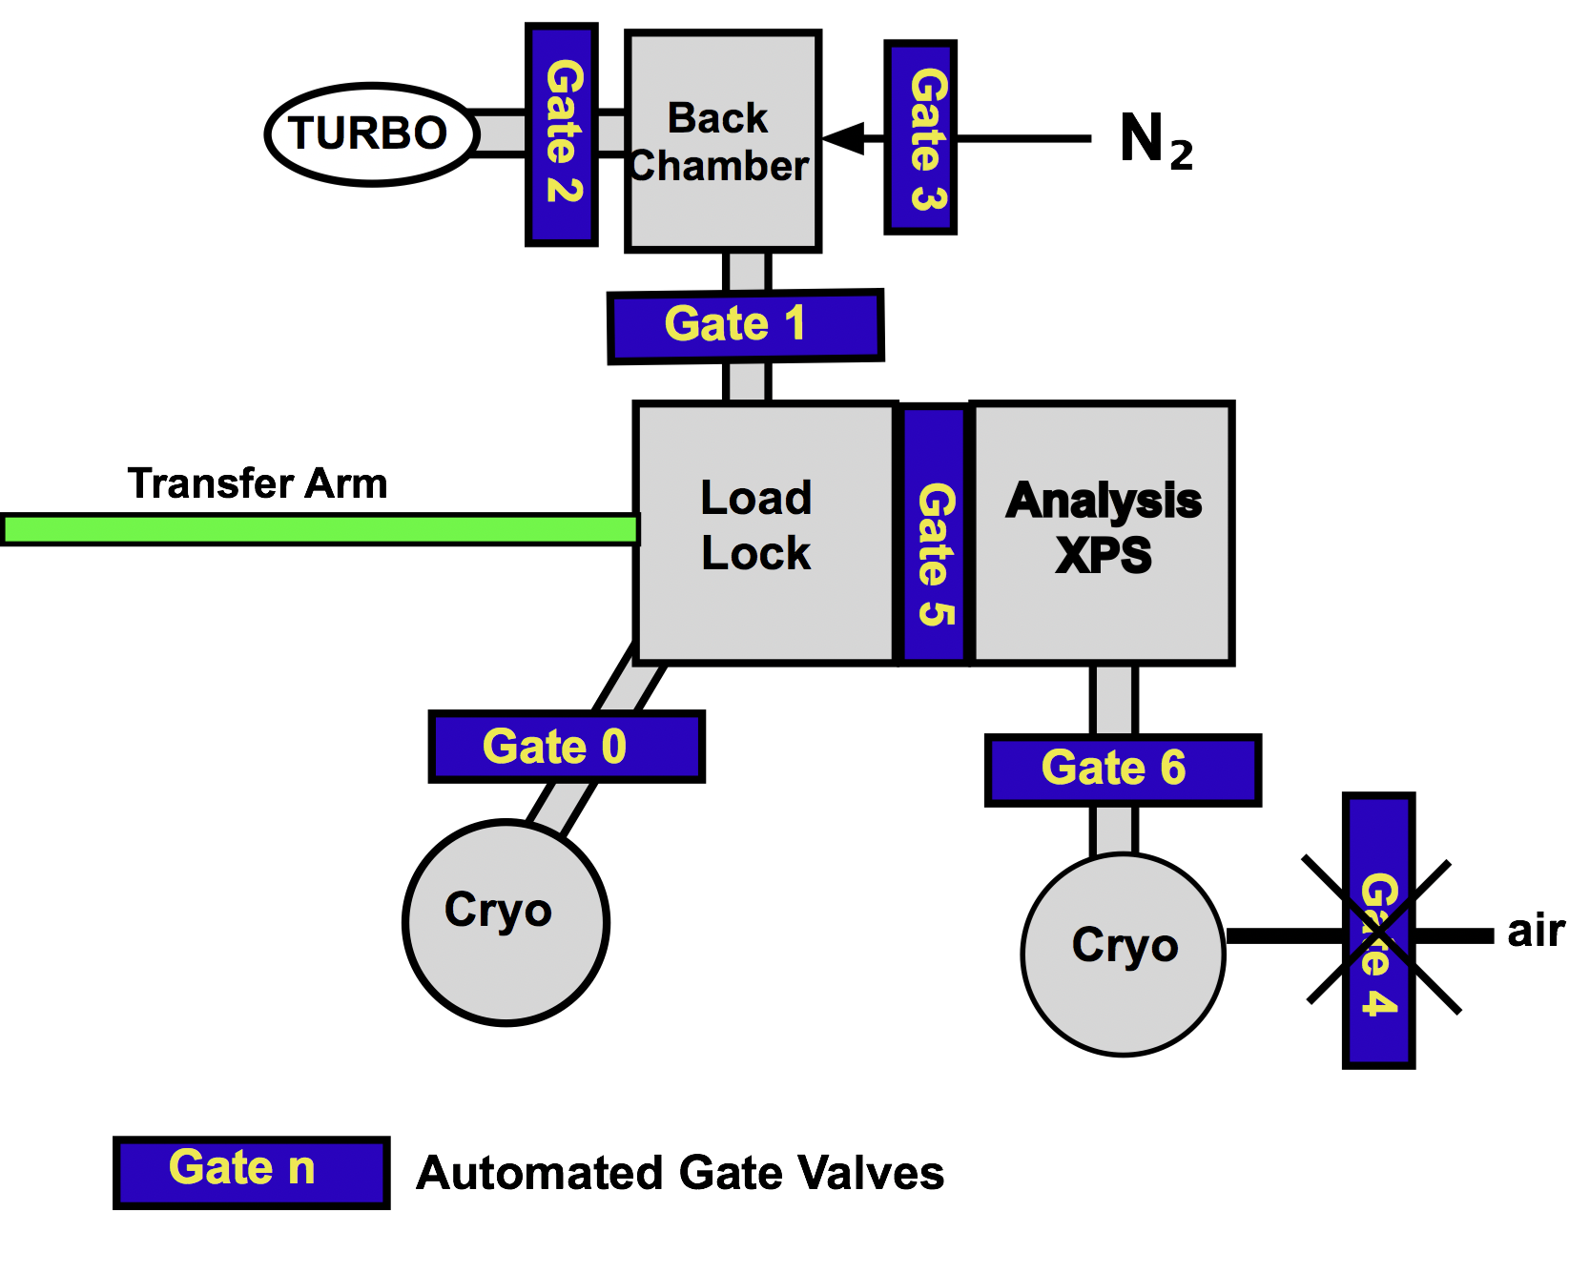

1. Turn off X-Ray Controller (9600), the Glassman High Voltage Power supply and then the Hawk water recirculation. Turn off the Spectrometer Power Supply, and the Charge Neutralizer Subsystem, and the Ion Gauges.
2. If you want to pump the cryos turn off the cryo compressor and wait for the cryos to warm about 1 hour if not shut gates 0 and 6 valve to the Cryo Pumps.

Figure 1 System Diagram

1. Wait 30 minutes for the system to cool before venting.
2. Close gate 2, set the override on the vacuum control box. Open gate 1 and 5.
3. Turn off the turbo pump.
4. Check that the E-Gun is cool, if not wait another 30 minutes.
5. Vent the system by opening gate 3.
6. Disconnect the water lines from the anode lines at the large nuts.
7. Remove the nuts from the flange of the X-Ray anode holder.
8. Remove the treaded studs from around the anode flange, you may need to lock two nuts together to get some of the studs out.
9. Carefully remove the anode flange from the analysis chamber.
10. Cover the anode opening with Al foil
11. Take the anode to the bench and remove the six 8-32 allen head screws from around the anode. Support the anode with a gloved hand in this process do not use the anode cooling tubes for leverage. Use caution in removing the screws so as not to damage or distort the structure.
12. Discard the used screws.
13. Remove anode keeper (the piece that held the allen head screws).
14. Remove the anode from its holder. NOTE: A small screwdriver or gasket removal tool may be required to remove the anode from it holder. Make sure that you do not damage the knife edge of the anode holder. Discard old 3 3/8 copper -gasket.
15. Clean the new anode with clean IPA and dry anode thoroughly.
16. Mark the new anode by drawing a diameter line on the Al surface that is parallel with the cooling indentations of the Cu side.
17. Locate the new anode in its holder with the aluminum side facing out (away from the cooling holes) and the rectangular milled slot parallel to the water cooling holes in the holder. The marked line should aide in doing this alignment. It is important that the water holes match up with the milled slot in the anode or no water will flow to cool the anode.
18. Install the anode keeper.
    1. Place new screws (do not use the old screws!) into anode keeper and loosely tighten with your fingers. If all the screws cannot be tightened with your fingers rotate the keeper so that the keeper holes are over other screw holes in the anode holder.
    2. Tighten all the screws gently in parallel in a cross anode manor (just a you tighten a flange). Turn, each screw a 1/4 of a turn until all screws have been tightened, be sure to support the anode flange with a gloved hand. The screws should be evenly tight all around.
19. Replace the 3/8 Cu gasket on the main flange and install about 3 studs around the flange.
20. Carefully fit the anode flange onto the studs. Note that there are two locator pins on the anode flange that must align with the holes in the mating piece.
21. Loosely screw on the nuts onto the 3 studs to hold the gasket in place. Install all the other studs. All studs need to stick out of the top flange enough so that the nuts can completely grab on.
22. Put nuts on all the studs.
23. Tight them in the standard cross flange manner, tightening each bolt 1/4 turn until all have been tightened.
24. Reinstall water cooling lines .
25. Open gate 2, shut gate 3 and turn on the turbo.
26. If the cryo pumps were **not turned off**,
    1. Pump the system with the turbo until you reawch about 1 x 10-5 T and open gates 0 and 6 to the cryos.
    2. If the cryo pumps were turned off and are warm let the turbo pump until the system reaches 1 x 10-5 T with gates 0 and 6 open. This might take an hour or two since the cryos are warm and need to be pumped out. Turn on the cryo compressor when the pressure is ≤1 x 10-5 T.
27. Turn on the Hawk cooler and the other electronics.
28. Remember you must degas the filaments and then align the e-gun (see e-gun alignment).

**Replacing water filter and Ion-X cartridge on Hawk circulator**

1. Turn off Hawk circulator
2. Remove top cover. Turn valve inside circulator to “**off**”.
3. Place plastic tray or container under filter housing.
4. Remove filter housing, replace old filter with new one, and replace housing. (Note you might need to use a filter wrench to turn the housing).
5. Place plastic tray with 3 to 4” sides under ion-x cartridge housing.
6. Press button on handle of ion-x housing and turn top to remove bottom of housing.
7. Remove ion-x cartridge.
8. Dump the water out of the housing to make it easy to assemble.
9. Put new cartridge into housing and fit it to top of connection.
10. Raise the housing and rotate the bottom to make connection to the top, make sure to rotate far enough that the latch catches.
11. Turn valve inside circulator to “**on”**
12. If you need to replace the water in circulator do it now and refill with 15 MΩ water.
13. Turn on Hauk circulator. When it starts to run to cool X-ray source you need to bleed the ion-x cartridge by pressing the lever on top of the cartridge housing.

**Replacing water filter for MProbe.**

1. Turn off cryo and Neslab.
2. Take a bucket and place it under the water filter in the overhead rack.
3. Turn the valve on the top of the filter housing to off.
4. Unscrew the base of the filter housing, remove the filter, and put in a new filter.
5. New filters are stored under the hood in the second to last cabinet.
6. Screw the base back onto the filter housing.
7. Turn the valve to on.
8. Start the Neslab and check the filter for leaks.

**Replacing the Compressed Air filter.**

1. The Compressed air filter is in a black round filter housing located in the rack to the north of the water filter for the MProbe.
2. The Compressed air controls the gate valves on the MProbe.
3. Turn off the valve to the compressed air filter locate a little behind the filter housing.
4. Bleed the airline to relieve the pressure (you can unscrew the nut holding the low-pressure line on the pressure reducing valve).
5. Unscrew (counter clockwise) the silver handle on the black filter housing, you may not be able to turn it without using a wrench. Use a closed end wrench and put it over one side of the silver handle in a manor so you can turn the handle ccw.
6. The cover the filter housing will come off and you can take out the old filter. It will look like a crushed toilet paper roll.
7. Put in a new filter (they are located in the same cabinet as the water filters).
8. Screw in the cover of the air filter and make sure the cover mates with the base and is tight.
9. Slowly turn on the compressed air and listen for leaks.
10. Turn off the compressed air and watch the pressure gages on the distribution manifold to see if the pressure drops. If it does you probably need to tighten the filter cover.
11. Turn on the compressed air again.