Procedure for General Use of the XPS

Loading a sample into the XPS:
- Fill out the XPS log book on the computer desk. Make a note of the pressure readings on the control panel over the XPS and the time you sign in.
- Mount your sample on the XPS stub. Public use stubs should be in a sealed box next to the sink. If you are a regular user, you should purchase your own stub to avoid contamination. Stubs should be handled only while wearing gloves, and should be stored in a clean, sealed container. Please do not remove stubs from the XPS room. Samples should not overlap the edges of the stub by more than a few mm.
- Check the control panel to make sure that all gates are closed EXCEPT Gates 2 (load lock/tubo) and 6 (XPS/cryo) are closed. Gates 2 and 6 should remain open. Check the pressures in the small cross and XPS chamber. Unusually high pressures (ca. 10⁻⁸) could indicate a problem with the instrument and should be brought to the attention of the GLA.
- Read the pressure in the load lock by pushing the soft button labeled “IG1/CG1 SELECT” on the control panel. The panel will now indicate the pressure inside the load lock. When the load lock is pumped down, the pressure will be ≈10⁻⁴ (torr, the lowest the capacitance gauge reads).
- Close Gate 2. The load lock turbo controller is above the XPS next to the switches for the gate valves. When you hear the gate click shut, turn off the load lock turbo pump by pressing the “ON/OFF” button on the right side of the control panel labeled “Load Lock Turbo”. The mechanical vacuum pump on the floor will turn off automatically.
- Open Gate 3. The pressure in the load lock will increase as N₂ fills the chamber. When the pressure reads approximately 760 torr, open the door to the load lock. When the load lock is coming up to atmosphere, the pressure in the small cross tends to rise to 10⁻⁸ or even 10⁻⁷. This is normal.
- Place the stub onto the load lock arm. The stub has a freely rotating spindle below a short, cylindrical collar. The top notch of the spindle should fit snuggly into the arm. Use one of the three slots facing sideways. Close the load lock door.
- Check that the turbo is stopped. If it is not wait until it is. The speed of the turbo is shown on the turbo controller.
- Close Gate 3 and open Gate 2. While holding the door closed, turn on the mechanical vacuum pump on the floor by the switch on its side. This should establish a vacuum strong enough to hold the door closed. Turn on the turbo pump by pressing the "On/Off" button on the right side of the “Load Lock Turbo” control panel. The pressure inside the load lock will decrease to ~10⁻⁴ Once it stabilizes, wait 30 minutes to allow the load lock to pump down before moving the stub.
- Turn on IG1 by pressing "IG1/CG1 SELECT" on the control panel.

Moving a sample into the XPS chamber:
- After 30 minutes open Gate 1 (load lock/small cross).
- Manually open Gate 8 (small cross/LEED).
- Using the controller, move the motorized transfer-arm stored behind Gate 8 into the small cross. Position the sample on the load lock arm in the small cross just in front of the motorized arm. Maneuver the prong of the motorized transfer-arm slowly forward so that the prong on the transfer arm is around the stub spindle. Move the transfer arm very slowly onto the stub; do not bend the load lock arm. Lock the stub into the prong of the transfer arm by rotating the transfer arm base 180°. Slowly pull the stub off the load lock arm. If the stub begins to slip, push the stub back onto the load lock arm and try again.
- Close Gate 1. (Note that Gates 5 and 1 cannot be open at the same time).
- Log into the XPS computer to access the motion control system. You may obtain the user ID and password from the GLA.
- . Check that Gate (switch) 7 is closed.
- Open Gate 5. Use the transfer arm to move the stub onto the stage in the XPS chamber. If the slot on the sample stage does not line up with the stub, move the sample stage using the stage joystick. Moving the joystick in the x and y directions will move the stage in the same direction. Holding the button on the joystick knob and moving the joystick up and down will move the stage up and down. To mount the stub on the stage, the stage must be fully down. Move the transfer arm slowly when placing the stub on the stage. The stub is fully on the stage when the collar above the stub spindle completely overlaps the semicircular wear mark on the stage. Unlock the stub from the transfer arm.
- Move the transfer arm back behind Gate 8.
- Close Gate 5.
- Close Gate 8.
- Open Gate 7. This lifts the stage into the appropriate position to collect data.

Collecting XP spectra:
- Turn on the microscope light power supply located on top of the box that contains the switches for the gate values and the pressure readings that is above the instrument.
- Focus the microscope on the sample by moving the sample stage along the x, y, z and rotational axes with the joystick. The focus should be done with the microscope set at 50x.
- Open the program on the desktop called ESCA Capture, and then open your personal database.
- To collect a survey scan of the sample, make sure the “recipes” button is selected in the upper left-hand corner of the screen. Select the project and then recipe file that contains the appropriate scan parameters. Recipe parameters are shown in the right-hand dialog box. Along the far right-hand side of the box are buttons that add, delete, and move regions within a recipe. Following are brief descriptions of some common region parameters that are used often:
  - Survey scan from 0-1000 BeV
    - Function: Survey
    - LBE (low binding energy): 0
    - Window width: 1000
    - Spot size: 800
    - Scans/Time: 2
    - Res #: 4
    - eV/step: 1

  - Detailed scan of a particular peak: method 1
    - Function: UnScanned
    - CBE (center binding energy): 101.5 (for Si 2p)
    - Window width: 8
    - Spot size: 800
    - Scans/Time: 10:00
    - Res #: 2
Note: although you are asked to set a window width, the actual data collection window is determined by the detector width, which is set by the resolution number. The detector widths are posted on the glass window next to the computer.
  - Detailed scan of a particular peak: method 2
    - Functions: ResHi
    - CBE: 101.5
    - Window width: 8
    - Spot size: 800
    - Scans/Time: 20
    - Res #: 2
    - eV/step: 0.065
Note: in this function, setting the window width does determine the width of the data collected.

- The last region in every scan must have the “spot size” set to “Off.” This is the only way to turn off the X-ray source. Save your recipe.
- In the lower right-hand region of the screen, name your project and experiment. You may add a description of your experiment if desired. Avoid using parenthesis, colons, semicolons, dashes, or underscores in your file names.
- Choose the button labeled “Run” at the top of the screen.
- At the end of the scan, the file may be opened by selecting the “Experiment” button in the upper left-hand corner of the screen. Data may be analyzed using a variety of techniques given in the data reduction program. See the GLA for more information.
- Export data to an Excel file. This must be done in the ESCA Analysis program. Select which experiment to export, then choose Export from the File menu. Select “EXCEL” in the dialog box. After several seconds an Excel file will appear with every region of your scan in a different sheet of the workbook. Save this to a disk. You are responsible for exporting and saving your own data; the MMRC and the XPS GLA are not responsible for lost data.
Unloading the sample:
- Close Gate 7 to lower the stage.
- Open Gates 5 and 8 and use the transfer arm to move the sample into the small cross. Move the stage as needed to align the stub with the transfer arm
- Close Gate 5.
- Open Gate 1 and move the sample to the load lock arm. Unlock the transfer arm by turning the base of the arm 180°. Retract the transfer arm behind Gate 8. Using the load lock arm, move the sample into the load lock.
- Close Gates 1 and 8.
- Close Gate 2. When you hear the gate click shut, turn off the load lock turbo pump. Turn off the mechanical vacuum pump on the floor.
- Open Gate 3. When the pressure reads approximately 760 torr, open the door to the load lock. Remove stub.
- Close Gate 3 and open Gate 2. While holding the door closed, turn on the mechanical pump on the floor and then turn on the load lock turbo.
- Log off the computer, sign out in the logbook and note any problems or observations while using the instrument.
Loading a sample into the glove box from the UHV:
- Place the sample on the load lock arm. This can be done either internally in the small cross or externally in the load lock.
- Open Gate 9 (small cross/glove box load lock) manually.
- Move the sample to the locking arm in the glove box load lock. Lock the sample in place by twisting the locking arm clockwise until it clicks.
- Pull the load lock arm back into the load lock, and close Gates 9 and 1.
- Turn off the glove box load lock turbo pump by pressing the yellow button on the control panel labeled “EC Turbo @ glove box.” This is located at the bottom right side of the XPS table. The pressure in the lock is the bottom number displayed on the free-standing control panel to the left of the XPS.
- When the pressure in the lock is about 760 Torr (this can take a while) open glove box load lock door from inside the glove box. Use the long metal prong stored inside the glove box to grab the sample. Walk around to the lock arm and unlock the prong by turning the arm counter-clockwise. Move the sample into the glove box, and close the glove box lock door inside the glove box.
- Turn on the glove box load lock turbo pump by pushing the yellow button on the control panel labeled “EC Turbo @ glove box.”
Loading a sample into the UHV from the glove box:
- Make sure all gates are closed EXCEPT Gates 2 and 6.
- Follow, in reverse, the procedure for loading a sample into the glove box from the UHV.
- Wait for the pressure in the glove box load lock to drop to 000, and then pump down for an additional 30 minutes before moving the sample.
- Sign out in the logbook.

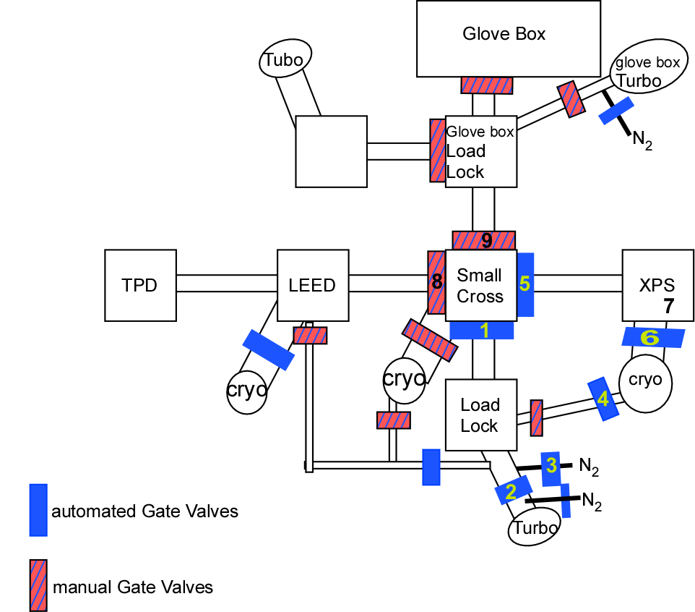
Updated by BSB 9 Jan 2005

